Based on previous theories of human interaction--such as Hippocrates "four temperaments" and Carl Jung's psychological types--Alessandra has mapped out four communication styles on four quadrants, as seen below.

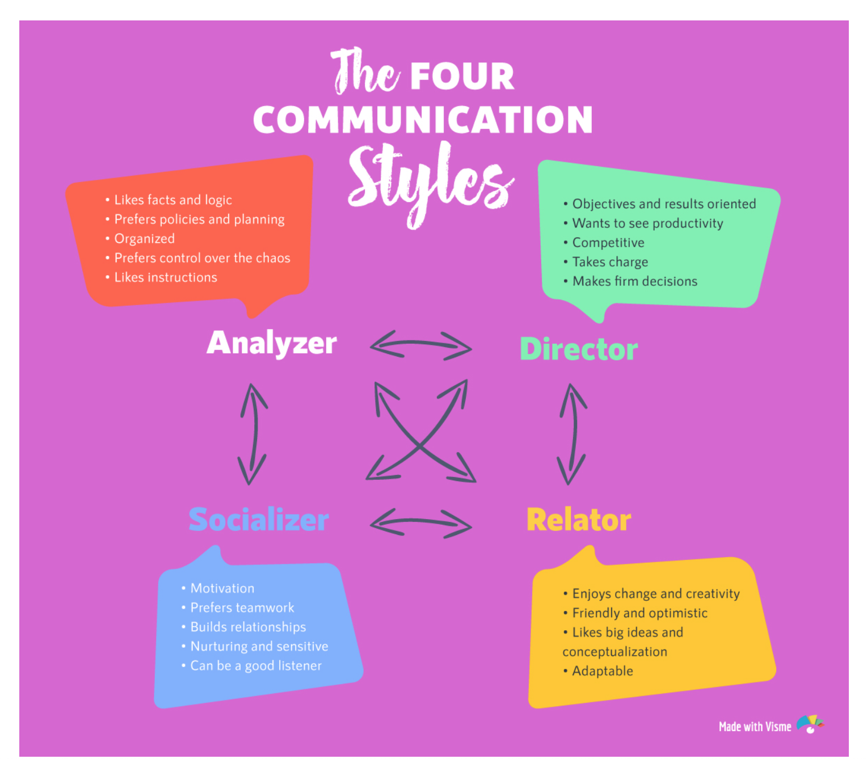

Source: https://visme.co/blog/the-4-communication-styles-quiz/

