Module Name: Communication Styles

Purpose: Gain an understanding of the four different communication styles and the impact style has on co-operation, engagement and interdependency within a team and the workplace.

Logistics: 2 – 3 hours

Facilitator: Member of the WEM Facilitation Team

Special Instructions: To increase the engagement level within this module it is recommended to bring in small and large group activities.

Essential Skills: Oral Communication

Transferability to the Workplace

Impact to the organization:

- Reduce errors.
- Increase interdependency.
- Increase co-operation

Learning Objectives

By the end of the session the participants will be able to:
- Identify the 4 different communication styles.
- Explore the strength of each communication style.
- Explore the challenges to working with each communication style.
- Discuss the concept of “treat people the way they want to be treated”.
- Identify 1 person and then 1 thing you can start-stop-keep regarding your communication style.

Assessment(s):

- MI Assessment completed prior to the program.
- Completion of activities during the module.

Program Overview

Learning objective: Identify the 4 different communication styles.

Hand out and review The Four Communication Styles, Appendix A.
Note: We are not one style. We are made up of all four styles, however, we generally have a lead communication style

Ask: Which style best represents your communication style?
Ask: What made you select that/those one or two types?

Learning objective: Explore the strength of each communication style.

Hand out and review Main Attributes of the Four Communication Styles, Appendix B.

Learning objective: Explore the challenges to working with each communication style.

Hand out and review Main Attributes of the Four Communication Styles, Appendix B.

Learning objective: Discuss the concept of “treat people the way they want to be treated”.

Ask: What does the saying “treat people the way they want to be treated” mean to you?

Ask: Do we do this?

Ask: What stops us from treating people the way they want to be treated?

Say: What we are talking about here is both parties adapting their communication style. It is not about one person or the other making changes. However, if the other person is not aware of their style and the impact it is making it can be more difficult. Once you understand your style, you can start to identify styles in other people.

Ask: What do you think of that?

Ask: How can we learn how another person wants to be treated?

Activity: Write one communication style onto each cue card. Hand out two cue cards to each table group.

Ask: How can these two communication styles communicate in a way that “treats the other person the way they want to be treated?”

Learning objective: Identify 1 person and then 1 thing you can start-stop-keep regarding your communication style.

Ask the participants to identify one person that is important to them.
Based on our conversation today what is one thing you can keep doing – stop doing – start doing?

Identify why making these changes are important to you.

Wrap-Up: Did you know there are 11 types of apples. Most of us only know of one or two. As you begin to learn more about topics like this, how to communicate, we become aware there is so much out to learn.

APPENDIX

Appendix A – The Four Communication Styles

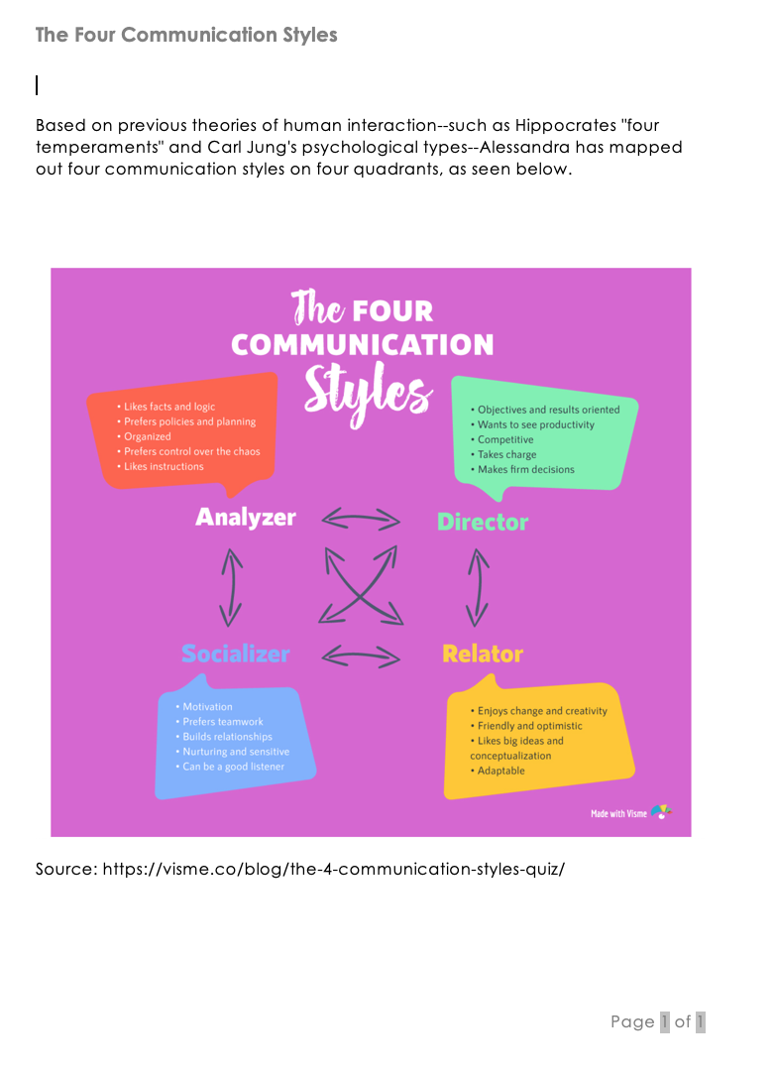

Appendix B - Main Attributes of the Four Communication Styles

