Module Name: How to Navigate Conversations?

Purpose: Our ability to hear and understand information, opinions, and ideas expressed through the spoken word and body language

Logistics: 3 hours

Facilitator: Member of the WEM Facilitation Team

Special Instructions: Not applicable at this time.

Essential Skills: Oral Communication

Transferability to the Workplace

Impact to the organization:

- Smoother working relationships.
- Increased productivity and quality.
- More effective training.
- More effective employees.

Learning Objectives

By the end of the session the participants will be able to:

- Identify the difference between conflict management and conflict resolution.
- Identify what causes conflict in the workplace.
- Identify how you generally respond to conflict in life and the workplace.
- Discuss conflict management, conflict resolution, and workplace conflict.
- Reflect on your own conflict style.
- Explore the role of an employee and leader in managing conflict.
- Differentiate between various types of conflict and what causes them.
- Discuss 6 strategies to manage conflict in the workplace and life.

Assessment(s):

- Assessment completed prior to the program.
- Completion of activities during the module.
- Assessments at the beginning, middle and end of the program.
- Conflict Questionnaire – Appendix A

Program Overview

Watch video: https://www.bing.com/videos/search?q=what+is+conflict&&view=detail&mid=72C4792555D5C1E1022B72C4792555D5C1E1022B&rvsmid=639ACA6AFEB44908DA67639ACA6AFEB44908DA67&FORM=VDRVRV

Ask: What is conflict? A serious disagreement or argument.

Learning objective: Identify the difference between conflict management and conflict resolution.

Write the following definitions on flip chart paper. Move the participants into small groups and ask them to identify what is different about that, followed by a group discussion.

Conflict Management: Conflict management is the process of limiting the negative aspects of conflict while increasing the positive aspects of conflict.
Source: https://en.wikipedia.org/wiki/Conflict_management

Conflict resolution is the process by which two or more parties reach a peaceful
resolution to a dispute.

Source: https://www.thebalancecareers.com/conflict-resolutions-skills-2063739

Learning objective: Identify what causes conflict in the workplace.
Identify how you generally respond to conflict in life and the workplace.

Split learners into groups of 3-4.

In your groups, brainstorm as many causes of conflict as you can. Try to focus on causes of conflict that relate to your life and the workplace. Take the time to reflect on your personal experiences.
Allow a few minutes, then chart what the groups identify as causes of workplace conflict.

Possible responses:
- Lack of trust
- Lack of communication
- Inconsistency in policies
- Lack of resources
- Lack of training
- Pressures
- Conflicting roles
- Different values
Watch video: https://www.youtube.com/watch?v=K4mKPI_EFvw
TKI Whiteboard animation

Ask: What did you think of the video?

Learning objective: Reflect on your own conflict style.

Activity: Hand out Conflict Questionnaire, Appendix A, and ask the participants to complete it.

Hand out and review Appendix B and C.

Learning objective: Explore the role of an employee and leader in managing conflict.

Ask: When you have had a conflict with a friend what is your role in making things better?

Ask: When you have a conflict with your grandparent/Auntie what is your role in making things better?

Ask: How could these situations relate to the classroom? For example: You were expected to be here at 9 am to leave for a tour, however, you never showed up until 9:15 am.

In any conflict, there are at least 2 people involved.

Ask: How is conflict different in the workplace than at home?
Ask: How is conflict different in the workplace than in the classroom?

In small groups explore the following questions as they relate to workplace:

- What is the role of the employee when a conflict has occurred?
Example: Conflict between the employee and manager.

- What is the role of the manager when a conflict has occurred?
Example: Conflict is between two employees.

Learning objective: Discuss 6 strategies to manage conflict in the workplace and life.

Review the following strategies to manage conflict in the workplace. Provide the participants with time to explore how they can apply these ideas in life and the workplace.

- Make sure that good relationships are a priority.
Treat the other person with respect. Do your best to be courteous, and to discuss matters constructively.

- Separate people from problems.
Recognize that, in many cases, the other person is not "being difficult" – real and valid differences can lie behind conflicting positions. By separating the problem from the person, you can discuss issues without damaging relationships.

- Listen carefully to different interests.
You'll get a better grasp of why people have adopted their position if you try to understand their point of view.

- Listen first, talk second.
You should listen to what the other person is saying before defending your own position. They might say something that changes your mind.

- Set out the "facts."
Decide on the observable facts that might impact your decision, together.

- Explore options together.
Be open to the idea that a third position may exist, and that you might reach it jointly.

Wrap-Up

Working with a partner ask the participants to explore the following 2 questions.

- Conflict is okay because _____________.
- Next time I am in conflict I am going to consider _______________.

APPENDIX

Appendix A – Conflict Questionnaire

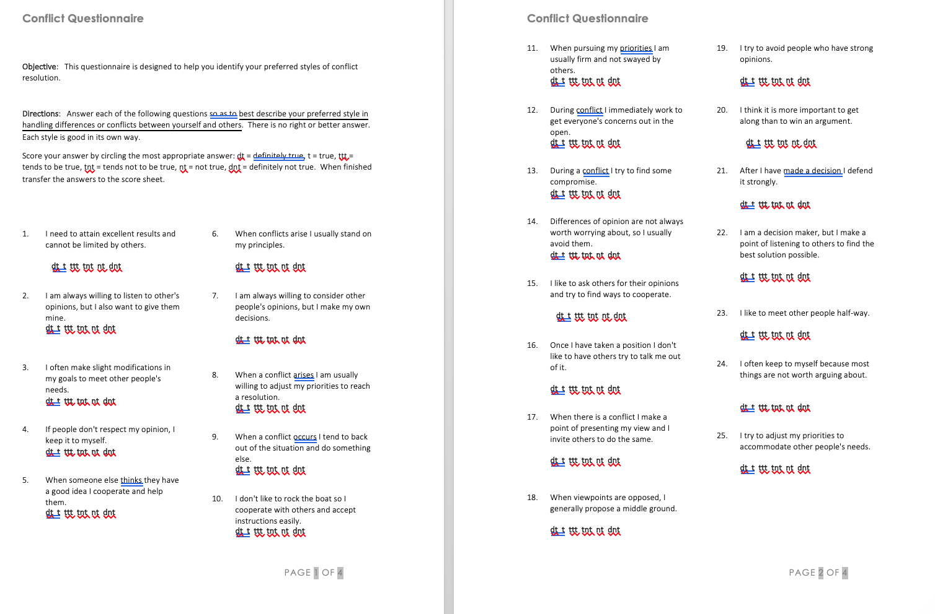

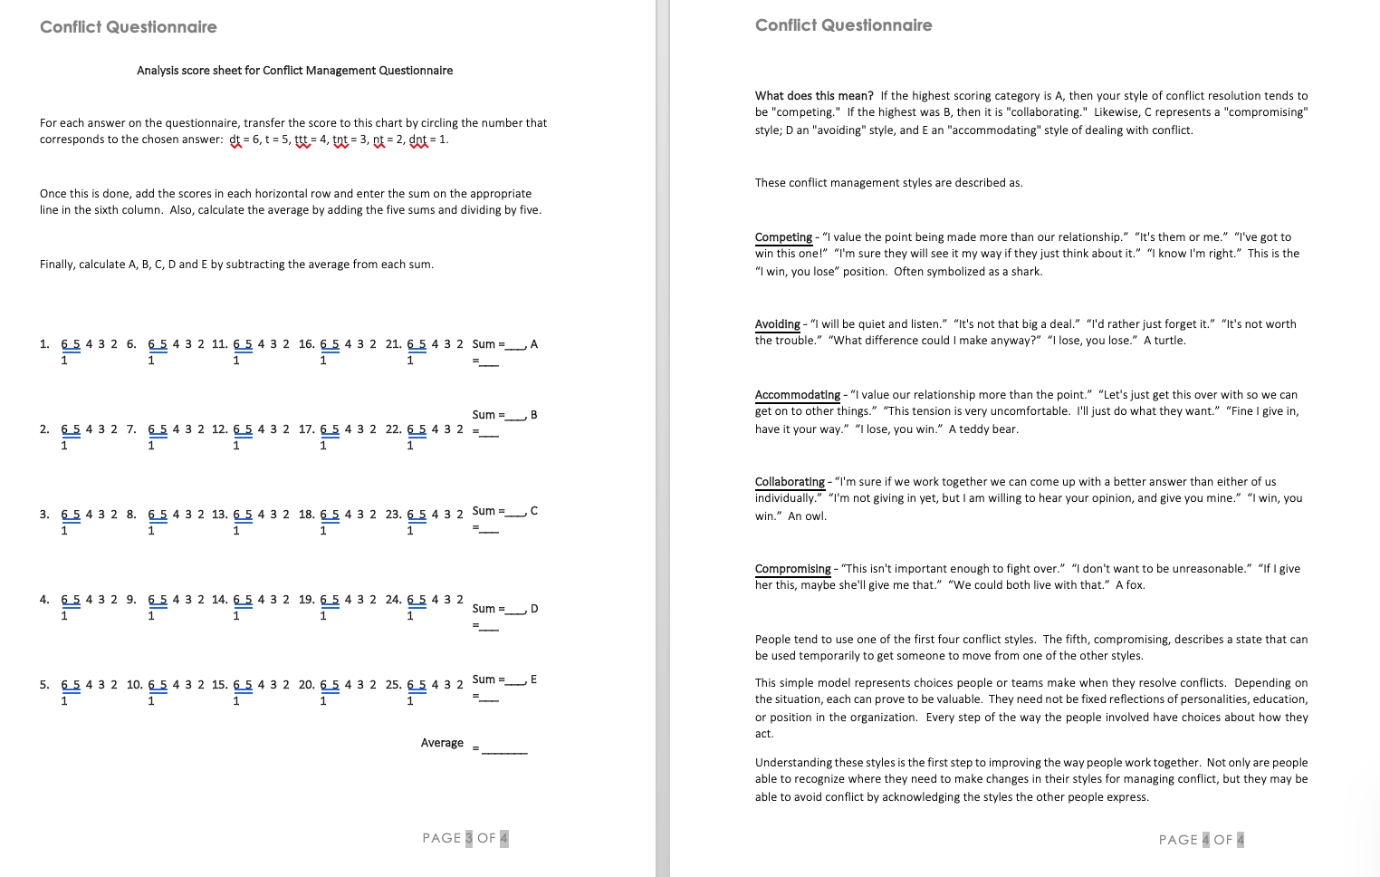

Appendix B – 5 Conflict Styles

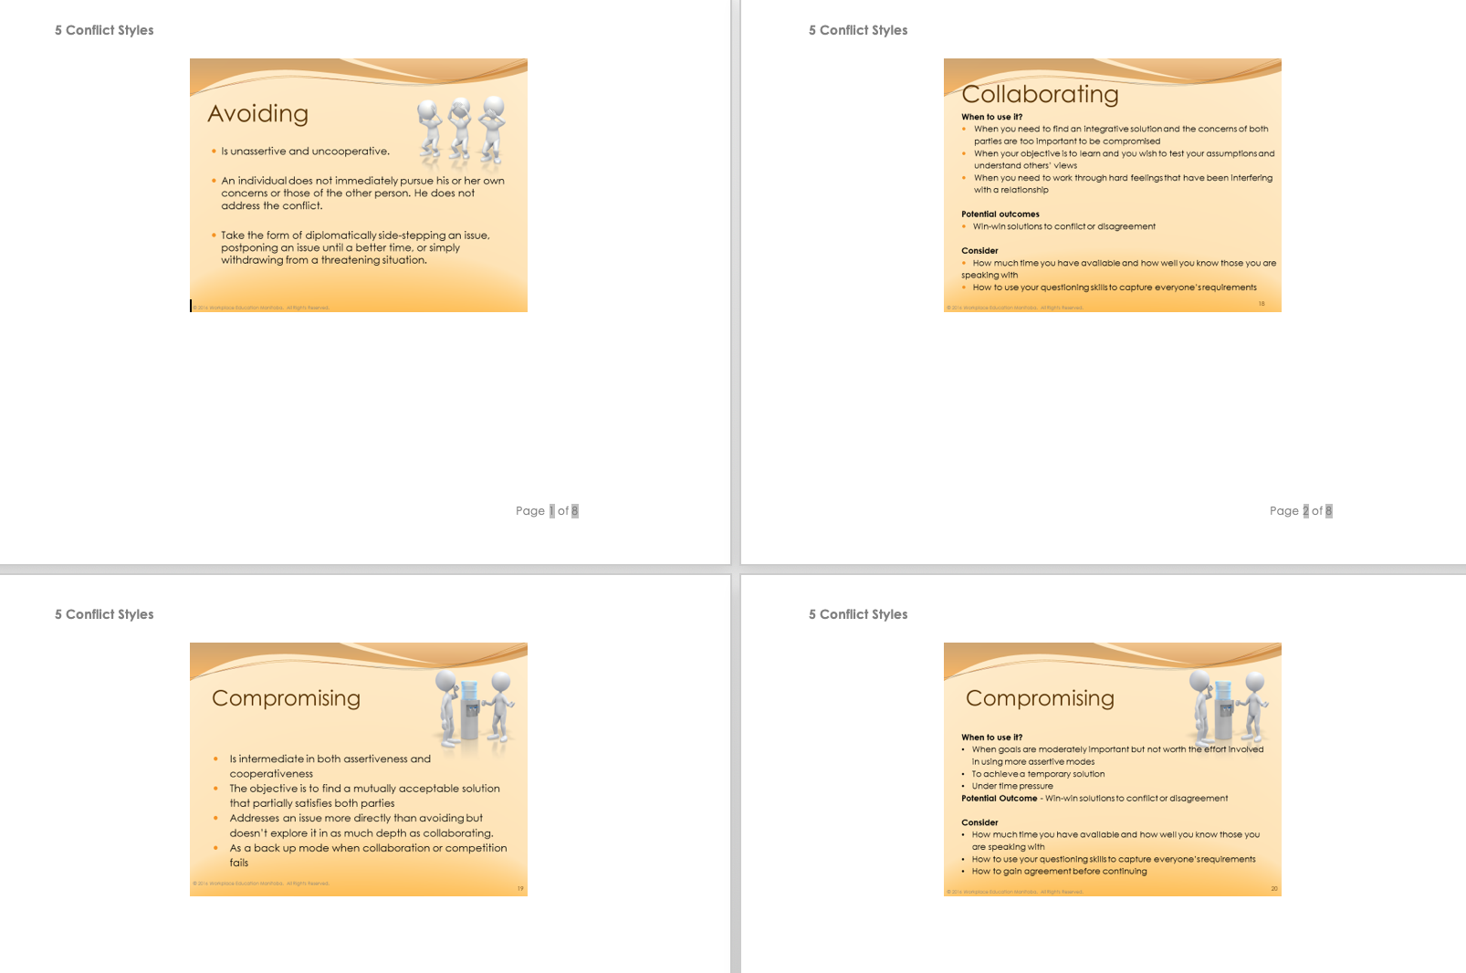

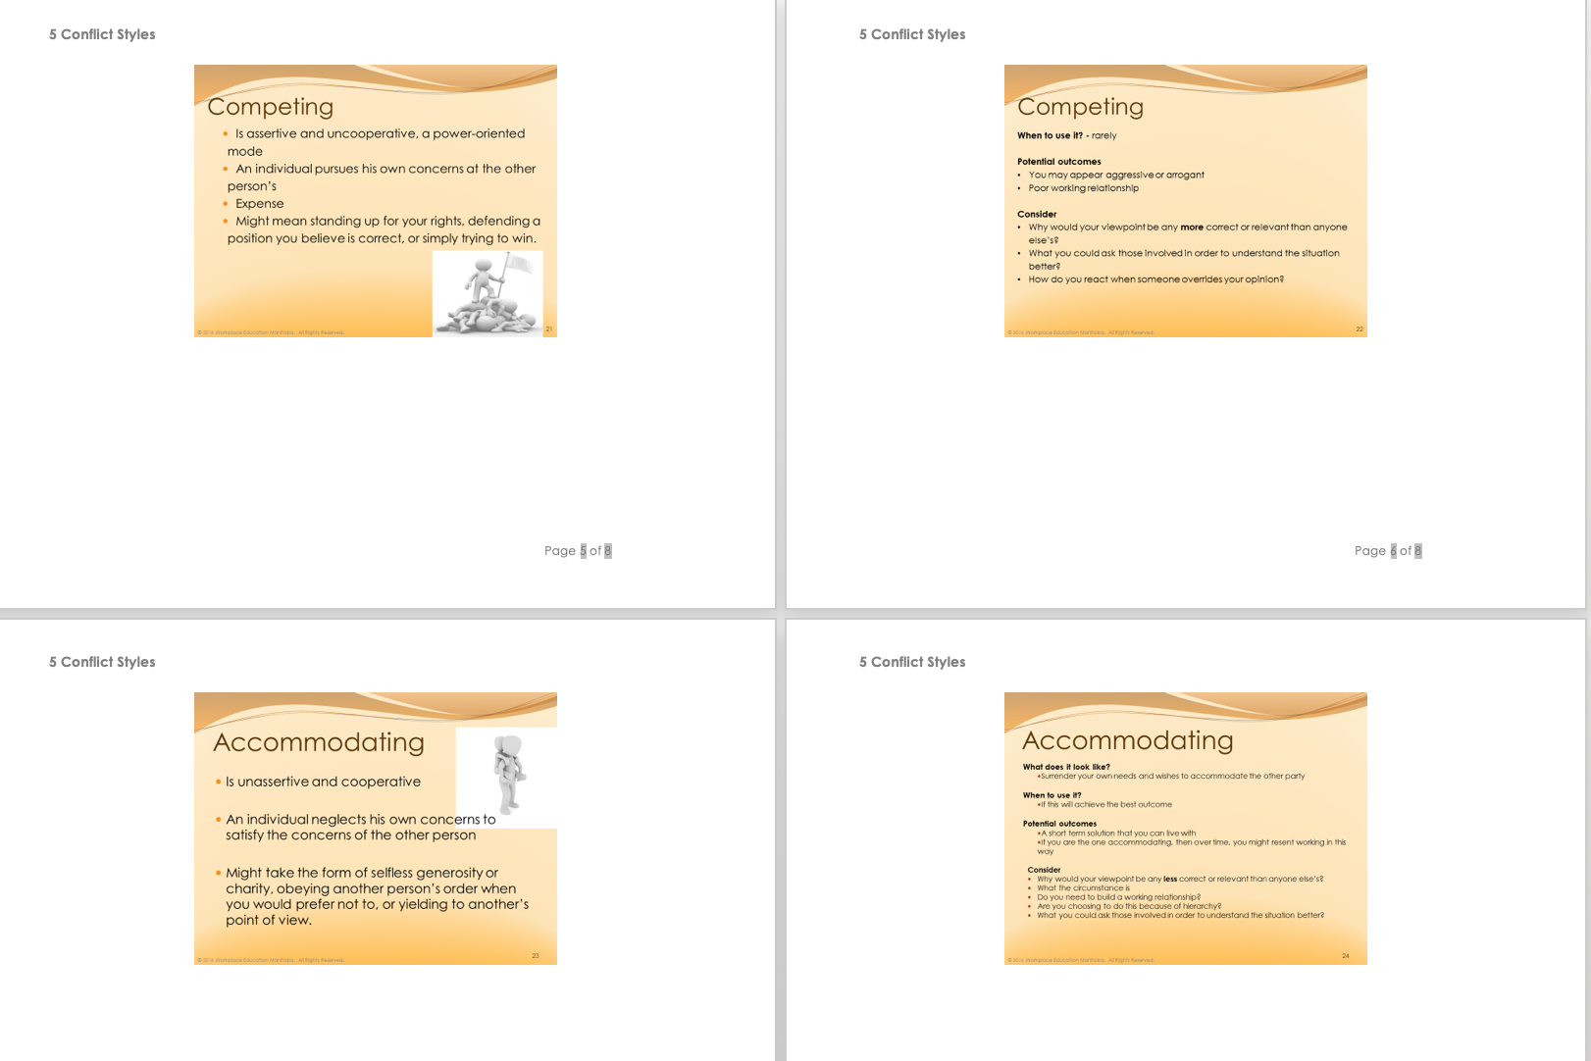

Appendix C - The Five Conflict Resolution Styles
