LINEAR-ACTIVE | MULTI-ACTIVE | REACTIVE
Talks half the time | Talks most of the time | Listens most of the time

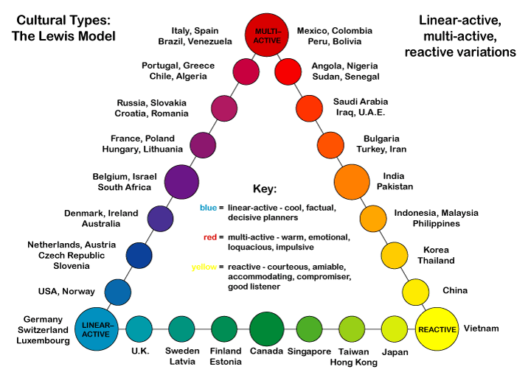

Note: These are generalizations based on research concerning the median, and everyone will be different.

