The listening spirit

The Chinese character for listen, ting, captures this spirit of listening.
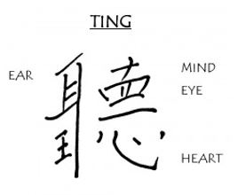

The upper left part of the symbol stands for ear. We use our ear to hear the words the speaker is saying. The lower left hand part of the symbol is for “king” or “dominant one”, indicating that hearing the words through our ear is the most important part of the listening process.

In the upper right hand part of the symbol, we see mind. Our minds help us understand the words the speaker is saying and the message they contain. Below that is eye. Our eyes allow us to see any non-verbal messages the speaker might be sending.

In the bottom right hand side is heart, and above that, the almost horizontal line translates to “one” or “to become of one”. This tells us that if we listen in this way, with our ears, mind, eyes, and heart, we can become of one heart.

Source: https://leaderonomics.com/personal/better-leaders-listen-with-ting

