Module Name: Listening

Purpose: Listening relates to the ability to hear and understand information, opinions, and ideas expressed through the spoken word and body language

(Example: non-verbal methods that use the body as a communication device)

Listening requires active efforts to comprehend multi
layered oral communication, including content meaning,
omissions and nuances. Depending on the circumstances, the content may range from every day conversation to specialized language.

Logistics: 2 – 3 hours

Facilitator: Member of the WEM Facilitation Team

Special Instructions: Not applicable at this time.

Essential Skills: Oral Communication

Transferability to the Workplace

Impact to the organization:

- Smoother working relationships
- Increased productivity and quality
- More efficient training
- More effective leaders

Learning Objective

By the end of the session the participants will be able to:

- Define listening skills.
- Identify our expectations of the sender and receiver of the message.
- Discuss active and proactive listening.
- Discuss the benefits of deeply listening.
- Discuss different perspectives of listening based on your country of origin.

Assessment(s):

- MI Assessment completed prior to the program.
- Completion of activities during the module.
- Assessments at the beginning, middle and end of the program.
- Assessment – Are you Listening? Appendix A

Program Overview

Activity: 3 Names

Ask: Write down the names of three people that you know to be good listeners.

Ask: What makes them a good listener.
The facilitator will scribe the participant’s ideas onto flip chart paper.

Learning objective: Define listening skills.

Based on our conversation, how would you define listening skills?

Definition of active listening: Active listening is a communication method which involves re-stating what is said, an open mind, and questioning to check understanding.

Learning objective: Identify our expectations of the sender and receiver of the message.

Share a few communication situations with the participants. Examples:
- Texting with a friend.
- Paying for something at the cash register/till.
- Reading an ad on a bulletin board.
In each of these examples there is a sender and receiver of a message.

Ask: As the sender of a text message what do you expect from the other person, receiver?

Ask: As the receiver of a text message what do you expect from the other person, sender?

Say: Today we are going to explore how we can improve the way we send and receive messages.

Learning objective: Discuss active and proactive listening

Share the following ideas with the participants.

Active listening is a way of listening and responding to another person that improves shared understanding. Often when people talk to each other, they do not listen attentively. They are often distracted, half listening, half thinking about something else.

Does any one here read Chinese?
IF YES, what does this say?

IF NO ONE CAN READ:

Hand out Appendix B, Listening with TING.

Chinese is a pictorial language and you will find the words here for eyes, ears and heart.
So according to the Chinese word for listening, effective listening involves the eyes, the ears and the heart.

Active listening, is “active” not passive. So, if you are not asking questions, you are probably not actively listening. Active listening involves keeping an open mind and not assuming what the speaker is going to say. It involves giving the speaker your undivided attention. It means that you keep interruptions to a minimum, and that you use questions to engage and clarify.

So, what is the difference between active and proactive listening? While active listening involves using questions to insure comprehension, proactive listening also uses questions, but questions are used to push the conversation forward. Proactive questioning is particularly important in leadership roles.

Activity: Practice active and proactive listening

Some people are lousy listeners – they think asking a lot of questions is good listening. It’s a way to destroy someone’s story. If you are a lousy listener, if you listen only to re-enforce your own stories, you sabotage your ability to learn from the stories you hear.

When you hear someone telling a story you might want to provide some feedback.

Recommended to review the differences between active listening and proactive listening.

Active Listening
Active listening is a communication method which involves re-stating what is said, an open mind, and questioning to check understanding.

Proactive Listening
Proactive listening allows the listener to move the communication, using probing questions.

Try the following prompts when your partner is telling you a story.

- “What your story tells me about you is…”
- “What I like about your story is…”
- “What your story helped me remember is…”
- “The impact I can see your story having is…”

Learning objective: Discuss the benefits of deeply listening.

Share the following ideas with the participants:
I don’t know about you, but this is not the way I was brought up to listen. I’m from New York. Where I grew up, people listen and talk at the same time. So, if you began a sentence, and I was excited by what you said, I’d jump right into the middle of your sentence with my addition or response. And, you’d feel free to do the same. We’d both be talking and listening and interrupting all at the same time. I did not learn to listen with ting until much later in my life.
Listening with ting enables us to have a much higher quality of conversation and communication. We are engaged in what the other person is telling us. We are deeply listening for their meaning. We bring our hearts, minds, ears, and eyes into the exchange. And we get a much better result.
Source: https://leaderonomics.com/personal/better-leaders-listen-with-ting

Ask: What could be the benefits to the receiver and sender when we listen deeply?

Ask: What can get in our way of listening deeply?

Ask: What can we do to enhance our ability to listen?

Learning objective: Discuss different perspectives of listening based on your country of origin.

Watch the video: SHOW VIDEO: GESTURES AROUND THE WORLD
https://www.youtube.com/results?search_query=gestures+around+the+world

Share the following ideas with the participants:

It is important to remember that in some cultures, the non-verbal communication is communicating more than the words that are being spoken.

It is also helpful to remember that the definition of good listening varies from culture to culture. According to Richard Lewis cultures have a tendency to place different weights on talking and listening.

Hand out and review Communication and Listening, Appendix C.

Ask: How does the information shared relate to you?

Ask: What value could this information bring to the workplace?

Ask: At the bottom of the handout it talks about not assuming everyone communicates the same way. Where and when could this reminder be of
value to you?

Ask the participants to share 1 new idea learned with the large group.

Wrap-Up Activity – Review all or a section of the questions with the participants.

- What are the qualities of an effective listener? Are you an effective listener?

- How do you check for clarification?

- How do you show that you are listening?

- Do you know the difference between active and proactive listening?

- What percentage of listening involves observing non-verbal skills?

- What barriers to listening may come into play in cross-cultural communication?

- How might our culture impact the balance of listening and speaking?

- How are gestures used differently from culture to culture?

APPENDIX

Appendix A – Are you Listening?

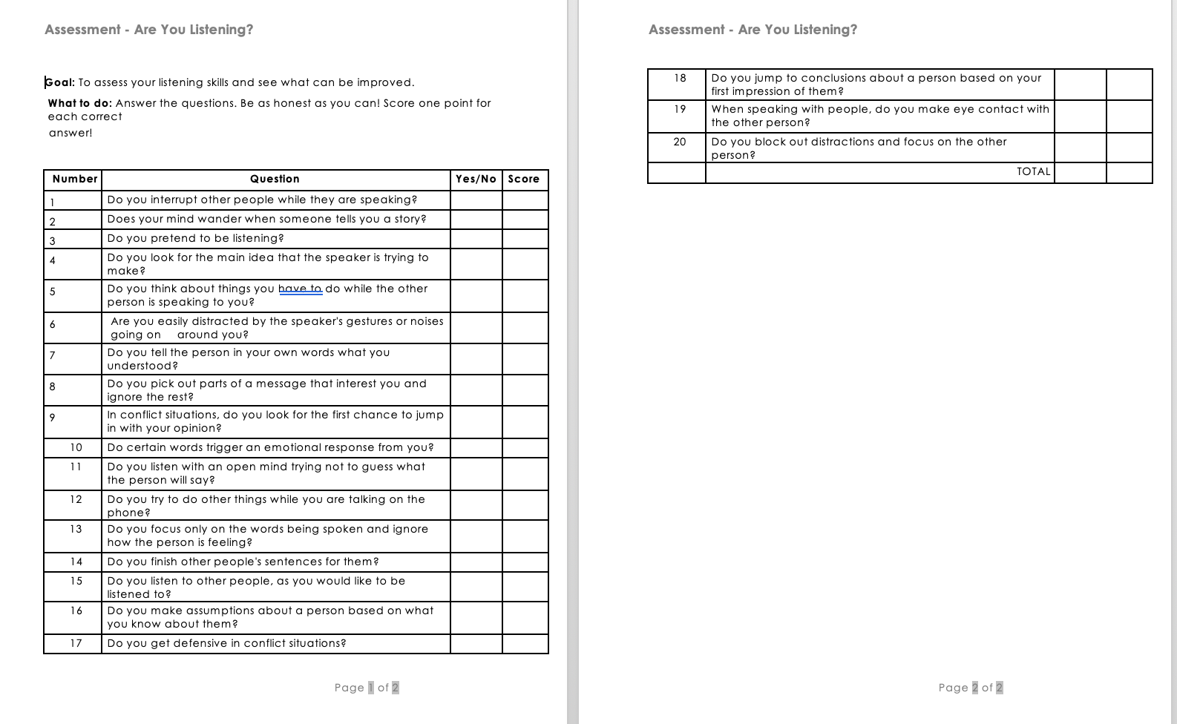

Appendix B – Listening with TING

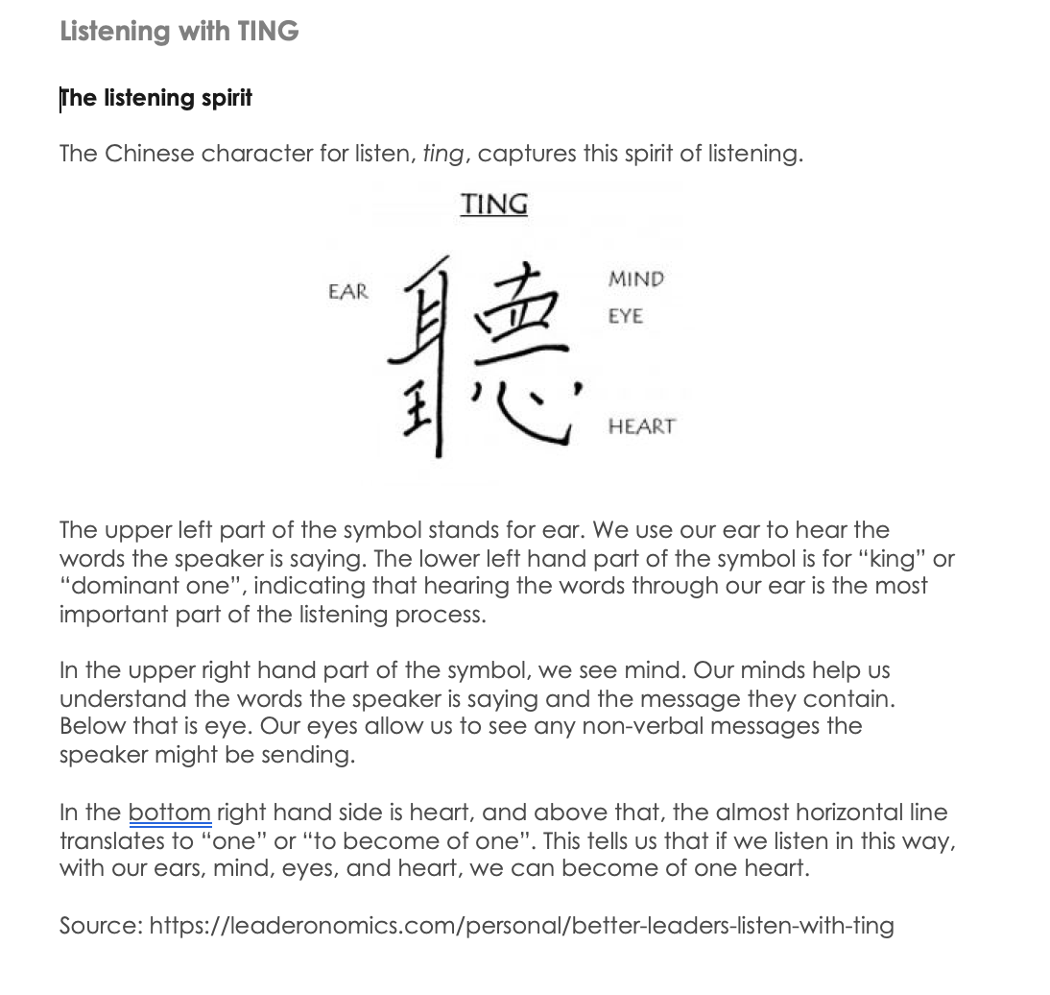

Appendix C – Communication and Listening

