Module Name: Communication – Technology

Purpose: Understand how to communicate through technology because people want or need to hear from you, and make the messages convenient and meaningful for the receiver.

Logistics: 1 session – 2 hours

Facilitator: Member of the WEM Facilitation Team

Special Instructions: This module is connected to the learning objectives within the technology module.

Essential Skills: Communication, working with others, and technology.

Transferability to the Workplace

The participant will be able to communicate effectively through technology in the workplace.

Learning Objective

By the end of the session the participants will be able to:

- Explain how to send a professional email.
- Explain how to send a professional text/message.
- Discuss how to start practicing these skills prior to entering the workplace.

Note: The participants will have the opportunity to practice and demonstrate these skills when in the technology lab.

Assessment(s):

- Comments and ideas shared throughout the session.
- Data will be collected through the weekly feedback form.
- Verification of skill development will take place during the technology module session.

Program Overview – Lesson Plan

Learning objective: Explain how to send a professional email.

Activity – Hand out cue cards with the different components of an effective email. Find the other participant in class that has the same card as you. Ask the participants to read over the component to an effective email and discuss the following questions:

- How come this component is important?
- How easy would it be for you to use/apply the component you have?
- What could get in your way of applying that component?
- In pairs create a list of 2 other email ideas you feel are important.

Ask the participants to present their ideas together to the group.

Facilitator to debrief.

Activity – Share and review example of poor and good email components with the participants. Ask the participants to share one new thing they can take away.

Learning objective: Explain how to send a professional text/message.

Handout, Appendix A, the following Top 10 Tips for Business Text Messages.

Assign each small group 2 workplace tips. Ask the participants to discuss the ideas shared in the article, with the end goal to present the idea to the large group.

Potential questions for the participants to reflect on:
- What surprised you about the tip you were assigned?
- What benefit would there be applying that tip in your daily life?
- What benefit would there be applying that tip in the workplace?

Wrap-up: Although texts often get instant attention, applying the tips above can help you make sure yours get positive attention, not groans of irritation.

Learning objective: Discuss how to start practicing these skills prior to entering the workplace.

Ask: How can you apply the ideas we have discussed regarding technology during our 12-weeks together? (Pairs or small groups)

Provide each group with the opportunity to share their ideas with the large group.

Facilitator will scribe the ideas on flip chart paper.

Conclusion: Observation is a great way to learn what works and does not work when it comes to effective communication.

APPENDIX

Appendix A - Sending Effective Emails

Source: http://www.globallearningpartners.com/blog/10-tips-for-effective-e-mail-communication/

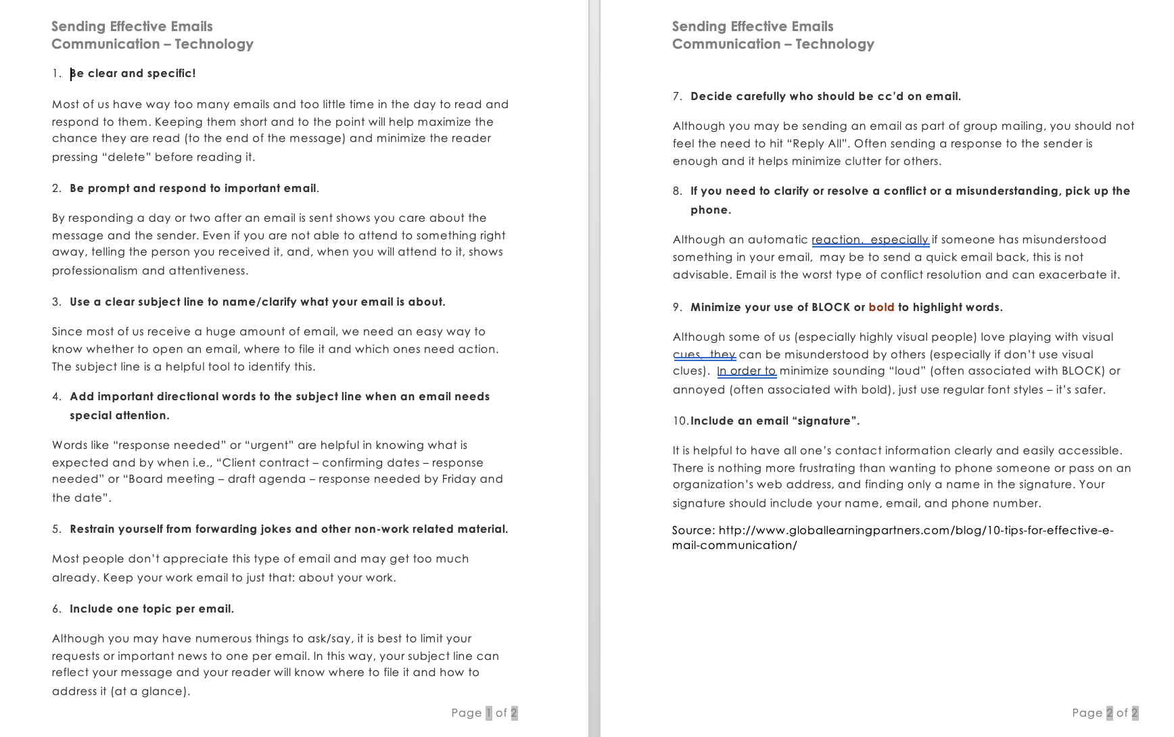

Appendix B - Top 10 Tips for Business Text Messages

Source: https://www.businesswritingblog.com/business_writing/2018/03/10-etiquette-tips-for-business-text-messages-.html

