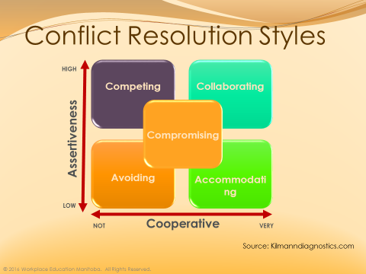

Avoiding Style

When to use it?

Potential outcomes

Consider:

*****
Collaborating Style

When to use it?

Potential outcomes

Consider:

*****

Compromising Style

When to use it?

Potential outcomes

Consider:

*****

Competing Style

When to use it?

Potential outcomes

Consider:

*****

Accommodating Style

When to use it?

Potential outcomes

Consider:

