

SYSTEMS THINKING
Skills to Navigate an Increasingly Complex World
for Effective Problem Solving and Decision Making

Contents
Thank you! 3
Learning Objectives 4
Introduction to Systems Thinking 5
Problems 5
Solutions 5
CAUTION! 5
WHERE TO WE BEGIN? 6
LEARNING OBJECTIVE 1: DEFINE SYSTEMS THINKING 6
SYSTEMS THINKING IS 6
LEARNING OBJECTIVE 2: IDENTIFY VARIOUS TYPES OF SYSTEMS 7
PARTS OF A SYSTEM 8
LEARNING OBJECTIVE 3: UNDERSTAND HOW SYSTEMS BEHAVE 8
THE SYSTEMS THINKING MODEL 9
GETTING TO THE ROOT OF THE PROBLEM 11
THE 5 WHYS 11
LEARNING OBJECTIVE 4: IDENTIFYING COMMON PATTERNS WITHIN SYSTEMS 13
Sub-Systems 13
Feedback 13
Time 13
Boundaries 14
Hierarchies 14
Synergize 14
Resources 14
LEARNING OBJECTIVE 5: UNDERSTAND HOW TO DEAL WITH COMMON PATTERNS 15
FURTHER REFLECTION 15
LEARNING OBJECTIVE 6: APPLYING SYSTEMS THINKING 16

Thank you!
Employment and Social Development Canada
and
Manitoba Education and Training
for supporting the development of this continuous learning curriculum.
This project was jointly funded through Human Resources Skills Development Canada and Entrepreneurship Training and Trade.

Workplace Education Manitoba
“Helping people to develop Essential Skills that are needed for
work, learning, and life.”
Vision:
That all Manitobans have access to the Essential Skills knowledge and training required to determine and pursue their goals related to
learning, the workplace and life.


Learning Objectives
- Define systems thinking.
- Identify various types of systems.
- Understand how systems behave.
- Identify common patterns within systems.
- Understand how to deal with common patterns.
- Apply systems thinking.

By the end of this workshop, you will be able to:
- Improve performance in personal and/or professional lives.
- Improve conflict situations with family and/or co-workers.
- Find solutions to problem patterns in your lives.

Introduction to Systems Thinking
Systems thinking allows us to see the effect of individual decisions and visualize individual decisions that people make in the workplace and how those decisions affect co-workers, managers, and the organization.

Problems
There is no area of life that is free of them.
They make it difficult to reach our performance goals in life, learning and work.
Our success is based on how well we deal with our problems.
They can make relationships difficult.
They can make managing our money difficult.

Solutions
Some solutions are easily found such as:
What should I wear today?
Where should I go for lunch?
Others are not so easily found:
The solution we found might not work as well as we had expected.
A problem may repeat itself.
We struggle to find a solution.
We are distracted by surface symptoms which make it difficult to find solutions that last.
We can apply Systems Thinking to various issues, such as:
Global issues, community issues, social issues, and/or workplace issues.

CAUTION!
Systems thinking may cause you to question the assumptions that have motivated your choices in the past.
A lasting solution to a stubborn problem may make the situation worse for a while before it gets better.
When done rights, it is empowering because when there is a problem, you can act intelligently.

WHERE TO WE BEGIN?
Systems Thinking begins with the insight that we are surrounded by interconnected systems, which is a shift from our tendency to see things in isolation.
How would you define Systems Thinking?
_____________________________________________________________________________
_____________________________________________________________________________
_____________________________________________________________________________
_____________________________________________________________________________

LEARNING OBJECTIVE 1: DEFINE SYSTEMS THINKING

SYSTEMS THINKING IS
A group of related or interconnected entities that work together to produce a desired result.
Systems can be either natural, mechanical, or social in nature.
Each of these systems has a purpose. Either one that it was expressly designed for or perhaps one that people assign to it over time.
Examples:
The purpose of digestive system is to digest the food we eat.
The purpose of the medical system is to provide medical assistance when we are ill.
The purpose of a vehicle (mechanical system) is to transport us from one place to another.
Each of these systems needs all its parts to work at their best.
Examples:
A vehicle has thousands of parts.
Which would you consider critical parts? ____________________________________________
Which less critical? __________________________________________________________________
Your hand is made up of many parts –
Which would you consider critical parts? ________________________________________________
Which are less critical? _______________________________________________________________
A system will frequently use feedback to maintain its own stability. Systems have the means to adjust to change and/or repair the damage.
Vehicle –
When you press the accelerator on your car, the system will push more fuel through the fuel injectors into the engine, so the car has the power it needs to pass another car or get itself rolling after stopping at a red light.
Hand –
Can heal if it is cut or can mend a broken bone.
System Thinking means taking a holistic approach, keeping the entire system in mind when we need to address a problem or make a change. When we think and act with the whole system in mind, we are more likely to identify the root causes or problems and find lasting solutions.
Whatever symptoms that troubled us before are less likely to come back. We are also less likely to encounter unintended consequences because we can see all the relationships within the system. Even if there are likely to be negative side-effects, we will know about them in advance and can be ready to deal with them.
What does Systems Thinking mean to you?
____________________________________________________________________________________________________________________________________________________________
Why is this important in the workplace?
____________________________________________________________________________________________________________________________________________________________

LEARNING OBJECTIVE 2: IDENTIFY VARIOUS TYPES OF SYSTEMS
List as many types of systems as you can think of in your life.
____________________________________________________________________________________________________________________________________________________________________________________________________________________________________________________________________________________________________________________________________________________________________________________________________________________________________________________________________________________
Do you see any defining features across all systems?
____________________________________________________________________________________________________________________________________________________________

Why might an understanding of a system be helpful when solving a problem that has been identified within it?
____________________________________________________________________________________________________________________________________________________________

PARTS OF A SYSTEM
What distinguishes a PART from a SYSTEM, and a SYSTEM from its PARTS?
____________________________________________________________________________________________________________________________________________________________________________________________________________________________________________________________________________________________________________________________________________________________________________________________________________________________________________________________________________________
What needs to happen to transform PARTS into a SYSTEM?
______________________________________________________________________________________________________________________________________________________________________________________________________________________________________________________________________________________________________________________________________________________________________________________________________
The process of transformation from parts into a system happens when interaction among elements influence or change each part. We have an interaction among parts when the behaviour of one part influences and modifies the behaviour of another part.

LEARNING OBJECTIVE 3: UNDERSTAND HOW SYSTEMS BEHAVE
Every day we deal with minor inconveniences, unexpected situations, mundane activities, and occasionally pleasant surprises. The dog chews on your slippers, you get a phone call from a coworker asking if you can cover their shift, a friend invites you to dinner. These are isolated events, and we treat them that way; we deal with them as they come, and we move on to the next thing.
Sometimes, there is more to an event than initially meets the eye. System thinkers sometimes describe events as the tip of the iceberg. What we see above the water is just a small part of something larger. What we see is a relatively minor incident, but underneath that may be patterns that we should be noticing and systems we should be making ourselves familiar with. Beyond that may be assumptions and information that we might need to consider.

THE SYSTEMS THINKING MODEL
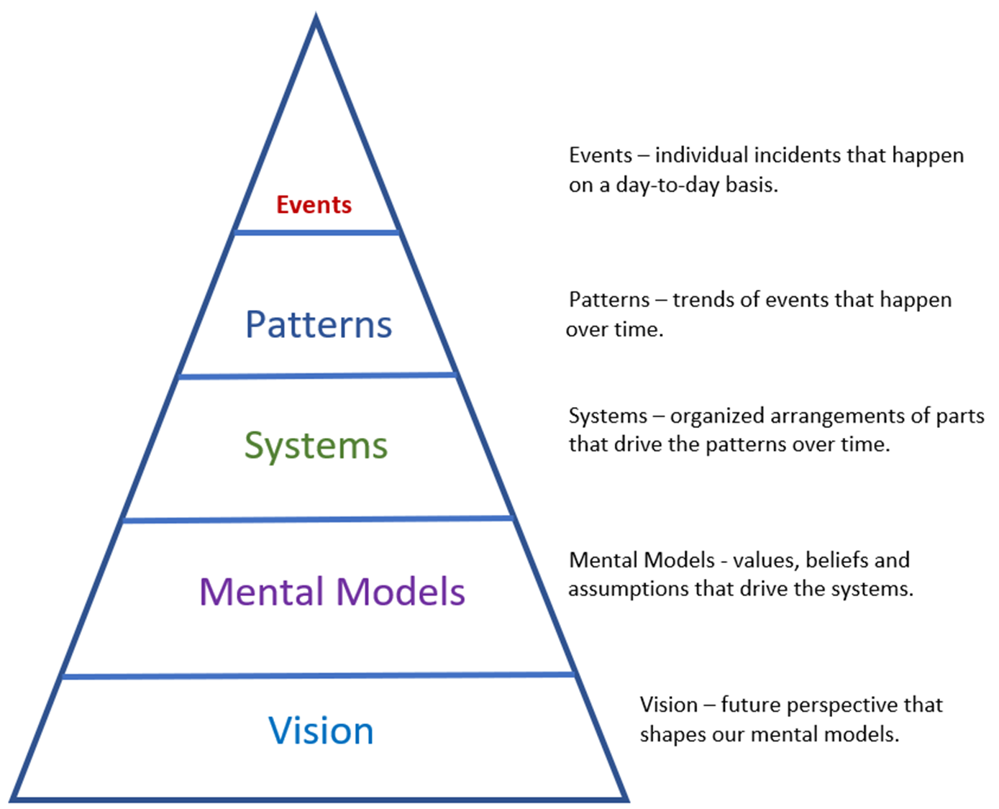

The following scenario explains this model:
Suppose you’re at work in an office and you’re working with your computer. Up to now, this computer has served you well. You’ve had it a couple of years, and it hasn’t caused you any problems.
You are responding to an email or entering data into a spreadsheet, and the computer freezes on you. After a minute or so of waiting, you reboot and pick up whenever you last saved your file. Hopefully, it won’t happen again. This is an EVENT.
An hour or so later, your computer freezes again. That’s twice in one day! The freeze-ups are starting to form a PATTERN. You may still believe the computer is reliable, and you don’t need to call tech support. Hopefully, this is just a coincidence, or it will clear up on its own. Still, you might begin to deal with the symptoms by saving your work more often until the symptom goes away.
Or perhaps you start to think about your computer as a SYSTEM. You almost certainly will after it locks up one or two more times. You probably aren’t ready to ask for a new machine, but you suspect that there is something wrong that needs to be corrected. If you have some computer knowledge, you might start to think about the hardware or software inside your computer. Maybe a file is corrupted? Or there is a problem you downloaded that isn’t compatible? Or there is a problem with the memory? You might call in a technician. This thing isn’t going to go away on its own.
At this point, you are starting to engage in some system thinking. But that doesn’t guarantee your problem will be solved immediately. If you and the technician are unable to find the problem, you will have to reconsider your MENTAL MODEL for the computer system. Up to now, you have assumed that the problem is a relatively minor one: a software glitch or a relatively inexpensive part that needs to be replaced. The computer is still basically reliable and up-to-date and should last five years as your last one did. Or so you think. But if this problem continues to go on, you will start to consider asking for a replacement. Maybe this thing just can’t be fixed. Now you have called into question one of your assumptions from when this whole thing started.
Finally, you may learn from your coworkers that they are having problems with their computers too. And their problems may be larger in scope than yours. The network can’t handle all the data they send in and out, and the software your company uses is behind that used by your clients and competitors. Someone might suggest replacing all the computers and servers with new equipment and installing new software. That is a VISION for a replacement system that spans the entire office. Addressing the root cause might mean additional costs and effort in the short term, but it will benefit the company in the long term because staff will have equipment that does more for them with fewer breakdowns.
All that is what might lie underneath the initial event.
The challenge is to identify when an event is part of a pattern, and the pattern points to systemic issues. If there is a system problem, whether it’s a defective desktop or your entire office computer system is outdated and unable to do the job, the number and severity of problems will likely escalate.
In that case, the sooner you and your team realize you have a systemic problem, the sooner you can start looking at the system, find the root of the problem, and address it. By applying system thinking, you can even anticipate and prepare for issues that might arise, head off problems before they start, and optimize your system to provide the results you want.

GETTING TO THE ROOT OF THE PROBLEM
There is a practice that system thinkers sometimes apply when they identify a problem – The 5 Whys.
The basic principle is that you should begin by asking why an event happened. Then take the explanation, turn it around, treat it as a separate event and ask why that happened. Then take the second explanation, treat that as another event, and ask why that happened. Keep going until you have asked ‘why did that happen?’ five times. At that point, you should have gotten down to the root cause.
Example:
Manufacturing Plant – Foreman and New Trainee Manager are on a facility tour.
Along the way they see a pool of oil on the floor which is a slipping hazard. The Foreman orders an employee to clean up the spill immediately, but the trainee decides to apply the five whys.
Why is there oil on the floor? Machine overhead is leaking.
Why is the machinery leaking? Broke down.
Why is the machine broken down? Gaskets were defective.
Why are the gaskets defective? Heard that purchasing got a good deal on them.
At this point, it is obvious the trainee is onto something. Digging around a bit, they discover that the company had adopted a policy of buying the cheapest possible replacement parts without regard to quality or reliability. The policy wasn’t limited to gaskets and defective replacement parts were causing breakdowns and hazards throughout the plant.
This results in a new policy which results in fewer breakdowns, increased production, and increased profits.

THE 5 WHYS
As an individual, identify a problem you have been dealing with. Make sure it is one that has repeated and become a pattern. Using the 5 Whys model, break down the problem to its root cause.
______________________________________________________________________________________________________________________________________________________________________________________________________________________________________________________________________________________________________________________________________________________________________________________________________________________________________________________________________________________________________________________________________________________________________________________________________________________________________________________________________________________________________________________________________________________________________________________________________________________________________________________________________________________________________________________________________________________________________________________________________________________________________________________________________________________________________________________________________________________________________________________________________________________________________________________________________________________________________________________________________________________________________________
__________________________________________________________________________________________________________________________________________________________________________________________________________________________________________________________________________________________________________________________________________________________________________________________________________________________________________________________________________________________________________________________________________________________________________________________________________________________________________________________________________________________________________________________________________________________________________________________________________________________________________________________________________________________________________________________________________________________________________________________________________________________________________________________________________________________________________________________________________________________________________________________________________________
____________________________________________________________________________________________________________________________________________________________________________________________________________________________________________________________________________________________________________________________________________________________________________________________________________________________________________________________________________________________________________________________________________________________________________________________________________________________________________________________________________________________________________________________________________________________________________________________________________________________________________________________________________________________________________________________________________________________________________________________________________________________________________________________________________________________________________________________________

LEARNING OBJECTIVE 4: IDENTIFYING COMMON PATTERNS WITHIN SYSTEMS

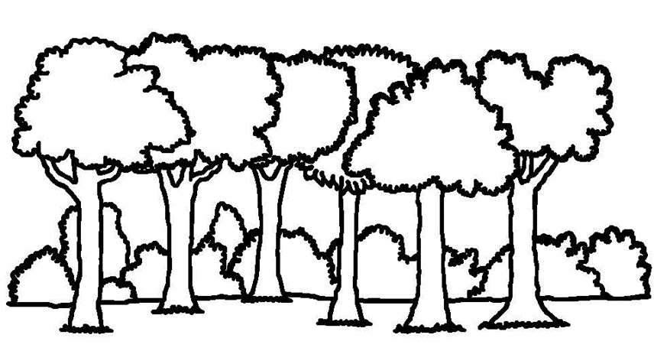
Think of a forest as a system. There are many parts of the forest.

Sub-Systems
A self-contained smaller system with a larger system. Each sub-system has parts of its own. Examples: Root system, fungi growth.

Feedback
A healthy system will use feedback to sustain itself. Feedback can reinforce and amplify or balance and correct the system’s functions. Feedback can lead to balance, or at least a bit of back and forth around an average that the system can handle reasonably well.
Example: As trees burn and decay, they release carbon back into the atmosphere. And with fewer trees left, more carbon dioxide remains in the atmosphere. Both lead to further warming and more tree dieback.

Time
The passage of time can sometimes complicate the operations of a system. Parts of a system do not always respond to each other instantaneously. The parts may be closely related, but they do not always act simultaneously. It may take anywhere from minutes to years for one part of a system to respond to activity in another part. This delay can complicate things. Delays may result in a system breakdown.
Example: After a forest fire, animal and plant life will move into the burned-out area, but the effect may take years to become apparent. Also, time for the seasons to change.

Boundaries
Systems thinking recognizes that systems can be influenced by environmental conditions outside of the system’s influence. What is in the system? What is outside the system?
Caution! We could potentially wrap up everything, everywhere, always into one system – forest, community, province, country, world, planet, solar system, galaxies, and the universe. Don’t take it too far!
Rule of Thumb: The system includes all the parts that are necessary for the system to function. Anything else is outside the system and may create a system on their own.
Example: The weather and seasons affect what plant life will grow. The solar system is necessary for plant life. Are these necessary? Include? If not, don’t include.

Hierarchies
Hierarchies help us to understand how systems respond and what the purposes of all the parts are. They help us understand who is in charge and why we are doing what we’re doing.
Example: Forests are populated by both moose and wolves. As the wolf population increases, they prey on the moose which decreases their population. However, as the moose die off, there is little food for the wolves and they then begin to die off, allowing the moose population to re-establish itself.

Synergize
Parts of a system will often synergize so the collective result is greater than what those same parts would have produced separately. It’s a lot like teamwork.
Example: Deadfall may create an ideal place for insects and/or fungi to thrive.

Resources
A system may store, move around, use, produce and distribute resources among its various parts. Observing how much is available and how they move – stocks and flows – will often be key to understanding and working with a system.
Example: Water runs from high ground to low ground creating pools of water for waterfowl, marsh plants.

What parts of the forest are interdependent?
__________________________________________________________________________________________________________________________________________________________________________________________________________________________________________

How does this apply to the workplace?
________________________________________________________________________________________________________________________________________________________________________________________________________________________________________________________________________________________________________________________

How do models or visuals help us understand how a system functions?
__________________________________________________________________________________________________________________________________________________________________________________________________________________________________________

How does this apply to the workplace? What examples have you encountered?
__________________________________________________________________________________________________________________________________________________________________________________________________________________________________________

LEARNING OBJECTIVE 5: UNDERSTAND HOW TO DEAL WITH COMMON PATTERNS
What might happen when locals use the forest to hike and enjoy nature?
What might happen when a local developer wants to build a lodge nearby?
What might happen when the seasons change year after year?
What might happen when locals pitch in to maintain hiking trails each year?
What might happen when a weather system passes through the region?
What might happen when the municipality issues several permits to allow trees to be removed for burning to heat houses?
What might happen when you remove piles of branches and small trees to be shredded or mulched?

FURTHER REFLECTION
What did you learn about systems and common patterns within them?
________________________________________________________________________________________________________________________________________________________________________________________________________________________________________________________________________________________________________________________
What actions sustained the system?
__________________________________________________________________________________________________________________________________________________________________________________________________________________________________________

What actions diminished the system?
__________________________________________________________________________________________________________________________________________________________________________________________________________________________________________

What does it mean to be a part of an interdependent system?
__________________________________________________________________________________________________________________________________________________________________________________________________________________________________________

How does this apply to the workplace?
__________________________________________________________________________________________________________________________________________________________________________________________________________________________________________

LEARNING OBJECTIVE 6: APPLYING SYSTEMS THINKING

Select a situation of interest that is likely to provoke a range of reactions; family gathering or work barbeque. Complete this exercise with a group of friends, family, or co-workers.
Write down your initial reaction to the situation. Then imagine the reaction of the others and write each one down on a separate piece of paper.
Have everyone write the name of the person they are imagining is their response on the outside of the paper after it is folded. The papers are then sorted into piles by name, and the piles are distributed to those named.
Each learner takes a turn reading aloud the responses of others, identifying which one is their original reaction.

Of what importance is the perception of others in a system comprised of people?
__________________________________________________________________________________________________________________________________________________________________________________________________________________________________________

In what ways does a system of people learn about itself through the views of its members?
__________________________________________________________________________________________________________________________________________________________________________________________________________________________________________

What can the perceptions of others and the group tell us about systems thinking?
__________________________________________________________________________________________________________________________________________________________________________________________________________________________________________

The perceptions of oneself and others, communicated in conversation, reveal the character, climate, vitality, health, and dysfunction in social systems.

