DO YOU INTEND TO BECOME A CLASS 1 TRUCK DRIVER IN CANADA?
WEM, in partnership with Supply Chain Manitoba, is here to help you prepare with no fees.
Our essential skills training for truck drivers will help you upgrade the reading, document use, writing, communication, and numeracy skills you need to succeed in your test, technical training, and career as a truck driver.

Don't miss out on this opportunity to prepare for your future career!
To learn more and register for the upcoming workshop, please contact us:

ESSENTIAL

SKILLS
FOR TRUCK DRIVERS


204-573-5146
cmorgan@wem.mb.ca 2005 McGregor Avenue
Brandon, MB R7B 4B3
FUNDED WORKSHOP
Funding Provided by:
The Government of Canada The Manitoba government

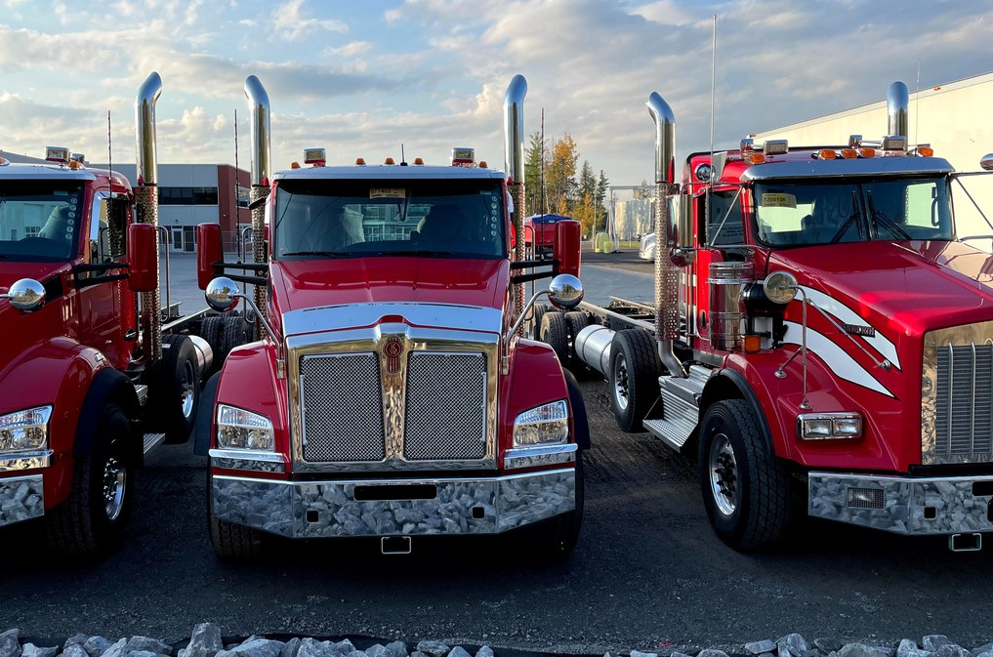
WORKSHOP SCHEDULE
Schedule in June
Schedule in June
Day

Monday

Tuesday
Wednesday Thursday
Date June 26th, 2023
June 27th, 2023

June 28th, 2023

June 29th, 2023
Hours

5:00 PM to 9:00 PM

5:00 PM to 9:00 PM

5:00 PM to 9:00 PM

5:00 PM to 9:00 PM

Registration deadline: Thursday, June 15th, 2023
Day Tuesday Wednesday
Thursday
Date June 20th, 2023
June 21st, 2023

June 22nd, 2023
Hours

5:00 PM to 9:00 PM

5:00 PM to 9:00 PM

5:00 PM to 9:00 PM

Candidates should attend all days of training to qualify for a certificate of completion
wem.mb.ca

