Funding provided by the Government of Canada and the Manitoba government.

For more information, visit www.wem.mb.ca or
contact west.steinbach@wem.mb.ca

INTRODUCTION
The Change Readiness workshop series is comprised of four (4) three-hour workshops. Participants will be engaged in learning to progressively build upon concepts related to change readiness applicable to both personal life and in preparing to enter the workplace as part of the LIFT Program.
Instructional Schedule:
Session 1 – What is Change?
Session 2 – Resilience
Session 3 – Strategies
Session 4 – Mastery and Maintenance

Participant Learning Objectives (by the end of the workshop the participants will be able to):
- Define change (both internal and external).
- Identify the benefits of change.
- Understand the 5 Building Blocks of Change.
- Recognize the connection between emotions/feelings with change and how they relate depending on internal or external factors.
- Evaluate personal change readiness through self-awareness and desire for change.
- Apply change readiness methods to life, learning, or work.
- Identify strengths, areas for development, and an action step regarding change readiness.

Benefits to teams/work groups:
- May increase morale and motivation, as employees are better prepared to embrace change in the workplace.
- May improve ability to execute change processes effectively and within desired timelines.
- May improve time management.

Benefits to organizations:
- May improve willingness and participation in positive change processes and change management.
- May increase innovation and industry leading standards.
- May increase performance overall.
- May increase revenue.

FACILITATOR ASSESSMENT TOOLS:
- Comments and ideas shared throughout the session.
- Data will be collected through the feedback form.
- Pre and Post Workshop Assessments.

HANDOUT: PRE-SELF-ASSESSMENT
Ask each person to write their name, today’s date, and complete the assessment.
Ask them to return completed assessment to the facilitator.
Explain there will be a Post Self-Assessment at the end of each workshop.

WORD MEANINGS RELATED TO TOPIC
CHANGE: make (someone or something) different; alter or modify.

READINESS: the state of being fully prepared for something, willingness to do something.

SELF-AWARENESS: conscious knowledge of one's own character, feelings, motives, and desires.

IMPACT: the force of impression of one thing on another, a significant or major effect.

EXTERNAL FACTORS: are those that stem from your surroundings. External factors may include expectations from your family, friends, cultural or gender stereotypes and family responsibilities.

INTERNAL FACTORS: are reactions that you create inside yourself in response to the world. Even though they happen inside you, it's best to think about them as behaviors because they are actions that you choose. By choosing how to perceive yourself, you can either behave your way to success or behave your way to failure.

ALTER: change or cause to change in character or composition, typically in a comparatively small but significant way.

ADAPT: make (something) suitable for a new use or purpose, modify, become adjusted to new conditions.

CONVERT: cause to change in form, character, or function, change one's religious faith or other beliefs.

SHIFT: a slight change in position, direction, or tendency.

DEFINING CHANGE
Make (someone or something) different; alter or modify. Change, alter, and vary mean to make or become different. Change may be used for making such a difference in a thing that it becomes something else. Change may also be used for substituting one thing for another.

Life happens, and what happens is something called change. Some changes are the result of biology and the passage of time, within the natural cycle or order of things. Others are self-generated, under our own control and willful effort, or dependent upon encounters with significant others—family, friends, and colleagues.

Our experiences are externally or internally focused; they either follow a linear pattern, regulated by chronological time, space, and the social structure, or emerge from our own internal strivings.
They may be subtle and gradual, easy and welcomed, or difficult and demanding. We may meet change with acceptance and grace, or with protest and resistance.

The personal significance of each change occurs when we decide to make change. This means we move from the passive state of just watching how things unfold to taking some action that enables us to utilize the change to create an outcome of our own choice. Shifting our focus from what happens (the events themselves) to what we do with what happens is another way to describe transition. Ultimately, the way we make change is our personal choice and responsibility.

“If we don’t change, we don’t grow. If we don’t grow, we aren’t really living.”
– Gail Sheehy

The Connection Between Internal and External Factors
The quality of your life depends to a large extent on the quality of your emotional and mental life.

What you think and how you feel affect your life, your relationships, your work, and everything else in your life. This means that what goes on inside you affects your external life. Inner changes create outer changes.

Every time you make inner changes, things are starting to change in your outer life. Situations and circumstance change, as well as the experiences you go through.

You might not always be able to change your external life directly, but by changing your mindset, your habits and your attitude, you create external changes.

Accepting and acknowledging this truth is a game changer. You can make small changes and you can make total life changes.

If you tend to procrastinate, worry too much, or afraid to try new things, you stick to the same spot.

However, if you are not afraid to go out of your comfort zone, and to change your thinking patterns, your life will soon start changing accordingly.

Your habitual thoughts, and the content of your subconscious mind, determine your behavior and the way you act and react.

When you change the way you feel and think, and the way you react to people and situations, your actions and behavior would change accordingly. The changes you start within you, create changes in your external, outer life.

If you are the worrying type, you are probably afraid of changes, and prefer to stick to the same kind of life that you know well. You see other people improving their life and achieving success, but you do not follow their steps, due to doubts and fears. In this situation, your current thinking pattern and your mindset may truly be limiting you.

What does it mean making inner changes?
- Changing your attitude toward people and toward life.
- Becoming a more positive person.
- Becoming more optimistic.
- Becoming a kinder and more tolerant person.
- Developing your willpower and your self-discipline.
- Awakening motivation.
- Overcoming negative habits and building positive habits.

What would happen if you made inner changes?

External factors, also referred to as situational factors, are influences that come from outside of the individual, such as the environment and those around them. Examples of situational factors include your surroundings, your place of employment and education, and the people in your immediate vicinity/community. External environment factors are significant because they can have a direct and indirect impact on an individual’s willingness to initiate and maintain change.

States of Change

It is easy to see changes in nature occurring as a process. Whether it is a caterpillar turning into a butterfly or winter shifting into spring, we can easily appreciate the process of change. But when we begin making personal changes in life, behaviours, and work, we often forget the fact that change does not happen instantaneously.

The easiest, most basic approach to understanding change as a process is to break change down into distinct, understandable elements. The three states of change provide a powerful framework: the current state, the transition state, and the future state.

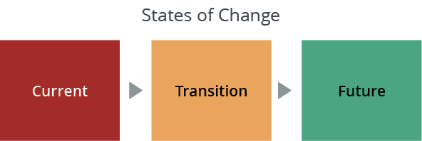

The current state is how things are done today. It is the collection of processes, behaviors, tools, technologies, organizational structures and job roles that constitute how we live life and how work is done. The current state defines who we are. It may not be working great, but it is familiar and comfortable because we know what to expect. The current state is where we have been successful and where we know how we will be measured and evaluated. Above all else, the current state is known.

The transition state may feel messy and disorganized. It may be unpredictable and constantly in flux. The transition state is often emotionally charged—with emotions ranging from fear and despair to anger, and to excitement and relief. During the transition state, productivity predictably declines. The transition state requires us to accept new perspectives and learn new ways of behaving, while still keeping up our day-to-day efforts. The transition state is challenging.

The future state is where we are trying to get to. It is often not fully defined and can actually shift while we are trudging through the transition state. The future state is supposed to be better than the current state in terms of performance. The future state can often be worrisome. The future state may not match our personal and professional goals, and there is a chance that we may not be successful in the future state. Above all else, the future state is unknown.

The three states of change provide a way to articulate how change actually occurs.

Excerpts from source: www.prosci.com

BENEFITS OF CHANGE

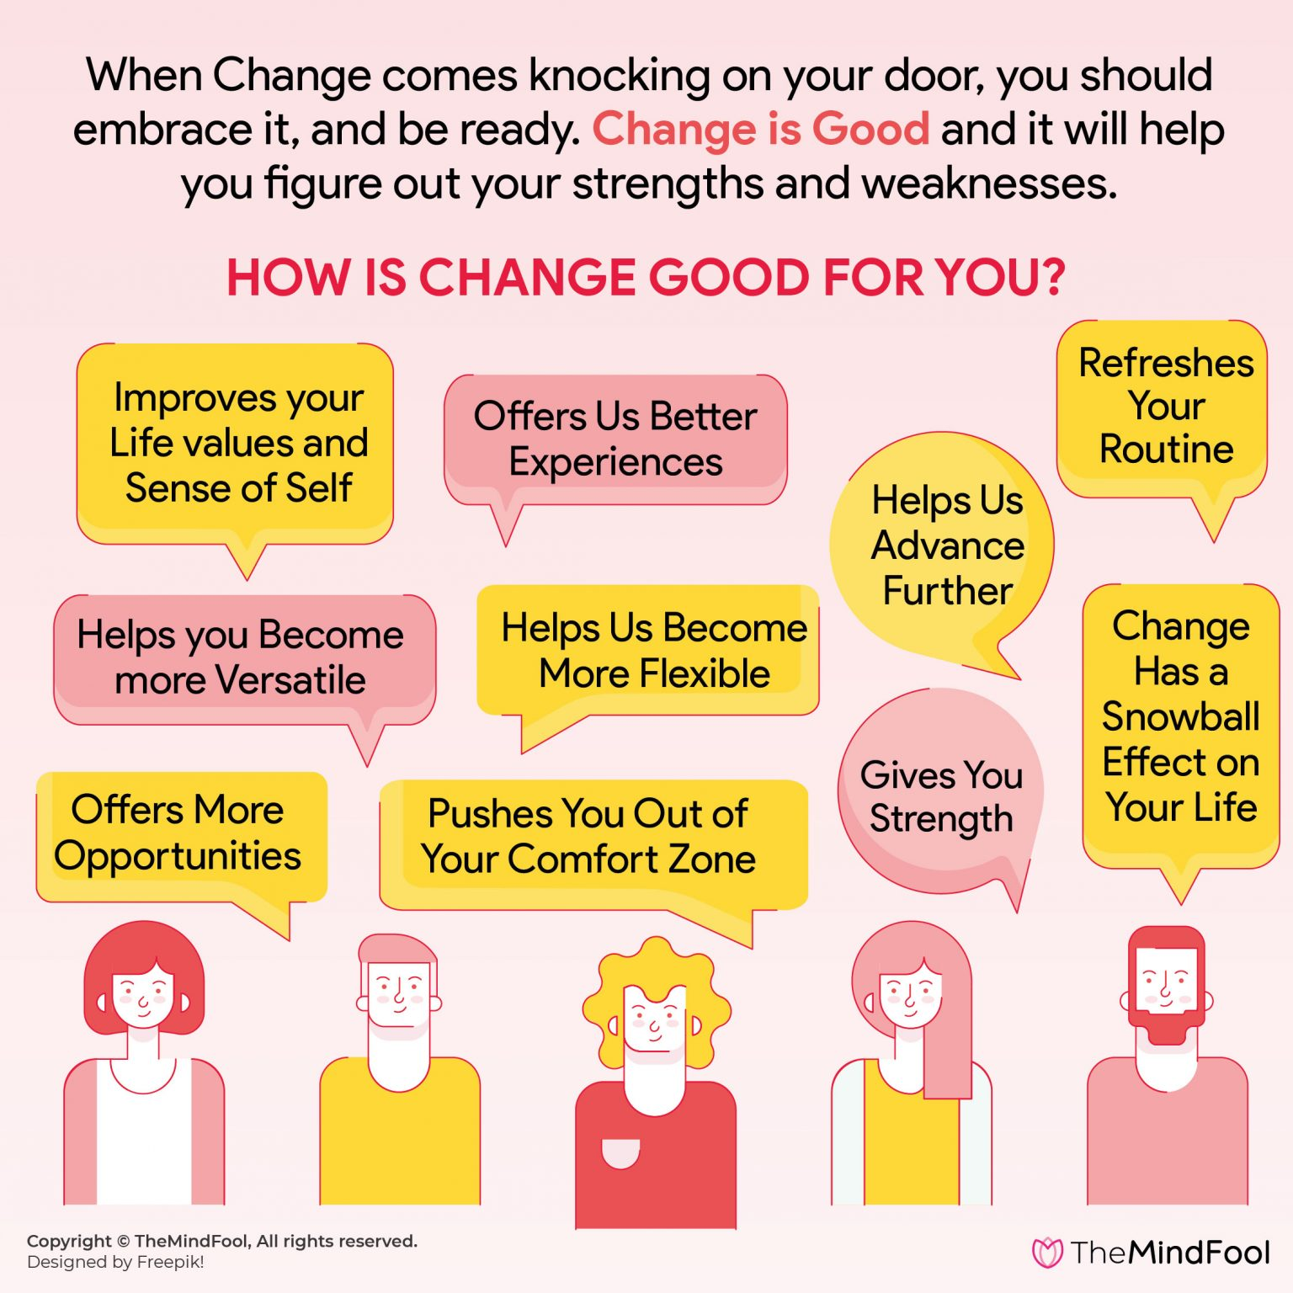
Source: https://themindfool.com/how-change-is-good-for-your-personal-and-professional-life/

THE 5 BUILDING BLOCKS OF CHANGE
The ADKAR Model is an individual change model involving 5 steps for making successful change whether it is at work, home, or in the community.
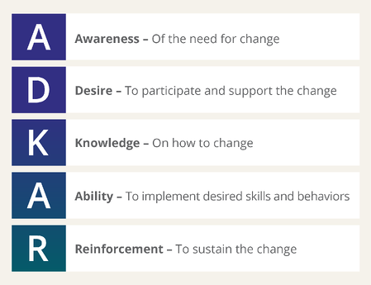
Source: www.prosci.com
Awareness:
- What is the nature of the change?
- Why is this change happening or needed?
- What is the risk of not changing? Is this important?
- How am I really feeling about this change?

Desire:
- Why is it important to change?
- What benefit will I experience from this change?
- Why do I want or need to make this change?

When the WHY becomes stronger, the HOW becomes easier…

Knowledge:
- Understanding how to change
- Are there any new skills or resources I need in order to change?
- Are there any habits or patterns of behaviour that I need to adjust to support my ability to change?
- Who can support me in making this change?

Ability:
- Able to demonstrate the ability to implement the change
- Identify any barriers that may inhibit implementing the change

Reinforcement:
- Sustaining the change
- Have the right mechanisms, supports, guides to keep change in place
- What keeps you motivated to maintain and continue to develop in this change?
- What is your success measured by? Do you value recognition, rewards, and incentives?

Connecting ADKAR to the Three States of Change
- A and D reflect your current state of change – how things are done today
- K and A reflect your transition state of change – how to move from current to future
- A and R reflect your future state of change – how things will be done tomorrow

“Change is the law of life. And those who look only to the past or present are certain to miss the future.” – John F. Kennedy

PERSONAL CHANGE READINESS SURVEY
The Change Readiness Self-Assessment is used as a conversation starter around the idea of personal readiness to change and one’s willingness to adopt new behaviors.
Facilitator will hand-out the assessment survey for you to complete, then discuss.

Recognizing the connection between emotions/feelings with change and how they relate depending on internal or external factors.
The traits measured in the Personal Change Readiness Survey are especially important in dealing with the stress of change. Nobody is perfectly suited to dealing with change. Understanding your own personality when faced with change will help you guard against stress where you’re vulnerable by relying on your strengths.

These are the traits to explore based on your survey results:

Resourcefulness
Being affective at making the most of any situation and utilizing whatever resources are available to develop plans and contingencies. Seeing more thatn one way to achieve goals and looking less in obvious places to find help. When people low in resourcefulness encounter obstacles, they get stuck and dig in their heels. Very high scorers (over 26) might overlook obvious solutions and create more work than is necessary.

Optimism
The pessimist observes only problems and obstacles while an optimist recognizes opportunities and possibilities. Optimism can’t be taught; it must be caught. You can get it by hanging around the right people. Optimists tend to be more enthusiastic and positive about change. Very high optimism scorers (over 26) may lack critical thinking skills.

Adventurousness
The inclination to take risks and the desire to pursue the unknown, to walk the path less taken. Since change always involves both risk and the unknown, adventurous people usually perform well during organizational shake-ups. Very high scorers (over 26) may indicate a tendency toward recklessness.

Drive
Combines physical energy and mental desire to create passion. It’s the fuel that maximizes all the other traits. If you have drive, nothing appears impossible. If you don’t, change is exhausting.

Adaptability
Flexibility and resilience. Flexibility involves ease of shifting expectations. Resilience is the capacity to rebound from adversity quickly with a minimum of trauma. Scoring too high (over 26) may indicate a lack of commitment or stick-to-it-ness.

Confidence
If optimism is the view that a situation will work out, confidence if the belief in your own ability to handle it. There is a direct correlation between levels of confidence and receptivity to change. If people feel confident in their ability to handle a new task, they’ll be more receptive to it and more positive about it. Scores above 26, however, may indicate a know-it-all attitude and lack of receptivity to feedback.

Tolerance for Ambiguity
Change sparks uncertainty. No matter how carefully you plan, there are always some elements of indefiniteness. Without a healthy tolerance for ambiguity, change is not only uncomfortable, but it can also be downright scary. Too much tolerance can also get you in trouble. You may have difficulty finishing tasks and making decisions.

You’ll probably find you have higher scores on some traits and lower scores on others. This is typical of most profiles and indicates that some of your change readiness traits are more developed than others.

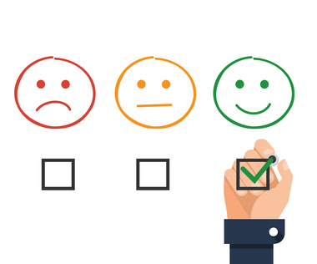
Every change costs someone something.
One of those costs, which is often underestimated by those leading change, is the emotional response to change. All change has an emotional response.
Realizing and recognizing the emotions of change can help you better lead through the change. Acknowledging someone’s emotions goes a long way towards helping them accept it. Change is hard either way, but if you ignore the emotions, you’ll find yourself always battling to make change successful.

Here are 7 common emotions to change:
Fear. Change can be very scary because it takes you into something unknown.
Grief. There’s a sense of loss associated with change. Something was left behind. People may have loved the way things were. Even if they know the change was needed people may grieve what they left behind.
Enthusiasm. This is a good emotion. Most of the time. And, for some people. There are times, however, that one groups enthusiasm further frustrates another person’s pain.
Anger. People can get mad about change. Change can cause people to react in very different ways. They may say or do things that are mostly out of character for them. (Although, sometimes change allows us to see someone’s true character.)
Confusion. Change takes people somewhere new and, therefore, can often leave people feeling very confused until they figure out and adjust to what the new reality will be after the change. There can even be an appearance of acceptance simply because a person doesn’t yet understand how they will be affected.
Loneliness. Change takes something away from people. It may have been what made them comfortable. They may feel an emptiness as a result of the loss.
Sadness. There can be a profound sadness to change. For example, moving from a community you have lived in for some time or leaving a workplace where you have solid relationships with coworkers.
Numbness. Sometimes change can leave people with their heads spinning — especially when change is fast. People don’t even know what to feel — which means they don’t know how to respond. (You won’t know their true emotion to change until after the period of numbness.)

Source: https://ronedmondson.com/2014/07/7-emotions-of-change.html

IDENTIFY STRENGTHS, AREAS FOR DEVELOPMENT AND AN ACTION STEP REGARDING YOUR DECISION MAKING

HANDOUT POST SELF-ASSESSMENT
Please write your name, today’s date and complete the assessment.
Return completed assessment to the facilitator.

WRAP-UP ACTIVITY:

What would you say had the most impact on your thinking around change because of today’s workshop?

