Funding provided by the Government of Canada and the Manitoba government.

For more information, visit www.wem.mb.ca or
contact west.steinbach@wem.mb.ca

INTRODUCTION
The Change Readiness workshop series is comprised of four (4) three-hour workshops. Participants will be engaged in learning to progressively build upon concepts related to change readiness applicable to both personal life and in preparing to enter the workplace as part of the LIFT Program.
Instructional Schedule:
Session 1 – What is Change?
Session 2 – Resilience
Session 3 – Strategies
Session 4 – Mastery and Maintenance

Participant Learning Objectives (by the end of the workshop the participants will be able to):
- Define resilience.
- Recognize the characteristics of resilient people.
- Review the 5 Building Blocks of Change (ADKAR model).
- Increase understanding of Knowledge and Ability focus more detail on these building blocks.
- Connect personal values to individual approach of coping with change and developing resilience.
- Evaluate personal adaptability skills.
- Apply resiliency methods to life, learning, or work.
- Identify strengths, areas for development, and an action step regarding building resiliency skills.

Benefits to teams/work groups:
- May increase ability to bounce back from adversity, unforeseen circumstances, and challenges in the workplace in a positive and solution-focused manner.
- May improve work-life balance.
- May increase morale and motivation, as employees are better prepared to embrace change in the workplace.
- May improve ability to execute change processes effectively and within desired timelines.
- May improve time management.

Benefits to organizations:
1. May improve adaptability and ability to leverage strengths across departments.
2. May improve willingness and participation in positive change processes and change management.
3. May increase innovation and industry leading standards.
4. May increase performance overall.
5. May increase revenue.

FACILITATOR ASSESSMENT TOOLS:
- Comments and ideas shared throughout the session.
- Data will be collected through the feedback form.
- Pre and Post Workshop Assessments.

HANDOUT: PRE-SELF-ASSESSMENT
Ask each person to write their name, today’s date, and complete the assessment.
Ask them to return completed assessment to the facilitator.
Explain there will be a Post Self-Assessment at the end of each workshop.

WORD MEANINGS RELATED TO TOPIC
FLEXIBILITY: the state or quality of being flexible; flexibleness; pliancy; pliability.

STRENGTH: the quality or state of being strong; ability to do or to bear; capacity for exertion or endurance, whether physical, intellectual, or moral; force; vigor; power; as, strength of body or of the arm; strength of mind, of memory or of judgment.

ENDURANCE: the act of bearing or suffering; a continuing under pain or distress without resistance or without being overcome; sufferance; patience.

BRAVERY: the quality of being brave; fearless; intrepidity.

DEFINING RESILIENCE
According to the American Psychological Association, Resilience is the process of adapting well in the face of adversity, trauma, tragedy, threats, and even significant sources of stress. These sources of stress can be family and relationship issues, major health problems, or career and financial difficulties.
APA further says, “As much as resilience involves “bouncing back” from these difficult experiences, it can also involve profound personal growth.” And then adds, “While these adverse events … are certainly painful and difficult, they don’t have to determine the outcome of your life. There are many aspects of your life you can control, modify, and grow with. That’s the role of resilience.”

Resilience is the capacity and dynamic process of adaptively overcoming stress and adversity while maintaining normal psychological and physical functioning. It can be viewed as a defense mechanism, which enables people to thrive in the face of adversity.

In psychology, resilience refers to the set of mental processes that a person must go through to overcome a traumatic event. The eight stages of resilience are defensiveness, finding life balance while facing stress, commitment, comeback, evaluation, meaning, and building of self-positivity.

Resilience = Recovering + Sustaining + Growing

Source: https://happyproject.in/resilience-definition/

How Resilience Relates to Change
Awareness is important because, as we become aware of how we typically respond to change and how those around us typically respond, we will begin to understand behaviours that we see during times of change for what they are, rather than giving a more sinister interpretation to what we experience. The ability to reduce stress for ourselves (rather than waiting for somebody else to do it) is important, because change is often accompanied by stress that can affect us both at work and home. We are resilient when we understand our own and others’ reactions to the change, and when we are able to recognize when our stress levels are getting too high and to do something to reduce it.

You have probably experienced some level of change (personally or professionally) in the none-too-distant past. The old adage is true: change is a constant. Most people experience some level of change every day, sometimes planned and other times more spontaneously. Maybe there is construction on your regular route to work, so you drive on unfamiliar roads. A toilet in your favourite stall is plugged, so you go next door. You reach for the cream for your coffee, and it has turned, so you drink your coffee black. Maybe it is a positive change, like getting that new computer or phone you’ve been wanting for months. Or you’ve lost those ten pounds and now you need new clothes.

Most of us handle many relatively small changes on a daily basis and manage to keep making it through our days relatively unscathed; but if we stop to pay attention, we will notice that all these changes have an impact on us. We may also notice that change impacts us differently from how it appears to impact some of those around us.

For some people change is an energiser, a motivator; in fact, these people may seek out change and appear to thrive on change. For other people, it is just the opposite, and change is experienced as exhausting and demotivating, something to put up with and be endured. Knowing how change affects you can help determine your own strategies that will allow you to be resilient in the face of the often-constant changes we face in our personal and professional lives.

My ‘Yippee!’ is your ‘Oh no!’ – Different reactions to change
The causes of stress-related change, how it shows up, and the tactics to combat it can be different for different people. This truth points to another interesting point about change. While we can agree on what changes may frequently occur in our lives, and while we have an idea of what our reactions would be to these changes, we are often surprised by other people’s reactions.

As human beings, our perspective on the world is largely influenced by our own perceptions, our own ways of taking in and processing information; we often forget that others may have different ways of perceiving events. This can result in uncertainty about ourselves or others, and we may find questions arising such as, “Gosh, why is John so excited by getting a new manager? I thought he liked Susan” or “How come everybody seems so depressed? This new project is going to be so exciting!” We may even move to placing judgments on ourselves or others based on these reactions.

We may condemn ourselves for being such a stick-in-the-mud, unable to get enthused by yet another re-organization; or maybe we thrive on change, and we find ourselves dismissing those who are slower to get on board or who actively resist what we see as a great new opportunity.

Understanding how these different reactions to stress may reflect our personality preferences can be very freeing. There is a broad spectrum of responses to change that are all considered ‘normal'. Understanding where you (and those around you) fall on this spectrum can allow you to cut yourself and others some slack where it comes to change and can also help you know what the best steps are to take to help yourself and others make it through the day-to-day and significant changes in life and work.
Source: https://www.insights.com/resources/remaining-resilient-through-change/

CHARACTERISTICS OF RESILIENT PEOPLE

1. They are able to detect the cause of their problems
Resilient people carry out the strategies needed to prevent the problematic situation from happening again. This also implies self-analysis, which is sometimes triggered by a conflict that does not come from the outside, but from within.

2. They know how to handle their emotions
Resilient people are able to manage their thoughts, since any emotion comes from here. We think, then we feel. Resilient people control their thoughts so they are not swayed by those with a negative charge.

3. They keep calm in stressful situations
We all go through difficult times throughout our lives and it is important to know how to stay calm when they occur. Resilient people are able to stay focused and calm in situations of chaos and momentary confusion.

4. They are realistic
There has been a lot of (and negative) talk about optimism which generated the global idea that being positive means to deny certain aspects of reality that are inevitable and present in the lives of many people. Being realistic but always hoping for the best is the best way to describe the optimistic characteristic of resilient people.

5. They trust themselves
Resilient people have confidence in their worth and competence to overcome adversity. What we say is what ends up forming our reality, so if we think we are not able to overcome an obstacle, of course we won’t be able to.

6. They are empathetic
People with greater capacity to address problems in the right way read the emotions of others, understand what is happening around them and act accordingly.

7. They are able to motivate themselves
Not all people are equal. Some challenges motivate us and others are opportunities for change. Resilient people know how to seek new ways of satisfaction from life. They are always highly motivated and are able to detect and attract positive things into their lives.

8. They don’t ask why, they ask how
One of the key characteristics of people who tend to easily collapse when facing a problem is that they are driven by thoughts of blame. They constantly question why the negative situation that distresses them has happened to them.

They focus on the why, unlike resilient people, who use their energy to understand how they can manage or get out of the conflicting situation.

If after reading these characteristics of resilient people you still don’t think that you are one of them, it is important that you realize that resilience is present in all people.

The difference between those that are more resilient and those who are less may be in key aspects of how the person is and how they put it into action.

If you start looking at things from another perspective, your problems will begin to appear less like a drama and more like challenges, which depending on the circumstances, you may even start to enjoy.

What’s the key? Your will to change.
Source: https://exploringyourmind.com/8-characteristics-resilient-people/

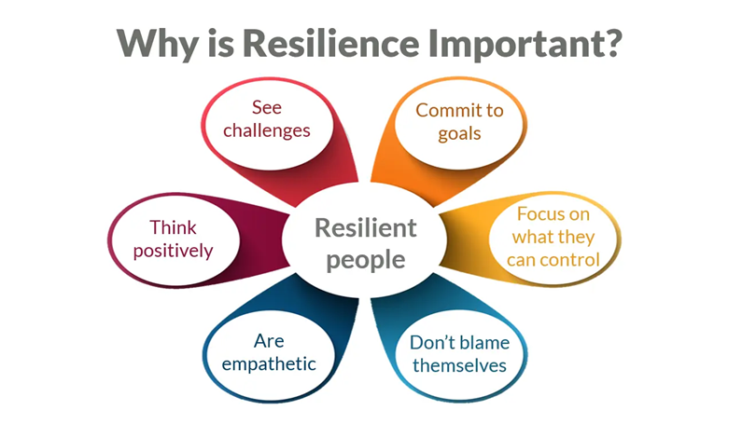
Source: http://www.trainerbubble.com/downloads/developing-resilience/

THE 5 BUILDING BLOCKS OF CHANGE: Focus on Knowledge and Ability with more detail on these building blocks and how they relate to resilience.
Review: The ADKAR Model is an individual change model involving 5 steps for making successful change whether it is at work, home, or in the community.
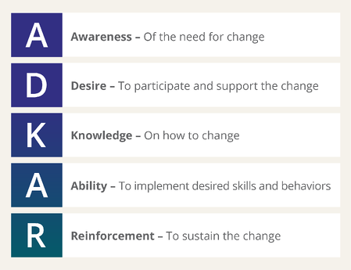
Source: www.prosci.com
Awareness:
- What is the nature of the change?
- Why is this change happening or needed?
- What is the risk of not changing? Is this important?
- How am I really feeling about this change?

Desire:
- Why is it important to change?
- What benefit will I experience from this change?
- Why do I want or need to make this change?

When the WHY becomes stronger, the HOW becomes easier…

Knowledge:
- Understanding how to change
- Are there any new skills or resources I need in order to change?
- Are there any habits or patterns of behaviour that I need to adjust to support my ability to change?
- Who can support me in making this change?

Ability:
- Able to demonstrate the ability to implement the change
- Identify any barriers that may inhibit implementing the change
Reinforcement:
- Sustaining the change
- Have the right mechanisms, supports, guides to keep change in place
- What keeps you motivated to maintain and continue to develop in this change?
- What is your success measured by? Do you value recognition, rewards, and incentives?

Connecting ADKAR to the Three States of Change
- A and D reflect your current state of change – how things are done today
- K and A reflect your transition state of change – how to move from current to future
- A and R reflect your future state of change – how things will be done tomorrow

“Change is the law of life. And those who look only to the past or present are certain to miss the future.” – John F. Kennedy

CONNECTING PERSONAL VALUES TO INDIVIDUAL APPROACH OF COPING WITH CHANGE AND DEVELOPING RESILIENCE
Our values serve as our individual architecture. Through the lens of our highest priority personal values when we look at a situation, hear something said, or feel a sudden rush of sensation, we form a thought of what that means for someone ‘like me’.

Our personal values shape our experience of the world.

What research has shown is that when we are consciously connected with our most important, heartfelt values that this can buffer us from physiological stress. Literally, conscious awareness of our values can stop our brain from producing overwhelming amounts of cortisol: the hormone which, when produced under pressure, stops us being able to think clearly.

Frequently doing things that keep us healthy and help us learn from and adapt in the light of experience. When we choose to make decisions and do things which align with our highest priority values, we are more likely to do them willingly, and gain a sense of satisfaction – even happiness. Working within your highest priority values, helps you translate the values into practical behaviour and then consciously focus on them every day. Over time, it becomes natural and, by definition, you are living your values. This is part of staying healthy and preparing for future challenges proactively.

Source: https://www.worldvaluesday.com/values-can-support-resilience-work/

PERSONAL ADAPTABILITY SKILLS
Adaptability is the ability to respond to unexpected change with grace and to be able to accomplish a task even if things go wrong.

Adaptability can include a variety of skills that help you adapt to change. Some examples of these important soft skills include:

Communication Skills
Being able to ask for clarification during transitions or seek out additional information or resources for a new and unfamiliar project can show your team leaders how motivated you are to learn and ask for help when you need it.

Active listening and other forms of communication like nonverbal communication are also equally important aspects of adaptability. Active listening shows you are attentive and ready to take a new direction and developing your nonverbal communication skills can help you navigate changes in team relationships or dynamics in the workplace.

Interpersonal Skills
Similar to effectively communicating with others, having excellent interpersonal skills can also play a key role in your overall adaptability. Being able to interact with others in healthy and positive ways can help you avoid miscommunication and conflict during operational shifts.

Problem-solving Skills
You might use your problem-solving skills to find creative solutions to challenging topics at work. Moreover, being able to observe and analyze how you might approach solving a new problem can show your managers your willingness to make adjustments or improvements to the way you approach solving problems

Creative and Strategic Thinking Skills
Adaptability can also require creative thinking and the ability to think strategically. For instance, developing new ideas to market products, finding ways to adapt to a changing market and implementing methods to improve and develop new strategies can all showcase your overall adaptability skills.

Teamwork Skills
Teamwork skills can be essential to being able to adapt to different personalities and working dynamics. Being able to work on a diverse team of people and deal with conflict, differing ideas, and other dynamics that can occur can positively benefit how adaptive you are in a team environment.

Organizational Skills
Organizational skills can include several different aspects that can make this skill necessary to develop your adaptability skills. When you maintain an organized work area, including paperwork, digital files and other aspects of your job, you can be better prepared if operational changes happen at work.
More Adaptability Skills
Here are additional important adaptability skills that can help you become flexible and ready for changes in your life:
- Collaborative
- Curious
- Determined
- Empathetic
- Innovative
- Observant
- Open-minded
- Resilient

How to Improve Adaptability Skills
Being adaptable and open to change may not always be easy, however, you might consider the following steps to help you develop and improve your adaptability skills:

1. Be aware of changes in your environment
One key method that can help you develop your adaptability skills is to be aware of changes in your environment. For instance, at work you might observe a new process in another department and be proactive in exploring how it may impact your work and if any changes may be required.

2. Develop a growth mindset
Being adaptable also means being willing to learn and try new things. Developing a growth mindset can positively influence your ability to take on new challenges, find new opportunities to develop your knowledge and contribute to new projects. Your willingness and motivation to keep improving upon your skills can also show your employer and those around you your commitment to your professional and personal growth.

3. Set goals for yourself
Another method that can help you develop your adaptability skills might be to set goals for yourself. For instance, if you feel you might benefit from developing your nonverbal communication or you tend to procrastinate when expected to complete challenging tasks, you might set a goal to work on each aspect of your skills so you can improve your overall ability to adapt to changes in life and in the workplace.

4. Ask for feedback
As you develop throughout your life, relationships, and career, you might think about requesting constructive feedback to help you improve on the skills you are developing. Positive and constructive feedback can be beneficial for setting goals and achieving success in your life and career.

5. Learn to acknowledge and accept change
Learning to acknowledge changes in your life and career can help you prepare yourself and be ready to adapt to differing circumstances. Additionally, learning how to be willing to accept change can be an effective step toward recognizing when you need to adjust to make transitions smoother for yourself.

Source: https://www.indeed.com/career-advice/career-development/adaptability-skills

IDENTIFY STRENGTHS, AREAS FOR DEVELOPMENT AND AN ACTION STEP REGARDING YOUR DECISION MAKING

HANDOUT POST SELF-ASSESSMENT
Please write your name, today’s date and complete the assessment.
Return completed assessment to the facilitator.

WRAP-UP ACTIVITY:

What would you say had the most impact on your thinking around resilience because of today’s workshop?

