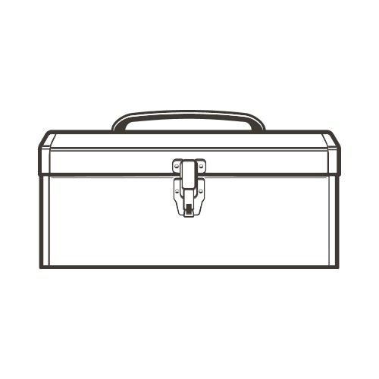
Strategies for Change
Exploring Your Internal and External Tools and Resources
Photo Source: www.thatshirt.com

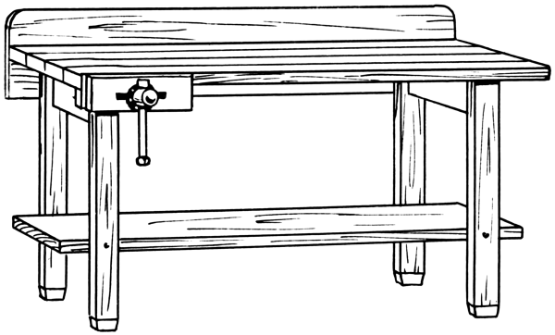
Photo Source: www.schoolplaten.com

Internal Tools/Strategies in my Toolkit:
_____________________________________________________________________________________________________________________________________________________________________________________________________________________________________________________________________________________________________________________________________________________________________________________________________________________________________________

External Tools/Strategies to support me:
_____________________________________________________________________________________________________________________________________________________________________________________________________________________________________________________________________________________________________________________________________________________________________________________________________________________________________________

