Funding provided by the Government of Canada and the Manitoba government.

For more information, visit www.wem.mb.ca or
contact west.steinbach@wem.mb.ca

INTRODUCTION
The Change Readiness workshop series is comprised of four (4) three-hour workshops. Participants will be engaged in learning to progressively build upon concepts related to change readiness applicable to both personal life and in preparing to enter the workplace as part of the LIFT Program.
Instructional Schedule:
Session 1 – What is Change?
Session 2 – Resilience
Session 3 – Strategies
Session 4 – Mastery and Maintenance

Participant Learning Objectives (by the end of the workshop the participants will be able to):
- Review the 5 Building Blocks of Change (ADKAR model).
- Increase understanding of Knowledge and Ability focus more detail on these building blocks.
- Review strategies covered in Session 1 and Session 2.
- Evaluate personal adaptability skills.
- Understand the ABCDE.
- Develop a 30-Day growth plan.
- Introduce concept of mastery – Reinforcement (Maintenance).

Benefits to teams/work groups:
- May increase knowledge and application of strategies and tools to use to achieve desired outcomes.
- May increase ability to bounce back from adversity, unforeseen circumstances, and challenges in the workplace in a positive and solution-focused manner.
- May improve work-life balance.
- May increase morale and motivation, as employees are better prepared to embrace change in the workplace.
- May improve ability to execute change processes effectively and within desired timelines.
- May improve time management.

Benefits to organizations:
- May improve adaptability and ability to leverage strengths across departments.
- May improve willingness and participation in positive change processes and change management.
- May increase innovation and industry leading standards.
- May increase performance overall.
- May increase revenue.

FACILITATOR ASSESSMENT TOOLS:
- Comments and ideas shared throughout the session.
- Data will be collected through the feedback form.
- Strength and Development Worksheet at the end of the workshop session series.

WORD MEANINGS RELATED TO TOPIC
STRATEGY: a plan of action or policy designed to achieve a major or overall aim.

PLAN: a detailed proposal for doing or achieving something; an intention or decision about what one is going to do; a detailed map or diagram.

PROACTIVE: (of a person, policy, or action) creating or controlling a situation by causing something to happen rather than responding to it after it has happened.

INITIATIVE: the ability to assess and initiate things independently; the power or opportunity to act or take charge before others do; an act or strategy intended to resolve a difficulty or improve a situation; a fresh approach to something.

ENTERPRISE: a project or undertaking, typically one that is difficult or requires effort.

INVENTIVENESS: the quality of being inventive; creativity.

RESOURCEFULNESS: the ability to find quick and clever ways to overcome difficulties.

CAPABILITY: the power or ability to do something; the extent of someone's or something's ability.

ADVANTAGE: a condition or circumstance that puts one in a favorable or superior position.

THE IMPORTANCE OF HAVING A STRATEGIC APPROACH TO CHANGE
We all have things in our life that we want to change—our eating habits, our hair color, our productivity, etc. But change is hard! That’s because these things you want to change serve an important purpose—consciously, you may despise the behavior, but on a deeper level the behavior you want to change is a protection or a pattern that helped or helps you meet your needs. If we were robots, change would be easy. But, because we are logical and emotional creatures, change is complicated: no matter how badly we logically want it, we must find the emotional balance in order to get it.

Whatever it is in your life that you want to modify—whether you know it or not—is part of a larger self-organized system that keeps your life going for you. For better or for worse, it’s a system or pattern you know and trust. Somehow, this behavior has helped you. Now it hurts. And you’re stuck.

Until you identify and understand the purpose of this behavior, change will be extremely difficult.
Here are strategies that can help you change:

1. Change Only One Thing at a Time
If you’re looking to change one area in your life, keep it to one area—especially if what you’re looking to rework is a major part of your current life. Trying to change many things all at once can be a set-up for exhaustion and defeat.

2. Identify Why You Want to Change
Everyone always wants to brush over this step with a glib answer. I suggest you think it through a bit more. I often ask folks to pretend a magic genie is offering to grant the change they seek. Only first, they have to explain why they deserve and need this change. This provides the opportunity to articulate to themselves some in-depth reasons why they are making this commitment to begin the difficult process of change. When it feels challenging to stick to your commitment, you can often reflect back on these reasons to help you hang in there.

3. Understand How the Behavior Serves You
We hinted at this in the opening—whatever behavior you’re trying to change, it does, in fact, serve a purpose for you. This can be difficult to believe, as it’s hard to imagine that an unwanted behavior could actually help you in some way. Keep in mind that “helping” you does not mean it’s good for you. It means it’s helping you to survive day-to-day. Understanding how this behavior works for you can help you understand the discomfort you experience during the process of change.

4. Sit With the Discomfort
This one can also help you with #3. When you’re feeling the discomfort of change, try not to run away from it so quickly. See if you can let yourself feel the discomfort and try to understand what it is that is so intolerable. Yes, I know you don’t like discomfort and I know it doesn’t feel good. Believe me, I don’t like it either. But quite often when we let ourselves fully experience our difficult feelings, we can learn some very important things about ourselves that can help us change.

5. Take Baby Steps
You can often break the behavior you’re trying to change into smaller, more attainable goals. If you’re trying to eat healthier foods, start with adding a vegetable and a fruit to your regular meal plan every day, rather than revamping your entire menu all at once. Slow and gradual modification, rather than huge abrupt change, gives you the opportunity to take things one step at a time, which can be more productive and more likely to result in permanent change.

6. No Time Limits
This goes along with #5. Many people hate this one because in our society, we want results now. True, lasting change usually happens slowly over time. Trying to rush the process of change usually results in going to an extreme only to eventually burn out and have the pendulum swing back to the other extreme. Let change happen at a pace that feels right to you.

Shifting our behaviors can take time, practice, and patience with ourselves. Remember that change doesn’t have to be perfect. It just must be in process.

Source: https://www.psychologytoday.com/ca/blog/inside-out/201308/6-steps-personal-change

BENEFITS OF POSITIVE THINKING AND A STRATEGIC APPROACH TO CHANGE
You have probably had someone tell you to "look on the bright side" or to "see the cup as half full." Chances are good that the people who make these comments are positive thinkers. Researchers are finding more and more evidence pointing to the many benefits of optimism and positive thinking.

Such findings suggest that not only are positive thinkers healthier and less stressed, they also have greater overall well-being. According to positive psychology researcher Suzanne Segerstrom, "Setbacks are inherent to almost every worthwhile human activity, and a number of studies show that optimists are in general both psychologically and physiologically healthier."

Even if positive thinking doesn't come naturally to you, there are plenty of great reasons to start cultivating affirmative thoughts and minimizing negative self-talk.

Stress Relief
When faced with stressful situations, positive thinkers cope more effectively than pessimists. Rather than dwelling on their frustrations or things that they cannot change, they will devise a plan of action and ask others for assistance and advice.

Pessimists, on the other hand, are more likely to simply assume that the situation is out of their control and there is nothing they can do to change it.

Increased Immunity
In recent years, researchers have found that your mind can have a powerful effect on your body. Immunity is one area where your thoughts and attitudes can have a particularly powerful influence.

In one study, researchers found that activation in brain areas associated with negative emotions led to a weaker immune response to a flu vaccine. Researchers Segerstrom and Sephton found that people who were optimistic about a specific and important part of their lives, such as how well they were doing in school, exhibited a stronger immune response than those who had a more negative view of the situation.

Improved Wellness
Not only can positive thinking impact your ability to cope with stress and your immunity, but it also has an impact on your overall well-being, including a reduced risk of death from cardiovascular problems, less depression, and an increased lifespan.

While researchers are not entirely clear on why positive thinking benefits health, some suggest that positive people might lead healthier lifestyles. By coping better with stress and avoiding unhealthy behaviors, they are able to improve their health and well-being.

Better Resilience
Resilience refers to our ability to cope with problems. Resilient people are able to face a crisis or trauma with strength and resolve. Rather than falling apart in the face of such stress, they have the ability to carry on and eventually overcome such adversity.

It may come as no surprise to learn that positive thinking can play a major role in resilience. When dealing with a challenge, optimists typically look at what they can do to fix the problem. Instead of giving up hope, they marshal their resources and are willing to ask others for help.

Researchers have also found that in the wake of a crisis, such as a terrorist attack or natural disaster, positive thoughts and emotions encourage thriving and provide a sort of buffer against depression among resilient people.

Fortunately, experts also believe that such positivism and resilience can be cultivated. By nurturing positive emotions, even in the face of terrible events, people can reap both short-term and long-term rewards, including managing stress levels, lessening depression, and building coping skills that will serve them well in the future.

Practicing Positive Thinking with a Realistic Perspective
Before you put on those rose-colored glasses, it is important to note that positive thinking is not about taking a "Pollyanna" approach to life. In fact, researchers have found that in some instances, optimism might not serve you well. For example, people who are excessively optimistic might overestimate their own abilities and take on more than they can handle, ultimately leading to more stress and anxiety.5

Instead of ignoring reality in favor of the silver lining, psychologists suggest that positive thinking centers on such things as a belief in your abilities, a positive approach to challenges, and trying to make the most of the bad situations.

Bad things will happen. Sometimes you will be disappointed or hurt by the actions of others. This does not mean that the world is out to get you or that all people will let you down. Instead, positive thinkers will look at the situation realistically, search for ways that they can improve the situation, and try to learn from their experiences.
Source: https://www.verywellmind.com/benefits-of-positive-thinking-2794767

FINDING THE APPROACH OR STRATEGY THAT WORKS FOR YOU
Models of the Process of Change
The Transition Curve, or Change Curve, was developed originally by Elizabeth Kubler-Ross to show how people come to terms with having a terminal illness and is a useful way of thinking about change. It shows the changing levels of confidence, morale, and effectiveness within an organisation or individual, as a change process develops, and shows how initial ignorance or denial gives way to anger, then exploration and finally acceptance.

Many organizations and individuals make the mistake of seeing a high level of energy early in a change process, and assuming that they are on the upward curve, and have therefore successfully bypassed anger. It’s much more likely that they are bang in the middle of Phase 1, and most people are either actively in denial, or still in blissful ignorance. Change takes longer than you think.

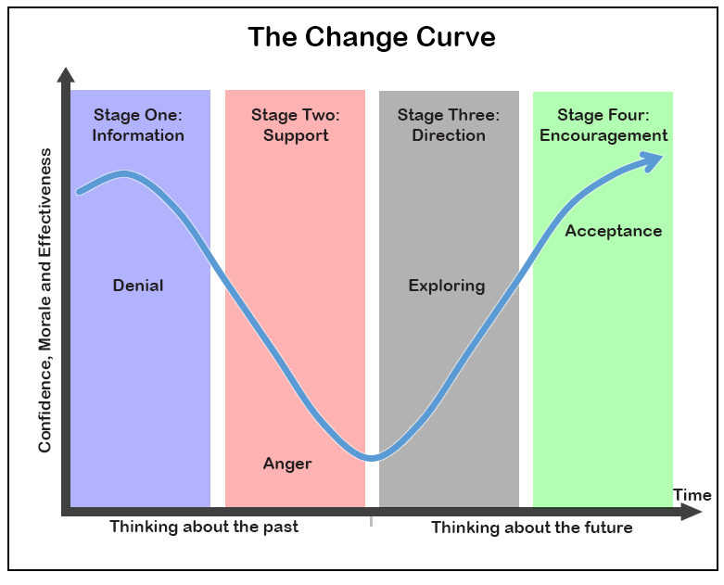
Source: https://www.skillsyouneed.com/ps/personal-change-management.html

THE 5 BUILDING BLOCKS OF CHANGE
Focus on Knowledge and Ability with more detail on these building blocks and how they relate to having a strategic approach to change.
Review: The ADKAR Model is an individual change model involving 5 steps for making successful change whether it is at work, home, or in the community.
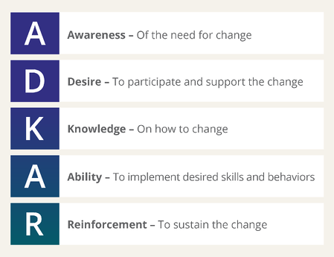
Source: www.prosci.com
Awareness:
- What is the nature of the change?
- Why is this change happening or needed?
- What is the risk of not changing? Is this important?
- How am I really feeling about this change?

Desire:
- Why is it important to change?
- What benefit will I experience from this change?
- Why do I want or need to make this change?

When the WHY becomes stronger, the HOW becomes easier…

Knowledge:
- Understanding how to change
- Are there any new skills or resources I need in order to change?
- Are there any habits or patterns of behaviour that I need to adjust to support my ability to change?
- Who can support me in making this change?

Ability:
- Able to demonstrate the ability to implement the change
- Identify any barriers that may inhibit implementing the change

Reinforcement:
- Sustaining the change
- Have the right mechanisms, supports, guides to keep change in place
- What keeps you motivated to maintain and continue to develop in this change?
- What is your success measured by? Do you value recognition, rewards, and incentives?

Connecting ADKAR to the Three States of Change
- A and D reflect your current state of change – how things are done today
- K and A reflect your transition state of change – how to move from current to future
- A and R reflect your future state of change – how things will be done tomorrow

WHO MOVED MY CHEESE?
Who Moved My Cheese? is a short, light-hearted parable about change, by best-selling author, Dr. Spencer Johnson. It follows the physical and emotional journeys of two mice (Sniff and Scurry) and two little people (Hem and Haw) as they search, find, lose, and must rediscover their supply of cheese, in a large, twisting maze.
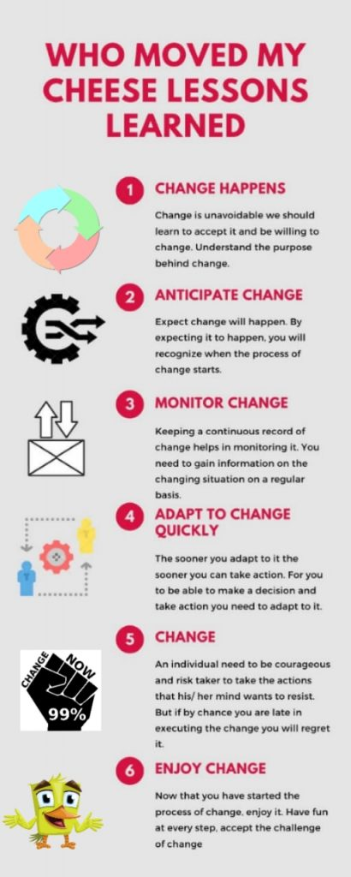

Change happens
You might have heard that change is the only thing that’s constant. So change is unavoidable we should learn to accept it and be willing to change.

How can we accept the change?
By understanding the purpose behind change, most of the time change is bought into action to improve a procedure or enhance a skill. We cannot change ourselves if we cling to who we are instead of who we want to be.

In the above story they didn’t expect any change, so they were not able to accept it later. Anticipate that there will be a change.

Anticipate change
We are so adapted and comfortable in our lives that we never expect change to happen, it seems like everything will remain same. But the reality is quite different we are punched with some change every once in a while, that we don’t expect.

How to anticipate change?
Expect change will happen. By expecting it to happen, you will recognize when the process of change starts, and you will be ready to accept it and deal with it.

Be aware of your surroundings, know what’s happening around you and observe what has changed. Be ready to accept it or deal with it.

Analyzing trend is another way of anticipating change and knowing where it will lead and work on how to tackle it.

In the above story also the two rats expected change as they used to measure the quantity of cheese every day so when the cheese vanished, they were not feeling as bad as Hem and Haw were. The rats quickly moved on and searched for new cheese whereas Hem and Haw kept on resisting it.

Monitor change
Dr. Spencer Johnson says keeping a continuous record of change helps in monitoring it. You need to gain information on the changing situation on a regular basis. Keep smelling the cheese to know when it’s old.

How to monitor change?
By measuring the amount of change that has taken place and keeping a written record of that.
Keeping a record will help you gain understanding what is the pace of change.
How much time is left for the change to be completed and build a strategy around it.

Adapt to change quickly
Now that you have expected change, anticipated it and monitored it, it’s time to adapt to it. The sooner you adapt to it the sooner you can take action. For you to be able to make a decision and take action you need to adapt to it. Accept the change and let go the previous conditions or situations.

Accepting the change is something mentally strong people do. So, learning how to be mentally strong is key.

How to accept change?
- See the positive side of the change.
- Realize how this change will improve your life.
- Talk to people that have experienced the same change and by focusing on what’s coming instead of focusing on what’s left behind.
- This is easy to do when you expect the change, expecting makes you ready and prepared for it.

Enjoy change | Meaning | How to do it?
Change happens | Change is unavoidable we should learn to accept it and be willing to change. | By remembering last time you thought everything will remain same but it changed.
Anticipate change | Trying to predict that change might happen. | Expect change and be alert of your surroundings.
Monitor change | Measuring change. | Keeping a record of changes that are occurring.
Adapt to change | Accepting the change. | By seeing the positive side of the change.
Change | Taking action towards changing. | Set goals and have a plan.
Enjoy change | Feeling good about the change. | Visualize how this change will improve your life.
Although everyone resists change but change is unavoidable. So, to deal with it happily, practice these steps that are mentioned above. Remember the story of Who Moved My Cheese? The sooner you accept it and let go what you had for what you can have life becomes happier.

Source : https://indieseducation.com/who-moved-my-cheese/

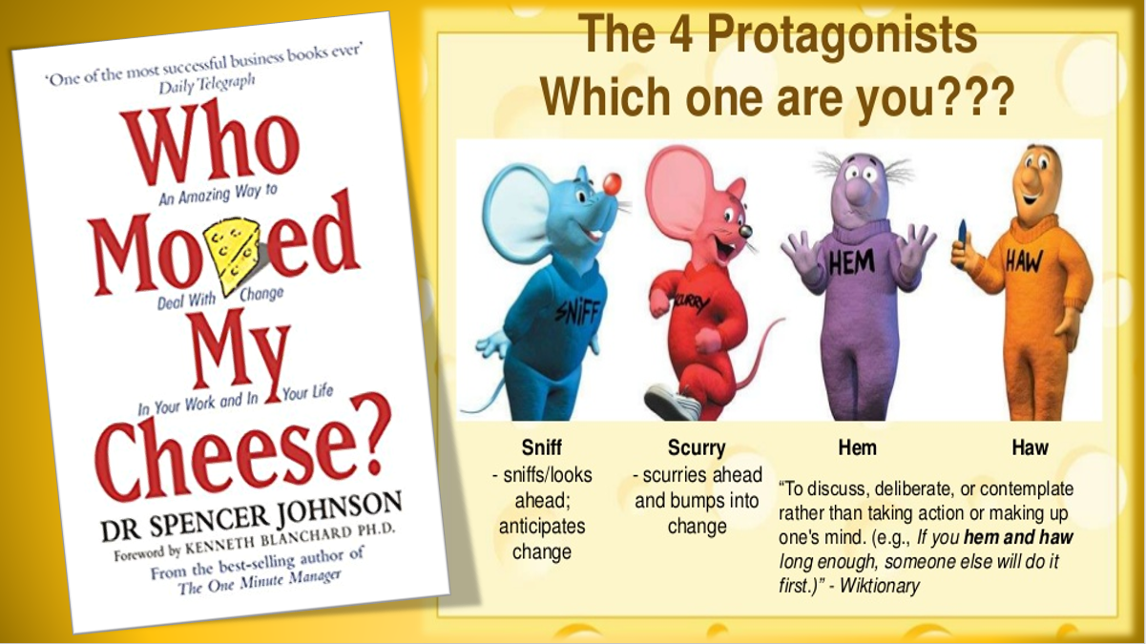
Source : www.tripsandbooks.com

UNDERSTAND THE ABCDE
ABCDE is a formula to deal with negative thoughts and change, adapted from “Learned Optimism”, Dr. Martin Seligman.

A = Adverse event or situation
Identify adverse situations or events that you routinely face OR a specific event (change) that you are currently facing.

B = Beliefs about that event
What thoughts do you have about this event? What are the things you are telling yourself?

C = Consequences of those beliefs
How are those beliefs making you feel, in terms of emotions, energy, will to act, etc (anxious? Irritable?)

D = Disputation and Distraction
Dispute those beliefs
- Challenge the negative thought
- Generate alternative specific, external, and temporary explanations
- Focus on evidence that contradicts or undermines the negative belief and supports a more positive interpretation
- Confirm your belief – maybe you are reacting to wrong information or do not understand the bigger picture

Distract yourself
- Stop the “loop” of these tapes in your head. This leaves you free to act.
- Write the worrisome beliefs, fears, etc down to think about at a set future time.

E = Effect
Notice what happens to your energy and will to act when you dispute the negative beliefs.
Over time, the disputation becomes as rapid and effective as the energization from it rewards you for the effort. Eventually, the positive explanatory style becomes your “default” response.

MY 30-DAY GROWTH PLAN
Now you are ready to put your learning and inspiration into ACTION by developing your own 30-Day Growth Plan.

1) Goals
Begin with the end in mind. Sustainable growth is the result of both self-awareness (so
that we understand our starting point) and clarity (so that we have focal certainty).

Goals Should Be:
S – Specific
H – Healthy
A – Action-Oriented
R – Reachable
P – Purpose-Aligned

My Goals in the Next 30 Days…

Personal:

Professional:

2) Motivation
Always start with WHY. WHY do you want this change to occur? What is this change
really about for you?
Compelling motivation is required in order to overcome the obstacles that will invariably
come your way. When the WHY gets stronger, the HOW gets easier.

My Motivation:

3) Obstacles
For sustainable change to occur, we must ask what has held us back in the past because
if you can name it, you can tame it. People don’t change until they address what holds
them back. When we identify obstacles, their power decreases, and our power increases.
Both the obstacles on the inside (intrinsic), and the obstacles on the outside (extrinsic)
must be addressed. List as many obstacles as possible, both Internal and External.

Controllable Obstacles:

Non-Controllable Obstacles:

4) Empowerment
Do a full inventory of your internal and external resources.
As we identify and itemize our resources, our sense of empowerment increases. Empowerment leads to execution.

Internal Resources:

External Resources:

5) Gap Analysis
My current level of skill has determined my current level of outcomes. Better outcomes
demand better skills. So, we need a clear idea of our gaps.
Honestly ask yourself: what additional skills, tools and resources do you need to develop
to help you achieve your goals?

My Gap Analysis:

6) Next Steps
The path to success involves focused and consistent action.
What next steps are required in the next 30 days and beyond in order to begin to move closer
to the goals I shared above, cultivate a sense of empowerment, address obstacles, and
close gaps? Write the next steps down.

Next Steps Required In The Next 30 Days To Complete or Move Closer To My Goals:

INTRODUCTION TO THE CONCEPT OF MASTERY AND MAINTENANCE – REINFORCEMENT (5th Building Block for Change in the ADKAR Model)
Reinforcement is the final building block in the ADKAR Model.
Reinforcing change is a process in change management. Its purpose is to sustain change – to maintain it even after the change is complete. Reinforcement has been recognized as an essential part of every change process.
Sustaining change is a major impediment to the process even when the other areas are successful. People adapt to change differently, and that influences how long it takes for new habits to stick.

Things to consider relating to Reinforcement:
• Sustaining the change
• Have the right mechanisms, supports, guides to keep change in place
• What keeps you motivated to maintain and continue to develop in this change?
• What is your success measured by? Do you value recognition, rewards, and incentives?

This will be covered in greater detail during Session 4 (Four).

WRAP-UP ACTIVITY:
What would you say is the most important strategy to implement that you feel will have the biggest impact on your ability to be successful in your 30-day growth plan?

