
Learner Handout |  | Workplace Education Manitoba |  | www.wem.mb.ca

customer service essentials

LEARNER WORKBOOK

Customer Service Series

Introduction and Housekeeping

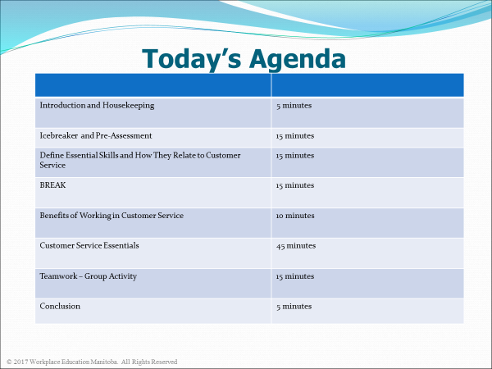

By the end of this session, learners will be able to:
- Articulate the essential customer service skills required to work in the retail and customer service industry,

- Be aware of the impact each employee has to the overall success of the company, and

- Apply effective strategies to create a positive and lasting impression of the business.

Icebreaker Activity – Who are your customers?

________________________________________________________________________________________________________________________

Internal Customers | External Customers

What are Essential Skills? 
- There are 9 Essential Skills that are used in different combinations, in different applications, in every occupation.
- They are the foundational skills you use to carry out your work tasks and they’re the building blocks you use to learn new ones.
The nine Essential Skills are:
1.
2.
3.
4.
5.
6.
7.
8.
9.

Working in Customer Service

Group Activity

- In your groups, list the top knowledge and skills required to work well in the Retail and Customer Service industry.
________________________________________________________________________________________________________________________________________________________________________________________________
________________________________________________________________________________________________________________________________________________________________________________________________

- Give two examples of how employees demonstrate these skills on a daily basis.
____________________________________________________________________________________________________________________________________________________________________________________________________________________________________________________________________________________________________________________________________________________________________________________________________________________________________
______________________________________________________________________________________________________________________________________________________________________________________________________________________________________________________________________________________________________________________________________________________________
Benefits Working in Customer Service

What are the benefits of doing your job well:
- For YOU?

- For the business?

- For the customer?

What would happen if you didn’t show up for work one day?
__________________________________________________________________________________________________________________________________________________________________________________________________________________
How would it impact your team, the business, the customer?
__________________________________________________________________________________________________________________________________________________________________________________________________________________
Customer Service Essentials 

- Be Informed about your Company

- Being knowledgeable of your business and its products is an essential sales skill
- Know management names and whom to go to with specific questions
- Know how many locations your business has and where they are located
- Keep company contact information within reach
  - Including building and website address and phone numbers
- Know the hours of operation, layout of your store, floor plan and additional services offered.
- Policies and procedures vary from one business to another – especially regarding dress codes, staff conduct, return policies, and the opening, closing and emergency procedures.
- Know what is required and acceptable for your company.
- This helps provide excellent and consistent customer service.
__________________________________________________________________________________________________________________________________________________________________________________________________________________

- Communicate Well

- Use positive and professional language
- Listen to understand
- Be patient with communication challenges – you are the professional
- Be aware of what your body language is saying!
- Always make eye contact
- Share information with co-workers and supervisors
- Speak clearly and accurately to customers
___________________________________________________________________________________________________________________________________________________________________________________________________________________________

- Solve Problems and Make Decisions

- Solving problems and making decisions are essential thinking skills in most jobs.
- You may have to make decisions on your own at work as well as solve problems for yourself, co-workers and customers.
- Some problems and decisions you need to make will be difficult, especially when you need to balance the needs of customers with the needs of your business.

Activity 1: What would you do?
Maria is faced with a problem and a decision to make. Read the scenario below and decide how she should proceed.

A customer comes into Barney’s Clothing and tells Maria that she would like to return a shirt. When Maria asks the reason for the return, the customer says, “I decided to buy a sweater to go with my skirt instead.” When Maria looks at the shirt, she notices a large stain in the front of the shirt. She now must decide how to handle this situation. .

Activity 2: What would you do?
Olivia is a sales associate at the local gift shop. It is the holiday season and she is feeling overwhelmed by all the tasks she needs to complete by the end of her shift. The tasks include the following:

___ Study the new product sell sheets to know more about the new products
___ Make several after-sales customer service telephone calls
___ Clean and organize the front of the store throughout the day
___ Help co-workers at the sales counter when there is a line-up of customers waiting
___ Fill in some forms requested by the supervisor
___ Serve the walk-in customers

- What suggestions do you have for Olivia to complete her tasks on time? ____________________________________________________________________________________________________________________________________________________________________________________________________________________________________________________________________________

- Prioritize Olivia’s tasks in order from 1-6 (1 = most important).

- Learn to Multi-task

- Multi-tasking is a thinking skill.
- The ability to manage your time and complete numerous tasks within a specific timeline happens daily.
- Identify your goals and the tasks you have to complete, how long they will take and what is required to do them. Don’t jeopardize customer service for completing all your tasks in a shift.
- Prioritize them by level of importance and ask the supervisor if unsure.
- Sometimes there may not be enough time to complete all the required tasks. To contribute to the team, always try to achieve as much as you can while serving customers.
- Remember customers come first!

- Create Positive Impressions 

- Any time a customer comes into contact with your business, it is an opportunity to form a positive impression.
- Greet and listen to the customer.
- Determine what the customer expects.
- Ask questions to clarify your understanding of what the customer wants and expects.
- Read the customers situation and react in a way that delights them.
- Ensure there will be a next opportunity for every customer.
________________________________________________________________________________________________________________________________________________________________________________________________

- Be a Team Player

- Making sure that your work meets the business’ standards
- Arriving to work on time for most shifts
- Keeping the work environment safe in everything you do
- Not offering to help co-workers who are busy
- Doing your fair share of the work
- Taking initiative to keep yourself from helping customers
- Showing respect to all co-workers and customers

__________________________________________________________________________________________________________________________________________________________________________________________________________________

“Do what you do so well that they will want to see it again and bring their friends.”
- Walt Disney

