
Learner Handout |  | Workplace Education Manitoba |  | www.wem.mb.ca

cultural considerations in customer service

LEARNER WORKBOOK

Customer Service Series

Introduction and Housekeeping

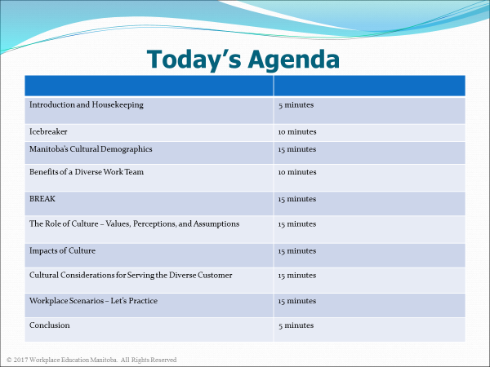

By the end of this session, learners will be able to:
- Have an awareness of the cultural demographics currently impacting Manitoba,

- Acknowledge personal biases, values, and assumptions and how culture influences customer service, and

- Have a stronger knowledge level and ability to communicate and work in a culturally diverse environment.

Manitoba’s Cultural Demographics

How many newcomers arrived in Manitoba in the year 2014?
  - 9,150
  - 13,100
  - 16,200

Today’s Diverse Workforce
Top Source Countries

1.
2.
3.
4.
5.
6.
7.
8.
9.
10.

Top Regional Communities in Manitoba (2014)

1. Brandon:
2. Neepawa:
3. Winkler:
4. Thompson:
5. Steinbach:
6. Morden:
7. Russell:
8. Portage la Prairie:
Source: Manitoba Immigration Facts 2014

Today’s Diverse Workforce
- Canada’s Aboriginal population is projected to increase much faster than the non-Aboriginal population from 2011 to 2036

- Projections suggest that the Aboriginal population could increase to approximately 1.4 million by 2017 from 1.1 million in 2006. As a result, Aboriginal people would account for between 4.6% and 6.1% of the Canadian population in 2036, compared with 4.4% in 2011.

- The proportion of the Canadian population that identify themselves as Aboriginal is projected to increase to 4% in 2017 from 3% in 2001.
Source: Statistics Canada

Benefits Working in a Diverse Work Team

- Better understand and respond to an increasingly diverse customer base;
- Tap into local markets, expanding your customer base through improved cultural awareness and communication;
- Broaden the talent pool for recruiting new employees;
- Attract and retain top talent in an environment of labour shortages;
- Enhance creativity, productivity, and decision-making through diverse approaches.
- Others?
- ____________________________________________________________________________________________________________________________________________

The Role of Culture – Values, Perceptions and Assumptions

What do you think of when you hear the word “culture”?
________________________________________________________________________________________________________________________________________________________________________________________________________________________________________________________________________________________________________________

Cultures are dynamic and changing.
“The way we do things when no one tells us how to do them.” (Kemp)

The Iceberg Analogy
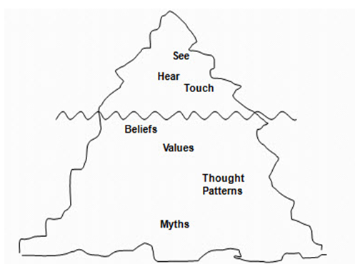

Customer Service Across Cultures
- Is it different?

- Who are your customers?

- How would you describe them?

Culture and Perceptions
How might you perceive the following behaviours?
- Customers that don’t say please and thank you.
- Customers call you Sir or Ma’am.
- Customers negotiate the price of your product or service.
- Customers look for someone from their ethnic community to help them.
- Customers speak limited English.

Not wrong, just different!
Different people have different perceptions of the same thing and all are equally valid.

Impacts of Culture: View of Hierarchy
- Even though hierarchy exists in the Canadian workplace, it is viewed differently than in many other cultures

- Employees and managers view each other as equals

- It is important to know how the chain of command works in your company.

- Employees are expected to ask questions to clarify and confirm instructions
- Leaders expect employees to take initiative by keeping themselves busy at all times
- Leaders value participation from all employees and levels within the company. All staff positions are viewed as integral parts of the company’s success.
- Leaders see themselves as “part of the team”; are usually accessible. You are the expert in your role!
- Leaders and employees will consult one another and share information freely
- Respect everyone; no matter the person’s title or position

Group Discussion: Cultural Considerations
How do we adapt our behaviours to meet the needs of all customers?
In small groups, brainstorm some considerations you can make when serving and/or working with culturally diverse individuals.

“Diversity is the one true thing we all have in common. Celebrate it everyday.”
- Author Unknown

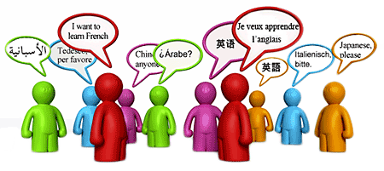

Thank you for participating!

