
Learner Handout |  | Workplace Education Manitoba |  | www.wem.mb.ca

handling challenging situations

LEARNER WORKBOOK

Customer Service Series

Introduction and Housekeeping

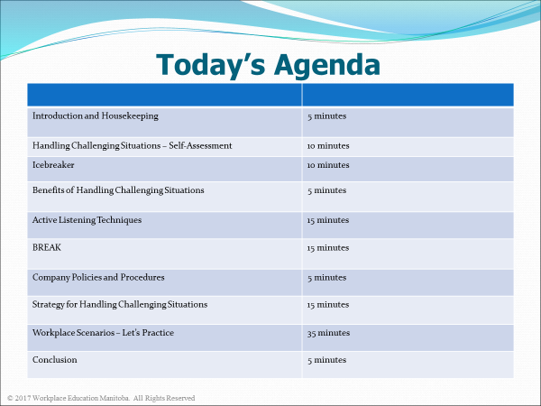

By the end of this session, learners will be able to:
- Assess one’s confidence and ability in handling conflict,

- Use active listening skills and communicate information clearly and accurately to others,

- Understand why policies and procedures are in place to prevent and resolve difficult situations, and

- Learn problem solving strategies to resolve difficult situations and maintain a loyal customer base.

Handling Challenging Situations: Self-Assessment

To what extent do you consistently: Never Sometimes Always
- Take time to review the policies and procedures
for your position? 1 2 3 4 5

- Use courtesy and manners when dealing with
customers and fellow staff? 1 2 3 4 5

Manage your “hot buttons” when faced with
a challenging or difficult situation? 1 2 3 4 5

- Listen actively to customers, giving your
undivided attention? 1 2 3 4 5

Smile sincerely? 1 2 3 4 5

Express empathy and understanding in response

to a difficult situation? 1 2 3 4 5

Apologize sincerely when you’ve made a

mistake? 1 2 3 4 5

- Do a perception check (restate, ask for clarification)
to make sure you understand the problem? 1 2 3 4 5

Report challenging or difficult situations to

your supervisor? 1 2 3 4 5

- Give that little extra – go beyond your
customers’ expectations? 1 2 3 4 5

- If most of your responses are a 4-5, congratulations! You are already an expert on handling difficult situations. This session will provide additional suggestions for dealing with difficult situations.

- If most of your responses are a 3, you are in the right place to further strengthen your skills in handling difficult situations.

- If most of your answers are 1-2, you need to develop your skills to learn the necessary steps in handling difficult situations. You’ve come to the right place!



Benefits of Handling Challenging Situations

For You?

For the Business?

For the Customer?



Active Listening Techniques

Ignore distractions

Focus your eyes and ears on the person who is talking

Listen for key words and points

Check to make sure you understand what the customer is saying

Ask questions to clarify what the customer is saying

Avoid making assumptions about what the customer is going to say

Don’t interrupt

Attend to the customers’ non-verbals: eyes, body language, tone of voice

Cue that you are getting the message

Tell the customer what you heard

Inquire about missing pieces of information

Open your mind to possibilities and opportunities

Notice the customers’ response.

Active Listening Techniques (con’t)
Some of these techniques will seem more comfortable to you than others. Remember, the technique will work only if your body language says the same thing!

Confirm | - Ensure you have an understanding of the key points.  - Confirm your understanding at the end of a conversation or before going on to a new topic. For example:  “So what you are most concerned about is ...?”  “The main item you need is ...?”
Clarify | - Ask for more details to help you understand. For example:  “Which color did you say you preferred...?”  “Were you asked to ...?”
Paraphrase | - Focus on the content of what is being said.  - Rephrase the main points in your own words. For example:  “Are you saying that ...?”  “Do you mean that ...?”  - Avoid repeating back exactly what they just said to you — word for word. This is not paraphrasing — this is parroting.


How to Satisfy Your Customers – Using Policies and Procedure
- When customers are dissatisfied, employees are expected to resolve the situation by following customer service policies
- An organizational policy is a set of guidelines and best practices put in place to protect the company, employees, and customers
- They provide boundaries within which to work and to specify acceptable behaviour

Benefits to adhering to organizational policies:
- Encourages consistent company behaviour
- Provides a framework for the delivery of consistent service (e.g. service standards, handling complaints)
- Protects company against legal liabilities
- Helps protect proprietary information and other assets
Why do company policies and procedures play such an important role when handling challenging situations?
____________________________________________________________________________________________________________________________________________________________________________________________________________________________________________________________________________________________________________________________________________________________________________________________________________________________________

Handling Challenging Situations - Problem Solving Strategy
A four-step method
- Listen – let the customer voice their concern without interruption. Continue to make eye contact and focus on what they are saying. Avoid making assumptions about what they are concerned about. Do not take the concern personally; you are representing the company. Actively listen to the details of the concern and ask questions to clarify your understanding. Paraphrase what you understood back to the customer to confirm understanding. This also tells the customer that they have your focus and attention.

Be empathetic. As an example, say “I understand your frustration.”

Manage your hot buttons!

- Acknowledge – Say you understand and apologize with sincerity. Saying you understand doesn’t mean you agree or will give them everything they want. It says that you understand what they have communicated to you. You are sorry for the customer being inconvenienced. This will also help the customer be more receptive to your solution to the problem.

- Solve – Offer the customer real solutions, telling them what you can do for them. Begin by asking the customer what they would like you to do. It might be a very small thing they would like done. Resolve the concern on the spot as much as possible. Know what your power of limitations are and be clear on the company’s policies. However, try to avoid telling the customer that it is “store policy”. They don’t want to hear that. Offer solutions to the customer by giving them choices whenever possible. Say “This is what we can do – I can offer you an exchange on another product or you can check back when we receive new products next week. What would you like to do?”

- Thank – What if customers never told us when they were unhappy with the product/service they purchased? When a dissatisfied customer takes the time to give us feedback, they are giving us a “gift”. The majority of dissatisfied customers don’t tell the business of their unpleasant experience. Instead they tell their friends and family. If it was your business, wouldn’t you want to know why customers weren’t returning?

Always express gratitude for customers sharing their concern with you. This gives you and your team the opportunity to keep improving what you do. This is how businesses stay ahead of the competition. Remember Walt Disney’s famous quote – “People don’t remember what you did for them, they remember how you made them feel.” We are in the people business for a reason, so show customers that you value their feedback.

Let’s Practice – Role Plays

- Marie is still learning some tasks as a new associate at the local clothing store. She rings in a customer's credit card purchase, then realizes it didn’t ring through the sale price. When she tries to reverse the transaction, she double charges the customer’s credit card. She is feeling flustered and embarrassed in front of the customer. The customer makes a comment that she needs to leave the store shortly to pick her kids up at school.

Decide who will play Marie’s role and who will be the customer. Use the four-step problem solving strategy to assist Marie in handling this challenging situation.
____________________________________________________________________________________________________________________________________________________________________________________________________________________________________________________________________________________________________________________________________________________________________________________________

- Carlos is working a busy Saturday afternoon at the grocery store. A regular customer, Mr. Klassen, approaches him and asks if the store has moved his favorite pasta sauce to a different aisle as he cannot find it in the usual location. Carlos advises Mr. Klassen that the store did not receive their shipment this week and that is the reason why his pasta sauce is not in stock. Mr. Klassen is noticeably upset. This is his third visit to the store to buy this product. He has threatened to go shop at another grocery store.

Decide who will play Carlos’ role and who will be the customer, Mr. Klassen. Use the four-step problem solving strategy to assist Carlos in handling this challenging situation.
___________________________________________________________________________________________________________________________________________________________________________________________________________________________________________________________________________________________________________________________________________________________________________________________

- Keisha is at the customer service area of Electronics R Us where she can hear a conversation between Jasdeep and a customer. The customer, Gary, is angry because he wants to return a laptop he purchased. When Gary hands over the sales receipt, Jasdeep notices that Gary purchased the laptop over two months ago. The return policy for electronics is 30 days. Jasdeep is trying to explain the return policy to Gary but Gary leans closer to Jasdeep and says, “You guys told me I could return this laptop up to 3 months of purchase. I’m sick and tired of having to deal with you guys. Now please give me my money back right now.” Keisha can see that Jasdeep is flustered and having challenges communicating the policy to Gary.

Decide who will play Keisha’s role, Jasdeep’s role and who will be the customer, Gary. Use the four-step problem solving strategy to assist Keisha and Jasdeep in handling this challenging situation.
___________________________________________________________________________________________________________________________________________________________________________________________________________________________________________________________________________________________________________________________________________________________________________________________

““Life is either a daring adventure or nothing at all.”
- Helen Keller


Thank you for participating!

