CHANGE READINESS
SESSION 1: WHAT IS CHANGE? Worksheet
Learning Objective 3
Understand the 5 Building Blocks of Change – refer to page 6 in the workbook
Activity 2: Focus on Awareness and Desire
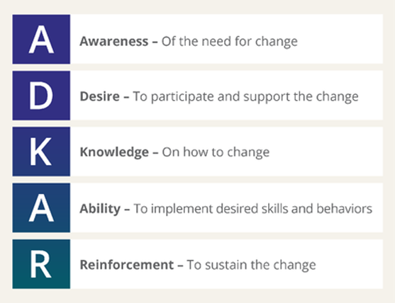
Source: www.prosci.com
At this level of the Change Readiness workshop series we are focusing on in-depth learning and understanding of the Awareness and Desire building blocks.
With your partner, please discuss and record your responses and insights to the following questions.

Awareness:
- Why do you feel self-awareness is the first step in making changes in life and work?
__________________________________________________________________________________________________________________________________________________________________________
- What should we consider when determining the need for change?
_______________________________________________________________________________________________________________________________________________________________________________________________________________________________________________________________

Desire:
- In what ways can you dig deeper to explore WHY you really want to make a change?
__________________________________________________________________________________________________________________________________________________________________________
- What factors can help to motivate and support changes both in life and in work?
_______________________________________________________________________________________________________________________________________________________________________________________________________________________________________________________________

