Module Name: Co-operating with Others - Interpersonal Skills

Purpose: The ability to work and communicate with a variety of people is essential to building strong relationships and achieving success in the workplace.

Logistics: PMB modules are weaved throughout the 12-week program.
This module could be broken down into smaller modules to meet the participants and schedule needs.
2 – 3 hours

Facilitator: Member of the WEM Facilitation Team

Special Instructions:

- Interpersonal skills are measures of how adept you are at interacting with others. Active listening is an interpersonal skill, as is knowing how to communicate to someone else that you respect. When problems arise you use your interpersonal skills to resolve conflict with others. People learn interpersonal skills by interacting with family members, going to school, and socializing with their peers. Healthy interpersonal skills reduce stress, resolve conflict, improve communication, enhance intimacy, increase understanding, and promote joy.

- It is suggested the module Interpersonal – Communication be held following this module.

Essential Skills: Continuous learning, Thinking Skills, Working with Others, Oral Communication

Transferability to the Workplace

Benefits to the team when individuals on a team have strong interpersonal skills:

- Become aware of behaviours or attitudes that might be impacting their ability to co-operate with others.
- Use appropriate tone to communicate respect for others.
- Recognize nonverbal and verbal cues and their meaning – their own cues and the cues of others.

Learning Objective

By the end of the session the participants will be able to:

- Learning objective: Define interpersonal skills.
- Discuss why co-operation is important to them.
- Discuss why co-operation is important in the workplace.
- Identify nonverbal and verbal cues and their meaning – their own cues and the cues of others.
- Identify strategies to enhance active listening.
- Discuss the importance of identifying the impact our body language and tone have on others.
- Identify 2 things they could do to work better with other people in the classroom.

Assessment(s):

- Comments and ideas shared throughout the session.
- Data will be collected through the weekly feedback form.
- The overall assessment tool at the beginning, middle and end.
- Active Listening questionnaire, Appendix B.
- Communication Effectiveness, Appendix C.

Personal Management Basics (PMB) Topics include:

Topics | Modules
Introduction to PMB’s | - Introduction to PMBs  - Self-Management Skills  - Co-operating with Others
Self-Management Skills | - Self-Awareness  - Responsible Behaviour  - Managing Stress  - Positive Attitude  - Taking Initiative  - Adaptability and Flexibility
Co-operating with Others | - Interpersonal Skills  - Respect for Others  - Respect for Expectations  - Reliability  - Personal Presentation

Program Overview – Lesson Plan

Activity – Watch video

Watch the following video (approximately 3 minutes in length) https://www.youtube.com/watch?v=k2PJ6T7U2eU&list=PLeroZ-zM8IWti1HM0P5ktfTX97jPoFtB9

Ask: What happened in the video?

Ask: How were the birds acting towards each other?

The facilitator to scribe the answers.

Debrief the video and connect it to today’s learnings.

Today we are going to be exploring the idea of interpersonal skills.

Learning objective: Define interpersonal skills.

Share the definition of interpersonal skills.

Interpersonal skills are a measure of how adept or how at ease you are at interacting with others.

Ask: Can we work with that definition today?
- If not, work with the participants to create a definition that works for the group.

Ask: Where did you learn how to interact with other people?
-Grandparents, family, friends, work, the community.

Ask: Do you believe you can develop and change the way you interact with each other?

Connect the words the participants used to describe the video to the definition of interpersonal skills.

Learning objective: Discuss why co-operation is important to them.

Ask: Why is co-operation important to you?

Ask: In your daily life how do you show/practice co-operation?

Ask: When we co-operate with others what happens?

Ask: What is your reason for choosing to co-operate?

Share that co-operation is a choice we make. It is a frame of mind to add value, versus, causes havoc in a situation or relationship.

Co-operation is a choice, so is choosing to not co-operate.

Ask: When you choose not to co-operate, what has often just taken place?

Even though we do not have the ability to control others, we do have the ability to control how we respond to them.

Ask: How could our internal response to a situation impact our outward behaviour? In this case, we are looking at non-cooperative behaviours.

Move the participants into pairs and ask them to share their answer with their partner.

Ask:
- Can you think of a time you choose to co-operate versus cause havoc?
- What was the short-term and long-term impact on the situation and / or relationship?

Debrief on the ideas shared to-date and if possible connect your comments back to the video.

Learning objective: Discuss why co-operation is important in the workplace.

Building on our conversation today and throughout our time together, we are going to explore why we would want to be co-operative versus non-cooperative in the workplace.

Write the following 2 questions on flip chart paper then move the participants into 2 groups.

Group A) Ask: What type of behaviours show co-operation in the workplace?

Group B) Ask: What type of behaviours do not demonstrate co-operation in the workplace?

Review the ideas shared by the participants and build on them where necessary.

The next few questions we would like you to reflect on, and, answer them on your own.

Ask:
- What is your personal reason for being a co-operative team member?
- What is your personal reason for being a co-operative class member?
- What often causes you to choose not to co-operate?
- In order to increase your co-operative spirit identify 2 behaviours you could do less of in your daily life? Work life? School life?

Ask the participants to share their ideas with their table or in small groups. Ideally, we would want to hear 1-2 ideas per table.

We live in a world where once we can identify something we would like to improve in ourselves, we have the opportunity to figure out how and practice it. Practice makes us better.

Learning objective: Identify nonverbal and verbal cues and their meaning – their own cues and the cues of others.
Learning objective: Discuss the importance of identifying the impact our body language and tone have on others

Hand out and review, Are you connected? Cues & Clues, Appendix D.

Ask: What happens to you when someone demonstrates they are attentive?
Ask: What happens the opposite way, when some demonstrates they are not interested?

Ask: Can we assume the items on this list are 100% true for every person we interact with?
- No

Ask: Why is this list not 100% true for everyone and in every situation?

Ask: Would it be fair to say this list is a good benchmark to work from?

Ask: If you thought someone was not interested in what you were sharing because they were not smiling and looking at their watch, what could you do?
-Ask them if they are interested?
- Ask them if now is a good time?

Ask: At the same time, what can you take away from this to improve the message you are sending?
-Example: My smile or lack of one, body stance, eye rolling and pace have an
impact on how others can connect with me.

Move the learners into small groups.

Review 3 workplace situations where cues and clues can send mix messages

Situation A – Example from workplace
Situation B – Example from workplace
Situation C – Example from workplace

Hand out Communication Self-Assessment, Appendix A.

Learning objective: Identify strategies to enhance active listening.

Active listening is an interpersonal skill, as is knowing how to communicate to someone else that you respect them.

Hand out and review Appendix B and C with the participants.

Learning objective: Identify 2 things they could do to work better with other people in the classroom.

Ask: Identify 2 things you could do better to increase co-operation with your peers and/or facilitator in the classroom?

Provide the participants with the chance to share their ideas and then wrap up.

Wrap-Up

Ask: What is the positive connection between co-operation, control and consequence?

APPENDIX

Appendix A – Communication Self-Assessment
Note: Assessment and answer key are available.

Appendix B - Active Listening Activity

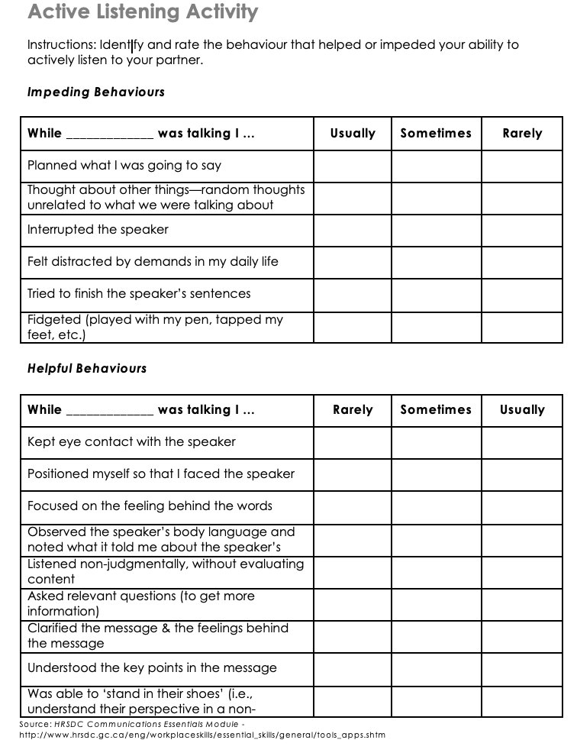

Appendix C - Communication Effectiveness

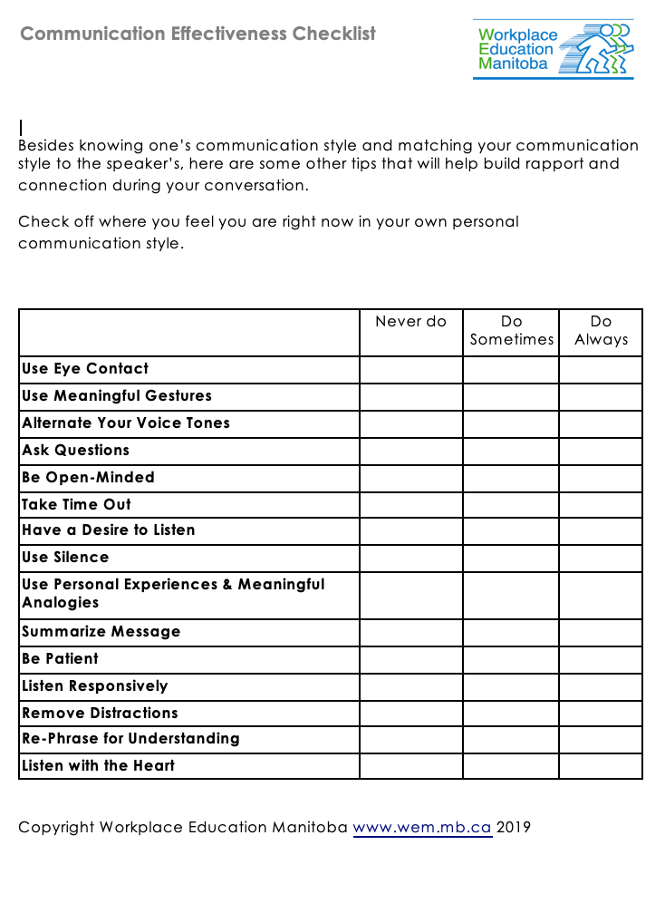

Appendix D - Are you connected? Cues & Clues
