Module: Planning and Goal Setting

Purpose: Group of skills that participants can develop to manage their everyday behaviour in life, learning, and work.

Logistics: 3 -4 hours

Facilitator: Member of the WEM Facilitation Team plus additional partners when and where applicable.

Special Instructions: This module would benefit from the participants creating their own dream/vision board. The following comments can be found at the beginning of the lesson plan.

Essential Skills Thinking Skills

Activity: Have the participants create a dream board. This activity could be done immediately before the module, few days before, or, with the projects wrap around organization.

Transferability to the Workplace

The ability of the participants to be able to plan and set goals as they relate to life, learning and the workplace, while at the same time re-evaluating them when necessary to achieve success.

Learning Objective

By the end of the session the participants will be able to:
- Identify 3 reasons why you would want to set goals.
- Identify what SMART goals stand for.
- Write a practice SMART goal.
- Discuss why SMART has been moved to SMARTER as it relates to goal setting.
- Discuss strategies as it relates to goal setting.
- Discuss the types of goal setting which takes place in the workplace.
- Discuss the concept of predicting the consequences of our actions.
- Re-evaluate your goals and make adjustments when it's necessary.
- Discuss the importance of delaying immediate gratification in order to pursue long term goals.
- Create a personal SMART goal.
Assessment

- Comments and ideas shared throughout the session.
- Data will be collected through the weekly feedback form.
- Work completed towards Personal SMART Goal Worksheet - Appendix A.

Lesson Plan

Activity: Have the participants create a dream/vision board. This activity could be done immediately before the module, few days before or with the projects wrap around organization.
Learning objective: Identify 3 reasons why you would want to set goals.
Part 1) Have the participants work in groups of three.
Part 2) Ask them to share their dream/vision board with each other.
Part 3) In the same groups identify 3 reasons why you would want to set goals.
Part 4) Hear from each small group regarding their why.
The facilitator to scribe and debrief on the activity.
Learning objective: Identify what SMART goals stand for.
Learning objective: Write a practice SMART goal.
Write SMART on flip chart paper.
Hand out the Personal SMART Goal Worksheet, Appendix A.
Walk through the first column in the handout with the participants. Then write 1 or 2 SMART goals with the participants.
Working at their table, ask the participants to write 1 SMART goal together.

Learning objective: Discuss why SMART has been moved to SMARTER as it relates to goal setting.
On the flip chart paper with SMART on it, add the letters ER to it.
The one thing we know for sure we generally do not go from point A to B. Often we have detours along the way.
Ask: What do you think the E and R could stand for?
E – Evaluate
R- Readjust
  - Re-evaluate your goals and make adjustments when it's necessary
Ask: Why do you think the ER is important to consider when we set a goal?
  - Because life happens.
Learning objective: Discuss strategies as it relates to goal setting.
Ask the participants to find a new partner and discuss ideas on strategies/ideas you have made to ensure you get to class every day and on-time.
Facilitator to scribe the ideas on flip chart paper.
Ask: Looking at the handout, Appendix A, how are these ideas relevant to good goal setting?
Learning objective: Discuss the types of goal setting which takes place in the workplace.
Note: It would be beneficial to understand the types of goal setting the workplace partner expects from their employees.
It is very likely you will be provided with daily expectations when you enter the workforce. Example: Tonight’s shift needs to produce 32 units, this order needs to be received, etc. Even when we are provided with direction like that, your supervisor is expecting you to take into consideration many factors to ensure you are able to reach the goal. Your goal may be set for you, and, you are expected to determine how you will get the job done. Your supervisor will be expecting this from an engaged and informed employee.
Review workplace situation A: To be provided by the workplace partner.
Review workplace situation B: To be provided by the workplace partner.
Review workplace situation C: To be provided by the workplace partner.
Ask: What surprised you about these conversation?
Debrief and highlight the strengths the participants brought to the conversation.
Learning objective: Discuss the concept of predicting the consequences of our actions.
Ask: If I forget my lunch a home, what can I expect to happen?
Ask: If I forget to put gas in my car, what can I expect to happen?
Ask: If I forget to buy medication I need, what can I expect to happen?
Say: If A happens then B is likely to happen.
Ask: Do you have other examples that you could share?

Ask: Looking at your dream/vision board what type of situation A then B could take place?

Ask: At your table to discuss the value in understanding the impact of A then B?

Facilitator to scribe the ideas shared on flip chart paper.

Ask: What is the value in having this conversation together today?

Facilitator to debrief the learning objective, discuss the concept of predicting the consequences of our actions.
Learning objective: Discuss the importance of delaying immediate gratification in order to pursue long term goals.
Thinking about roasting that perfect marshmallow - Golden on all sides.

Share the quote “Great things come to those who wait!”

Ask: What does this quote mean to you?

Ask: Is this an easy thing to do?
For most of us it is not an easy thing to do.

Handout - Strategies for Delayed Gratification, Appendix B.

Review the document with the participants.
Learning objective: Create a personal SMART goal.
Hand out another copy of the personal SMART Goal Worksheet, Appendix A, for the participants to work through.
Conclusion: Encourage the participants to work towards their personal SMART goal and to keep their dream/vision board close to them. It is important to understand that our goals are important to us, and, in order to achieve them, we need to be flexible and adaptable to what is happening to us and around us.
You are in control.

APPENDIX

Appendix A - Personal SMART Goal Worksheet

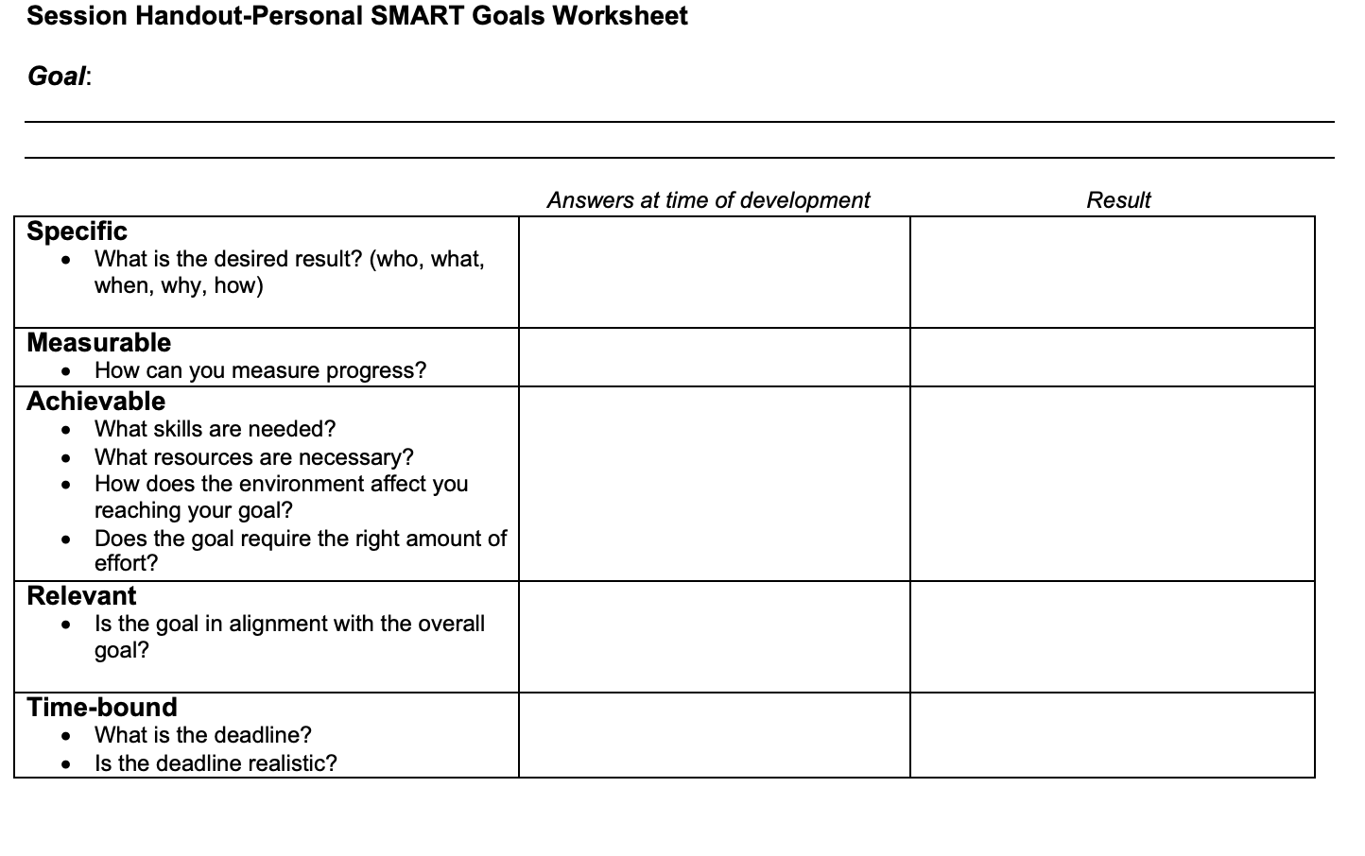

Appendix B - Strategies for Delayed Gratification

