Module Name: Positive Attitude

Purpose: A positive attitude is a belief that the best will happen-that there will be happy outcomes, and that you have some control or power over the outcomes. At work, a positive attitude can help you overcome challenges and manage change. It can also drive you to work harder towards achieving your goals and support you when you are navigating difficult personal or interpersonal issues.
.
Logistics: PMB modules are weaved throughout the 12-week program.
This module could be broken down into smaller modules to meet the participants and schedule needs.
2 hours

Facilitator: Member of the WEM Facilitation Team

Special Instructions: We can all have challenging days. Prior to this session, it is important the facilitator does a check in of their own attitude that day.

Essential Skills: Continuous learning, Thinking Skills, Working with Others, Oral Communication

Transferability to the Workplace

Benefits to the team when individuals on a team are positive there is often:
- Less stress
- More trust
- Increased cooperation
- Better problem-solving
- Higher retention
- More self-direction
- Coordinate work with one or a few others.

Benefits to the organization
- When individuals are positive, this reflects positively on the organization. Example: There is a perception that the workplace culture is healthy and positive.
- Positive people tend to find solutions and to stick it out when things get rough and so they may stay at a job longer.

Long-term impact
- Overall, potentially higher productivity, less interpersonal issues to manage, higher retention and increased mental and physical health-resilience and hardiness.
- Generally positive people tend to navigate change well.

Learning Objective

By the end of the session the participants will be able to:
- Identify events/behaviours which have a positive and negative impact on your attitude.
- Define what it means to have a positive attitude.
- Identify strategies when there is an awareness that your attitude is going to be changing in an unfavourable way.
- Discuss the impact of the following on your attitude:
  - Have a healthy eating plan
  - Exercise regularly
  - Get enough sleep daily to give you energy
- Identify which activities are contributing to feelings of stress.
- Discuss how our choices can impact our ability to manage stress.
- Identify how you can contribute to positive results in the workplace.
- List the benefits of a positive frame of mind in the workplace.
- Manage and balance all the activities in your life and take time to relax.
- Discuss where to find help as it relates to stress management.

Assessment(s):

- Comments and ideas shared throughout the session.
- Data will be collected through the weekly feedback form.
- The overall assessment tool at the beginning, middle and end.
- Positive Attitude Reflection Questions - Appendix A.

Personal Management Basics (PMB) Topics include:

Topics | Modules
Introduction to PMB’s | - Introduction to PMBs  - Self-Management Skills  - Co-operating with Others
Self-Management Skills | - Self-Awareness  - Responsible Behaviour  - Managing Stress  - Positive Attitude  - Taking Initiative  - Adaptability and Flexibility
Co-operating with Others | - Interpersonal Skills  - Respect for Others  - Respect for Expectations  - Reliability  - Personal Presentation

Program Overview – Lesson Plan

Introduction

Ask each participant to find a clean piece of paper and a pen/pencil. Note: Markers and pencil crayons could enhance the impact of this activity.

Ask: Draw an emoji you would send to someone when they have something good happen to them.

Facilitator will ask the participants to show their emoji to the person sitting next to them.

Today we are going to be exploring the topic of attitude. Where does our attitude come from, what triggers it, how does it impact our life, and, to explore the idea we have control over it.
Learning objective - Identify event/behaviours which have a positive and negative impact on their attitude.
Ask: How do you feel when you or when you are out with a friend and they get a flat tire on their car?
Things like a flat tire can happen to us on a regular basis. It is not the event itself, rather the way we respond to it that has an impact on our day.
Move the participants into small groups and provide them with flip chart paper and marker.
Ask: Identify events/behaviours which have a positive and negative impact on your attitude.
Facilitator will ask one member of each team to share the ideas their group came up with.
Ask: Did any words surprise you on this list? If so, which ones? Why?
Learning objective: Define what it means to have a positive attitude.
Move the participants into a new group of three.
Ask: List 10 words to describe/define what it means to have a positive attitude.
Facilitator will scribe the ideas on flip chart paper.
The facilitator to share the following idea to summarize the learning objective.
Having a positive attitude means to maintain a set of ideas, values, beliefs, thoughts, and actions, that simply put, feel good. Depending on the circumstances, a positive attitude may mean to be solution-oriented, or to look at the positive aspects, or even to trust that whatever happens is okay.

Learning objective - Identify strategies when there is an awareness that your attitude is going to be changing in an unfavourable way.
The facilitator will draw the image below on flip chart paper.
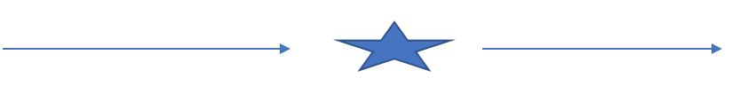
Before “Event/Situation” After
Note: We want to explain to the participants that we are always going to be confronted with situations which can have an impact on our attitude. Long-term success comes from an awareness that something is happening, within or around us, which could impact our attitude. When we become aware of the potential for our attitude to change in an unfavourable way, we have an opportunity to stop the negative/unfavourbale attitude from occurring.
Work with the participants to identify strategies they can apply to ensure their attitude does not become unfavourable.
Learning objective - Discuss the impact of the following on our attitude:
  - Have a healthy eating plan
  - Exercise regularly
  - Get enough sleep daily to give you energy
Put up 3 pieces of flip chart paper with the following heading on them.
- Eating well
- Moving our bodies daily
- Time for sleep
Ask the participants to evenly separate themselves amongst the flip chart paper.
Ask: As a society/community how could we be doing more of this?
Move the participants from one flip chart to another to provide them with the chance to contribute to all three ideas.
Facilitator will ask one member of each team to share the ideas on their flip chart paper. (The one they ended up on)
Assign one flip chart paper to each group.
Ask: What impact does that behaviour have on you?
Ask: What impact does it have on your attitude?
Facilitator will ask one member of each team to share the team’s ideas and scribe them.
Ask: Write down 3 ideas you could take away and start to practice.
Ask: Why are the 3 ideas you wrote down important to you?
Learning objective - Identify which activities are contributing to your feelings of stress.
This learning objective could be completed as a solo activity.
Ask: Who here has been in a car accident?
Ask: How did that make you feel?
Ask: Would it be fair to say you felt a level of stress?
Ask: What is stress? (Large or small group discussion)
Facilitator to share the definition:
A state of mental or emotional strain or tension resulting from adverse or very demanding circumstances. "He's obviously under a lot of stress" ·

Other words to describe stress could be: Strain, pressure, tension, nervous, worry, anxiety, nervousness, trouble, difficulty, distress, trauma, suffering, pain, grief and hassle.
Ask: What are 5 things which are causing you stress today?
Ask: Write down a few words to describe how those things make you feel?
Learning objective - Discuss how our choices can impact our ability to manage stress.
Ask: Think of something in particular caused you stress. How did you respond?
Facilitator will scribe the answers to “How did you respond?” on flip chart paper.

Ask: What impact did your response have on the situation or relationship?

Ask: If you had to do it over again, would you respond the same way?

We are going to come back to your example, however, first we are going to look at the 5 Why strategy.

Facilitator to write 5 Whys on a flip chart paper.
Example of flip chart paper.
5 Whys
Why
Why
Why
Why
Why

The facilitator will work through an example or two regarding the 5 Why strategy.

Do: Move the participants into small groups.

Ask: Work through the following example: Ran out of gas on my way to work.

Facilitator will ask each group to share their 5 Why example.

Ask: Was it easy to do?
Ask: If No, why do you think it was hard?

Ask: Why do you think someone might not have acted before running out of gas?

Ask: What choices did we have in this example “Running out of gas on the way to work?”

Participants will move back to their seats.

Ask: (Solo activity) Work through your personal example applying the 5 Whys strategy.

Ask: What could you have done differently to prevent this stressful situation?

Facilitator will scribe the ideas on flip chart paper.

Learning objective - Identify how you can contribute to a positive results in the workplace.
Hand out Attitude Quotient, Appendix B, and ask the participants to complete it.

Review the meaning of the words found within Appendix B.

Write the following questions on 3 different pieces of flip chart paper.

- How does each of these items contribute positively in the workplace?
- How we can demonstrate these behaviours in our classroom?
- How we can contribute to these ideas within the workplace?
Move the participants into 3 small groups and move them to a flip chart question. Have them work on that question and then move them to the other questions.
Have a participant review the ideas on the final flip chart paper.
Facilitator to debrief the learning objective as required.
Learning objective - List the benefits of a positive frame of mind in the workplace.
Ask: When you are hanging out with your friends what impact does a positive frame of mind have on you and your friends?
Now we are going to look at that same question from the perspective of the workplace.
Ask: When you are at work what impact does a positive frame of mind have on you and your co-workers?
Facilitator will scribe the ideas on flip chart paper
Facilitator to share the following idea s:
- Positive attitudes manifest in the following ways:
- Positive thinking.
- Constructive thinking.
- Creative thinking.
- Optimism.
- The motivation and energy to do things and accomplish goals.
- An attitude of happiness.
- Doing our work tasks happily- being positive while we do them
- A positive frame of mind helps employees in many ways, such as:
- Expecting success and not failure.
- It makes you feel inspired.
- It gives you the strength not to give up, if you encounter obstacles on your way.
- You regard failure and problems as blessings in disguise.
- Believing in yourself and in your abilities.
- You show more self-esteem and confidence.
- You look for solutions, instead of dwelling on problems.
- You see and recognize opportunities.
- Additional ideas to share:
- It helps you achieve goals and attain success.
- It brings more happiness into your life.
- It produces more energy.
- Positive attitude increases your faith in your abilities, and brings hope for a brighter future.
- You become able to inspire and motivate yourself and others.
- You encounter fewer obstacles and difficulties in your daily life.
- You get more respect and love from other people.
- Life smiles at you.
Learning objective – Explore how to manage and balance the activities in your life and take time to relax.
Facilitator to recreate the wheel of life onto flipchart paper. Note: The scale could or could not be included on it.
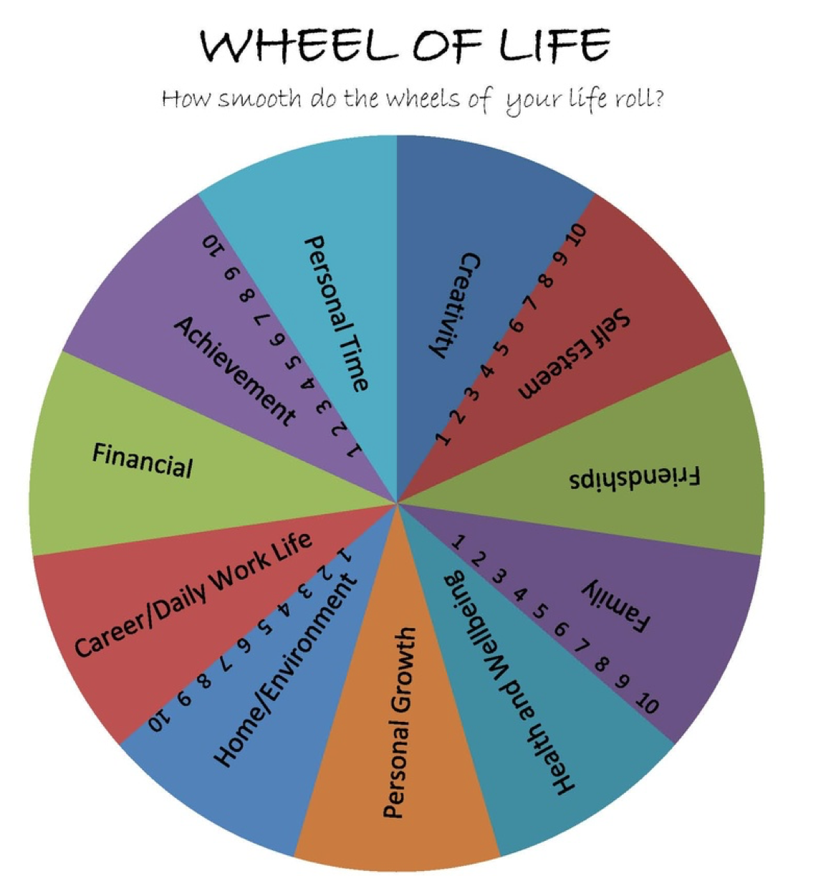
Source: https://i.pinimg.com/736x/d9/cb/49/d9cb491673c23b36e8e13971874cdc0b--wheel-of-life-enjoying-life.jpg
Ask: What activities and expectations are part of your daily life?
Ask: Which activities make you happy?
Ask: Which activities make you stressed or not as happy?
Ask: Are you spending too much or too little time in certain areas of your wheel?
Ask: What could you do more of to bring additional happiness to your wheel of life?
Ask: What is your reason for wanting to make the changes you came up with?
Move the learners into small groups. Ask them to share their ideas and in particular their ideas to “What could you do more of to bring additional happiness to your wheel of life?”
Facilitator to scribe the ideas on flipchart paper “What could you do more of to bring additional happiness to your wheel of life? “.
Learning objective - Discuss where to find help as it relates to stress management.
Ask: When you are feeling stress and it is impacting your attitude, what can you do today to keep a positive attitude?
Facilitator will remind the participants of the resources available within the program.
Conclusion activity: Draw another emoji to express how you are feeling today.

APPENDIX

Appendix A – Positive Attitude Reflection Questions

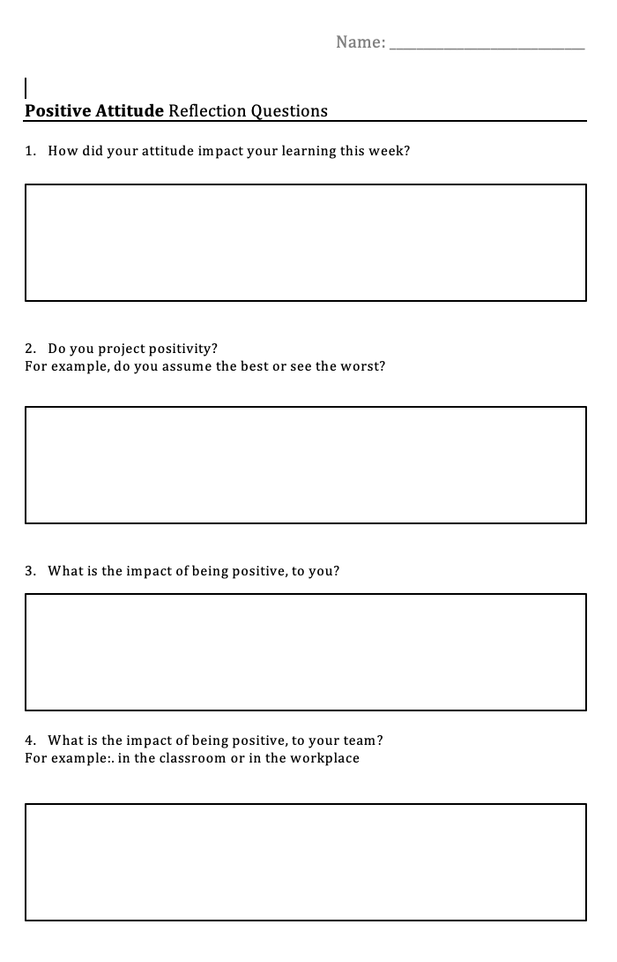

Appendix B – Attitude Quotient

