Module Name: Program Overview with Participants

Purpose: To introduce the 12-week LIFT to Work Program to the participants.

Logistics: Day 1
Time: 1.5 hours

Facilitator: A member of the WEM Facilitation Team

Special Instructions: The learning objectives below will be adapted to meet the needs of each cohort.

Transferability to the Workplace

- Participants to gain skills and confident in themselves.

Learning Objectives – Overall LIFT to Work Program

By the end of the LIFT to Work Program the participants will be able to:

- Explain how they add value as a team member in their working team, future workplace, community and family.
- Explain their personal meaning behind being employed.
- Demonstrate a change within their essential skills levels.
- Identify the next 3 steps in their continuous learning journey.

Assessments
Assessments relating to the Learning Objectives – Overall LIFT to Work Program

- Assessment A - Adding Value as a Team Member Assessment
- Assessment B - Personal Statement
- Assessment C - Self-Reflection
- Appendix D - Weekly feedback form Kirkpatrick level 1 and 2

Learning Objectives – By Essential Skills

By the end of the session the participants will be able to:

Reading
- Read workplace schedules. Examples: Production schedule and shift schedule.
- Read workplace job list. Example: Work orders.
- Read documentation on the workplace communication board (Paper and/or electronic) Example: Memos, product updates.
- Understand workplace rules and regulations as it relates to the workplace and your job.

Document Use
- Identify the forms, labels, signs, product codes, and other notations in print and non-print media accurately.
- Apply the information within the forms, labels, signs, product codes, and other notations in print and non-print media accurately.
- Complete workplace forms and/or charts.
- Identify/Read a MSDS (Material Safety Data Sheet), SDS (Safety Data Sheets) and/or PSDS (Product Safety Data Sheets).
- Describe the images within the MSDS, SDS and/or PSDS.
- Apply the information founds with the MSDS, SDS and/or PSDS.
- Recall the list of ingredients.
- Pick out the list of ingredients.
- Explain the process for combining the different ingredients. (Unless it can be shown and explained)
- Identify the different parts of a workplace schematic diagram.
- Interpret workplace schematic diagrams.

Writing
- Practice completing workplace documents:

Numeracy
- Show how to use a measuring tape.
- Show how to measure quantities.
- Show how to calculate quantities.
- Show how to measure thicknesses, weights and volumes.
- Show how to calculate weights and volumes.
- Analyze basic product test results.
- Identify factors which will have an impact on estimating time, distances, quantities, volumes, weights, and thicknesses.
- Explain how you estimate time, distances, quantities, volumes, weights, and thicknesses in the workplace.
- Practice estimating time, distance, quantity, volumes, weights and thickness in the workplace.

Communication
- Write basic note and notations.
- Create list.
- Practice communicating when there is a difference between actual and a workplace form.
- Employ appropriate language and behaviours in communicating with customers, suppliers, co-workers and supervisors in a food-processing environment.
- Practice explaining a workplace hazard to their supervisor.
- Discuss effective ways to communication with your peers.
- Discuss effective ways to communicate with your supervisor/manager.
- Discuss effective ways to communicate with the HR Manager.
- Role-play workplace interview.

Thinking Skills (Problem Solving, Decision-Making, Critical Thinking)
- Practice the 5 Why principle as it relates to the workplace.
- Explain the 5S as it relates to workplace environment.
- Identify the 8 lean wasters in the workplace.
- Discuss how to implement the 8 lean wasters principles in the LIFT to Work classroom environment.
- Identify opportunities for decision making within everyday workplace operations and tasks.
- Discuss what to do, steps to take, if the best decision was not made.
- Explain the concept of the best versus right decision.
- Practice organizing workplace task effectively.
- Discuss the importance of following workplace PPE.

Memory
- Recall workplace procedures and processes.
- Recall workplace safety procedures.
- Recall/show how to wear PPE.
- Recall workplace codes.

Digital Technology
- Demonstrate minimum computer proficiency.
- Practice applying for a job on-line.

Others
- Practice wearing PPE equipment. Example: Hard hat, safety vest.

Continuous Learning
- Identify continuous learning opportunities within the workplace and community.
- Share their personal, participants, reason for continuing their learning(s).
- Create a continuous learning plan.

Summary Lesson Plan - Program Overview

Activity: Hockey as an Essential Skill.
Purpose: To demonstrate how essential skills are part of our everyday life.
Note: Ideal to pick a sport or hobby that many of the participants can relate to.
Working in small groups the participants will write down all the things a person needs to know to play hockey (ideally 20 things). Once they have an extensive list we will ask the participants to classify the ones that relates to the 9 essential skills.

Share an overview of the 12-week LIFT to Work Program.
- Discuss the journey we will be on together over the next 12-weeks. As with any journey there will be times we are engaged and having fun, and there will be other times you wish you were somewhere else. That is part of life and part of the journey as we learn new things. Suggestion: Relate it to a camping/fishing trip.
- Learning objectives for the program
- 12-week schedule
- Review the weekly agenda, appendix F, and the purpose of the document
  - Ask the participants to identify three specific pieces of information from the sample agenda.
    - Example: What are we doing on Thursday morning?
    - Example: What day is our tour?
    - Example: Who is coming in on Friday afternoon?
- Share details regarding the facilitation team:
  - The role of the facilitation team
  - Share contact information with the participants
  - Discuss expected turnaround times with the participants
  - Discuss what they can expect from you.
- Explore the value of confidentiality with the group.
  - What does confidentiality mean to you?
  - What does confidentiality mean to the facilitation team?
- Indicate we will be coming back to these topics and ideas again throughout the program. We encourage and really want you to share questions and ideas with us, in the way that works best for you today.
- Other items to be added if necessary.

Activity: Draw a picture that represents the next 12-weeks of our journey together.
Note: Ideal for the facilitator(s) to take part in the activity as well.
Ask the participants and facilitator(s) to share their picture with another person at their table.
Ask if we could have three people share what they drew with the larger group.

Appendix

Appendix A – Adding Value as a Team Member Assessment

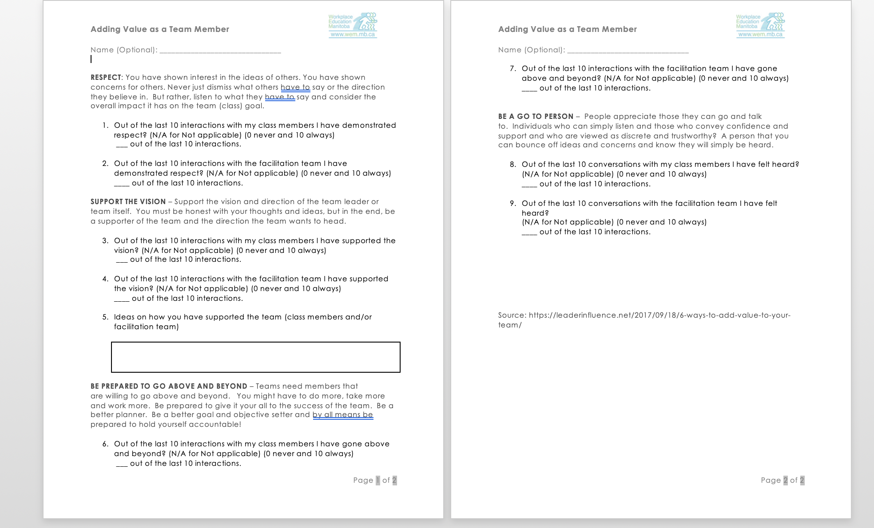

Appendix B – Personal Statement Assessment

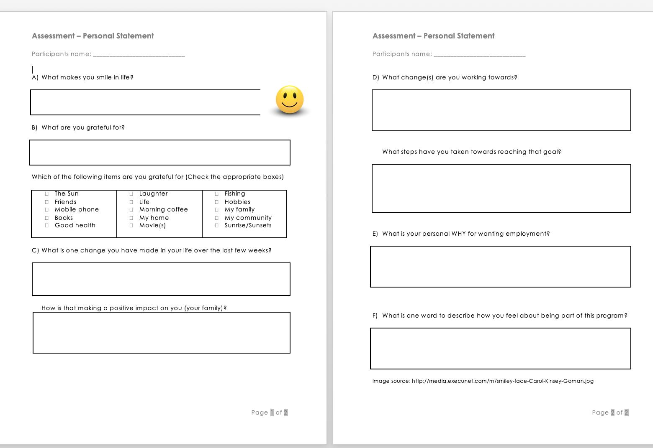

Appendix C – Self-Reflection Assessment

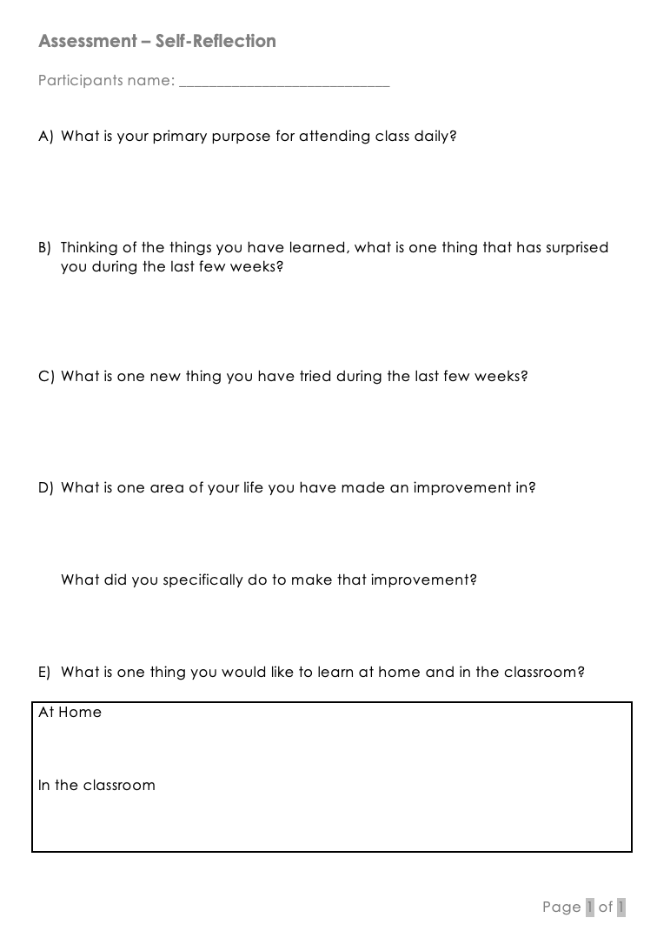

Appendix E – Weekly feedback form Kirkpatrick level 1 and 2

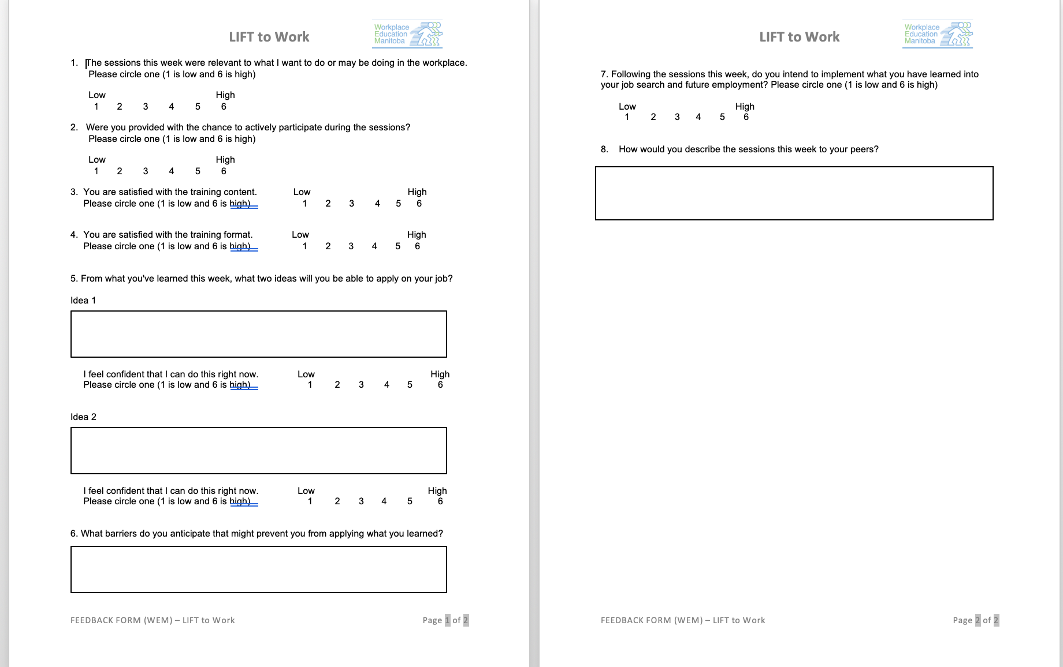

Appendix F – Weekly Agenda

AGENDA
Week 1: November 5th – 9th
Monday  Nov. 5th | Program Overview  Get to Know the Team  Expectations and Responsibilities
Tuesday  Nov. 6th | Industry Overview  Introduction to Essential Skills  Team Building
Wednesday  Nov. 7th | Shift Work: Making it Work  Working with Others
Thursday  Nov.8th | Tour: Food Development Centre  Essential Skills: Numeracy Introduction | Transportation Provided
Friday  Nov. 9th | Tour: Simplot  Tour Debriefs  Weekly Overview and Look into Next Week  Wrap Around Organization | Transportation Provided  In conjunction with the wrap around organization.
Facilitation Team | Name:  Email:

