Module Name: Co-operating with Others – Reliability

Purpose: Respect for expectations means acknowledging, and accepting, that you are expected to perform certain tasks, in a specific way, at certain times.

Logistics: PMB modules are weaved throughout the 12-week program.
This module could be broken down into smaller modules to meet the participants and schedule needs.
3 hours

Facilitator: Member of the WEM Facilitation Team

Special Instructions: This module would benefit to follow Respect for Expectations.

Essential Skills: Continuous learning, Thinking Skills, Working with Others, Oral Communication

Transferability to the Workplace

Benefits to you:

- Increased understanding of why you do things or think things.
- Recognition that people have difference expectations.
- Potential to increase self-esteem. Example: Feel better about oneself when others are positive and encouraged and grateful for reliability.
- Increased understanding of personal bias or judgment based on reliability.
- Increased understanding of behaviors that can build or breach trust.
- Ability to understand why other people may do or think things - we can relate to others better.

Benefits to the team:

- May increase respect, patience, and communication among and across the team.
- May increase ability to work with others. Example: People usually prefer to work with people they can rely on.

Benefits to the organization:

- May enable individuals to move beyond their own wants and thoughts.
- Have a better understanding of accountabilities and consequences of being unreliable.
- May increase understanding of interdependencies.

Learning Objective

By the end of the session the participants will be able to:

- Define reliability.
- Define dependability.
- Identify and discuss how reliable you are.
- Discuss the employer expectations regarding dependability and reliability of their employees.
- Identify what gets in our way of being reliable.
- Describe how reliable you are in life and the workplace.
- List 10 ways to be dependable.
- List 10 ways not being dependable impact others.
- Identify 2 behaviours we can demonstrate in the classroom to respect the LIFT to Work Program expectations.

Assessment(s):

- Comments and ideas shared throughout the session.
- Data will be collected through the weekly feedback form.
- Respect and Respecting Expectations Assessment, Appendix A.

Personal Management Basics (PMB) Topics include:

Topics | Modules
Introduction to PMB’s | - Introduction to PMBs  - Self-Management Skills  - Co-operating with Others
Self-Management Skills | - Self-Awareness  - Responsible Behaviour  - Managing Stress  - Positive Attitude  - Taking Initiative  - Adaptability and Flexibility
Co-operating with Others | - Interpersonal Skills  - Respect for Others  - Respect for Expectations  - Reliability  - Personal Presentation

Program Overview – Lesson Plan

Activity: Reliability

Ask: What do you expect when you attend this class?
Ask: What happens to you if that is not in place?

That is a common feeling when we come to expect something from someone else.

Learning objective: Define reliability.
Learning objective: Define dependability.

People inherently value reliability. In fact, every day we value:
- Reliable cars that save time and money on repairs
- Reliable mail that gets delivered on time
- Reliable investments that deliver expected returns
- Reliable cell-phone service to stay connected
- Reliable vendors who show up on time
- Reliable airlines that take off on time
- Reliable restaurants that have the food on their menu
- Reliable friends and colleagues who do what they say
Definition of reliability is when you are able to be trusted; you are perceived as being predictable and you are dependable.

Work through the following questions with the participants. The facilitator to scribe the participant’s ideas.

- How does someone show you they trust you?
- How do we show others we are predictable?
- How can we show others we are dependable?

Learning objective: Discuss the employer expectations regarding dependability and reliability of their employees.

Review the following expectations with the participants:
- Expectation A – Appearance
Do you look like the right person for the job?
4 aspects of your appearance concern employers. Employers are concerned about your appearance as shown by the way you look, behave, write, and speak. Each type of appearance is just as important as all of the others. If you meet these expectations, your first impression will be a good and lasting one.
The Way You Look
It may seem obvious, but good personal appearance and hygiene are extremely important when you are looking for a job. Many people suffering from extended unemployment stop paying attention to their physical selves. You should realize, however, that 40 percent of those remaining unemployed do so because of poor personal appearance. Don't be one of these people!
When you go to an interview, look like the right person for the job. In the first few seconds the employer will probably decide not to hire you if you have neglected your personal appearance. It makes no difference how skilled you are. The employer will usually hire someone with a pleasing appearance.
Three factors determine the way you look. These factors are dress, grooming, and hygiene.
Hygiene
Hygiene is another important factor in your personal appearance. Practice the following basic rules for good personal hygiene.
Keep your body clean. Good personal hygiene begins with a clean body.
Wash your hair regularly.
Brush and floss your teeth every day.
Use deodorants.
Clean your fingernails.

NOTE: Be sure to reference workplace guidelines and code of conduct.
- Dress, grooming, and hygiene are closely related. Neglect of one hurts the others. Even if you are well-dressed and well-groomed, you will not have a good personal appearance if you have overlooked your hygiene.

The Way You Write
The third aspect of appearance is the paperwork that you must do to make your job-search successful. For example, almost all employers require applicants to fill out application forms. You must do your paperwork in a way that shows employers you are neat, complete, and accurate.
The Way You Speak
Another part of your appearance is the way you speak. Your manner of speaking is most important during the interview and during your phone contacts. Making a good appearance with your speaking means
*Thinking and organizing your thoughts before talking

- Expectation - Dependability

Can you be counted on to do the job?
Employers hire people who show the most promise of being at work on time every day. Most companies operate on the idea that time is money. In turn, workers are usually paid the amount of time they give the company. Employees who often miss work entirely, or frequently arrive late, or cannot contribute fully. A highly skilled worker who is often absent will not produce as much as a more dependable worker with fewer skills. Nonproductive employees do not stay employed for long. Such workers often cost the company money rather that help it make a profit.
The second important employer expectation, then, is dependability. Dependability includes two specific qualities: attendance and punctuality. It also includes a general quality of reliability. During all parts of your job-search, you must convince employers that you meet their expectations in these areas.
Attendance
Employers want to hire people who will maintain good attendance. Employers expect all workers to be on the job as scheduled. Employees who are at work every day produce more. In this way they make more money for the company and for themselves.
During an interview your task is to give the interviewer specific and concrete examples of when and how you've shown good attendance in the past. You can do this with examples from any of your life, work, or educational experiences.
When you give employers specific examples of your skills, you show employers your ability to do good work. This also shows employers that you invested time and energy in preparing for your job-search and that you have the communication skills they want their workers to have. A specific example tells a story by describing some of the who, what, where, when, why, and how of that example.
There are a few basic ways for you to show the employer during an interview that you meet his or her expectations of attendance. Show the employer that you've not missed many days at work or at school. If you did miss a few days and made up the work, say so! As a rule of thumb, six missed days a year, without serious illness are considered acceptable to most employers ... but not all.

Hand out a sample of the following words on cue cards to each small group.

Hand out the article, 8 Ways to Be the Most Reliable Person in the Room, Appendix A.
- Manage commitments
- Proactively communicate
- Start and finish
- Excel daily
- Be truthful
- Respect time, yours and others’
- Value your values
- Use your BEST Team

Have the participants review and report back on one of the 8 items handed to them on a cue card.

Learning objective: Identify and discuss how reliable you are.

Handout Appendix B, How Reliable am I, and work through the questions with the participants.

Learning objective: Identify what gets in our way of being reliable.

With the participants review what gets in our way of being reliable. An option could be to ask what the opposite of the 8 ways to be the most reliable person in the room are.

- Manage commitments
- Proactively communicate
- Start and finish
- Excel daily
- Be truthful
- Respect time, yours and others’
- Value your values
- Use your BEST Team

Goal: For each participant to identify what is or has gotten in their way of being reliable.

Ask: (Solo) What is your number 1 and number 2 things that gets in your own way of being reliable?

Learning objective: List 10 ways to be dependable.
Learning objective: List 10 ways not being dependable impact others.

Hand out Appendix B, list 10, and work through the questions with the participants.

Learning Objective: Identify 2 behaviours we can demonstrate in the classroom to respect the LIFT to Work Program expectations.

Solo or in pairs.

Ask: Identify 2 behaviours you could demonstrate in the classroom to respect the LIFT to Work Program expectations?

Have the participants sit in a circle and share 1 idea with the group.

APPENDIX

Appendix A - 8 Ways to Be the Most Reliable Person in the Room

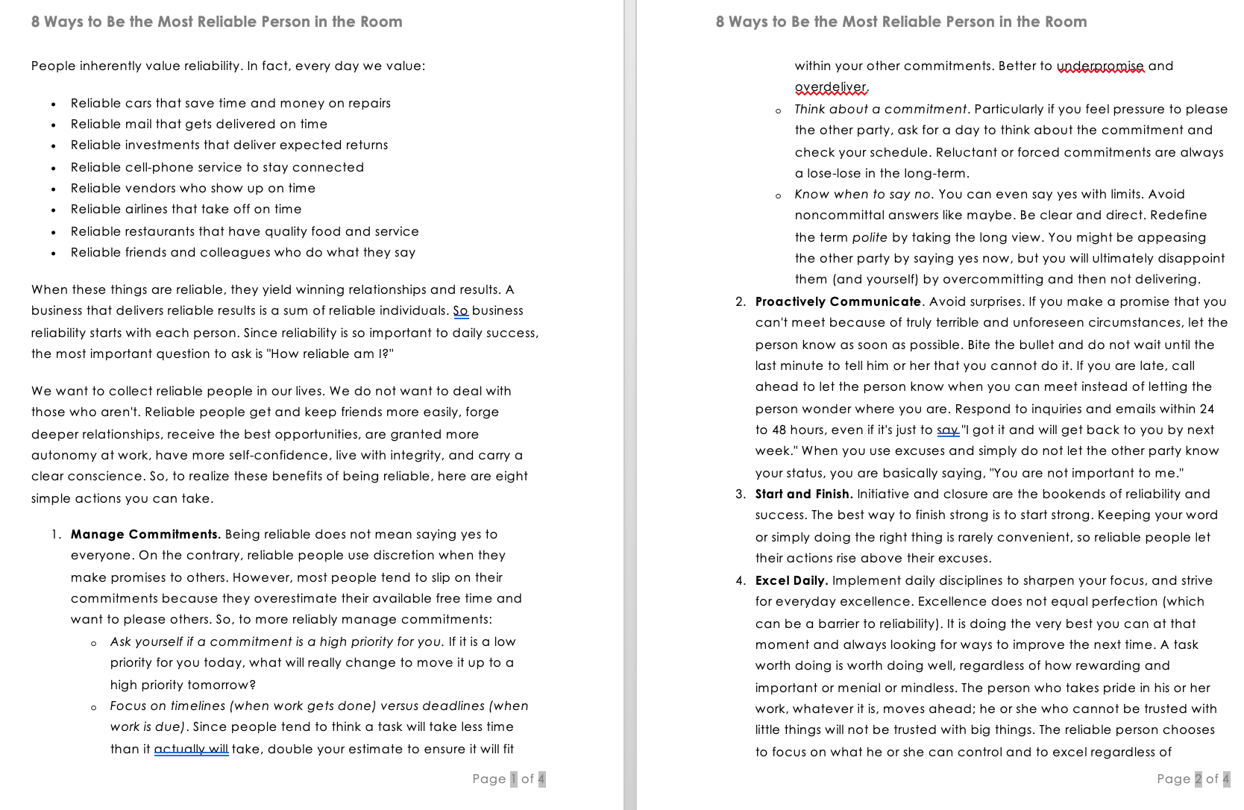

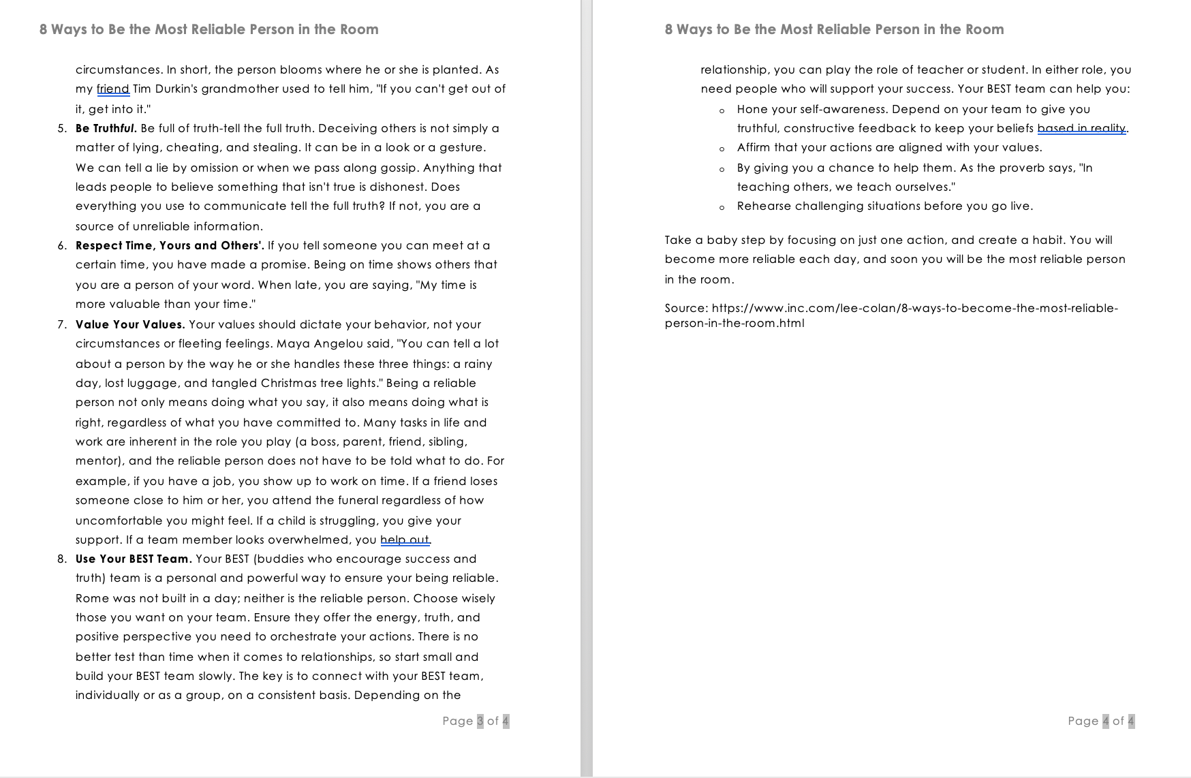

Appendix B – How reliable am I?

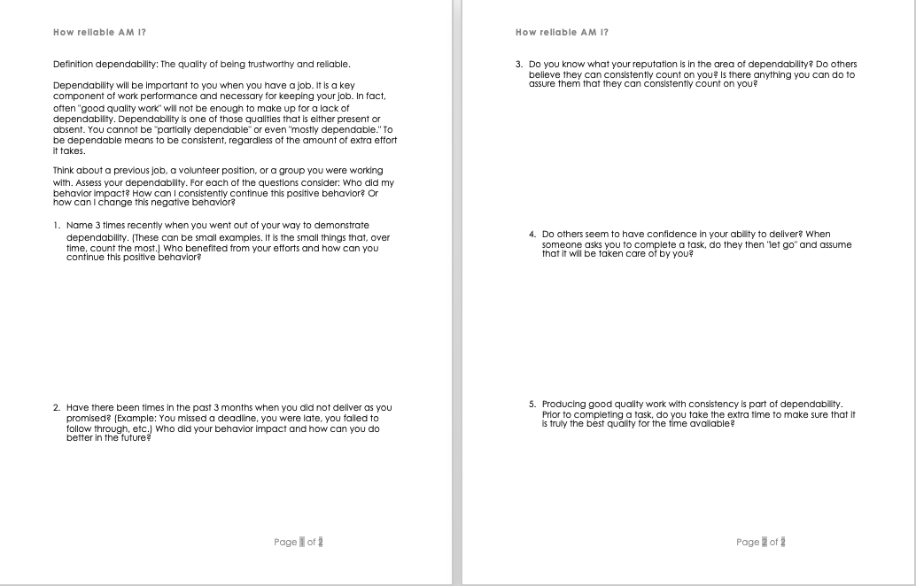

Appendix C – List 10

