Module Name: Co-operating with Others
– Respect for Others and Expectations

Purpose: Respect for expectations means acknowledging, and accepting, that you are expected to perform certain tasks, in a specific way, at certain times.

Logistics: PMB modules are weaved throughout the 12-week program.
This module could be broken down into smaller modules to meet the participants and schedule needs.
2 – 3 hours

Facilitator: Member of the WEM Facilitation Team

Special Instructions: Not applicable at this time.

Essential Skills: Continuous learning, Thinking Skills, Working with Others, Oral Communication

Transferability to the Workplace

Benefits to you:

- Understanding your role(s) in the workplace and acting accordingly.
- Understand what the role of the employer is.
- Know what you should do related to lateness and absences and act accordingly.
- Increase your knowledge which could enhance your job search skills.
- Understand some of the expectations in the workplace.

Benefits to the team:

- May increase respect, patience, and communication among and across the team.
- May help to clarify roles and responsibilities.
- May improve communication.
- May reduce interpersonal conflict.

Benefits to the organization:

- May enable individuals to move beyond their own wants and thoughts. Example: Working towards the goals of others, and the goals of the organization.
- May foster accountability.
- May enable individuals and teams to self-direct. Example: When expectations are clearly outlined.

- May reduce overall stress

Learning Objective

By the end of the session the participants will be able to:

- Identify expectations you have of yourself and others have of you in your daily life.
- Discuss what having respect for expectations means.
- Identify expectations of yourself, the team and the management within the workplace and in life.
- Discuss the impact on the team when we meet/exceed other peoples’ expectations.
- Identify behaviours which show a lack of respect for expectations in the workplace and in life.
- Identify behaviours which show respect for expectation in the workplace and in life.
- Identify 2 behaviours we can demonstrate in the classroom to respect the LIFT to Work Program expectations.

Assessment(s):

- Comments and ideas shared throughout the session.
- Data will be collected through the weekly feedback form.
- Respect and Respecting Expectations Assessment, Appendix A.

Personal Management Basics (PMB) Topics include:

Topics | Modules
Introduction to PMB’s | - Introduction to PMBs  - Self-Management Skills  - Co-operating with Others
Self-Management Skills | - Self-Awareness  - Responsible Behaviour  - Managing Stress  - Positive Attitude  - Taking Initiative  - Adaptability and Flexibility
Co-operating with Others | - Interpersonal Skills  - Respect for Others  - Respect for Expectations  - Reliability  - Personal Presentation

Program Overview – Lesson Plan

Activity: You are going on a camping fishing trip. What are 3 expectations you have of the camp ground?

Say: In life and in the workplace, we have expectations of others and they have expectations of us. Together we are going to explore the idea of respecting not only our own expectations, but also the expectations of others.

Ask: How do you see this topic connecting with the things we have been learning together in this program?
- A team is successful when we understand what others need. To understand what others need we need to be able to communicate. It is not all about me, there are other people that rely on me as well.

Learning Objective: Identify expectations you have of yourself and others have of you in your daily life.

Put up 2 flip chart papers and then provide the participants with sticky notes to scribe their answers/ideas on. On the 1st flip chart write expectations of yourself and on the 2nd flip chart write expectations others have of you. Provide the participants with time to share their ideas to the flip chart questions via sticky notes.

The facilitator will review the ideas the participants have shared and fill in any additional ideas/information.

Learning Objective: Discuss what having respect for expectations means.

Potential definition or description to share with the participants: Respect can be shown through behaviour and it can also be felt. We can act in ways which are considered respectful, yet we can also feel respect for someone and feel respected by someone. Because it is possible to act in ways that do not reflect how we really feel, the feeling of respect is more important than the behaviour without the feeling. When the feeling is there, the behavior will naturally follow.

In small groups have the participants discuss the following ideas/questions 1at a time. There is the opportunity to hand out How to Respect Yourself and Others Around You by Daniel Branch, Appendix 2.

- What does respect mean to you?
- Why is respect important to you?
- What does having respect for expectations mean to you?
- Why is the idea of respect for expectation meaningful to you?

Have each small group share their answers. Ideally we will work through 1 questions and then review before moving onto the next one.

Learning Objective: Identify expectations of yourself, the team and the management within the workplace and in life.

Moving the participants from one flip chart to the next ask them to identify expectations in the following roles:

- Expectation of you in the workplace.
- Expectations of your team in the workplace. Example: Your shift (team) and other shifts in your department/area.
- Expectations of your manager in the workplace. Example: Supervisor, Plant Manager

The participants would value understanding the different expectations as they relate to the LIFT to Work Program workplace partner(s).

Learning Objective: Discuss the impact on the team when we meet/exceed other peoples’ expectations.

Ask: You go to the local store to buy something or find something out. How could or how has the person helping you exceeded your expectations?

Example: The person at the till/check out recognizes I have a size 8 and 9 shoe and lets me know. That would make me very happy.

In your table groups.

Ask:
- Based on your role as a class member how do you and how can you exceed each other’s expectations?
- What impact does exceeding expectation have on each other and the classroom?

Now we are going to move to looking at scenarios in the workplace.
Hand out 2 to 3 workplace scenarios to each table group. Generally we would recommend 15 different examples to add depth and variety to the conversation.

Ask: Based on your workplace example how could you meet and then exceed expectations?

Ask: What impact does exceeding expectation have on you, your team and the overall workplace?

Learning Objective: Identify behaviours which show a lack of respect for expectations in the workplace and in life.
Learning Objective: Identify behaviours which show respect for expectation in the workplace and in life.

Moving from one participant to the next ask them to identify a behaviour which show a lack of respect for expectations. Then start over, this time asking which behaviours show respect for expectations in the workplace and life.

Learning Objective: Identify 2 behaviours we can demonstrate in the classroom to respect the LIFT to Work Program expectations.

Solo or in pairs.

Ask: Identify 2 behaviours you could demonstrate in the classroom to respect the LIFT to Work Program expectations?

Have the participants sit in a circle and share 1 idea with the group.

Wrap-up activity: Share 2 words or a specific situation to describe the shift in your thinking today.

APPENDIX

Appendix A - Respect and Respecting Expectations Assessment

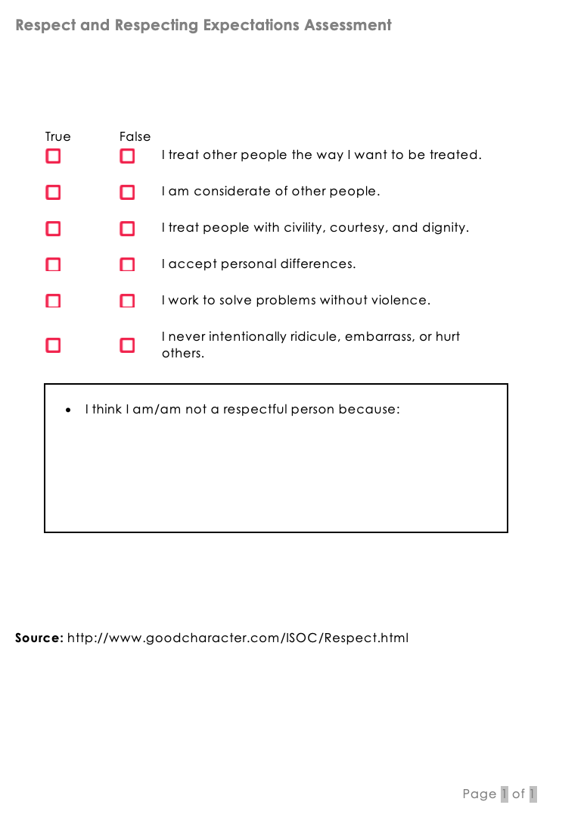

Appendix B - How to Respect Yourself and Others Around You
By Daniel Branch

