Module Name: Self-Management Skills – Responsible Behaviours

Purpose: Being responsible means making the right choices. It means identifying and accepting the consequences—good or bad—of your decisions. Ultimately, it means considering how your actions will affect people and situations around you. In your daily life, you may hear people talk about “being responsible” for people or outcomes. Responsible behaviour is made up of five essential elements—honesty, compassion/respect, fairness, accountability, and courage.

Logistics: PMB modules are weaved throughout the 12-week program.
This module could be broken down into smaller modules to meet the participants and schedule needs.
2 hours

Facilitator: Member of the WEM Facilitation Team

Special Instructions: Not applicable at this time.

Essential Skills: Continuous learning, Thinking Skills, Working with Others, Oral Communication

Transferability to the Workplace

Benefits to the team:

- If each employee on the team is responsible, then:
  - There are potentially fewer issues related to perceived irresponsibility
  - Teams self-regulate
  - Managers and supervisors can be less involved

Benefits to the organization:

- Individuals and teams are better able to take responsibility.
- Increased buy-in and engagement from individuals and teams.
- Increased understanding that each individual contributes to the outcome of the organization.

Learning Objectives

By the end of the session the participants will be able to:

- Define responsible behaviour.
- Identify responsible behaviours in the classroom, life and in the workplace.
- Discuss how to identify inappropriate or irresponsible behaviours in the workplace.
- Explain the importance of acting responsibly within life and the workplace.
- Discuss the consequence of not being responsible in the workplace.
- Define honesty, compassion/respect, fairness, accountability, courage and attitude.
- Demonstrate how to exhibit responsible behaviour through honesty, compassion/respect, fairness, accountability, and courage.
- Identify how you can be responsible and accountable at work.
- Identify 2 things they could do to demonstrate responsible behaviour in the classroom and at home.

Assessment(s):

- Comments and ideas shared throughout the session.
- Data will be collected through the weekly feedback form.

Personal Management Basics (PMB) Topics include:

Topics | Modules
Introduction to PMB’s | - Introduction to PMBs  - Self-Management Skills  - Co-operating with Others
Self-Management Skills | - Self-Awareness  - Responsible Behaviour  - Managing Stress  - Positive Attitude  - Taking Initiative  - Adaptability and Flexibility
Co-operating with Others | - Interpersonal Skills  - Respect for Others  - Respect for Expectations  - Reliability  - Personal Presentation

Program Overview – Lesson Plan

Activity –
Hand out, complete and review What am I responsible for?, Appendix A.

Learning objective: Define responsible behaviour.

As a group define
- Responsibility
- Behaviours
- Responsible Behaviours

Recap:

A) Being responsible means a lot more than just doing what others tell you to do. It means taking a stand for what you believe in. It means doing the right thing, even when the right thing is hard or unpopular. It means respecting other people and yourself enough to be honest, fair, compassionate, and courageous.

B) Having a good system of personal ethics in place will help you make responsible decisions and stick to them. It doesn’t mean that you’ll be perfect or always know what to do. But, it does mean that you’ll have less difficulty figuring out what to do when you’re in challenging situations. It’s not always easy to be responsible, but it’s always honourable to try.

Learning objective: Identify responsible behaviours in the classroom, life and in the workplace.

Working in small groups ask the participants to identify responsible behaviours in the classroom, life and in the workplace.

Suggested Ideas to explore:
• Showing up for work on time and puting in expected hours
• Making appropriate choices – such as how you dress and how you interact with others
• Being reliable – your boss, the people you work with and clients, should be able to rely on you on a daily basis, especially during peak or urgent periods
• Meet deadlines (or complete work prior to deadline)
• Meet or exceed each of your current job goals.
• Quantify and present your successful results
There is an opportunity to ask 1 participant or 3 to assist with the scribing of the ideas.

Learning objective: Discuss how to identify inappropriate or irresponsible behaviours in the workplace.

Share the following ideas with the participants:

Some types of behaviour are always inappropriate when in the workplace. However, you may be wondering how you can identify these types of behaviour and know when you need to report them. Keeping inappropriate behaviours out of the workplace will boost employee morale and increase productivity.

- Know that jokes about someone's gender, race, cultural background, religion or other personal characteristics are very inappropriate. This is true even if it seems that the person is poking fun at himself, as it could also hurt the feelings of someone else. If this happens to you, try respectfully asking the person to stop making jokes about the particular subject. If the behaviour doesn't stop, then you should bring it to your boss's attention.

- Remember that touching someone else's body or making comments that are sexual in any way are always inappropriate behaviours. This type of behaviour, both in and out of the workplace, could result in a lawsuit. If you are on the receiving end of uninvited touching or sexual comments, report them to your supervisor immediately.

- Understand that dating among colleagues is usually inappropriate. However, this often depends on the company. In most cases though, relationships between a manager and an employee are inappropriate, because they can cause problems in the workplace.

- Consider possible instances of discrimination. Discrimination based on age, gender, disability, national origin, race and religion is always inappropriate in the workplace. An example of this might be when a company only wants to hire men for manual labor jobs because they assume women can not do the job because they are women.

- Realize that pushing religion in the workplace is inappropriate. For example, if a christian manager is trying to share his religion with a new employee to make him feel welcome, this could make the employee uncomfortable. He might feel like he can't voice his feelings and discomfort to his manager for fear of losing respect. If you feel that a supervisor or coworker is pushing unwanted information about his religion, you should ask them to stop. If they don't, make a report of inappropriate workplace behaviour.

Learning objective: Explain the importance of acting responsibly within life and the workplace.

Hand out appendix B, Identifying Responsible Behaviours

Ask the participants to work through it and then review it as a large group.

Learning objective: Discuss the consequence of not being responsible in the workplace.

You've probably heard the clichés: the bored receptionist chewing gum and filing her nails at the desk; the frustrated supervisor yelling at an employee who has made a major mistake; the analyst playing computer games rather than running reports. Chances are, when you've seen these types of behaviours, you've thought, "That's unprofessional." How you behave at work has important consequences for your own professional image and that of your employer, and it could mean the difference between a satisfying career and a series of dead-end jobs.
- Professional Image and Retention: If you have a negative attitude or cannot control your emotions, or you spend more time chatting or doing anything but work, chances are you will be terminated at the end of your probationary period (usually 90 days).

- Representing Your Employer: Your behaviour influences the customer's impressions of your business, so it's important that you behave like a polite professional. Being rude, inflexible or inappropriate can lead to the customer taking his business elsewhere -- and possibly telling others about his bad experience with you.

- Legal Issues: What you believe to be good-natured teasing of a co-worker could fall within the scope of sexual harassment. Even if it does not constitute harassment, the Human Resources Department or management still has to investigate complaints, spending valuable time and money. To prevent misunderstandings -- or worse, lose your job and face legal problems -- keep your behaviour professional and respectful at all times.

- Productivity: It is fine to express an opinion, or break tension with humour, but your overall behaviour should remain professional to keep the team environment productive and the workplace a pleasant place to work.

Learning objective: Define honesty, compassion/respect, fairness, accountability, courage and attitude.

Working as a group define the following words:

A) Honesty - The quality of being honest and/or fairness and straight forwardness of conduct.

B) Compassion/respect - A feeling of deep admiration for someone or something elicited by their abilities, qualities, or achievements

C) Fairness - Treating people equally without favouritism or discrimination

D) Accountability - The fact or condition of being accountable; responsibility

E) Courage - The ability to do something that frightens one; bravery

F) Attitude - A settled way of thinking or feeling about something

Learning objective: Demonstrate how to exhibit responsible behaviour through honesty, compassion/respect, fairness, accountability, and courage.

Assign each group 1 of the following words:
- Honesty
- Compassion/respect
- Fairness
- Accountability
- Courage

Ask: How do we and/or how can we exhibit these words through our behaviours?

Provide the groups with the opportunity to present their ideas to the group.

Learning objective: Identify how you can be responsible and accountable at work.

Hand out and review, Tips for Becoming More Responsible, Appendix C.

Ask: What other items/ideas could we add or emphasize as it relates to the workplace.

Learning objective: Identify 2 things they could do to demonstrate responsible behaviour in the classroom and at home.

Ask the participants to find a partner and share with them 2 things they will start doing to demonstrate responsible behaviour.

Wrap-Up: Ask each participant to finish this question “Being responsible allows me to…”.

APPENDIX

Appendix A - What am I responsible for?

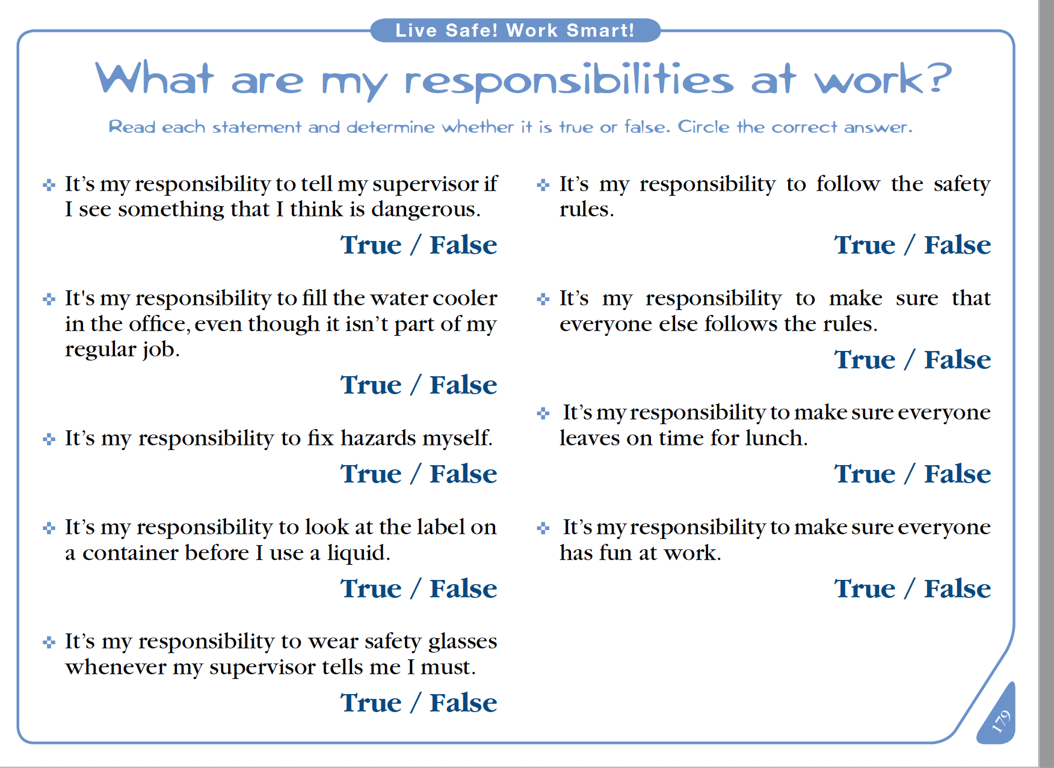

Appendix B - Hand out appendix B, Identifying Responsible Behaviours

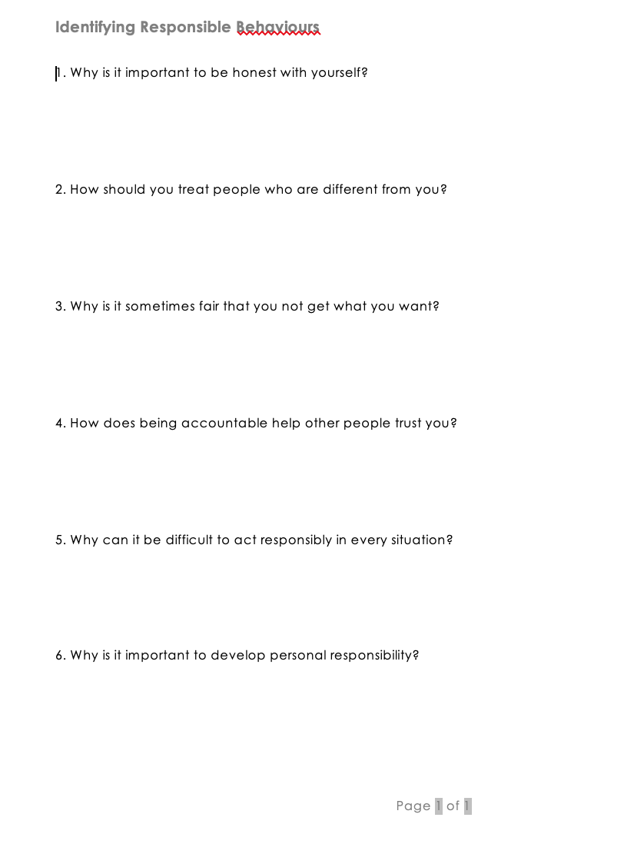

Appendix C – Tips for Becoming More Responsible

