Module Name: Self-Management Skills – Taking Initiative

Purpose: Initiative is all about taking charge. An initiative is the first in a series of actions. Initiative can also mean a personal quality that shows a willingness to get things done and take responsibility.

In North American business settings, taking or showing initiative is an important skill. Consistently taking initiative will help you meet and exceed, the expectations of employers, co-workers and those you serve.

Participants will have the chance to gain the skills knowledge to become more responsible, take proactive steps, build their confidence, and may be perceived as a leader.

Logistics: 4 hours

Facilitator: Member of the WEM Facilitation Team

Special Instructions: Not applicable at this time.

Transferability to the Workplace

Benefit to the organization:

- May give leaders an opportunity to shine.

- May take pressure of supervisors, e.g., don’t need to “baby sit”

- May build culture of responsibility and measured risk taking.

Essential Skills: Continuous learning, Thinking Skills, Working with Others, Oral Communication

Learning Objectives

By the end of the session the participants will be able to:

- Define initiative.
- Identify ways to take initiative in your life and in the workplace.
- Discuss your personal why for taking initiative.
- Explore through the 5 Whys strategy why we do not take the initiative.
- Discuss strategies to take initiative in the workplace.
- Discuss the connection between taking initiative, confidence and leadership.
- Create a personal SMART Goal.
- Discuss strategies to answer interview questions around taking initiative.
- Identify ways to take initiative within the classroom.

Assessment(s):

- Comments and ideas shared throughout the session.
- Data will be collected through the weekly feedback form.
- Appendix D - Self-Assessment Questions – Taking Initiative

Personal Management Basics (PMB) Topics include:

Topics | Modules
Introduction to PMB’s | - Introduction to PMBs  - Self-Management Skills  - Co-operating with Others
Self-Management Skills | - Self-Awareness  - Responsible Behaviour  - Managing Stress  - Positive Attitude  - Taking Initiative  - Adaptability and Flexibility
Co-operating with Others | - Interpersonal Skills  - Respect for Others  - Respect for Expectations  - Reliability  - Personal Presentation

Program Overview – Lesson Plan

Activity: Complete Self-Assessment Questions – Taking Initiative, Appendix D. Provide the participants with the chance to review their ideas with their table partners.

Learning objective: Define initiative.

Ask: What words would you use to describe taking initiative?

Share the following definition of initiative with the participants.

- The ability to assess and initiate things independently.
- The power or opportunity to act or take charge before others do.
- An introductory act or step; leading action.
- Readiness and ability in initiating action; enterprise.
- One's personal, responsible decision.

Learning objective: Identify ways to take initiative in your life and in the workplace.

Move the participants into groups. Assign each group with a life and work situation.

Examples:
- Groceries are needed
- Laundry needs to be done
- New shipment of materials had been delivered
- Local street has been closed
- Etc.

Hand out and review 48 Ways for You to Take Initiative in your Life and Work, Appendix A.

Learning objective: Discuss your personal why for taking initiative.

As a large group explore reasons why people take the initiative in different areas of their life.

Once you have a thorough list ask the participants to identify their personal why and then share it as a large group.

Learning objective: Explore through the 5 Whys strategy why we do not take the initiative.

Ask the participants why people or themselves do not take the initiative in their daily or work life.

Once you have a few examples, work through one or two of them by applying the 5 why strategies.

Ask: What did you learn/discover about yourself as a result of the 5 why activity?

Learning objective: Discuss strategies to take initiative in the workplace.

Review Appendix A and discuss strategies for how you can apply these ideas in the workplace.

Learning objective: Discuss the connection between taking initiative, confidence and leadership.

Definitions

- Initiative:
  - The ability to assess and initiate things independently.
  - The power or opportunity to act or take charge before others do.
  - An introductory act or step; leading action.
  - Readiness and ability in initiating action; enterprise.
  - One's personal, responsible decision.

- Confidence:
  - the feeling or belief that one can rely on someone or something; firm trust.
  - the state of feeling certain about the truth of something.
  - secret or private matter told to someone under a condition of trust. (Confidences)

- Leadership
  - the action of leading a group of people or an organization.
  - the state or position of being a leader.

Ask: What is the connection between these three words, initiative, confidence and leadership?

Note: There may be a need to reiterate that being a leader does not require a formal title.

Learning Objective: Create a personal SMART Goal.

Hand out SMART Goal Worksheet, Appendix C.

Review the following concepts with the participants.

GOAL SETTING:
1. Set A Plan and Work It
Setting and achieving goals is an important part of a successful job search. No one can claim to be successful unless you have a set of goals that you have set out to achieve and a plan to attain it. Working that plan is also an important part.
2. Make Sure They Are Meaningful and Motivating
Many people looking for a job make the mistake of thinking that setting goals is not your duty. That when you get a job it is up to the manager to tell you what your goals are. This is not true. As an future employee, it is also your duty to set goals for yourself. You may not be familiar with it initially but eventually you will get the hang of it. When setting and achieving goals – make sure that your goals are meaningful and motivating.
Think like a manager. What would I want from my employees?
SMART goals
As beginners, this is the most common and easiest format used for setting and achieving goals. Goals should be SMART.
- Specific
Good performance goals are specific. The common mistake in setting specific goals is stating an outcome rather than specific achievement in order to produce that outcome. For example, stating, “Find a job.” is an outcome. What is needed is specific achievements that result in someone losing weight. In the process of setting and achieving goals, the first step is to make sure the goals are specific.
- Measurable
Some career newbies find this difficult to do. After all, not all good goals are measurable. But based on experience, majority of good performance goals will have measurable results. Think hard about this. Sometimes it is a matter of looking at it from a different angle. Think about the goal’s intention. That may help you write it differently.
- Achievable
Goals that are challenging yet achievable builds self-esteem and confidence. That can result in more responsibilities and rewards. Some people believe that goals should be impossible to achieve. Yet others make the mistake of making it easily achievable. These goals are not good as they aren’t very motivating for you.. Be brave enough to set realistic, challenging goals that you alone or with the help of family, friends and support workers can achieve. Remember, it is about setting and achieving goals. Not just setting.
- Results-focused
When setting goals remember the activities must target the result you are trying to achieve. Common mistakes are thinking of activities as results. For example, writing a new resume is an activity, finding a job is a result.
- Time-bound
Give a time to when your meaningful and motivating goals will be achieved.

Provide the participants with time to create a personal SMART goal. Share it with a partner. Potential question to ask your partner “What is one thing we could do to make the idea within the SMART goal stronger?”

Learning objective: Discuss strategies to answer interview questions around taking initiative.

Hand out and review the document Interview Questions related to Taking Initiative, Appendix B.

Wrap up: Initiative is critical for success in anything you do. If an interviewer can get a sense of what kind of employee you will be based upon how well you answer these questions, you will either be hired, or never hear from the company again. Expect to be asked these questions to find out if you are a self-starter or are someone who needs a lot of encouragement and close supervision. Some people are bursting with energy and are eager to take on responsibility. Others don’t have what it takes. Many people are somewhere in between. It’s the interviewer’s job to find out if you can take initiative. People with initiative are self-confident and willing to accept a challenge. They are also easily bored with routine tasks. Self-starters tend to be more creative and look for opportunities to put new ideas into action.

Learning objective: Identify ways to take initiative within the classroom and explain your purpose for those choices.

Ask: (Solo or pair activity) Identify ways you can take initiative in the classroom and explain your purpose for those choices.

Facilitate a discussion around the ideas and the participants purpose for their choices.

Conclusion: You will have the chance to practice these ideas each and every day we are together. This is a journey not a destination.

APPENDIX

Appendix A – 48 Ways to Ways for You to Take Initiative in your life and work

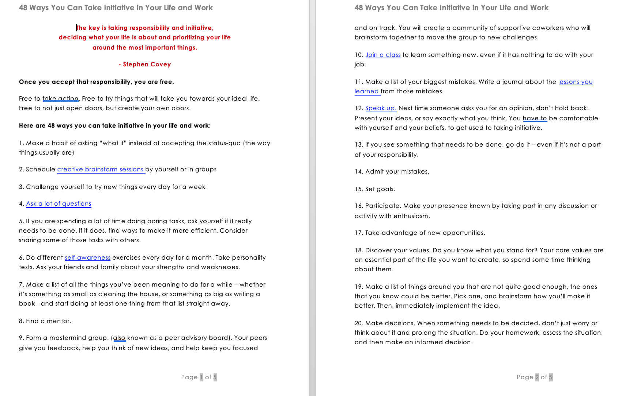

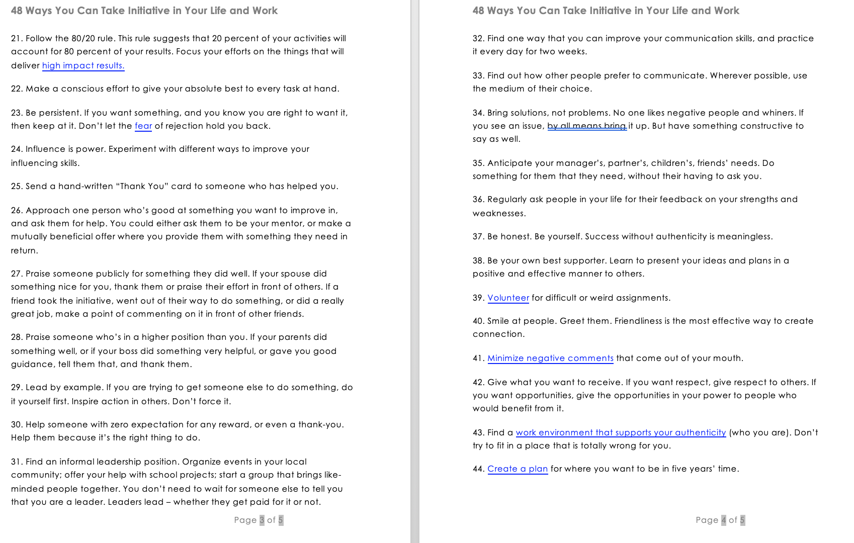

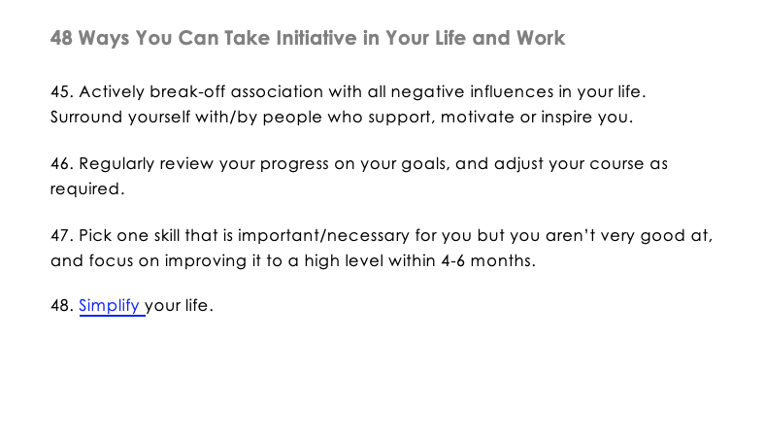

Appendix B - Interview Questions related to Taking Initiative

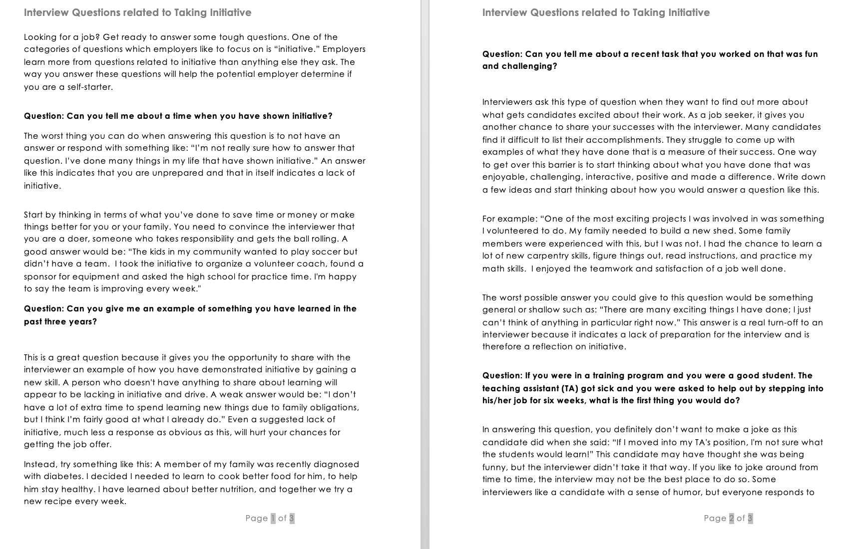

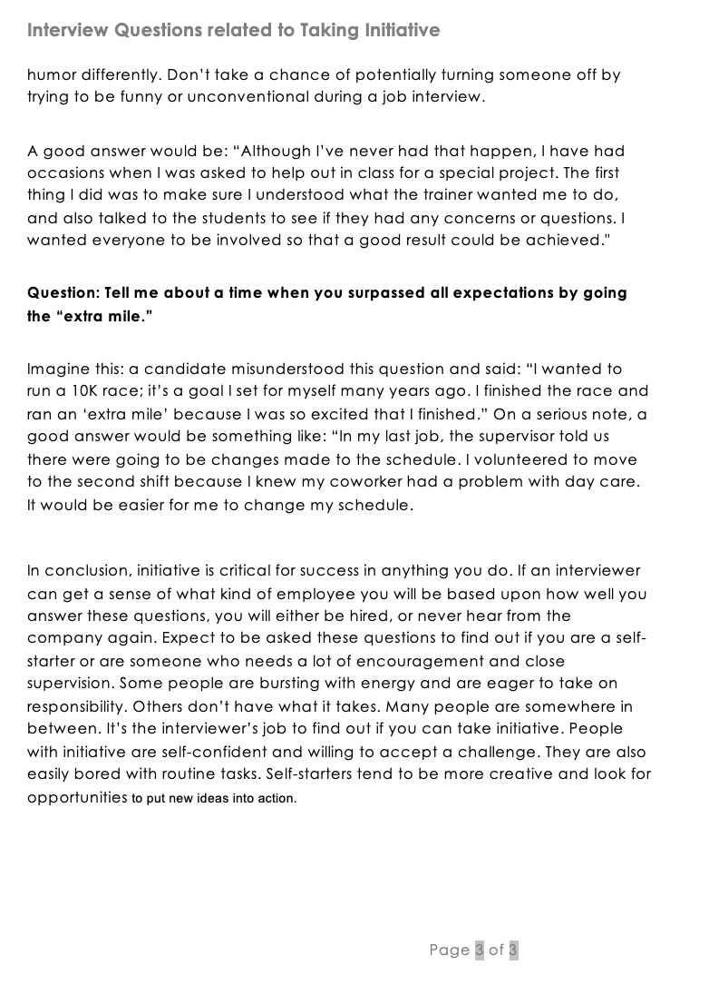

Appendix C – SMART Goal Worksheet


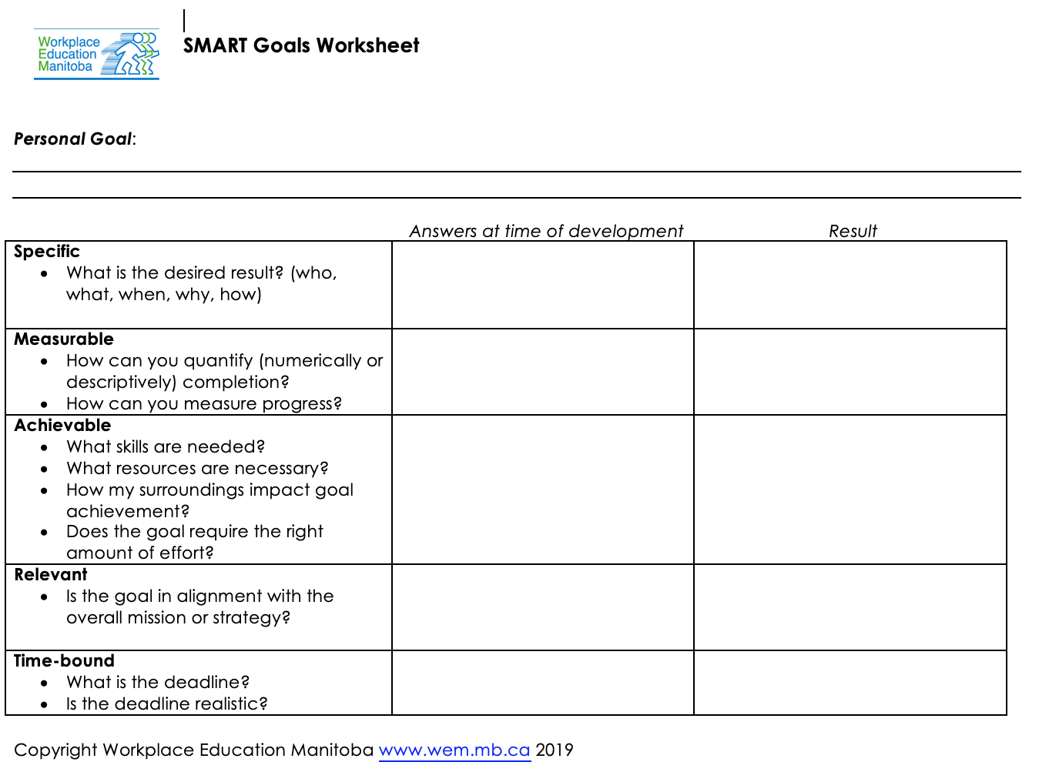

Appendix D - Self-Assessment Questions – Taking Initiative

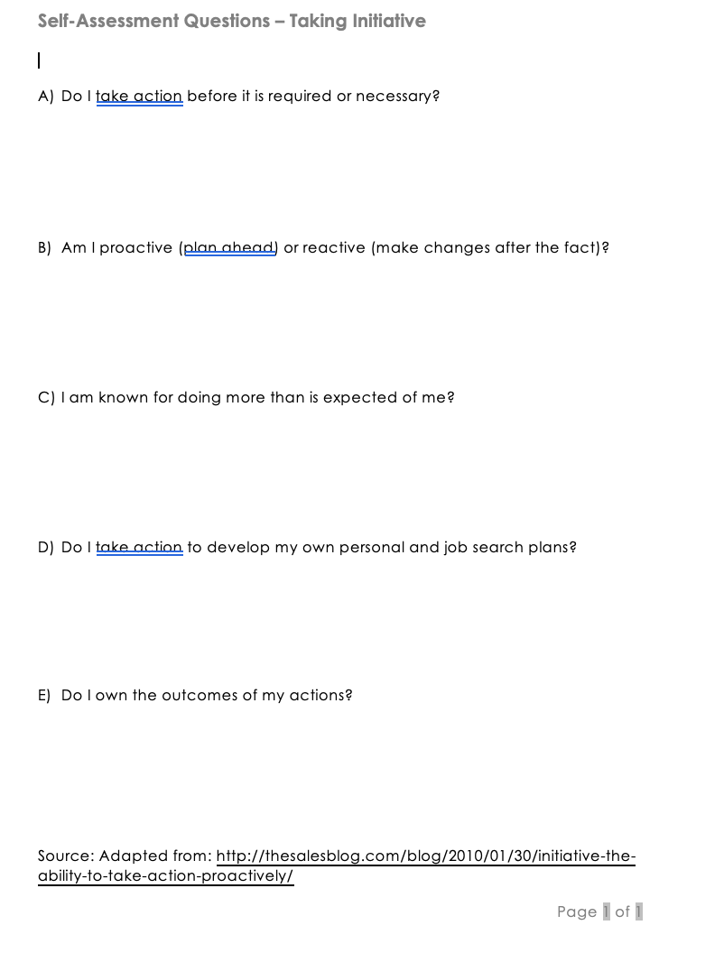

Appendix E – Initiative Resource Guide

