Module: Decision-Making Strategy

Purpose: Participants being able to implement thinking strategies to:
        - Use information from diverse sources to develop a clear understanding of a problem and its root causes.
        - Evaluate the comparative strengths and weaknesses of alternative solutions, including potential risks, benefits, and short and long-term consequences.
        - Make informed and balanced decisions appropriate to the goal, context, and available resources.
        - Evaluate the effectiveness of selected solutions for future situations.

Logistics: Half day or full day

Facilitator: Member of the WEM Facilitation Team.

Special Instructions: Not available at this time.

Essential Skills Thinking Skills
Decision-making is considered one of 7 sub-skills under a broader category of Thinking Skills. Problem-solving, Use of Memory, Finding Information, Critical Thinking are other examples of the sub-skills.

Transferability to the Workplace

Benefits to the organization:
- May increase revenue when good decisions are made by most employees.

Benefits to the team:
- May increase efficiency if team members learn to make quick, informed decisions.

Learning Objectives

By the end of the session the participants will be able to:
- Identify the 7 steps to decision-making.
- Discuss the 7 steps to decision-making.
- Practice decision-making strategies to workplace example.
- Explore thinking skills strengths and areas of growth.
- Discuss the 4 quadrants of the time-management matrix.
- Evaluate your personal decision-making skills.

Assessment

- Comments and ideas shared throughout the session.
- Data will be collected through the weekly feedback form.

Lesson Plan

Activity: What’s in the bag?

The facilitators will need four bags. Place a small treat inside each bag. Ask for three participants from the group. Each volunteer chooses a bag based on how it looks. Each volunteer can keep his bag, trade it with someone else or trade it for the extra fourth bag.
Next, each volunteer feels the object inside the bag without looking. Then he has the option to trade again. Finally, each person opens his bag and sees what is inside.
Debrief: The leader of the activity should ask why certain bags were chosen and what changed their desire for that bag. Ask participants if they felt confident in the decision-made or if there were moments of doubt?
Ask:
A) What do you think causes these moments of doubt?
B) Do you ever experience moments of doubt when making decision in your life?
C) What do you think is the cause of these moments of doubt when making a decision?

Learning objective: Identify the 7 steps to decision-making.
Learning objective: Discuss the 7 steps to decision-making.

Activity: Making a sandwich

Ask the participants to share with a partner the steps they go through in making a sandwich.

Hand out and review The Decision-Making Process with the participants, Appendix A.

Note: There is the Decision-Making Process Facilitator’s version available, Appendix B.

Work through the steps with practical life and workplace examples. Example: Grocery shopping, planning for a fishing/camping trip, having a barbecue, ensuring you have enough produce/product/material to complete a task at work.

Learning objective: Practice decision-making strategies to workplace example.

Move the participants into small groups, then hand out Decision-Making Practice, Appendix C.

Provide participants with time to work through the different sections of the document. Ideally, we would want to complete one section before moving on to the next.

Debrief – Ask the participants what has been their greatest area of learning so far. The facilitator would scribe their ideas on flip chart paper.

Learning objective: Explore thinking skills strengths and areas of growth.

Activity (Solo)
Hand out and provide the participants with the opportunity to work through Thinking Self-Assessment, Appendix D.

Note: Provide participants with time to work through the different sections of the document. Ideally, we would want to complete one section before moving on to the next.

Activity: I am good at…

Write the following 3 statements on flip chart paper.

- I am good at….
- It is important to me because
- I learned this … from…

SOLO: Provide the participants with time to reflect on these 3 statements.

Have the participants stand up and create 2 equal lines facing each other. Each participant will have 2 minutes to share their answer to the reflective questions with the person standing in-front of them, then repeat with their partner. Repeat 2 more times with another person in the line.

Move the participants back into small groups where they will have the chance to share ideas relating to section 2 of the handout, Thinking Skills Assessment, Appendix D.

Debrief: What is one thing you could see yourself doing differently as a result of these conversations?

Learning objective: Discuss the 4 quadrants of the time-management matrix.

Activity: Urgent – Yes or No
Provide each table group with 4 – 6 cue cards. Suggested words on each card:

- Flat tire on your way to work
- Running out of coffee at home
- No one to pick your child up from school
- Running out of potato chips at home
- Not having your driver’s license on you when pulled over by a Police Officer (Random check – Everyone is being pulled over)
- Chipped your tooth

Ask the participants to do the following:
- First, categorize these topics as either urgent or non-urgent.
- Second, rank the items with the 2 categories from top priority to not a priority.

Ask:
- Was this activity easy for you to do?
- What caused this activity to be either easy or not for you?

Have the different groups share their ideas so everyone can hear the variety of answers from the room.

Hand out and review the Time-Management Matrix, Appendix E.

Activity: 4 Quadrants
Ask the participants to find a blank piece of paper and place 4 quadrants on it.

Working in partners ask the participants to identify 2 to 3 things which take place in their life, work or classroom that could apply to each of the 4 quadrants.

Ask the participants to share their ideas. It is important here to challenge the participants if they have placed an item in a quadrant that it is not suitable for.

Learning objective: Evaluate your personal decision-making skills.

Hand out Decision-Making Reflections, Appendix F.

Provide participants with solo time to reflect and write.

Wrap-Up: What is one word to describe our conversations today?

Appendix

Appendix A – Decision-Making Process

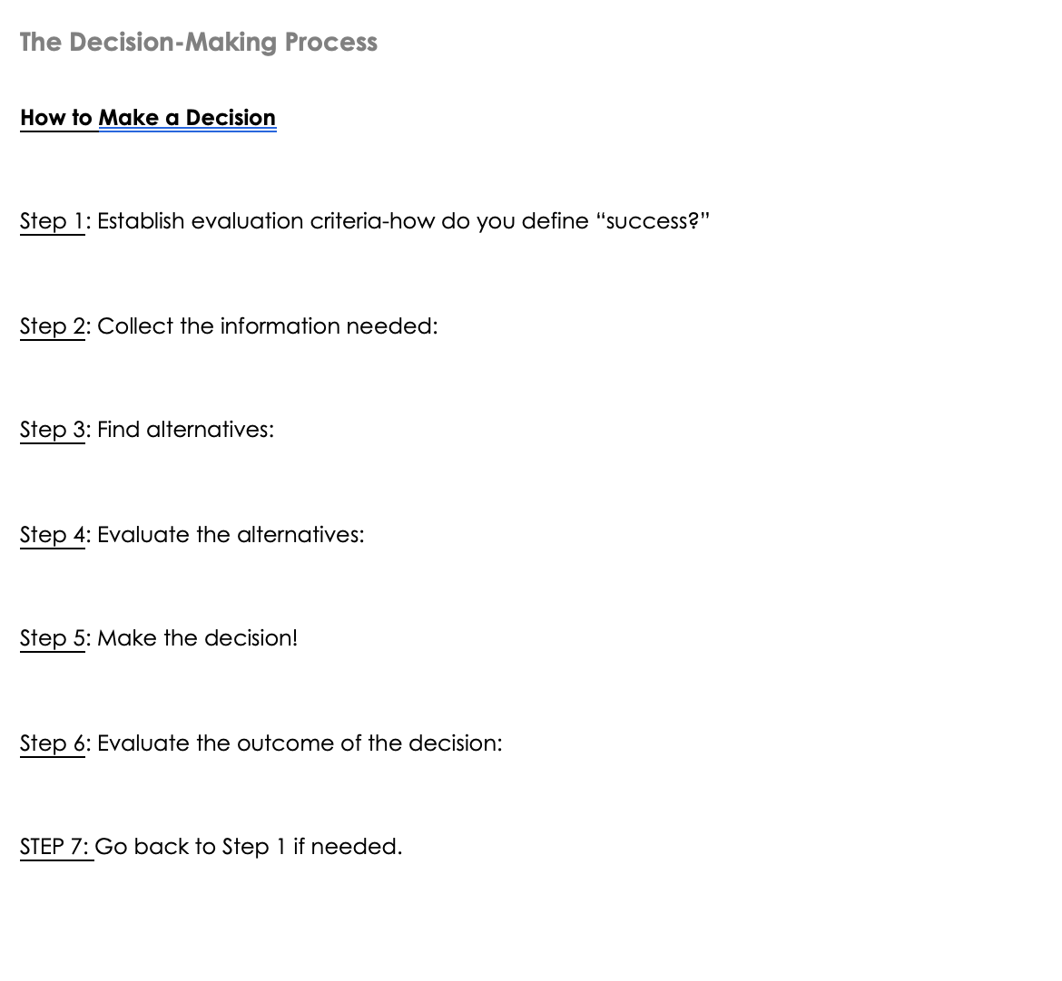

Appendix B – The Decision-Making Process – Facilitator’s version

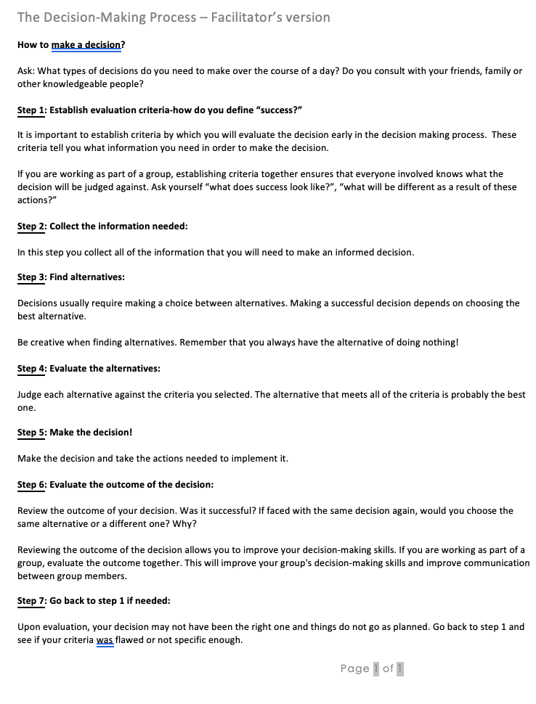

Appendix C – Decision-Making Practice
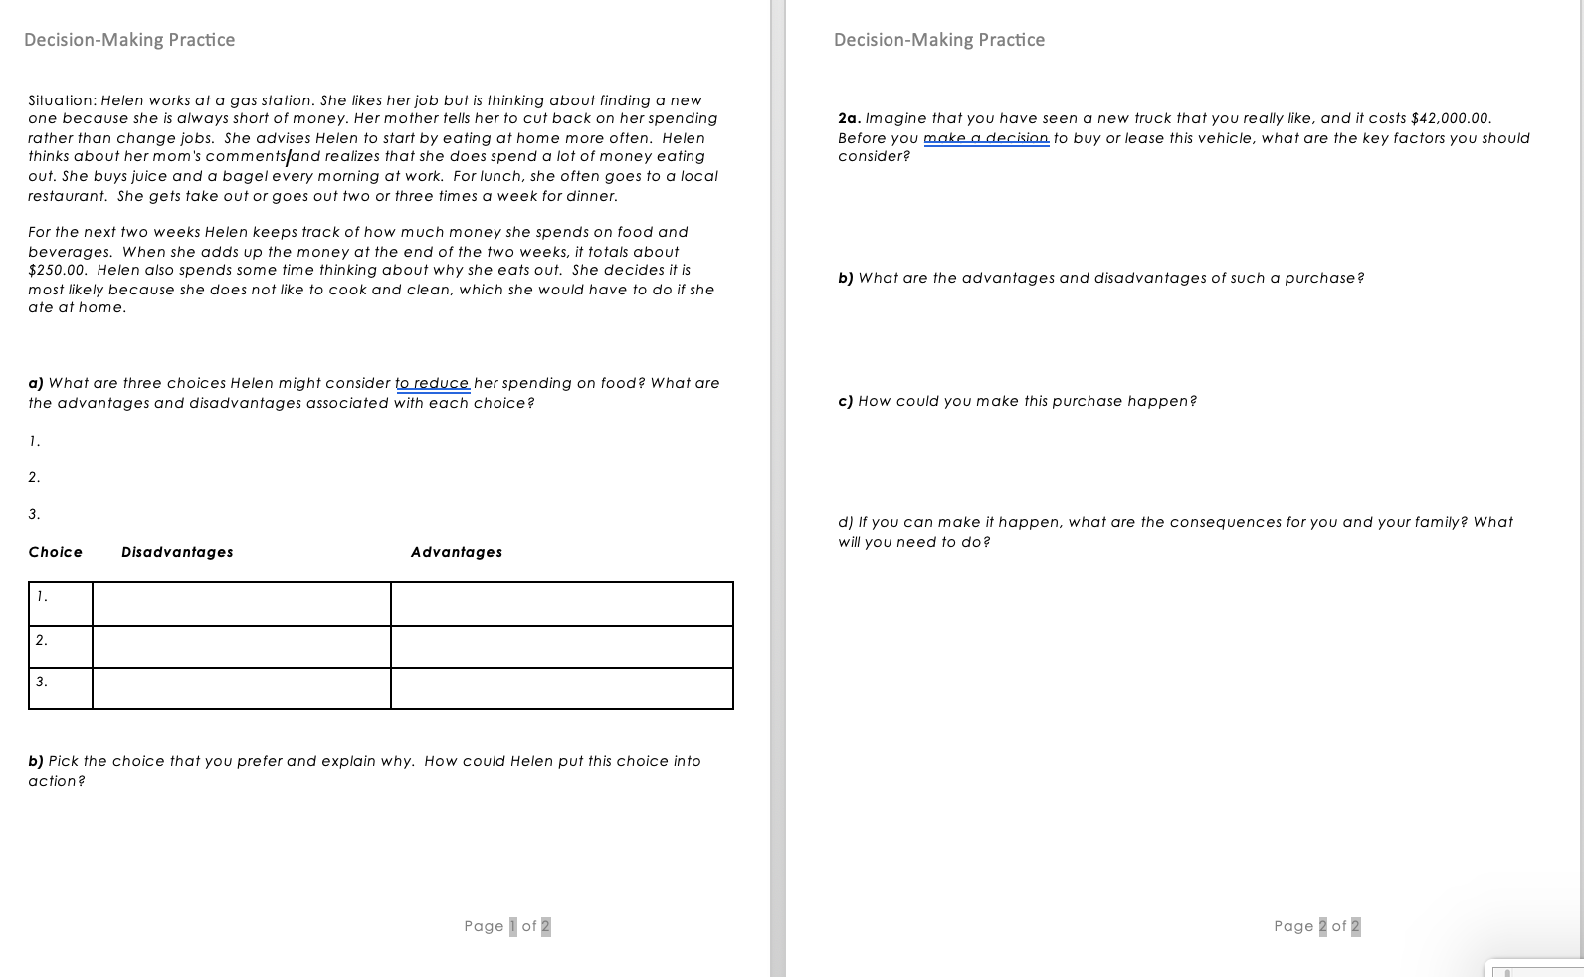
Appendix D – Thinking Self-Assessment

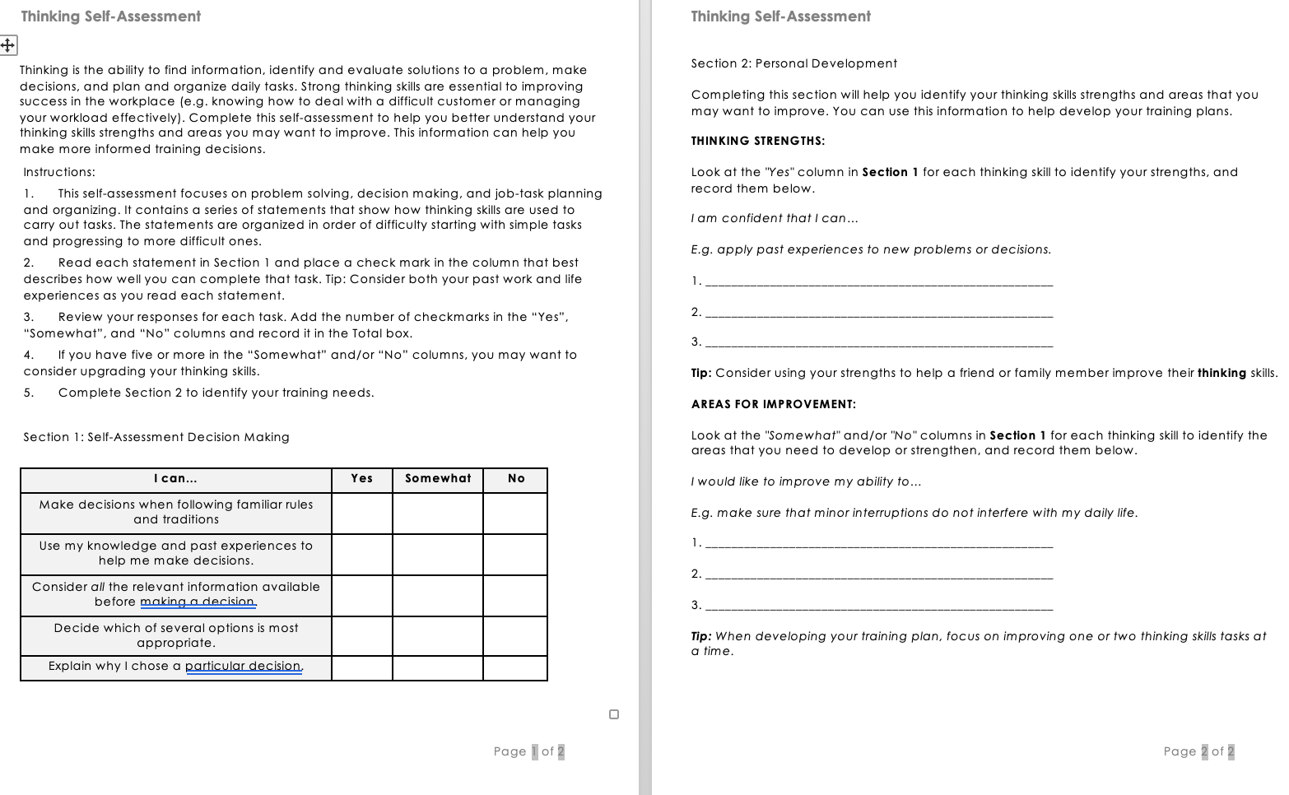

Appendix E – Time-Management Matrix

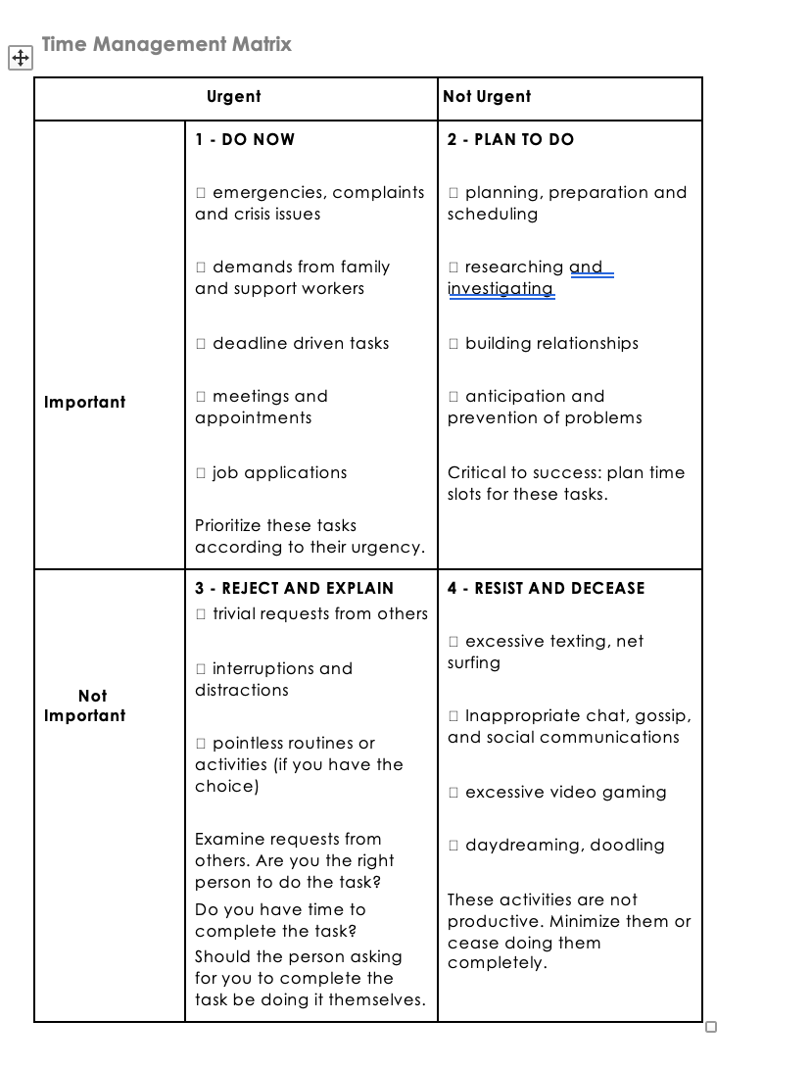

Appendix F - Decision-Making Reflections

