Module- Working with Others – Working Habits Around Safety Mindset

Module Name: Working Habits Around Safety Mindset

Purpose: Increase participant’s awareness that safety is a mindset. A mindset that can have implications for themselves and others, when we are not in the right state of mind.

Logistics: 3 hours

Facilitator: Member of the WEM Facilitation Team

Special Instructions: There is the opportunity to find a few humourist work place safety photos to bring into this session.

Transferability to the Workplace

Learning Objectives

By the end of the session the participants will be able to:
- Explain their personal why for being safe at work.
- Identify behaviours which have a negative and positive impact on our safety mindset.
- Discuss the connection between building a workplace community/team and your approach to safety.
- Discuss the four signs of the right safety mindset.
- Discuss strategies to develop your situational awareness.
- Review everyday events anticipating a potential hazard(s).
- Review workplace situations from a safety mindset.
- Identify 2 ways you can apply the strategies discussed today to your daily life.

Assessment(s):

- MI Assessment completed prior to the program.
- Completion of activities during the module.
- Informal reflection activities within the module.

Program Overview – Lesson Plan

Learning objective: Explain their personal why for being safe at work.

Activity: Your Personal Safety Reason

Prior to the module: Facilitator to fold paper into a name tag holder, however, they will not be used for the participant’s name.

Facilitator to share a story regarding workplace safety and why it is important to them.

Ask the participants to write on the folded paper, the reason safety at work or in life is important to them. Then have each participant share their reason and why they selected it.

Learning objective: Identify behaviours which have a negative and positive impact on our safety mindset.

Put up two flip chart papers, and then split the participants into 2 groups. On one flip chart write positive and the other negative behaviours.

Have the participants create a list of behaviours which have a negative or positive impact on our safety mindset.

Once the groups have their list completed ask them to identify the top 3 ideas on their list. Then have the participants present their ides.

Hand out and review Four Mindsets That Cause Accidents, Appendix A.

Before moving forward ask the participants if they have any questions.

Learning objective: Discuss the connection between building a workplace community/team and your approach to safety.

Share the following situation:

You see the tire on the car is looking a little low. You decide to not tell anyone, your friend/family member takes the car out and ends up being stranded on the highway.

Ask:
A) What do you think happens next?
B) What role did you play in the situation?
C) Would you admit you thought the tire was low?
D) In this situation what impact do you think it could have on your relationship with the other person?
E) How could the outcome of this situation been different?
F) If the situation was different what impact do you think it could have on your relationship with the other person?
Let’s move this conversation to the workplace or our classroom.

Ask: What is the connection between building a workplace community/team and how you approach safety?

Following the conversation, ask the participants if they have had a shift in how they feel regarding the connection to safety and building a community/team?

Learning objective: Discuss the four signs of the right safety mindset.

Activity: Broken Glass - Now What?

Working in their table groups share the following situation:
- You notice there is broken class on your front step what do you do?

Ask each group to share their ideas, then connect it to the concept of a safety mindset.

Note: Safety mindset can be described as follows:
- Aware of your limitations, and when assistance is needed.
- Aware of the signage and labels in the space.
- Behave in a way that respects the safety rules and expectations.
- Wears the protection equipment properly.
- A want to versus a need to attitude.
- Correct something that is out of place, to ensure others are not hurt.
- Aware of their personal mental and physical capabilities at that time.

Hand out, Four Signs of Personnel with the Right Safety Mindset, Appendix B.

Move the participants into 4 groups, then assign them 1 of the 4 signs.

Learning objective: Discuss strategies to develop your situational awareness.

Hand out and review the following strategies to develop/enhance your situational awareness, Appendix C.

Learning objective: Review everyday events anticipating a potential hazard(s).

Working with the participants create a list of everyday activities they take place in, then move the participants into small groups. Assign the small group 2 activities to review from the following lens:

What are potential hazard(s) we need to be aware of.

Hear from each group, then ask the participants if they will approach these daily activities differently now that they have heard the potential hazards. If so how?

Learning objective: Review workplace situations from a safety mindset.

Provide the participants with the following workplace situations.
Note: If the employer has pictures to share, please include them in this activity.

- Broken ladder
- Empty boxes on the floor, not put away.
- Garbage bin over flowing.
- No safety googles on the safety shelf and you need them.
- Water on the floor.
- Needing to talk with the person on the fork lift machine.
- Been asked to use a tool or do a procedure you have never done before.
- You heard from a friend the tool was broken, now a member of your crew has picked it up to use it.
- Showing up late for work.
- Not eating during your lunch, dinner or midnight break.
- Material not put away, rather kept on the floor which is now starting to block up the walk way.

Learning objective: Identify 2 ways you can apply the strategies discussed today to your daily life.

Based on our conversation, share with your partner 2 ways you can apply these strategies in your daily life. Then ask a few participants to share their ideas.

Appendix

Appendix A - Four Mindsets That Cause Accidents

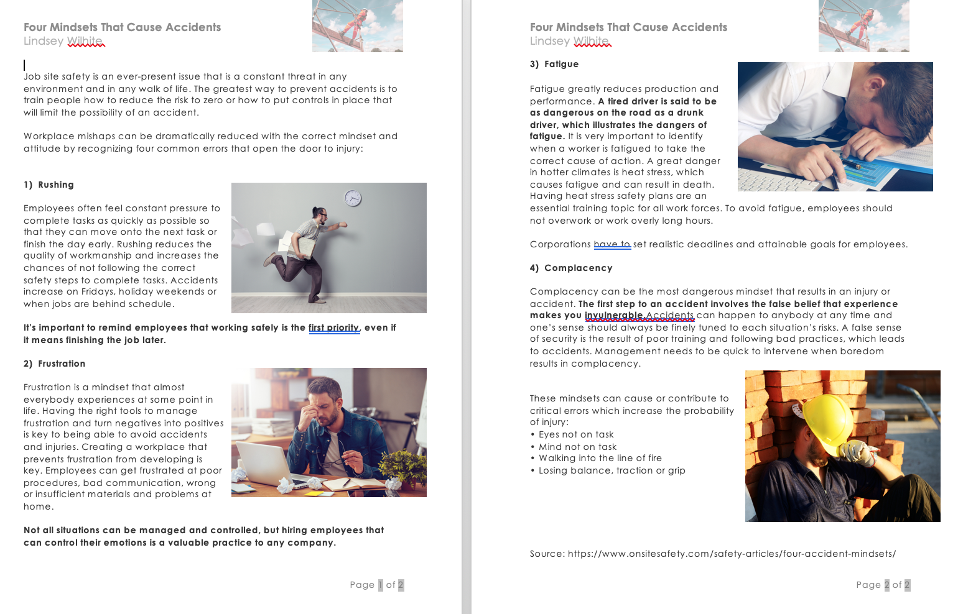

Appendix B - Four Signs of Personnel with the Right Safety Mindset

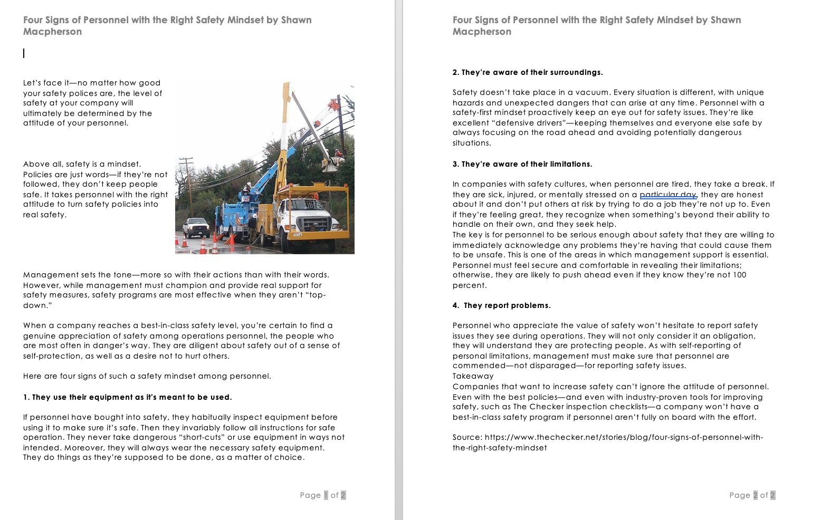

Appendix C – 10 Ways to Build Situational Awareness

