Module- Working with Others – Shift Work Making It Work

Module Name: Shift Work Making It Work

Purpose: To have honest conversations around good strategies to enhance the success of employment, which involves shift work.

Logistics: 2-3 hours

Facilitator: Member of the WEM Facilitation Team

Special Instructions: Conversation will be influenced by the shifts and expectations of the workplace partner(s).

Transferability to the Workplace

Overall the organization would have engaged employees who are ready to work at any time of the day or night.

Learning Objectives

By the end of the session the participants will be able to:

- Identify the benefits of shift work.
- Identify the struggles with shift work.
- Discuss shift work strategies for success.
- Identify 2 ways you can apply the strategies discussed today to your daily life.

Assessment(s):

- MI Assessment completed prior to the program.
- Completion of activities during the module.

Program Overview – Lesson Plan

Note: Assumption shift work material/learning opportunities have been presented to the participations before this module. If not, then an introduction to what is shift work would need to be included.

Learning objective: Identify the benefits of shift work.
Learning objective: Identify the struggles with shift work.

Move the participants into small groups, provide them with flip chart paper and a marker.

On the screen or as a handout show the participants the workplace partner(s) work schedule.

Ask them to identify potential benefits and struggles with shift work. Once they have had time to work through the activity, have the participants go around and read the other groups ideas.

Ask: What did you discover as you were going through that activity?
Ask: What can you see as your greatest challenge with working shift work?
Ask: What can you see as a potential perk/benefit of working shift work?

Learning objective: Discuss shift work strategies for success.

3 things that can have a huge impact on your success are the following things:

- Sleep
- Nutrition
- Support

Work through the 3 handouts found in Appendix A, B and C with the participants.

Learning objective: Identify 2 ways you can apply the strategies discussed today to your daily life.

Based on our conversation, share with your partner 2 ways you can apply these strategies in your daily life. Then ask a few participants to share their ideas.

Appendix

Appendix A – 10 Sleep Tips for Shift Workers

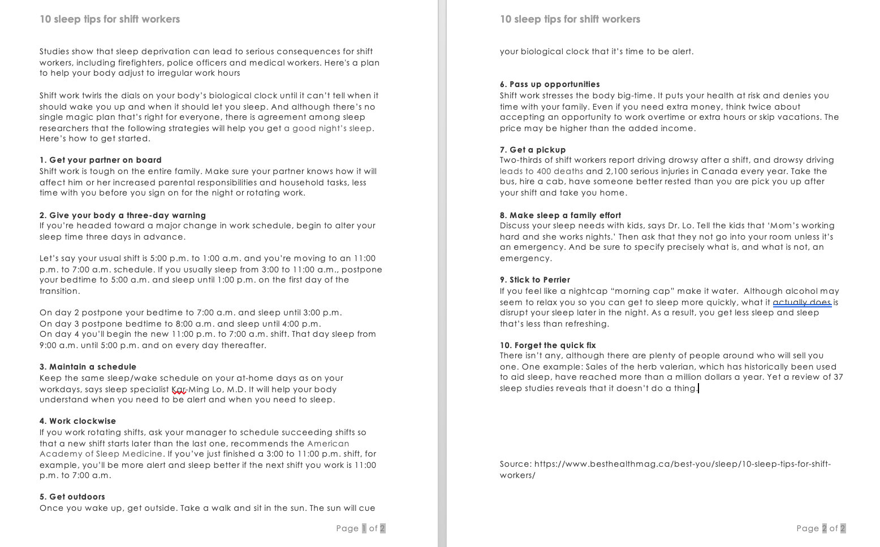

Appendix B – 10 eating Habits for Shift Workers

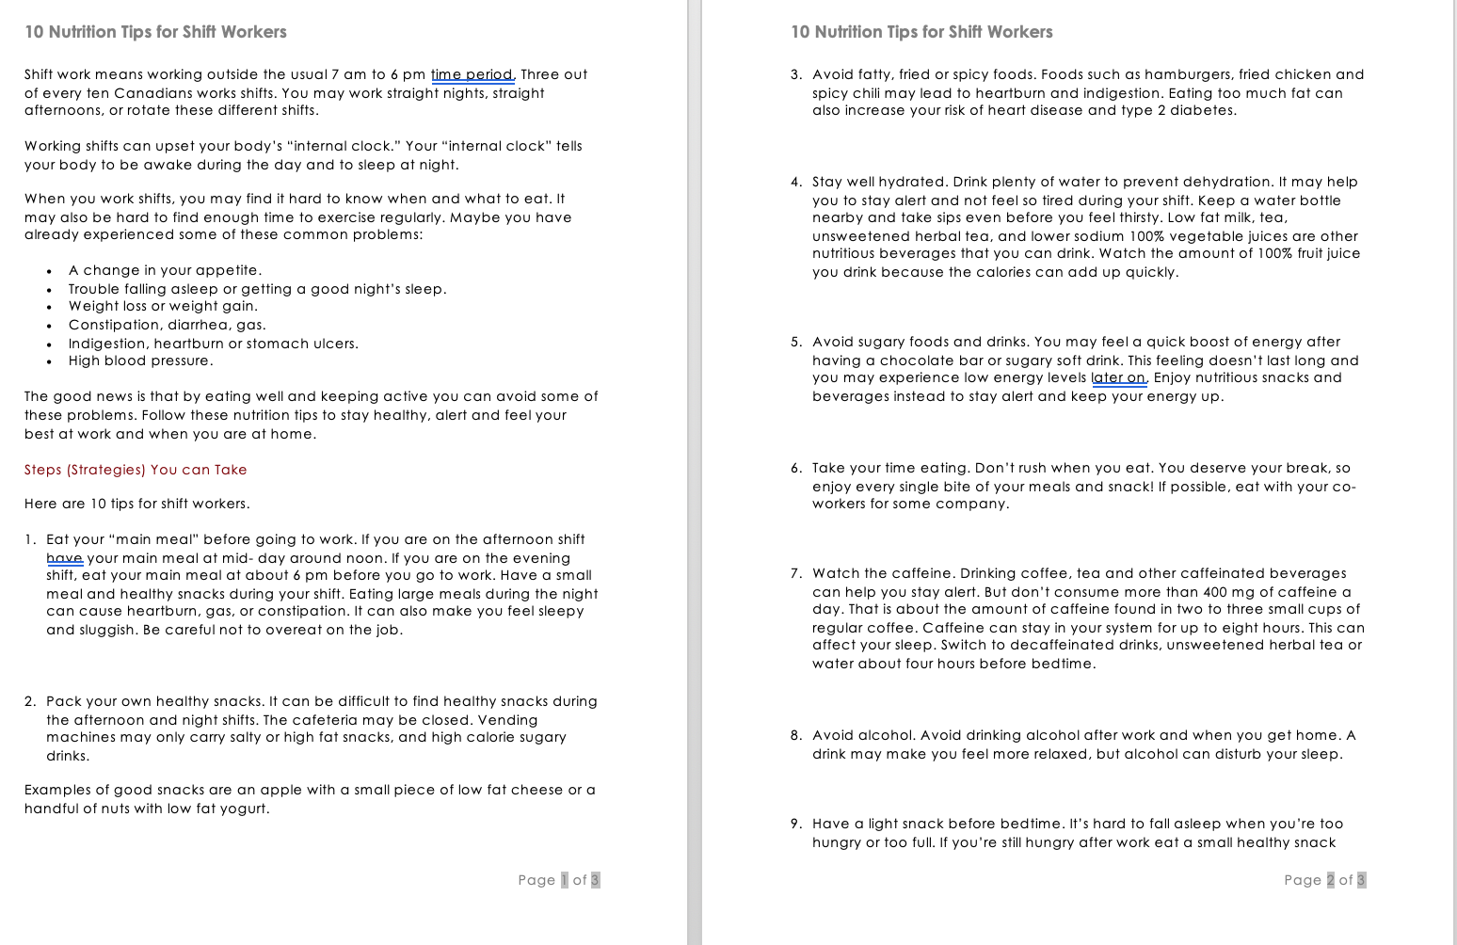



Appendix C – Gaining Support

