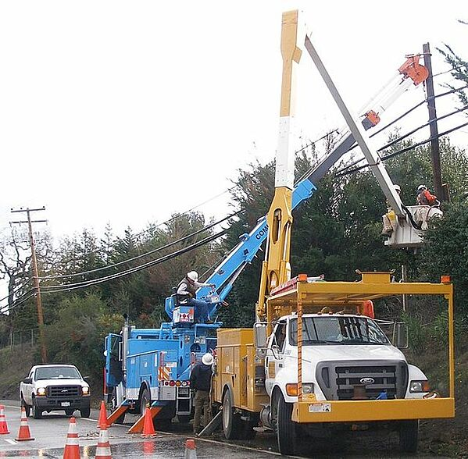
Let’s face it—no matter how good your safety polices are, the level of safety at your company will ultimately be determined by the attitude of your personnel.

Above all, safety is a mindset. Policies are just words—if they’re not followed, they don’t keep people safe. It takes personnel with the right attitude to turn safety policies into real safety.

Management sets the tone—more so with their actions than with their words. However, while management must champion and provide real support for safety measures, safety programs are most effective when they aren’t “top-down.”

When a company reaches a best-in-class safety level, you’re certain to find a genuine appreciation of safety among operations personnel, the people who are most often in danger’s way. They are diligent about safety out of a sense of self-protection, as well as a desire not to hurt others.

Here are four signs of such a safety mindset among personnel.

1. They use their equipment as it’s meant to be used.

If personnel have bought into safety, they habitually inspect equipment before using it to make sure it’s safe. Then they invariably follow all instructions for safe operation. They never take dangerous “short-cuts” or use equipment in ways not intended. Moreover, they will always wear the necessary safety equipment. They do things as they’re supposed to be done, as a matter of choice.

2. They’re aware of their surroundings.

Safety doesn’t take place in a vacuum. Every situation is different, with unique hazards and unexpected dangers that can arise at any time. Personnel with a safety-first mindset proactively keep an eye out for safety issues. They’re like excellent “defensive drivers”—keeping themselves and everyone else safe by always focusing on the road ahead and avoiding potentially dangerous situations.

3. They’re aware of their limitations.

In companies with safety cultures, when personnel are tired, they take a break. If they are sick, injured, or mentally stressed on a particular day, they are honest about it and don’t put others at risk by trying to do a job they’re not up to. Even if they’re feeling great, they recognize when something’s beyond their ability to handle on their own, and they seek help.
The key is for personnel to be serious enough about safety that they are willing to immediately acknowledge any problems they’re having that could cause them to be unsafe. This is one of the areas in which management support is essential. Personnel must feel secure and comfortable in revealing their limitations; otherwise, they are likely to push ahead even if they know they’re not 100 percent.

4. They report problems.

Personnel who appreciate the value of safety won’t hesitate to report safety issues they see during operations. They will not only consider it an obligation, they will understand they are protecting people. As with self-reporting of personal limitations, management must make sure that personnel are commended—not disparaged—for reporting safety issues.
Takeaway
Companies that want to increase safety can’t ignore the attitude of personnel. Even with the best policies—and even with industry-proven tools for improving safety, such as The Checker inspection checklists—a company won’t have a best-in-class safety program if personnel aren’t fully on board with the effort.

Source: https://www.thechecker.net/stories/blog/four-signs-of-personnel-with-the-right-safety-mindset

