

CHANGE READINESS
PARTICIPANT WORKBOOK
What is Change?

Learning Objectives
- Define Change.
- Outline benefits of Change.
- Describe attitude.
- Identify our attitude towards life.
- Discuss how the book “Who moved my cheese” relates to our attitude towards life and work.
- Discuss The Seven Traits of Change Readiness.
- Discuss Types of Change.
- Review Stages of Change via The Change and Transition Curve Model.
- Brainstorm challenges change brings and discuss adapting/coping strategies.

Activity: Draw your perspective of change

What is change?

Perspectives on Change

I Believe that…. | Yes | Somewhat | No

1. Change is inevitable

2. Change is ongoing

3. Change is mostly good

4. Change is something I have no control over

5. Change is something that happens to me

6. Change is something I choose to actively participate in

7. Change is always hard

8. Change must be managed to be effective

9. A person can never prepare enough for change.

10. Change always presents opportunities

Notes:

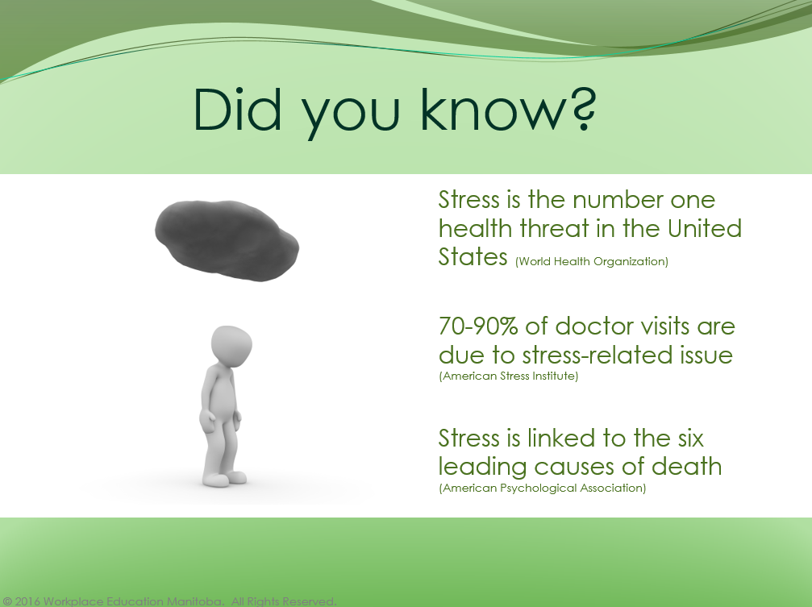

List the positive impacts of change/stress? | What are the negative impacts of change/stress?

Positive Impacts of Stress
- Causes the human brain to use more of its capabilities.
- Improves memory and intelligence.
- Increases productivity.
- Speeds recovery from things like knee surgery.
- Creates greater mental toughness.
- Helps build deeper relationships.
- Heightens awareness.
- Fosters new perspectives.
- Provides a sense of mastery.
- Builds a greater appreciation for life.
- Gives people a heightened sense of meaning.
- Strengthens priorities.

For more information on the Harvard study, please go to: (http://blogs.hbr.org/cs/2011/02/make_stress_work_for_you.html)

Notes:

Attitude

Describe the word attitude:

Attitude Assessment by: John Mehrmann

Rate the following ten statements to conduct a personal attitude assessment. Rate the Statements using the following scale:
0 = Strongly Disagree, 1 = Disagree, 2 = Neutral, 3 = Agree, 4 = Strongly Agree
Rate each of the following statements on a scale of zero to four based on the extent with which you agree, or disagree, with the statement.
Ask Yourself:
- In uncertain times, I would expect the best results

- It’s easy for me to relax

- If something can go wrong with me, it probably will

- I am always optimistic about my future

- I really enjoy my friends

- It’s important for me to keep busy

- I hardly ever expect things to go my way

- I don’t get upset very easily

- I rarely count on good things happening to me

- Overall, I expect more good things to happen to me than bad

Score Your Answers
Step One: Put a line through your rating response for questions 2, 5, 6, and 8. Ignore these random questions because they have nothing to do with your score.
Step Two: Reverse your rating response for questions 3, 7, and 9. (0=4, 1=3, 2=2, 3=1, 4=0)
Step Three: Add up your rating responses for questions 1, 3, 4, 7, 9, and 10. (Remember to use the reverse rating numbers for questions 3, 7, and 9.)
The sum of your rating responses to questions 1, 3, 4, 7, 9, and 10 is your total real score.

How to interpret your score:
0-4 No news is good news, and for you there is no such thing as good news. So, stop reading the news. Go out and buy some good books instead.
4-8 People say that every cloud has a silver lining, and for you it is a silver lightning bolt that you are always dodging. Don't bother with the parade; you need to get out of the rain.
8-12 Your glass is perpetually half empty. You should stay near people who have faucets.
12-16 You tend to be optimistic. No matter how much you sip from it, your glass is always half full. It's time to satisfy your thirst and drink deeply.
16-20 The harder you work, the luckier you get. Get busy and reap the rewards!
20-24 Your momentum compels you forward, and motivates those around you. Remember to look both ways before crossing the street.

Score Less than Eight
Individuals with a score below eight may find it difficult to participate in opportunities that are perceived risky. Unfortunately, these individuals may also feel that almost all situations are risky, and therefore simply avoid them altogether. This attitude might manifest as a lack of confidence, implying an underlying lack of self-respect, or lack of self-awareness. A lack of self-awareness simply means that the individual does not fully recognize his or her personal strengths, talents, attributes, real value, and inherent ability to overcome anticipated obstacles.
Individuals with scores below eight may also find it difficult to engage in personal or professional relationships. After all, relationships also have a certain amount of risk. This reluctance may manifest as either a limited number of relationships, or a limited depth of relationships, or both. Quite often, this is the result of bad experiences in previous relationships that create caution, and a desire to avoid repeating the same mistakes. Unfortunately, focusing attention on undesired circumstances or interactions in a relationship is almost guaranteed to make them occur again. Anticipating or looking for unwanted behaviour will yield the desired results, you will eventually find it. Watching for unwanted activity in others will most certainly create the perception that it is occurring. Even more alarming, the other individual is typically unaware of the specific attributes or activities that you may find so disturbing, and therefore be completely unable to do anything to positively allay these concerns. If the other individual tries to act in a different manner to correct the perception, then the situation may continue to deteriorate.
The only way to end this continuous cycle of disappointment is to communicate openly, honestly, and clearly. While the communication may not be immediately effective every time, it will be effective over time with those individuals who share a commitment to participate in the relationship with you. This enables you to identify the other people who are committed to relationships with you, and simultaneously improves those relationships. Overcome the reluctance to communicate, and you will overcome the barriers to identifying and participating in the right relationships.

Score Less than Twelve
Individuals with a score less than twelve have a tendency to focus primarily on disappointments and perceived failures with much greater attention than achievements. Stop doing that. Analyzing defeat for the purpose of identifying areas that need improvement is a commonly accepted practice. The intent of analyzing a mistake or failure is to avoid repeating them. Once the areas of improvement are defined, and then focus on how you can utilize your experience going forward. Reach out to other individuals for motivation, optimism, and guidance. Don't be embarrassed to ask for advice or to share your experience. Sharing your experience is a gift if it helps someone else avoid a similar mistake. Asking for advice or suggestions is regarded as a compliment, and will help to build your relationship with a desired mentor or coach. In other words, when you ask for suggestions of assistance, both sides benefit.
Regardless of your score, there will be obstacles, and there will be challenges in life. The way that you respond to these obstacles, the way that you respond to subsequent victories, and the way that you handle occasional disappointments define you. If your score is less than twelve, begin by challenging yourself to take small risks. Stretch out to try new experiences, or test the limits of your capabilities. Make a conscious effort to spend more time analyzing your successes, your victories, and the things that you have accomplished. Gain a deeper understanding for the reasons that you win, rather than the reasons that you think that you have lost. Surround yourself with people who encourage you, legitimately care for you, and who celebrate your successes.
Score Greater than Twelve
Congratulations! You have the vision to see opportunity, and the realization that it can be achieved. You are optimistic, enthusiastic, and ready to reach new personal heights. The higher the score, the more confidence that you have in yourself. What should you do with this confidence? You should continue to challenge yourself to achieve more than you expected possible. Take a few chances on yourself, and you will rarely be disappointed. Even a temporary set-up is never a failure, but merely a learning experience to apply to the new approach that you take to overcome your obstacles. Obstacles are merely challenges and puzzles to be solved, and you know that you can solve them with enough time and effort.

Temper the attention to your own perseverance and goals with a balance of attention to those individuals who can also benefit from your attitude. Look for the other individuals who may have assessed themselves with a score of less than twelve, and share some of your confidence with them. You share your confidence by helping them to find the confidence within themselves. Take a little time to point out their successes, their talents, and the value that they bring to others. Share your appreciation for what they do to contribute to you, and to your success. Nurture the capabilities and aspirations of those people who perceive their glass as half empty, but letting them know how much they mean to you, and how much they contribute to others. As you help those people to accomplish more, the results will naturally benefit both of you.
Score Greater than Twenty
If your score is over twenty, you are extremely confident in yourself and ready to tackle any project. No task is too great for you. You can overcome barriers, create solutions, and inspire the people around you. Everything will work out eventually, if not sooner. Life has many delicious experiences, and you have likely tasted many of them. By most standards, you truly live a charmed life.
However, it is also very possible that you may have occasional conflicts with other individuals who have a score over twelve. In other words, your own enthusiasm knows almost no bounds, but it may also have very little appreciation or understanding for enthusiasm or optimism that is founded in ideas that are different from your own. This can result in sometimes severe conflicts or miscommunications. While you have limitless patience for individuals who are struggling, patiently sharing your time and energy to mentor the individuals who express a need for your help, the same feelings may not apply for those who have optimism that is different from your own. While you derive tremendous pleasure in sharing your own positive attitude with others, you may be handicapped in experiencing excitement that you do not create yourself. Therefore, your biggest challenge is to learn to embrace the accomplishments of other motivated individuals. Your own accomplishments will expand dramatically when you learn to enthusiastically embrace the achievements of your peers with the positive attitude.
Furthermore, if you have a score over twenty, balance your optimism with a robust gathering of trusted advocates and advisors. It will be easier to overcome some obstacles, and avoid unnecessary failures, by accepting guidance from individuals who have extensive experiences of their own.
Share or score those around you;
Once you have had some fun with your own personal assessment, think about how your friends, colleagues, clients, or peers may score themselves. Share the ten quick statements with coworkers, friends, or family members and share results to see how you relate to one another.
Source: The Two Minute Attitude Assessment is based on a quiz originally designed by M.F. Scheier and C.S. Carver.
______________________________________________________
John Mehrmann is author of The Trusted Advocate: Accelerate Success with Authenticity and Integrity, the fundamental guide to achieve extraordinary sales and sustain loyal customers. John Mehrmann is a freelance writer and President of Executive Blueprints Inc., an organization devoted to improving business practices and developing human capital. www.ExecutiveBlueprints.com provides resource materials for trainers, sample Case Studies, and educational articles. www.InstituteforAdvancedLeadership.com provides self-paced tutorials for personal development and tools for trainers. Presentation materials, reference guides and exercises are available for continuous development.

Attitude Assessment

A) What did you learn about yourself?
B) Following this assessment what are you thinking about?

Who Moved My Cheese?

Watch the video: Who moved my cheese?

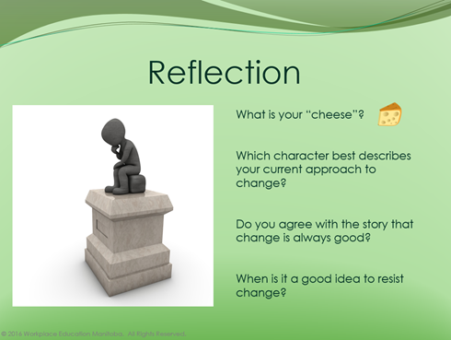
Notes:

The Seven Traits of Change Readiness
The traits measured in this assessment are especially important in dealing with the stress of change. Nobody is perfectly suited to dealing with change. Understanding your own personality when faced with change will help you guard against stress where you’re vulnerable by relying on your strengths.

The scale you’ve just taken measures the following traits:

Resourcefulness—being effective at making the most of any situation and utilizing whatever resources are available to develop plans and contingencies. Seeing more than one way to achieve goals and looking in less obvious places to find help. When people low in Resourcefulness encounter obstacles, they get stuck and dig in their heels. Very high scorers (over 26) might overlook obvious solutions and create more work than is necessary.

Optimism—the pessimist observes only problems and obstacles while the optimist recognizes opportunities and possibilities. Optimism can’t be taught; it must be caught. You can get it by hanging around the right people. Optimists tend to be more enthusiastic and positive about change. Very high optimism scorers (over 26) may lack critical-thinking skills.

Adventurousness—the inclination to take risks and the desire to pursue the unknown, to walk the path less taken. Since change always involves both risk and the unknown, Adventurous people usually perform well during organizational shake-ups. But very high scorers (over 26) may indicate a tendency toward recklessness.

Drive—combines physical energy and mental desire to create passion. It’s the fuel that maximizes all the other traits. If you have drive, nothing appears impossible. If you don’t, change is exhausting.

Adaptability—flexibility and resilience. Flexibility involves ease of shifting expectations.
Resilience is the capacity to rebound from adversity quickly with a minimum of trauma.
Scoring too high (over 26) indicates a lack of commitment or stick-to-it-ness.

Confidence—if optimism is the view that a situation will work out, confidence is the belief in your own ability to handle it. There is a direct correlation between levels of confidence and receptivity to change. If people feel confident in their ability to handle a new task, they’ll be more receptive to it and more positive about it. Scores above 26, however, may indicate a cocky, know-it-all attitude and a lack of receptivity to feedback.

Tolerance for Ambiguity—change spawns uncertainty. No matter how carefully you plan there are always some elements of indefiniteness. Without a healthy tolerance for ambiguity, change is not only uncomfortable, it’s downright scary. But too much tolerance can also get you in trouble. You may have difficulty finishing tasks and making decisions.

You’ll probably find you have higher scores on some traits and lower scores on others.
This is typical of most profiles and indicates that some of your Change Readiness traits are more developed than others.

Note page:

Types of Change

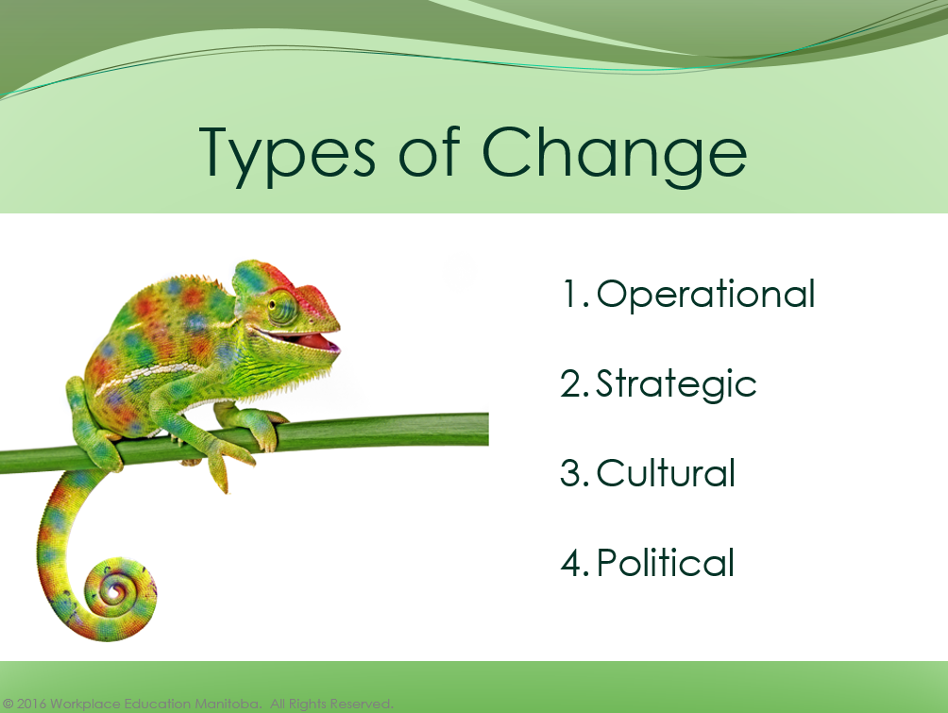
Change can mean something different depending on the organization. Lorenzi and Riley (2000) identify four types of changes, with the definite possibility of overlap among them, these are:
- Operational changes, affecting the way the ongoing operations of the business are conducted.

- Strategic changes, that occur in the strategic business direction

- Cultural changes, which affect the basic organizational philosophies by which the business is conducted

- Political changes, occurring in staffing primarily for political reasons of various types.

Notes:

The Change and Transition Curve Model

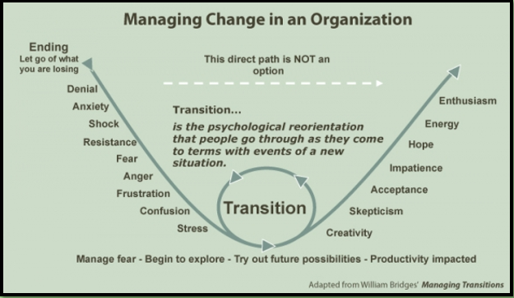

Notes:

Benefits and Challenges of Change Worksheet

Benefits Change Brings

To Individual

To Team

To Organization

Challenges Change Brings

To Individual

To Team

To Organization

Additional Activities

Personal Change Readiness Survey
(Taken from Sacred Cows Make the Best Burgers by Robert Kriegel and David Brandt)
- Focus on your performance at work.
- Answer each question honestly.
- Circle the number that most accurately describes your beliefs and your behaviors as they actually are, not as you would like them to be or think they should be.

CHARACTERISTIC OR BELIEF | LESS LIKE ME |  |  | MORE LIKE ME
- I prefer the familiar to the unknown. | 1 | 2 | 3 | 4 | 5 | 6
- I rarely second-guess myself. | 1 | 2 | 3 | 4 | 5 | 6
- I am unlikely to change plans once they are set. | 1 | 2 | 3 | 4 | 5 | 6
- I can’t wait for the day to get started. | 1 | 2 | 3 | 4 | 5 | 6
- I believe in not getting your hopes up too high. | 1 | 2 | 3 | 4 | 5 | 6
- If something is broken, I’ll find a way to fix it. | 1 | 2 | 3 | 4 | 5 | 6
- I get impatient when there are not clear answers. | 1 | 2 | 3 | 4 | 5 | 6
- I’m inclined to establish routines and stay with them | 1 | 2 | 3 | 4 | 5 | 6
- I can make any situation work for me. | 1 | 2 | 3 | 4 | 5 | 6
- When something important doesn’t work out, it takes me time to adjust. | 1 | 2 | 3 | 4 | 5 | 6
- I have a hard time relaxing and doing nothing. | 1 | 2 | 3 | 4 | 5 | 6
- I believe if something can go wrong, it will. | 1 | 2 | 3 | 4 | 5 | 6
- When I get stuck, I’m inclined to improvise solutions. | 1 | 2 | 3 | 4 | 5 | 6
- I get frustrated when I can’t get a grip on something. | 1 | 2 | 3 | 4 | 5 | 6
- I prefer work that is familiar and within my comfort zone. | 1 | 2 | 3 | 4 | 5 | 6
- I can handle anything that comes along. | 1 | 2 | 3 | 4 | 5 | 6
- Once I’ve made up my mind, I don’t easily change it. | 1 | 2 | 3 | 4 | 5 | 6
- I push myself to the max. | 1 | 2 | 3 | 4 | 5 | 6
- My tendency is to focus on what can go wrong. | 1 | 2 | 3 | 4 | 5 | 6
- When people need solutions, they come to me. | 1 | 2 | 3 | 4 | 5 | 6
- When an issue is unclear, my impulse is to clarify right away. | 1 | 2 | 3 | 4 | 5 | 6
- It pays to stay with the tried and true. | 1 | 2 | 3 | 4 | 5 | 6
- I focus on my strengths, not my weaknesses. | 1 | 2 | 3 | 4 | 5 | 6
- I find it hard to give up on something, even if it’s not working out. | 1 | 2 | 3 | 4 | 5 | 6
- I’m restless and full of energy. | 1 | 2 | 3 | 4 | 5 | 6
- I believe things rarely work out the way you want them to. | 1 | 2 | 3 | 4 | 5 | 6
- My strength is to find ways around obstacles. | 1 | 2 | 3 | 4 | 5 | 6
- I can’t stand to leave things unfinished. | 1 | 2 | 3 | 4 | 5 | 6
- I prefer the main highway to the back road. | 1 | 2 | 3 | 4 | 5 | 6
- My faith in my abilities is unshakeable. | 1 | 2 | 3 | 4 | 5 | 6
- I believe, when in Rome, do as the Romans do. | 1 | 2 | 3 | 4 | 5 | 6
- I’m a vigorous and passionate person. | 1 | 2 | 3 | 4 | 5 | 6
- I’m more likely to see problems than opportunities. | 1 | 2 | 3 | 4 | 5 | 6
- I look in unusual places to find solutions. | 1 | 2 | 3 | 4 | 5 | 6
- I don’t perform well when there are vague expectations & goals. | 1 | 2 | 3 | 4 | 5 | 6

Change Readiness Scoring and Interpretation

Drive |  | Resourcefulness |  | Optimism |  | Adventurousness |  | Adaptability |  | Confidence |  | Tolerance for  Ambiguity
Q # | score | Q # | score | Q # | score | Q # | score | Q # | score | Q # | score | Q # | score
4 |  | 6 |  | 5 |  | 1 |  | 3 |  | 2 |  | 7
11 |  | 13 |  | 12 |  | 8 |  | 10 |  | 9 |  | 14
18 |  | 20 |  | 19 |  | 15 |  | 17 |  | 16 |  | 21
25 |  | 27 |  | 26 |  | 22 |  | 24 |  | 23 |  | 28
32 |  | 34 |  | 33 |  | 29 |  | 31 |  | 30 |  | 35
Sub |  |  |  |  | - |  | - |  | - |  |  |  | -
 |  |  |  |  | 35 |  | 35 |  | 35 |  |  |  | 35
Total

DRIVE: Add up questions 4, 11, 18, 25, and 32. This is the total score.
RESOURCEFULNESS: Add up questions 6, 13, 20, 27, and 34. This is the total score.
OPTIMISM: Add up questions 5, 12, 19, 26 and 33 – then subtract that subtotal from 35 to get your total score.
ADVENTUROUSNESS: Add up questions 1, 8, 15, 22 and 29 – then subtract that subtotal from 35 to get your total score.
ADAPTABILITY: Add up questions 3, 10, 17, 24, and 31 – then subtract that subtotal from 35 to get your total score.
CONFIDENCE: Add up questions 2, 9, 16, 23, and 30. This is the total score.
TOLERANCE FOR AMBIGUITY: Add up questions 7, 14, 21, 28, and 35 – then subtract that subtotal from 35 to get your total score.

Plot Your Scores:

CHANGE CHARACTERISTICS | Below 22 Points | 22-26 Points | Above 26 Points
DRIVE
RESOURCEFULNESS
OPTIMISM
ADVENTUROUSNESS
ADAPTABILITY
CONFIDENCE
TOLERANCE FOR AMBIGUITY

Activity: Reflection Time
What are your strengths?
______________________________________________________________________________________________________________________________________________________________________________________________________________________________________________________________________________________________________________________________________________________________________________________________________

Where are their opportunities for personal growth? What makes this important to you?
______________________________________________________________________________________________________________________________________________________________________________________________________________________________________________________________________________________________________________________________________________________________________________________________________

Are you surprised by any of your scores?
______________________________________________________________________________________________________________________________________________________________________________________________________________________________________________________________________________________________________________________________________________________________________________________________________

Learner Tip Sheet – Managing Stress

"Stress is an inevitable part of work and life, but the effect of stress upon us is far from inevitable," says Shawn Achor, an expert in positive psychology and the founder of Good Think, Inc. Both Achor and Menkes agree that altering your approach to stress can yield positive effects. "Stress can be good or bad depending on how you use it," says Achor. In fact, how you manage pressures can distinguish you as a leader and give you a career advantage.

Here are five principles to follow.

1. Recognize worry for what it is
"When you hear about stress being unhealthy it is so often because people aren't getting to a place where they are seeing worry for what it is: a feeling," says Menkes. The heightened reaction — tension in the body, heart racing — is an indicator of how much you care about the task you are about to do. In fact, according to Menkes, how much stress you feel is directly correlated to the importance of the activity. "If it didn't matter, you wouldn't worry," he says. Once you understand worry as an indicator rather than a symptom of dysfunction or a cause for panic, you can react to it more rationally. Plus, remember that stress is not unending. "Feelings by definition are fleeting. They feel like they will be eternal but just give it five minutes," says Menkes.

2. Then, reframe the stress
Once you've recognized what worry is, you then need to adjust your mindset. Achor's research shows that how you view stress determines its effect on you. "Our brains work much better at positive than at negative, neutral, or stressed," he says. When you are negative and worried, your brain goes into "fight or flight" mode, which limits your ability to think. If you are positive and concerned, then your brain turns to "broaden and build" thinking which allows you to process more possibilities. Which direction you go in is up to you. "When people have a stress in their life, they can attempt to see it as a challenge, instead of a threat," says Achor. This mental shift will allow the feeling to be activating rather than paralyzing.

3. Focus on what you can control
One of the most positive things you can do when faced with worry or anxiety is to remember what you can affect and what you can't. Far too many people spend time feeling bad about things they simply can't change. In Achor's book, The Happiness Advantage, he outlines an exercise he calls the Island Experiment. He suggests you write out a list of stresses and put them into two circles, "islands." One island holds the things you can control. The other is for the things you can't. Ignore that second island and choose a single concrete action to take in the first. This will begin to solve the stress and move you toward your goal.

4. Create a network of support
Knowing that you have somebody to turn to can help a lot. "It's important to have that outlet so you know you can freak the heck out of if you need to," says Menkes. You may not use this option, but it can be comforting to know it's there. Build supportive relationships when you're not stressed. Menkes encourages you to "put in the effort and build the emotional deposit" so you can cash it in when and if required. The company you keep also makes a difference. "Surround yourself with people who do not complain or ruminate upon things they can't change," says Achor.

5. Get some stress-handling experience
According to Menkes, the best way to learn to handle stress is through practice. "If the body is not used to stress and you experience it, you'll panic and it becomes a vicious cycle that needs to be broken," says Menkes. He often sees this in younger people: "They have more intense reactivity than older people. It's not only a function of hormones but it's a function of experience." Don't wait for a dire situation to try out these techniques. "Think about ways you can put yourself in non-game-changing, but pressured, situations. Pressure and fear are good because it means you are stretching," says Menkes. For example, if public speaking is nerve-wracking for you, he suggests you sign up for Toastmasters and try out your skills in a contained setting. Set up experiments in which you feel stress, but can manage it.

Principles to Remember
Do:
- Think of stress as an indicator that you care about something, rather than a cause for panic
- Focus on the task, rather than the emotion
- Build relationships so that you have people to turn to in times of stress
Don't:
- Assume your stress is going to last forever
- Worry about things that are out of your control
- Spend time with people who are negative

(Source: http://blogs.hbr.org/cs/2011/02/make_stress_work_for_you.html )

