

Individual Learning

Overview:

This session explored Peter Senge’s 5 disciplines. It helps participants connect continuous learning skills. It introduces the concept of self-directed learning.

Learning Objectives:
- Explore a learning organization
- Discuss
  - Self-directed learning
  - The five (5) principles of Peter Senge
- Explain personal mastery
- Explain the role of
  - Personal mastery
  - Mental Models
  - Shared vision
  - Team learning
  - Systems thinking
- Create a personal vision statement

Acronyms:
- SDL - Self-directed learning

Resources:
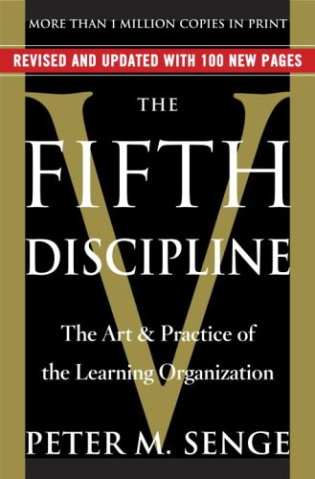
- Peter Senge Book – The Fifth Discipline

- http://infed.org/mobi/peter-senge-and-the-learning-organization/#_The_learning_organization

Explore a learning organization
Learning opportunities provided to employee are:

Definition of a learning organization according to Peter Senge.
“Organizations where people continually expand their capacity to create the results they truly desire, where new and expansive patterns of thinking are nurtured, where collective aspiration is set free, and where people are continually learning to see the whole together.”

Source: http://infed.org/mobi/peter-senge-and-the-learning-organization/

Reflection

Why do you need to continue to learn?

What’s in it for your organization?

What’s in it for you?

Five (5) Learning Obstacles which limit success

- Lack of big picture
- The tough get going
- Short term goals
- Slow reaction
- Over reliance on experience learning

Source: http://trainingstation.walkme.com/5-organizational-learning-disabilities-which-can-limit-success/

Discuss self-directed learning (SDL)

Self-directed learning definition by Malcolm Knowles

“In its broadest meaning, ’self-directed learning’ describes a process by which individuals take the initiative, without the assistance of others, in diagnosing their learning needs, formulating learning goals, identifying human and material resources for learning, choosing and implementing appropriate learning strategies, and evaluating learning outcomes.”

Of primary concern in this definition of SDL is the fact the learner takes 1) the initiative to pursue a learning experience, and 2) the responsibility for completing their learning. Once the initiative is taken, the learner assumes complete responsibility and accountability for defining the learning experience and following it through to its conclusion. This does not preclude input from others, but the final decision is the learner’s. Self-direction does not mean the learner learns alone or in isolation. While that may be the case in any given learning situation, the critical factor here, again, is the fact the learner is driving the total learning experience, beginning with recognizing a need to learn.

Source: http://www.selfdirectedlearning.org/what-is-self-directed-learning

How do we encourage and engage our employees to want to learn new things in the workplace?

Discuss the five (5) disciplines of Peter Senge

For Peter Senge, real learning gets to the heart of what it is to be human. We become able to re-create ourselves. This applies to both individuals and organizations. Thus, for a “learning organization it is not enough to survive. ”Survival learning” or what is more often termed “adaptive learning” is important – indeed it is necessary. But for a learning organization, “adaptive learning” must be joined by “generative learning”, learning that enhances our capacity to create.”

The dimension that distinguishes learning from more traditional organizations is the mastery of certain basic disciplines or ‘component technologies’. The five (5) disciplines that Peter Senge identifies are said to be converging to innovate learning organizations. They are:

- Systems thinking
- Personal mastery
- Mental models
- Building shared vision
- Team learning
Source: http://infed.org/mobi/peter-senge-and-the-learning-organization/
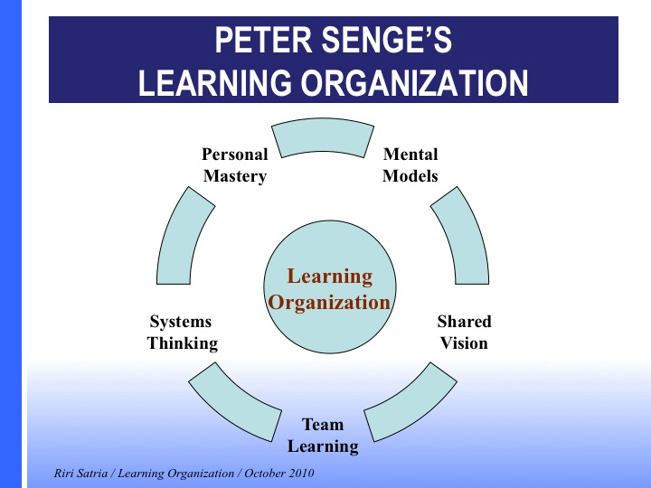

Discipline
Systems thinking | Systems thinking [is] a way of thinking about, and a language for describing and understanding, the forces and interrelationships that shape the behaviour of systems. This discipline helps us to see how to change systems more effectively, and to act more in tune with the natural processes of the natural and economic world.
Personal mastery | Personal mastery is the discipline of continually clarifying and deepening our personal vision, of focusing our energies, of developing patience, and of seeing reality objectively.  In other words, it means we have the commitment, motivation and persistence to gain knowledge and skills in any given situation because we are aware of our ignorance and shortcomings. This means we try to have an honest self-awareness about our strengths and weaknesses. We also dedicate ourselves to building patience and endurance as individuals, because complex issues are not solved overnight. It is easy to become distracted by the unimportant things and get lost in the busyness of the day-to-day. Instead, we must stay focused on our calling and keep important goals in sight in order to understand and engage the world with clarity and wisdom.
Mental models | Mental models are conceptual frameworks consisting of generalizations and assumptions from which we understand the world and take action in it. We may not even know that these mental models exist or are affecting us.  Mental models are an important component of Peter Senge's conception of a learning organization since you must have a command of mental models in order to effectively build a learning organization. Learning organizations are important because they facilitate and encourage learning within all levels of an organization, permitting the organization to adapt and transform in a complex environment.
Building shared  vision | Peter Senge starts from the position that if any one idea about leadership has inspired organizations for thousands of years, ‘it’s the capacity to hold a shared picture of the future we seek to create.’  Such a vision has the power to be uplifting – and to encourage experimentation and innovation. Crucially, it is argued, it can also foster a sense of the long-term, something that is fundamental to the ‘fifth discipline’.
Team learning | Team learning starts with ‘dialogue,’ the capacity of members of a team to suspend assumptions and enter into a genuine, ‘thinking together’.  In other words, team learning is about practicing the first three disciplines of personal mastery, mental models, and shared vision in the context of an effective, healthy, and unified team. Teams are living systems and work best when there is strong understanding, relationship, and communication between and among their members.

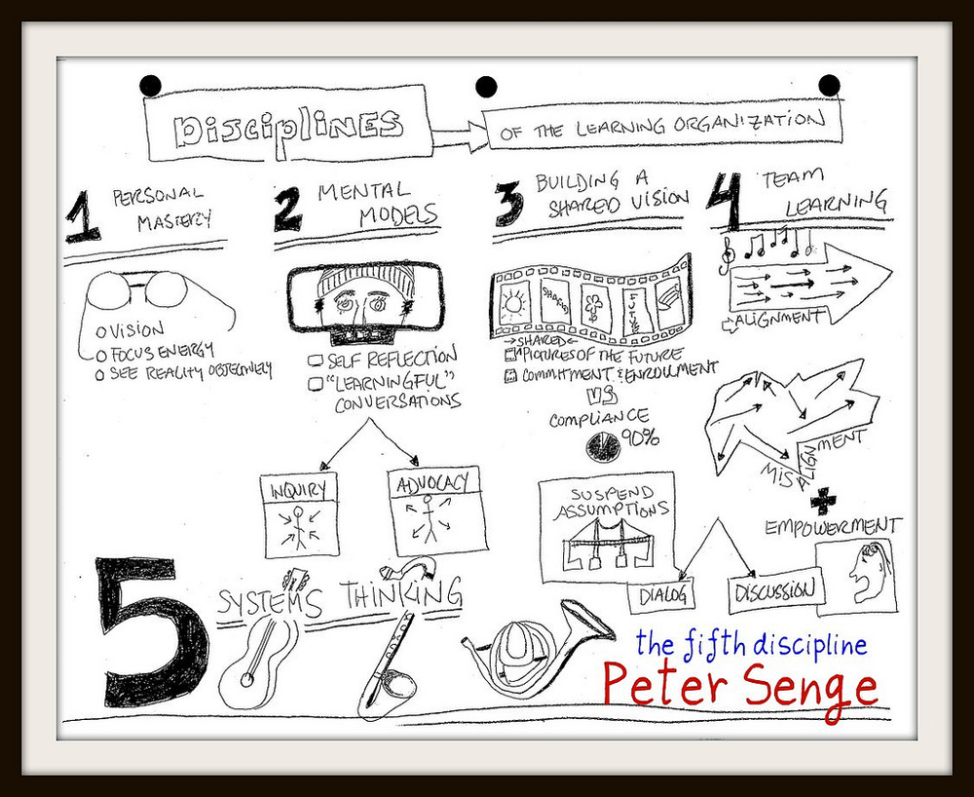
Source: http://teachinginhighered.com/resources/mindmap-peter-senges-disciplines-of-the-learning-organization-as-described-in-the-fifth-discipline/

Reflection Activity

Discipline

Systems thinking

Personal mastery

Mental models

Building shared vision

Team learning

Activity – Personal Mastery

What are you committed to at home or work?
What makes it important to you?
Where could you practice personal mastery in the workplace?
How can you stay focused to ensure you reach personal mastery?

Create a personal vision statement

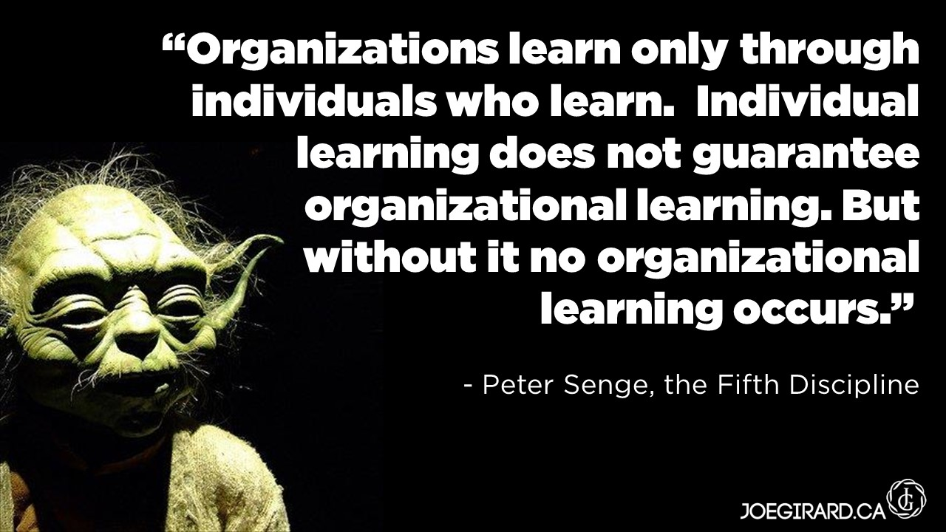

Doodle / Note Page

