
CHANGE READINESS
1000 Waverley Street  Winnipeg, MB, R3T 0P3 |  | 204-272-5030 |  | www.wem.mb.ca

PARTICIPANT WORKBOOK
Managing Change

Introduction and Housekeeping

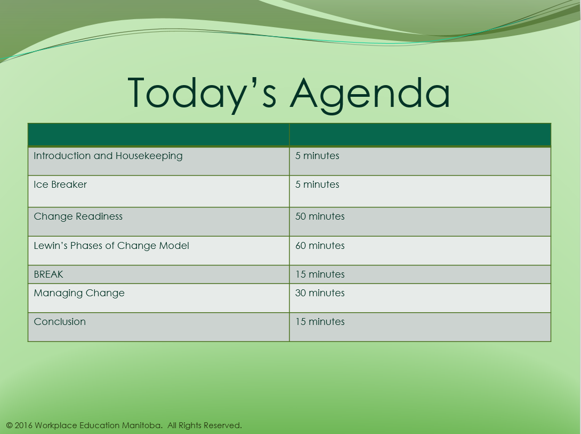

Today you will:
- Define “change ready” and “change management”
- Analyze Lewin’s Change Management Model
- Discuss:
  - Key barriers to managing change
  - Risk assessment
  - Stakeholder analysis
  - Planning change
  - Managing change
- Review common mistakes related to change management
Change Readiness
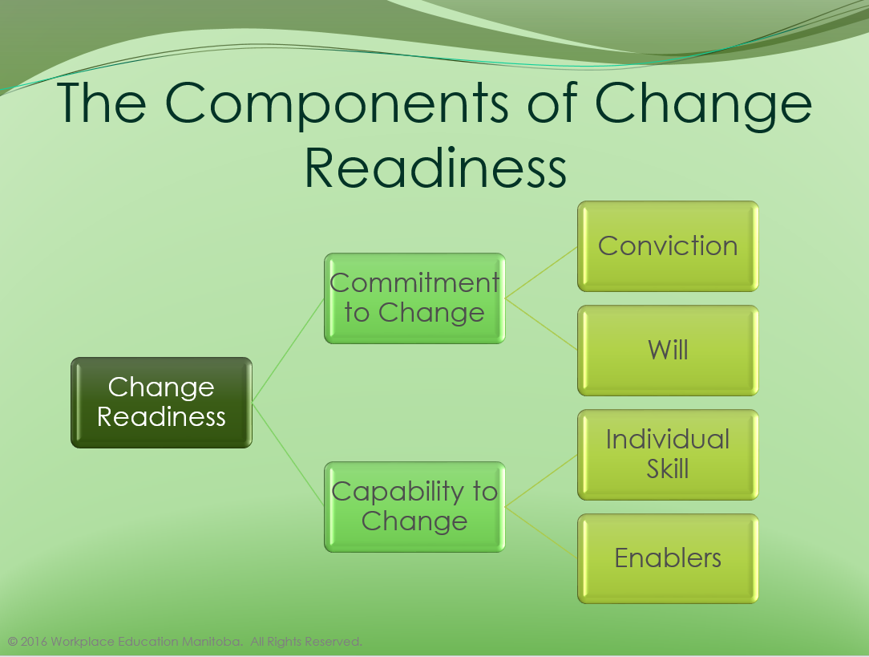
Notes:

Change Readiness

This survey, consisting of 14 questions, can provide you with an indication of your organization’s change readiness. This is not a ‘pass or fail’ test of transition readiness. If the answer is ‘yes’ to fewer than 10 of these questions, the organization is likely to have a difficult time moving through a transition. The results may be different—and likely less positive—when a deeper sample of the organization is surveyed compared to the opinions of only senior managers.

Answer the following questions with YES or NO:
- Is there a fairly widespread sense that the change is necessary?
- Is the change part of a widely understood strategy?
- Does the culture of your organization validate the idea of helping employees deal with the problems they encounter, or are they pretty much on their own?
- Do most people accept that the change is an effective response to the underlying problem?
- Does your organization tend to blame people if they make mistakes in a new situation?
- Are there people in your organization who have expertise in the handling of change and who could assist others who may need it?
- Do people know when it is time to let go of—and why?
- Does your organization provide people with adequate training for the new situations and roles that it thrusts them into?
- Has the change been explained to those who are going to be affected by it in as much detail as is currently possible?
- Has the proposed change polarized the workforce in any way that is going to make the transition more disruptive?
- Does your organization’s history work in its favour during times of transition?
- Is the level of trust in your organization’s leadership adequate?
- Has your organization set up some way to monitor the state of the change?
- Has a clear set of responsibilities been established for seeing that the human side of the change goes well?

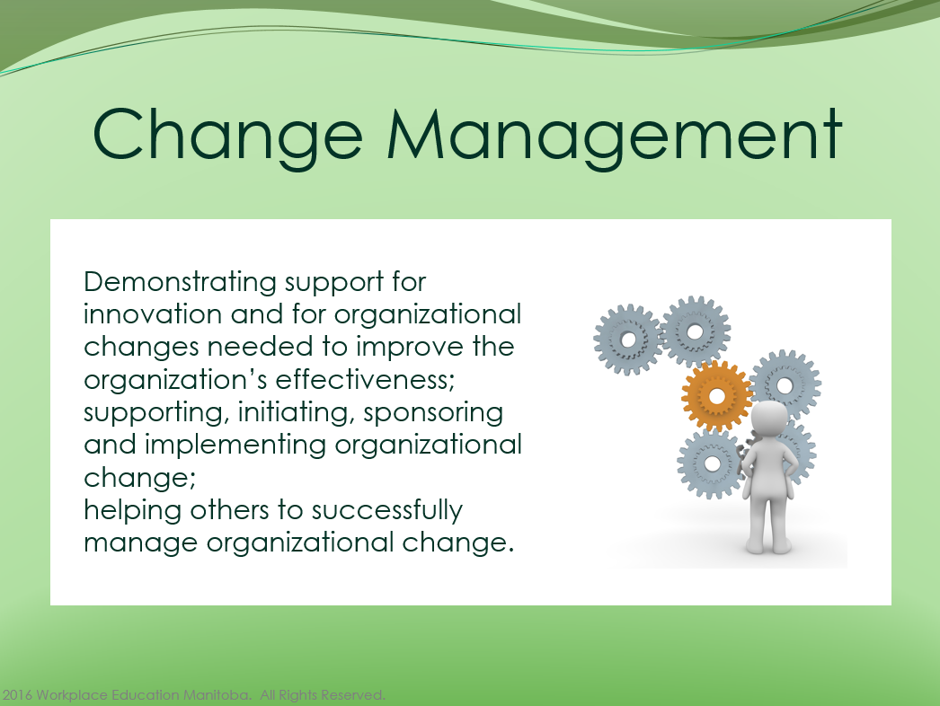
Notes:

Predictors of Ability to Manage Change
According to Carol Kinsey Goman, Ph.D. president of Kinsey Consulting Services, Berkeley, CA, there are five factors that determine which individuals deal successfully with change.
Rank yourself for each of the factors on a scale from 1 (low) to 10 (high). Then describe for each factor what you could do to improve.

1. Confidence. Confident people are self-motivated, have high self-esteem, and are willing to take risks. Quite simply, they know how good they are.

2. Challenge. With any change, the danger of possible reversals co-exists with incredible opportunities for personal and professional success. Leaders need employees to be excited by the opportunities in change. When change-adept people are asked for verbal images they associate with change, they acknowledge the stress, uncertainty, pressure, and disruption, but they also emphasize the benefits -- the opportunity, growth, adventure, excitement and challenge.

3. Coping. Some people are naturally more flexible and better at coping with, and adapting to, a complex, fast-paced reality than others. These individuals take charge of change by accepting responsibility and assuming control. To be successful in chaotic times, the trick is not to brace yourself for change, but to loosen up and learn how to roll with it. In your organization, strategies will be planned, announced, implemented, and then-- right in the middle of execution -- they will all too often have to be altered or aborted because of external changes. What leaders need from employees is the ability to commit to a course of action and, at the same time, to stay flexible enough to quickly alter behaviour and attitude.

4. Counterbalance. Those who are most resilient not only have a job -- they have a life. Change-adept individuals compensate for the demands and pressures of business by developing counterbalancing activities in other areas of their lives. They engage in exercise programs and healthful eating habits, they cultivate interests outside of business -- sports, hobbies, art, music, etc. -- which are personally fulfilling, and they have sources of emotional support. Because employees with counterbalance have a life that includes both work and recreation, they handle stress better and are more effective on the job.

5. Creativity. Buckminster Fuller once said, "Everyone is born a genius. Society de-geniuses them." Change-adept professionals have survived the de-geniusing of society to remain curious, creative, and innovative. You can easily spot creative people in organizations. They are the employees who are constantly seeking ways to improve products, services, or themselves. Typically, they question rules and regulations, and contribute ideas beyond the limits of their job descriptions -- to other functions, to other departments, and to the organization as a whole. These creative employees solicit diverse opinions that generate new thoughts, and they value any business experience that exposes them to new knowledge and skills.

Phases of Change

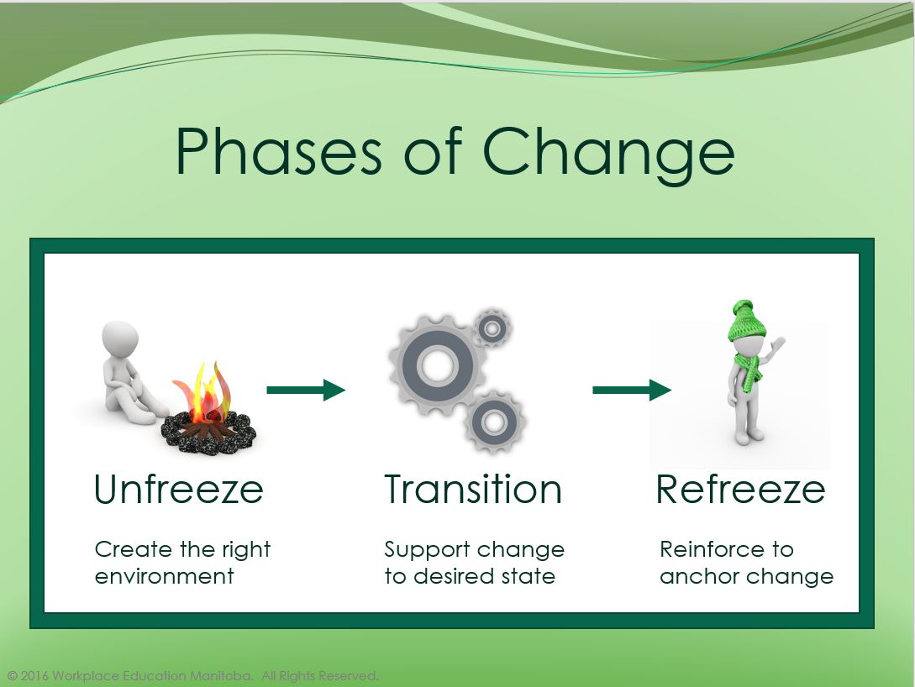
Notes:

Notes:

6 Stakeholder Roles
There are 6 stakeholder roles identified when using the Continuous Learning Model:
Stakeholder/Role | Responsibilities | Accountabilities
Change-maker | Decision-making  Distributing authority  Enable culture of learning | Vision
Change Project Manager | Manage Logistics  Cost analysis  Planning | Ensure Return on Investment  Setting process and structure
Change Monitor | Assessment  Measurement  Analysis  Full-circle communications with stakeholders | Documentation  Completion of the communication loop
Change Facilitator/Agent | Empowering Teams/individuals  Removing barriers  Create environment that motivates  Provide tools  Facilitating change activities | Alignment  Day-to-day implementation of change plan.
Change Competency Coaches | Provide learning supports  Assess needs  Deliver training  Build skills | Change Management Competency across the organization
Change Champions | Engage fully  Participate in change activities  Take responsibility for own learning  Support the team  Champion the cause | Embrace change  Be change oriented


Notes:

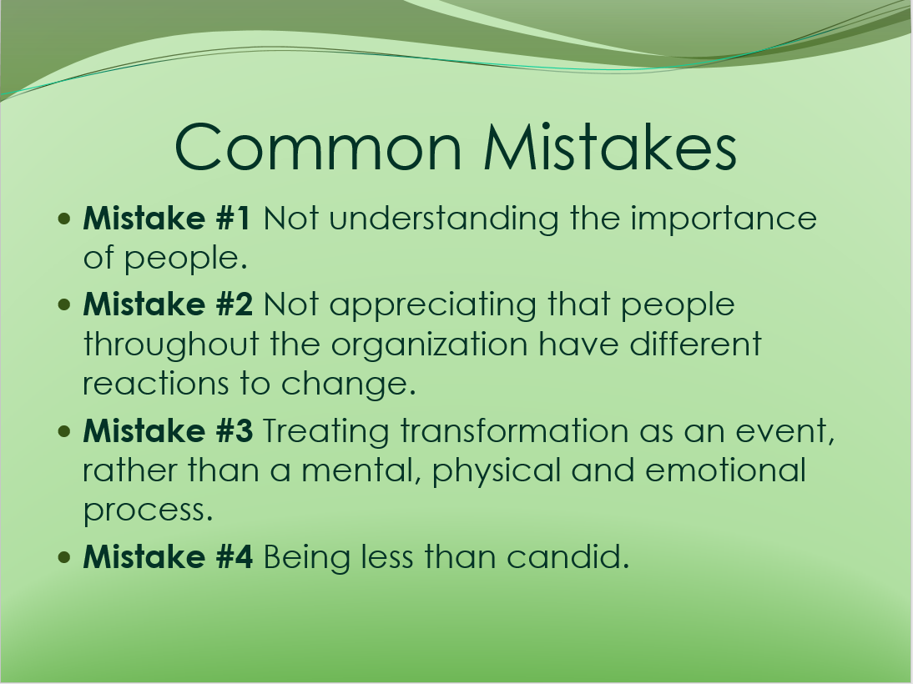
Notes:

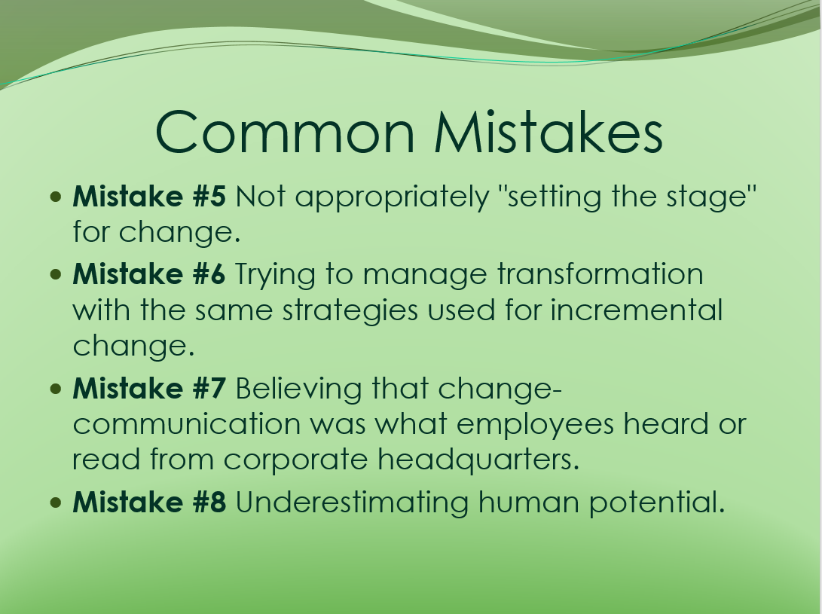
Notes:

Eastman Kodak Case Study
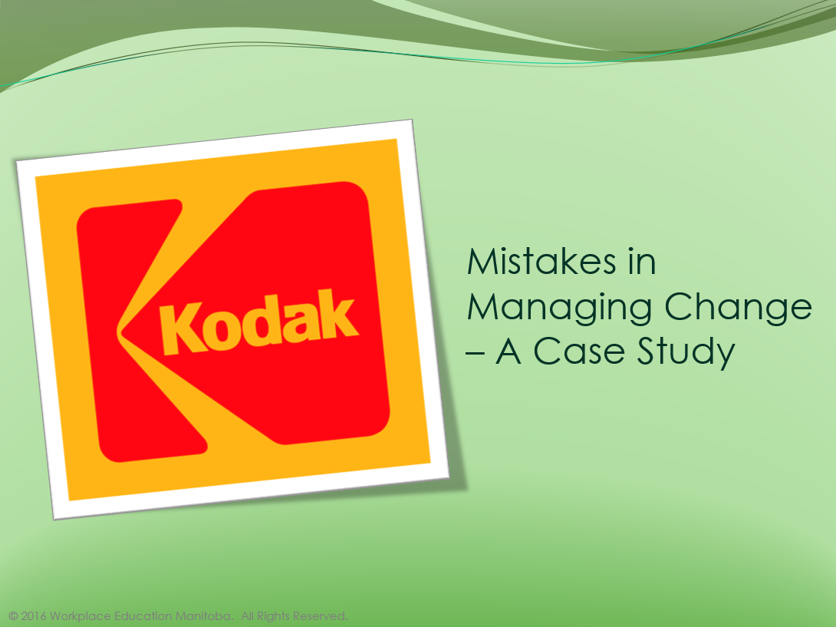

Mistakes Made On the Road to Innovation
Led by CEO Antonio M. Perez, Kodak is struggling to reinvent its business model. It's not alone
November 26, 2006 — 11:00 PM CST
When Eastman Kodak (EK ) vowed in 2000 to become a leader in digital cameras, the idea seemed ludicrous. The old-line Rochester (N.Y.) company had film and print all through its DNA. Yet by 2005, Kodak ranked No. 1 in the U.S. in digital camera sales. Its digital sales surged 40%, to $5.7 billion, even as its film-based businesses fell 18%. The key: product innovation, something Kodak knew how to do oh-so-well. The company designed one award-winning breakthrough after another to make digital photography nearly as simple as pointing and clicking.
So why does Kodak Chief Executive Antonio M. Perez now dump on digital cameras, calling them a "crappy business"? Simple: While blazing growth of camera sales has helped blunt the effects of Kodak's fast-fading film revenues, it hasn't replaced the rich profits of the film business. Even the best mass-market cameras yield slim profit margins. So, although Kodak's digital camera business was a roaring sales success, it turned out to be a crushing profit disappointment. Perez, who arrived at Kodak in 2003 and became chief executive last year, had championed a dramatic change only to find it wasn't the right model for turning the company around.
Now he's crafting yet another strategy for Kodak, its third in less than a decade. Building on the mistakes made and lessons learned in recent years, Perez is attempting innovation of another sort -- reinventing the company's core business model. He aims to make Kodak do for photos what Apple does for music: help people to organize and manage their personal libraries of images. He's developing a slew of new digital photo services for consumers that he expects to yield higher returns. They include everything from online photo sharing to a rapid-fire scanning system, called Scan the World, that takes shoe boxes full of yellowed snapshots and converts them into crisp digital images organized by the date originally printed. But the shift from hard product to digital services is a huge challenge. It's "a very hard transformation," says Perez. "History says very few companies have made it."
In an era when innovation is all the rage, many CEOS, like Perez, are discovering that product innovation alone isn't enough to save sick companies or turbocharge healthy ones. For many, their core businesses are being disrupted by globalization, technology shifts, and new competitors. They must reinvent the company. Even at healthy companies, business model innovations are essential to retaining their competitive positions. Microsoft (MSFT )Chief Executive Steve Ballmer says he no longer thinks of his competition as individual companies. Instead, "it's alternative business models that we'll have to compete with or embrace," he says. His two biggest threats are the open-source phenomenon and advertising-supported software.
There's no better example than Kodak of the importance of coming up with new ways of doing business -- and the difficulties of succeeding. At its peak, Kodak was an icon of American technology innovation. Now it's fighting to recover from a tech revolution that is strangling its core business. Kodak was late to recognize the problem, slow to react, and then went down the wrong innovation path. It faces many of the problems and is making many of the mistakes that any company can make when so threatened. Because of these delays and missteps, it's still far from clear how Kodak's story will play out. Yet it provides a vivid case study for businesses facing similar challenges. A March survey commissioned by IBM (IBM ) showed that 65% of the world's top CEOs plan on radically changing their companies in the next two years.
Over time, all innovation gets commoditized. In this regard, business models are not different than products and services. So business model innovation must be a perpetual quest for renewal. Look at how Dell, (DELL ) long the PC industry's heavyweight champ, has suddenly become wobbly in the knees. It revolutionized the PC business by assembling computers to order for customers while eliminating the middleman. Now competitors have caught up with Dell's efficiencies and are even undercutting its prices. So Dell is emphasizing designing a better customer experience and selling through retailers.
This reinvention stuff can be a tough slog. "Business model innovation is harder than product innovation. It's harder to visualize, and the scope is larger and much more complex. It includes everything the company does. Everything has to be changed," says Jay Desai, chief executive of management consultancy Institute of Global Competitiveness.
Apple Computer (AAPL ) shows how it's done. Here's a company that was trapped in an ever-dwindling niche of the PC business. Then came the iPod, a must-have device for music fans, and iTunes, an online music shop that turned music downloading into a profit-making business. By making iPod and iTunes work with Windows PCs, Apple broke out of selling only to its niche of loyal fans. But its transformation is even more profound than that: In essence, it switched from being a great designer of computer products into a great designer of consumer experiences delivered via devices and services. Now music represents 44% of Apple's revenues, and an even larger share of profits.
Kodak's Perez dreams of replicating Apple's success. "In two to three years, this will be seen as one of the most successful transformations in the history of our country," he predicts. Maybe. Wall Street doesn't share his optimism. Kodak's stock is trading at about 26 per share, down from a high of 95 in 1997. Kodak has been in the red for eight consecutive quarters, losing a total of $2 billion. It hopes its new strategy will get it into the black by yearend 2007.
Many of Kodak's problems can be traced to the successes of its past. Wherever Perez turns in Rochester, N.Y., he is haunted by the specter of George Eastman, one of America's greatest innovators. In spite of the fact that Eastman died in 1932, his mark is still huge on the company he founded in 1880. Decades after his death, it remains difficult to change Kodak's long-established ways. One of them is a hierarchical culture that believes in the omnipotence of leadership. It's so powerful a habit that when Perez came to Kodak from HP in 2003 as chief operating officer, he couldn't get people to openly disagree with him. "If I said it was raining, nobody would argue with me, even if it was sunny outside," he laments.
WATCH FOR TREACHEROUS SHIFTS
Before Perez arrived on the scene, Kodak was in denial. The company had supposedly been on a decade-long journey to digital technology, yet very little had actually been done. The pressure to rethink the business didn't seem that great. There was no crisis. It wasn't until 2001 that film sales dropped, and even then insiders attributed the financial shocks to the September 11 attacks. The hope was that Kodak might be able to slow the shift to digital through aggressive marketing.
The company hedged its bets and launched an all-out blitz on the digital camera market. Its family of digital cameras, called EasyShare, was widely praised. The company spent a tremendous amount of time and energy studying customer behaviour. It found that women in particular loved taking digital photos but were frustrated in moving them to their computers. It was just too hard. Kodak's researchers had found a key unmet consumer need -- a huge opportunity.
Once Kodak got its product development machine humming, it cranked out model after model offering consumers top-quality cameras at reasonable prices that made it easy to share photos with friends and family members via their PCs. One of the coolest innovations: a printer dock. Consumers could insert their cameras into this compact device, press a button, and watch their photos roll out.
But there was a fatal flaw in Kodak's strategy. Its executives didn't anticipate how fast these digital cameras would become commodities, with low profit margins, as every competitor raced into the market. Then film really began to tank. Perez had counted on rising demand for traditional photography in China to slow the fall. But China went digital as fast as everybody else.
Perez began investing heavily in digital technologies, shutting down film factories and eliminating 27,000 jobs. He spread the word that Kodak would have to come up with new services and new ways of capitalizing on its technology innovation to boost profit margins. When he was promoted to CEO in May, 2005, he summoned his top seven executives to the President's Room, a spacious, wood-paneled conference space on the second floor of the Kodak tower. The most dramatic change in Kodak's strategy in over a century was under way, and there would be no turning back. "You have to burn the boats," the Spanish-born Perez told them, quoting conquistador Hernán Cortéz.
For the new service-oriented business model to work, Kodak had to throw out some of its most cherished notions. No longer would it fool itself that product innovation would be sufficient for it to be successful. And no longer would it try to do everything itself, from manufacturing to selling finished products.
GET YOUR BEST PEOPLE BEHIND THE PROGRAM
Perez found he had to replace a lot of executives to get the company on a new track. The film-era lifers just didn't get it. Of the company's 21 executive officers in 2003, the year Perez arrived, only three remain. Most of their replacements came from outside Kodak, and most had digital experience.
Perez believes that in any organization, one-third of the staff will readily support a change, one-third can be convinced, and one-third will be unwilling to make the shift. He calls it The Rule of the Thirds. To help him win over a clear majority, he assembled a group of people who were skeptical by nature and assigned them to a committee he called the R Group. ("R" stood for rebels.) He asked them to make suggestions on how the company could be improved. Those discussions contributed to the strategy of coming up with new digital services and new ways of commercializing existing technology. Also, once these people felt like they were part of the conversation for change, they spread the word throughout the organization that Perez was a good leader. And, because they had credibility, their opinions influenced many others.
Other companies haven't been as fortunate. Take Siebel Systems. When the idea of delivering software as a service emerged as an alternative to selling packages of software, Siebel Systems CEO Thomas Siebel threw his weight behind it. Yet even his influence wasn't enough. A watershed moment came when Siebel competed against upstart Salesforce.com for the business of tech giant Cisco Systems (CSCO ). Even though Cisco was tilting toward Salesforce.com, (CRM ) Seibel's sales people pushed traditional product software because they'd get richer commissions that way. Siebel lost the deal, and its business was forced to sell out to Oracle (ORCL ). "There were groups of disbelievers in the organization, which is a recipe for disaster," says Bruce Cleveland, who ran the software-as-a-service initiative.
GIVE YOUR NEW INITIATIVES ROOM TO BREATHE
A company's core business and its new initiatives are typically at odds with one another. Force them together, and the old business may well smother the new one. Kodak tried it both ways. For two years it placed the digital camera group within its film business so they could share resources and digital could grow more quickly. But last year it split them off again. "One really couldn't piggyback on the other," says Pierre Schaeffer, chief marketing officer for the digital business.
Other companies have scored big by managing their new businesses separately from the start. When Dow Corning conceived of its e-commerce business, Xiameter, the idea was to run it independently. The company didn't want to devalue the Dow Corning brand, which is equated with premium service. Xiameter was about selling large quantities of silicone at low prices with no services attached. Since its 2002 launch, Xiameter has grown to about 15% of Dow Corning's total sales.
MAKE PAINFUL BREAKS WITH THE PAST
Switching business models requires a thorough rethinking of everything a company does, from planning to manufacturing to marketing. For 120 years, Kodak had done everything for itself. At one time, it even raised its own cattle and used the bones for making photographic gelatin. When it tried to collaborate with others, the results could be messy. For instance, it sought outside expertise from Adobe Systems (ADBE ) in 1999 when it was developing a product for transferring consumers' photo prints to compact disks so they could be viewed on PCs. Yet the alliance was fraught with bickering. When Adobe people came up with suggestions, the knee-jerk reaction from Kodakers was "This will never work," recalls Brian Marks, a 19-year Kodak veteran.
Today, Kodak has had a complete change of heart. In early January, Perez and Motorola (MOT ) CEO Edward Zander stood together at the International Consumer Electronics Show in Las Vegas and announced a 10-year partnership in which Kodak would provide chips to operate high-quality cameras in Motorola's cell phones. It was a startling break with Kodak's past. An organization that had always built its own products would now provide technology for somebody else. Kodak will also help consumers transfer images to PCs or online galleries (75% of all photos never leave cell phones).
Perez is gambling that the match will be well worth all the contortions Kodak is going through. He expects much of the growth in digital photography to happen in mobile phones, and he believes profit margins for sensor chips will be twice those of the digital camera business.
In spite of the changes Perez has made, he admits he still has a lot to do. Old habits die hard. At Kodak, it's standard procedure to test a new product or service -- and then test and test again to make it perfect, even if that stretches out the journey to the marketplace. Case in point: Kodak has been talking up its Scan the World consumer service for a year, but it's still not sure when or how it will be introduced broadly. The company hopes to sell or lease scanners to photo shops, plus get a piece of the fees charged to customers for the service. Among other things, it's wrestling with the $50,000 cost of the scanner. Will Kodak be able to adjust quickly enough to meet the demands of new and untried markets? Not clear.
DON'T CONFUSE WHAT YOUR COMPANY DOES WITH HOW IT DOES IT
It is taking time for Kodak to understand that it is an image company, not a film or camera company. Perhaps it should take lessons from Western Union. (WU ) Founded in 1851, the company has managed to ride each successive wave of change in its history rather than getting swamped. (A bankruptcy protection filing in the early 1990s was caused by management mistakes rather than external threats.) After handling the first transcontinental telegram in 1861, it spotted the opportunity to transfer money by wire 10 years later. Then, a series of firsts: a city-to-city facsimile service, a microwave communications system, a commercial satellite network, and online money transfer.
Why has Western Union been able to adapt to severe disruptions and survive over so many years? It never confused the business it was in with the way it conducted its business. At its core, Western Union was about facilitating person-to-person communications and money transfers -- whether via telegraph, wireless networks, phone, or the Internet. "We always saw ourselves as a communications company," says president Christina Gold. Contrast that with Kodak. By defining itself too narrowly as a product company all those years, it was headed for a fall.
Kodak teeters on the precipice, and with it stand some of the other once-great businesses of the 20th century, from autos to newspapers. They were immensely successful and proud, but their very success made it difficult to adjust. "The more successfully you use a way of working, the stronger your culture is, which is a great strength right up to the time when you need to change," says Clayton Christensen, a professor at Harvard Business School. All innovation is hard. Reinventing your entire business is the hardest innovation of all.
By Steve Hamm and William C. Symonds

Question:
Considering what we have learned, what do you think were the mistakes made by Eastman Kodak, and what would you have done differently?

Workplace Education Manitoba would like to express appreciation to the following for supporting the development of this Continuous Learning Skills curriculum:
Employment and Social Development Canada (ERSDC) and
Manitoba Education and Training.
This project was jointly funded through Human Resources Skills Development Canada and Entrepreneurship Training and Trade.
For more information, visit www.wem.mb.ca or contact info@wem.mb.ca

