TOOL QUIZ
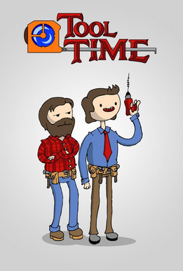
ANSWER SHEET

1 |  | 2
3 |  | 4
5 |  | 6
7 |  | 8
9 |  | 10
11 |  | 12
13 |  | 14
15 |  | 16
17 |  | 18
19 |  | 20
21 |  | 22
23 |  | 24
25 |  | 26
27 |  | 28
29 |  | 30
31 |  | 32
33 |  | 34
35 |  | 36
37 |  | 38
39 |  | 40

