

ESSENTIAL SKILLS TRAINING PROGRAM – DOCUMENT USE

PARTICIPANT GUIDE

Session 1

Workplace Education Manitoba would like to express appreciation to the following for supporting the development of this Continuous Learning Skills curriculum:
Employment and Social Development Canada (ERSDC) and
Manitoba Education and Training.
This project was jointly funded through Human Resources Skills Development Canada and Entrepreneurship Training and Trade.
For more information, visit www.wem.mb.ca or contact info@wem.mb.ca

INTRODUCTION TO ESSENTIAL SKILLS: what are Essential Skills?

The nine Essential Skills – What are they?

- Reading – understanding materials written in sentences or paragraphs
- Document Use – using and understanding checklists, symbols, labels and other similar materials
- Numeracy – using and understanding numbers
- Writing – writing txt or typing on a computer
- Oral Communication – using speech to share thoughts or information
- Working with Others – interacting with others to complete tasks
- Thinking – reviewing information to make decisions
There are 6 categories of thinking skills including:
- Problem Solving
- Decision Making
- Job Task Planning and Organizing
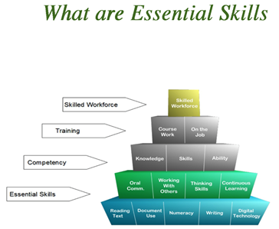
- Significant Use of Memory
- Finding Information

- Computer Use – using computers and other technical tools
- Continuous Learning – participating in an ongoing process of gaining skills and knowledge.

TRAINING OBJECTIVES

How I will use these skills:

- Contribute to classroom discussions by sharing, posing questions and providing responses
- Read and follow instructions to complete tasks
- Work with others to share knowledge
- Develop Excel proficiency by watching, applying knowledge and practicing
- Identify opportunities to apply skills gained when back in the workplace

DOCUMENT USE WORKSHOP LEARNING OUTCOMES

Learners will be able to complete the following upon completion of the training:

- Demonstrate understanding of Document Use as an essential skill and how it applies in the workplace.
- Navigate the document process in a step-by-step manner.
- Recognize the importance of accurately entering and locating information in a variety of document templates such as forms, tables, lists and schedules.
- Identify various symbols, signs and legend markers.
- Recognize the importance of following instructions and reporting details in an objective fact-based manner

INTRODUCTION

In most workplace situations, workers are required to use a variety of documents in in the execution of their daily responsibilities. A document is a written, printed, drawn, photographed or electronic piece of information that provides evidence or proof, and is viewed as an official record. Examples of documents are drivers’ licence, passports, employment contracts, bills of sale, mortgage documents and the list goes on.

Documents are set up in structured templates, have exact wording and require factual information. Most documents are based on facts, figures and concrete details. They are used to verify information and as evidence or proof of the veracity of claims or statements being put forth.

Documents are also used as standards for fulfilling requirements, an example being the necessary documentation needed to begin work or school. For instance, if enrolling in an education program, students are required to provide evidence that they meet the pre-requisites such as completion of a grade 12 education (documentary evidence would be a high school diploma). In the workplace, once an employee is hired, they are required to provide documentation to support their identity and tax status (eg. Social insurance number).
In our workplaces, we may have the responsibility to complete a variety of documents with critical information. Other times we must be able to read and understand information provided on documents that are completed by others. Both of these expectations are extremely important and critical to maintain an efficient and safe workplace.

Some common document types that you may come across in the workplace include (but are not limited to):

- Entry forms
- Lists
- Graphs and charts
- Mimetic documents

DOCUMENT NAVIGATION

Being able to find your way around a document is called navigation. To navigate is to go from one place to another. For example, imagine you live in Winnipeg and you need to get to 825 Manitoba Avenue in Selkirk. You might ask a friend for directions or look at a map online. The map shows you how to get to your destination. The map would show you how you would navigate to get to the address.

In documents, navigation is a process that allow you to source out the information you need in a structured way. This process provides the steps that you need to follow when you navigate a document initially. Once you have used a document several times these steps become less necessary and often you will just quickly locate the section needed. It should be noted that even when you are comfortable you still need to remain diligent in ensuring that document use remains accurate.
In a sense, documents are like maps. Document navigation is a special reading strategy. When you see a document for the first time, you will have to follow steps to make sure that you understand it well. After you have used the document several times, you can skip these steps to quickly get to the parts you need.

Document Navigation Step 1: Understand Document Structure

People who write documents use sections to make it easier for the reader to find what he or she is looking for. No two documents are exactly the same. Different documents are made up of different sections that are organized in different ways.

The structure of a document includes both the sections and how they are organized.

Some documents have many sections, and some have only a few.

- Headings and Sub-headings

- PRINT OF DIFFERENT TYPE AND SIZE

- Boxes to separate information

- Lines to separate information

- White Space around each section

- New sections on different pages

- Longer documents may include a Table of Contents to detail what is in the document.

- Longer documents with many sections may have dividers to separate sections.

- Some documents will have a key or a legend to give you more information and tell you what the symbols mean (eg. Maps).

- Some documents will have pictures or drawings to help you understand the information (eg. Assembly instructions).

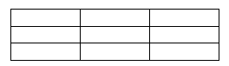
- Documents may include tables to lay out information.

Activity 1: Four Sample Documents

The four sample documents on the next several pages will help you become familiar with some of the different types of documents that you may need to use.

Look at how each document is structured. See how the sections are separated and how the information is organized. The documents are numbered from 1 – 4. Write the number of the matching documents on the lines below.

- Which document has the most white space and the least words?

- Which documents have small boxes for you to put a check mark in?

- Which document uses heavy dark lines to divide it into three major sections?

- Which documents have blank lines to enter information?

- Which document has a drawing to help you understand the information?

- Document #1 has a table to enter information. How many headings does this table have?

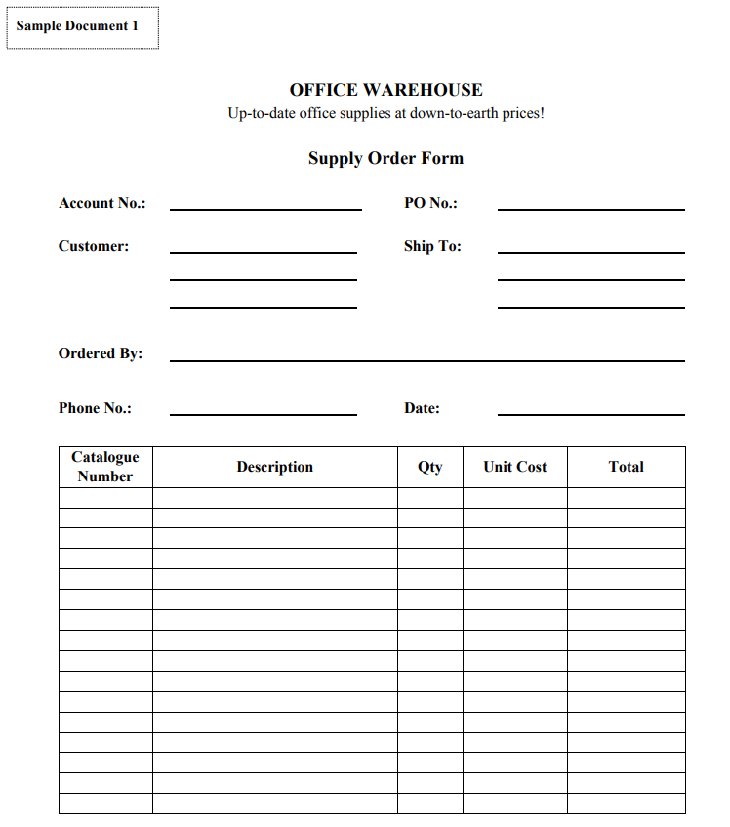

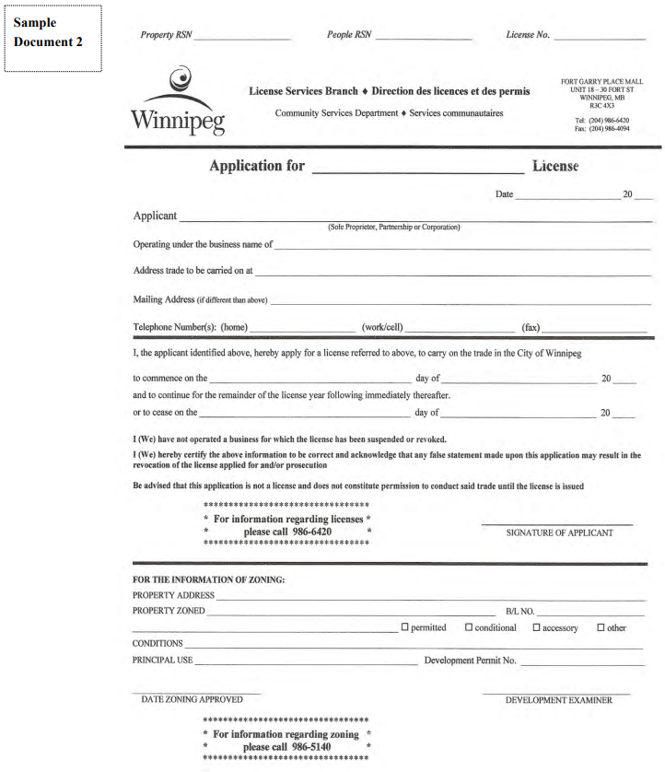

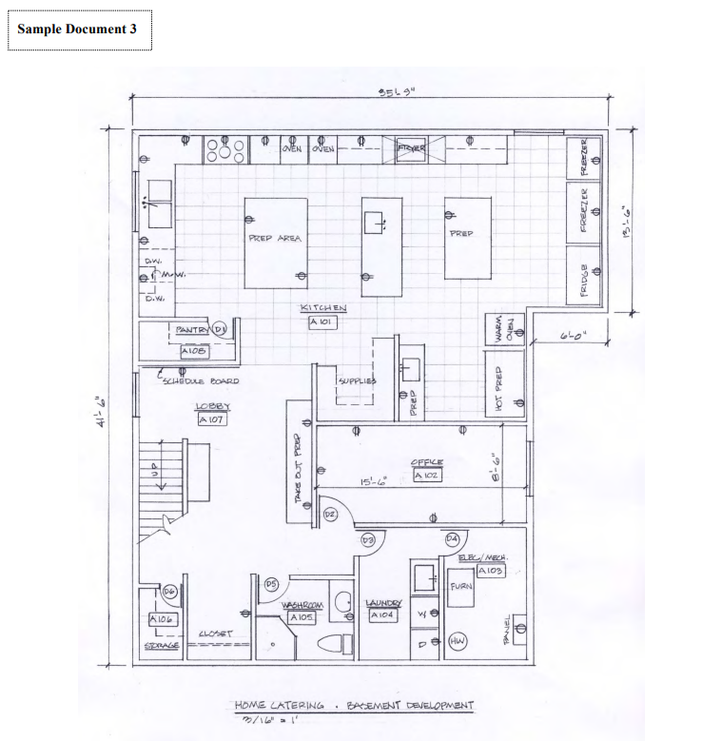

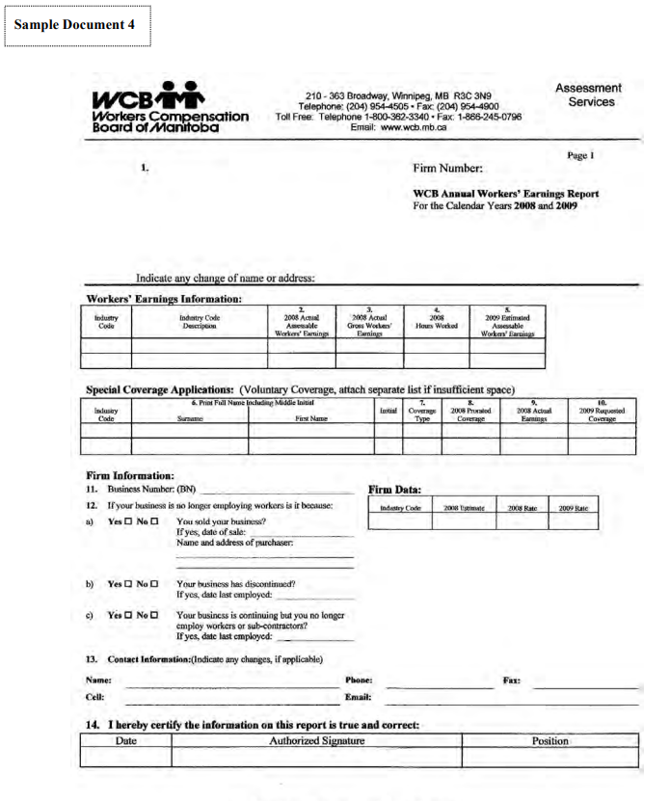

Document Navigation Step 2: Skimming

Skimming is a type of reading where you look over something to get the main idea. As you skim, you read some parts and miss others. You often do this when flipping through a magazine or glancing at the newspaper. When you find a particular article that catches your interest, then you cease skimming and begin to read every word. Skimming gives you the “general idea” about what the magazine or paper contains.

This is also true when you skim a document to get a general idea of information, layout and overall structure. In addition to these you should also look at the following as you skim:
- The title
- Headings
- Key words
- Charts
- Pictures
- Diagrams

When you skim, you should be reading three or four times faster than you do when reading word for word. You actually skip more words than you read. Some people skim by looking at the centre of the page while others skim by moving their eyes in an “s” pattern.

Activity 2 – Skimming

Read the questions below. Skim Sample Documents 1 – 4 on the previous pages to find the answers. Write your answers to the corresponding questions below:

- Key words are main or important words What document has Special Coverage Applications as key words?

- Which document has labels to help you understand the drawing?

- When you sign a document you give your name as proof that the information is true. Which documents ask for your signature?

- Most documents are created for more than one person to use. Read the possible audiences below. Write the matching document number (from 1 – 4) on each line.

- Document ____ builders, contractors
- Document ____ clerk working for the city
- Document ____ order desk clerk, warehouse workers
- Document ____ clerk working for the province

- The purpose is the reason the document was created. Write the purpose for each document:

- Document 1___________________________________________________
- Document 2___________________________________________________
- Document 3___________________________________________________
- Document 4___________________________________________________
Document Navigation Step 3: Scanning

Scanning is a kind of reading where you look for specific information. When you scan, you read some parts and miss or ignore others. For example, if you are looking for a phone number, you do not read the whole phone book. The first thing you do is find the section or page you need by looking for key words. Then you focus your attention on the name and number you need.

When you scan, you should ask yourself these questions:

- What information do I need?
- What are the key words or phrases I can look for?
- In what section or on what page will I probably find this information?
- How will I know when I find the information?

In the last activity, you skimmed four documents to get a general idea of what they were about. Now you are ready to scan one document at a time to find more specific information.

Activity 3: Scanning

Scanning: Charts and Tables

A spreadsheet is information in the form of a table. This is also called a grid. It has information in columns from side to side and rows from top to bottom. Each space on the grid is called a cell. The information in the cells is called data.

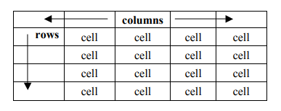

The following is an example of a spreadsheet with data listing the shifts employees work in one week:
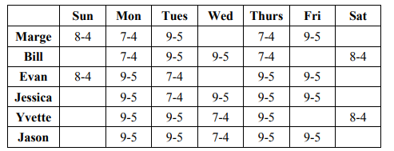

Imagine you are Evan. You want to find out when you work on a Thursday.

- Please a finger from your left hand on your name (Evan)
What time is Evan’s shift on Thursday?
- Place a finger from your right hand on Thursday.
- Move the finger on your left hand across the row.
- Move the finger on your right hand down the column.
- You will find the data you want where your two fingers meet.

Activity 4 – Employee Deductions

The spreadsheet below has the data about Employee Deductions. Scan the document to find answers to the questions that follow.

Follow these steps:

- Read the whole question
- Look for key words in the question.
- Look at the columns and rows to find the key words.
- Run your fingers or eyes down the columns and across the rows until you find the answer to the question. You may have the read the question more than once.
- Write the answers in the corresponding questions below.

Note: Some questions use key words that are a bit different from those found on the document. You may have to infer (work out from clues) what the question is asking:

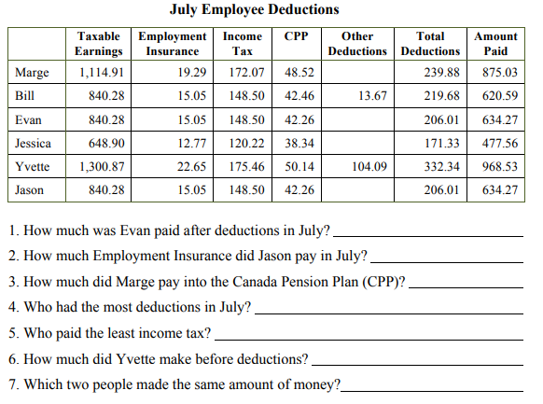

Scanning: Technical Drawings

Technical drawings are documents that are labeled. A floor plan is one type of technical drawing. Numbers and symbols are keys to understanding information on this type of document.

Activity 5 – Scan a Floor Plan
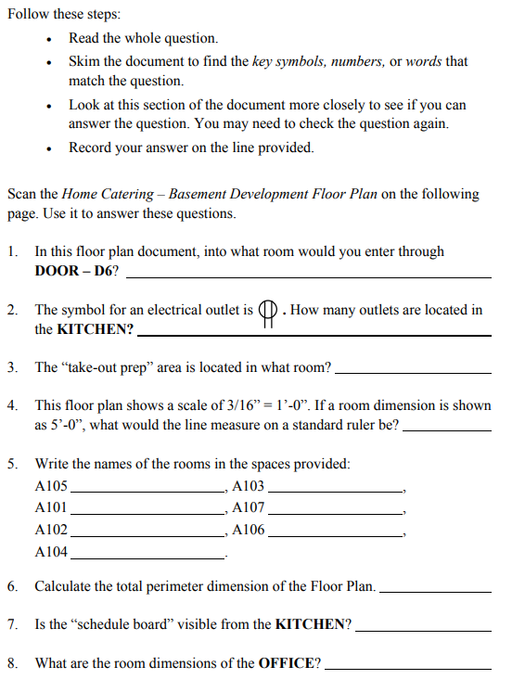
Refer to the floor plan on the following page

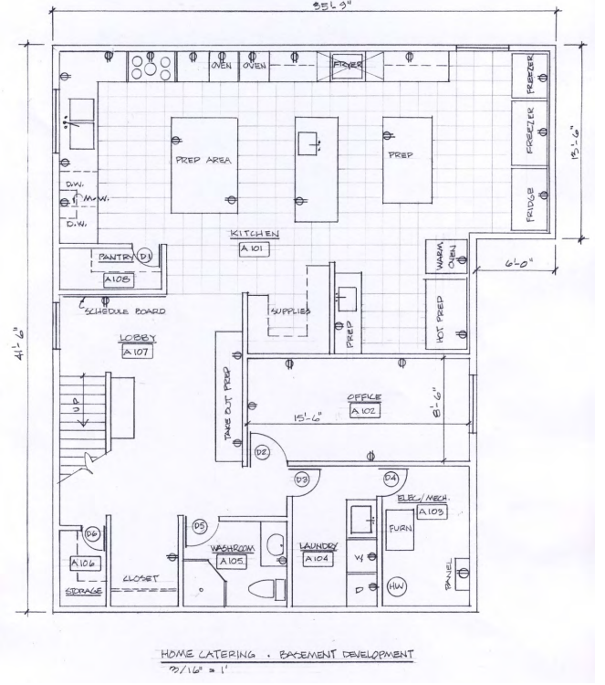

Document Navigation: Step #4 Use Information

You will use many documents in your workplace. Some you will read to locate needed information and some you will be required to complete with facts and figures that you know. Often parts of documents that you use are also filled in by other people such as Supervisors, HR personnel, co-workers, administrative staff, etc.

The documents you use on a regular basis become familiar and you soon know exactly what information to locate or write down to do your job well.

When you are first presented with documents in the workplace that you will be required to complete, take the time to note the document’s purpose, audience, why the data is being collected, and who else will be required to use this document and its data. Often these things are outlined in Policies and Procedures Manuals.

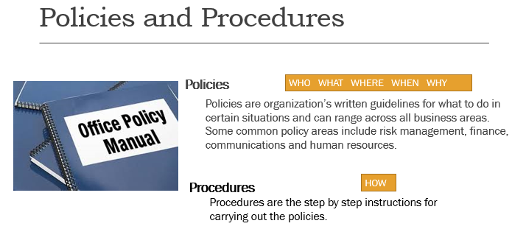
While all documents are different, may do have similar parts or structure. In addition, many documents are made to collect, record and use information in similar fields, professions, situations and environments. If you reflect on why the document was constructed, it will help you understand your purpose when reading or writing on it.

Multiple Choice Tests

You may encounter tests designed to assess specific skills such as reading comprehension or numeracy. The Manitoba Essential Skills Assessment (MESA) is an example of such a test which is comprised of several assessments to determine a learner’s current skill level in reading, writing, numeracy, digital technology and listening.

Strategies for MC Test Strategies for MC Tests

- On your first pass through the test, don’t guess on questions. Answer questions you know, mark the ones you don’t know or are unsure of – come back to them later
- Look at the answers first to know what information you are trying to find in the passage / drawing
- Eliminate answers you believe are likely to be untrue
- Skim the passage to get a quick idea of what it is about
- Scan the passage to find the information needed to answer the question
- Manage your time – ensure you know how much time you have and estimate your half-way point
- Go back through the questions for those that you were unable to answer initially – if you are still not certain of the answer, make your best guess

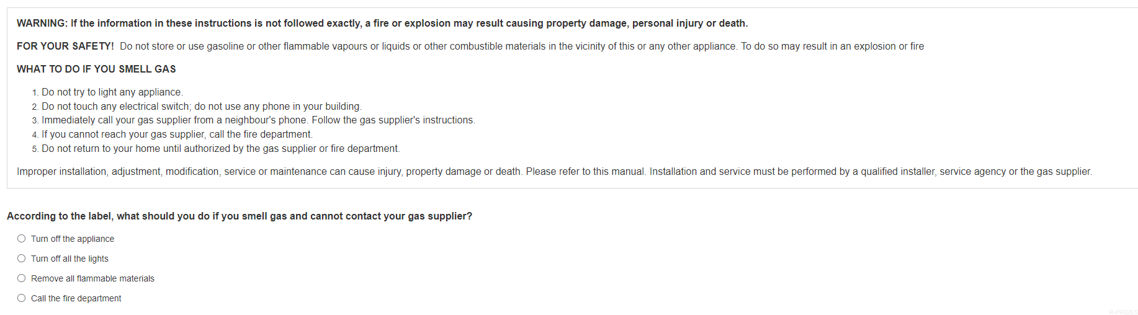

Reading Comprehension Assessment Tips
Source: Red River College Degrees of Reading Power Workshop
- Integrate Prior Knowledge – think about wha you already know about the topic. Identify personal experiences or second-hand knowledge that relates to the topic.
- Preview the text – give an initial glance, read the topic sentence and then try to predict an answer (mentally try filling in the blank). Then read the full text before answering. Was your initial prediction correct?
- Connections – what’s the key idea? Read all the topic sentences first on the page. Look for key words and phrases that supportthe topic sentence.
- Self-monitor – Get your rest. Turn off cell phone. Stretch. Drink water. Be comfortable. Pay attention to the test, not what’s your next agenda item for the day.
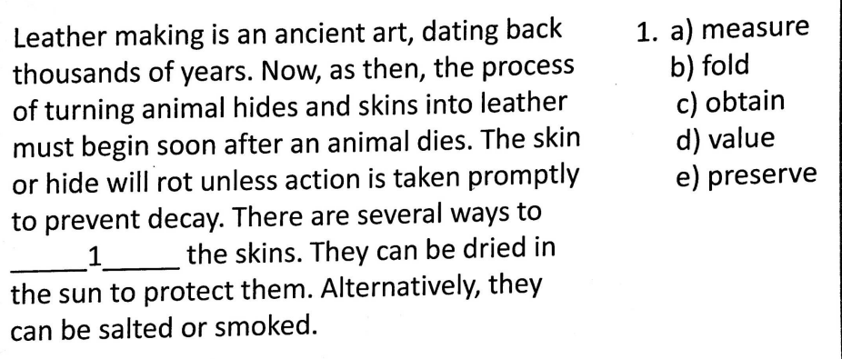
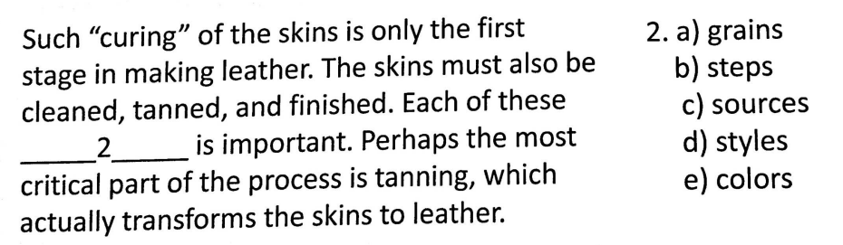

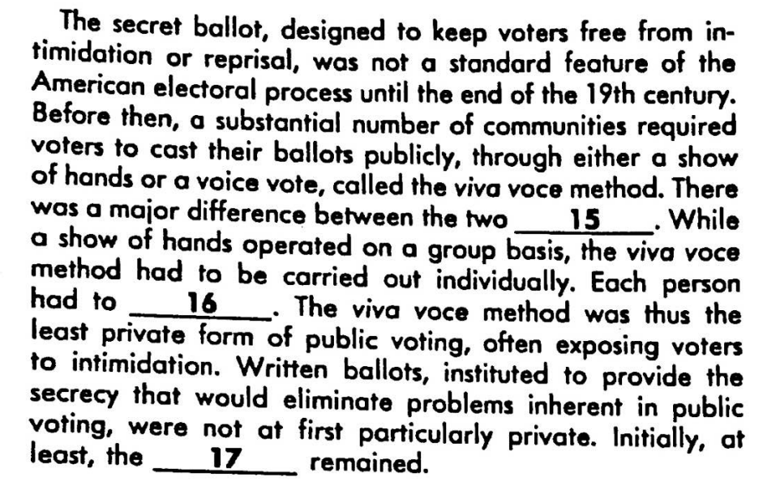
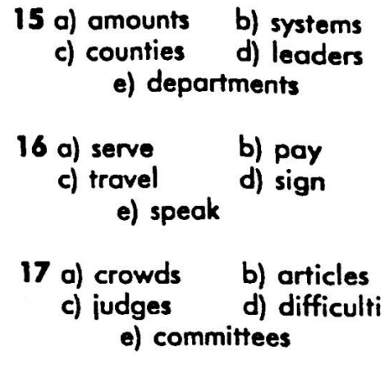
es

Summary
A document is a written, printed, drawn, photographed or electronic piece of information that provides evidence or proof, and is viewed as an official record.
Documents are set up in structured templates, have exact wording and require factual information.
Different types of workplace documents include:
- Entry forms (fillable forms)
- Lists
- Graphs and charts
- Mimetic documents (drawings, diagrams, plans)
Document use is an essential skill and as organizations collect, analyze, retrieve and report on data and information, workers must be proficient as using documents to meet business needs.
Being able to find your way around a document is called navigation – this allows the user to source out the information they need in a structured way.
4 Steps involved in document navigation:
- Understand document structure
- Skim
- Scan
- Use information

