

ESSENTIAL SKILLS TRAINING PROGRAM – DOCUMENT USE

PARTICIPANT GUIDE
Session 2

Workplace Education Manitoba would like to express appreciation to the following for supporting the development of this Continuous Learning Skills curriculum:
Employment and Social Development Canada (ERSDC) and
Manitoba Education and Training.
This project was jointly funded through Human Resources Skills Development Canada and Entrepreneurship Training and Trade.
For more information, visit www.wem.mb.ca or contact info@wem.mb.ca

INTRODUCTION TO ESSENTIAL SKILLS: what are Essential Skills?

The nine Essential Skills – What are they?

- Reading – understanding materials written in sentences or paragraphs
- Document Use – using and understanding checklists, symbols, labels and other similar materials
- Numeracy – using and understanding numbers
- Writing – writing txt or typing on a computer
- Oral Communication – using speech to share thoughts or information
- Working with Others – interacting with others to complete tasks
- Thinking – reviewing information to make decisions
There are 6 categories of thinking skills including:
- Problem Solving
- Decision Making
- Job Task Planning and Organizing
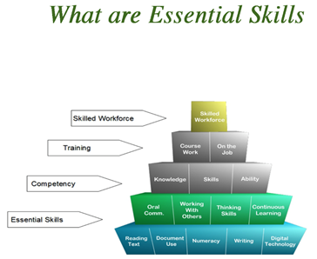
- Significant Use of Memory
- Finding Information

- Computer Use – using computers and other technical tools
- Continuous Learning – participating in an ongoing process of gaining skills and knowledge.

TRAINING OBJECTIVES

How I will use these skills:

- Contribute to classroom discussions by sharing, posing questions and providing responses
- Read and follow instructions to complete tasks
- Work with others to share knowledge
- Develop document use proficiency by watching, applying knowledge and practicing
- Identify opportunities to apply skills gained when back in the workplace

DOCUMENT USE WORKSHOP LEARNING OUTCOMES

Learners will be able to complete the following upon completion of the training:

- Demonstrate understanding of Document Use as an essential skill and how it applies in the workplace.
- Navigate the document process in a step-by-step manner.
- Recognize the importance of accurately entering and locating information in a variety of document templates such as forms, tables, lists and schedules.
- Identify various symbols, signs and legend markers.
- Recognize the importance of following instructions and reporting details in an objective fact-based manner

INTRODUCTION TO SESSION 2

As you learned in Session 1, in the workplace, documents are used by workers to find information needed to get their jobs done and for the collection and reporting of information needed elsewhere in work processes.

When dealing with documents, it is important for the user to understand a variety of factors about the document including its purpose, what the information is being gathered for, how it contributes to other work process and its overall importance in the workplace.

Some common types of documents include lists, entry forms, graphs & charts, and mimetic documents such as drawings, diagrams and plans

Today’s session will focus on lists, charts and graphs.

LISTS
(Adapted from SkillPlan Document Literacy Guide)

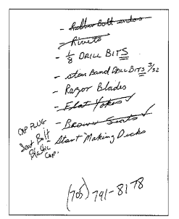
In a sense, lists are the building blocks of documents. They are a basic and universal way of organizing information in a way that makes it easier to understand, identify and analyze. Think about having a page of text and numbers and trying to find a specific piece of information. That might be an exercise in frustration! If that information is instead sorted in lists and tables, it can be a simple act of scanning the document for the information you need.

Chances are you have been dealing with lists since childhood. Think about Christmas and the “naughty or nice” list. In school we learned about putting lists in alphabetical order or chronological order (time ordered).

Lists can be quickly compiled and written down by hand, captured on your Smartphone or typed.

What are some lists you can think of?

___________________________________________________________________________
___________________________________________________________________________
___________________________________________________________________________
___________________________________________________________________________
___________________________________________________________________________
___________________________________________________________________________

Simple Lists

A simple list is a series of items which are related in some way. Usually, the title of the list is an indicator of what that relationship is (eg. Today’s To Do List).

All of the items in the list have one shared feature – the reason they have been grouped into a list (eg. Food items on a grocery list)

Each item in a well-formed list must be equivalent to the next. All items in the list must be the same type of example (eg. Eggs, bread, milk, butter).

Lists can be laid out vertically or horizontally.

Items in the list may be organized according to a particular convention (eg. most important to least, alphabetical, chronological, etc.)

Lists can also be steps in a process

Workplace Examples

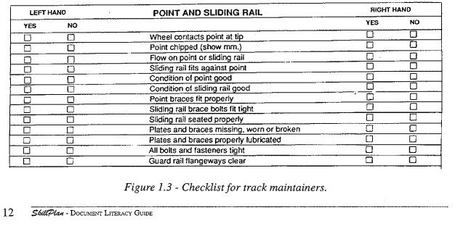
Figure 1.3 below is an example of a list used by maintenance personnel working on an urban transit line. The list on this form controls how the rail switch is to be checked, and the checkboxes ensure that each item on the list is examined. This would be an entry form used by staff as a checklist (note the checkboxes) or a list of directions to guide work performance.
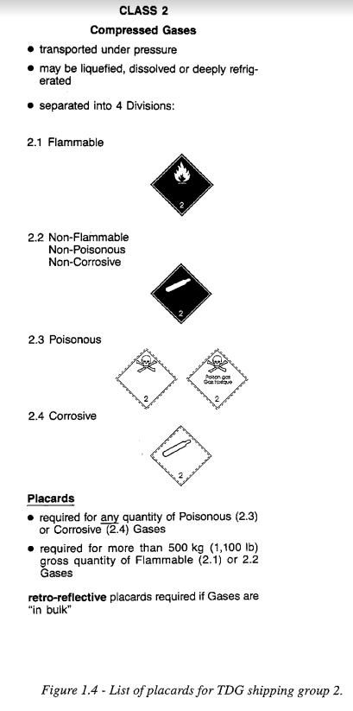

Figure 1.4 is another example of a list that serves to provide information about the transportation of dangerous goods. Notice how this list includes both text and symbols, not uncommon in the workplace.

Also notice the use of bullets () and numbers (2.1, 2.2….) to separate information for ease of reading and comprehension.
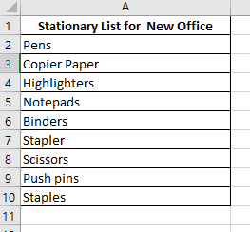
Another example of a list is inventory of office supplies. In this example, a staff member is responsible for setting up a new office and has made a list of stationery items that are needed.

Combined Lists

When two or more simple lists are combined, the resulting document is recognizable as a table. A table is a series of columns and rows that contain data in intersecting cells (much like what you would see in an Excel spreadsheet).

A table displays information in columns and rows and can be used to present data / information or can be an entry form which users will enter date or information.

Why used combined lists or tables? The main purpose is to be able to include data in one place for ease of access but also to gain understanding of what the combination of the lists mean.

For instance, you might have a list of employee names in alphabetical order. All that is telling you is that these are the employees. You may have a second list that lays out the shifts for the coming week. All that is telling you is that there are work shifts. By combining these two lists, you gain access to important information about which employee is working which shifts. This table is now useful and contains necessary information that would be missing from the two separate lists.

Combined lists or tables may be organized by a common convention (e.g. alphabetically, chronologically, etc.)

Examples of combined lists might be an inventory sheet that shows the items by quantity and price.

Example: We had our stationary list for the new office. Presumably, we went to the supplier’s website or a catalogue to find the cost per item. The combined list or table now looks like this:

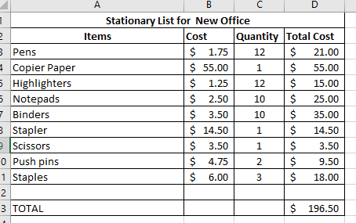
Now we have a useful set of information that can us make decisions about what to buy, what we can afford or to create a budget for setting up a new office.

Activity Create a Combined List

You have been tasked with organizing the upcoming staff potluck dinner. You have a list of employees and a list of items which need to be brought to the dinner. You decided that the easiest thing to do will be to create a combined list that shows the categories of items that need to be brought to the potluck and the list of staff. You want to print this table and put it up in the staffroom for people to complete.
Staff Names
Doug
Rebecca
Steven
Tara
Adrienne
Cooper
Janet
Richard
Damon
Polly
Dana
Categories
Breads/Buns
Dessert
Serving items (plates, etc.)
Hot dish
Appetizer
Salad

Using the table below, fill in the information on the horizontal and the vertical axes.

Intersecting Lists

The final list we will look at today is the intersecting list which is one that consists of three related lists.

Combined lists allow multiple pieces of information to be displayed but they are limited if there is more than two sets of data to be presented. What if we were in a situation where we wanted to include 3 lists into one table? The answer is the intersecting table.

An intersecting list consists of three related lists. Two of these lists are arrayed along the horizontal and vertical axes.
Terminology Check

Arrayed – positioned or laid out

Horizontal axis – data displayed from left to right

Vertical axis – data displayed up and down

Both axes of the intersecting list are searched to match search terms and find information in the third list. Required information I found at the intersection of the two search lists.

Workplace Example

Judy, the Office Manager at IBD, is responsible for setting the shift schedule for the shipping office. She drafted the schedule in the form of a chart which combined a list of names, a list of jobs, and a list of shift numbers. Her original combined list looked like the one below. The problem is that she cannot quickly answer some questions such as:
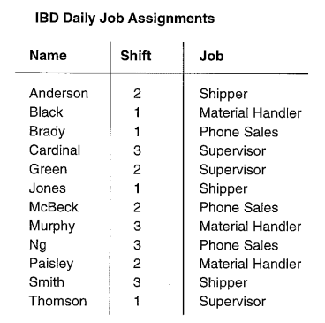
- Who is doing the phone sales on shift 3?
- Which job is Smith doing?
- Which employees are responsible for material handling?
Judy can use an intersecting list to better lay out the information so she can answer questions much more quickly with a quick glance. This new table also takes up less room and is much easier to understand who is doing what and on which shift.
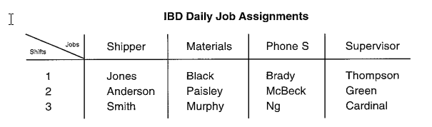

Activity Create an Intersecting List

Using the combined list you created in the last activity, now convert it to an intersecting list by adding information that connects the horizontal axis (item categories) with the vertical axis (staff members)

Imagine you have been told that Dana is going to bring dinner rolls, Tara is bringing perogies and Polly is bringing Caesar salad. Update your table with this information.

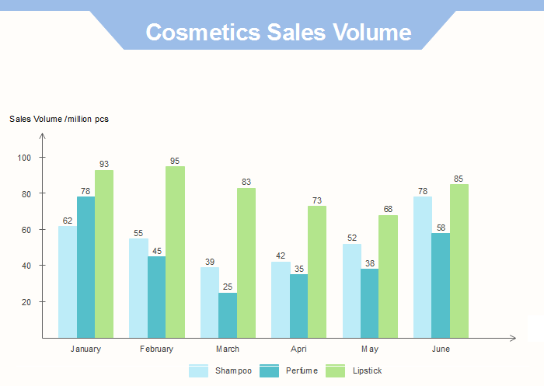
CHARTS AND GRAPHS

Graphs are a way of summarizing numerical data and displaying information quickly. They are used in a wide variety of work settings by workers in many different occupations:
- A store manager compares last year’s sales figures to this year’s to find out whether sales are up or down.
- A hospital administrator reviews trends in emergency room admittance rates to understand how new policies may affect patient care.
- A machinist compares graphs that record machining output to learn when parts are machined outside acceptable tolerances.

In this session we will look at 2 common types of charts/graphs: Bar charts and Pie Charts.

Common Charts – Bar Charts

Bar Graphs represent amounts. Typically display several bars so workers can compare numbers across different categories. The length of each bar represents a quantity. When read together the bars show how quantities relate to eachother. Some uses:

- Display the dollar value of sales in different months in the sales and services sector.
- Show how much was produced in a manufacturing setting.
- Bar charts can extend vertically (up and down) or horizontally (sideways)
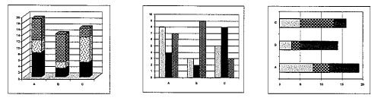

Reading Bar Charts

- Scan the graph to locate the title.
- Locate the y-axis (vertical) and the x-axis (horizontal).
- Locate the legend to identify categories or subcategories for the graph.
- Identify any additional information, such as data labels, found in the graph.

Activity Practice reading a bar chart

Using the bar chart on the next page “Bar Graph 1.1” answer the following questions:

- What is the title of this graph? ____________________________________________________
- What does the x-axis display? _____________________________________________________
- What does the y-axis display? _____________________________________________________
- What does the legend tell you? ____________________________________________________
- What additional information, if any, does this bar graph display? _________________________
- In your own words, summarize what this bar graph displays. Try to keep your description brief.
________________________________________________________________________________
________________________________________________________________________________ ________________________________________________________________________________ ________________________________________________________________________________
- How many customer contact minutes were there in June? __________________________________
- Which month had the most customer contact minutes? ____________________________________
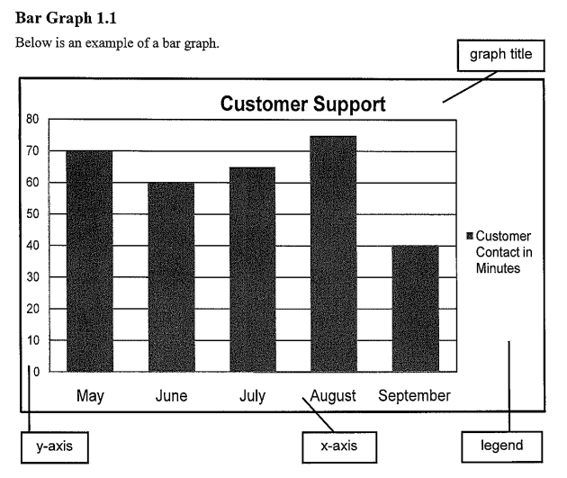

Common Charts – Pie Charts

Pie charts are mainly used to represent proportions (parts) or percentages. The circle represents the whole and the proportion or parts of the whole are represented as pieces or segments of the pie or circle.

Some workplace situations where you may encounter pie charts are:
- Sales associates read pie charts to see which products consumers buy most.
- Administrative assistants create pie charts to show the proportion of time they spend completing different activities each day.
See some examples below of pie charts.
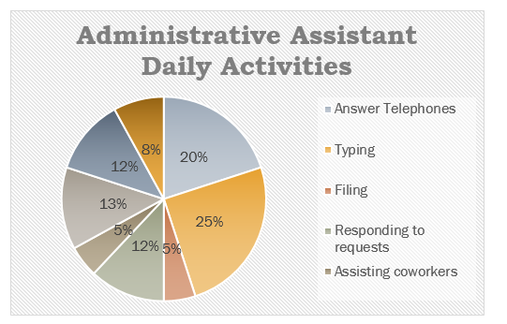

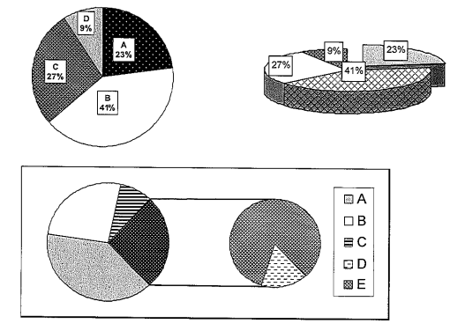
Reading Pie Charts
- Scan the pie chart to identify the title.
- Locate the legend, if presented, to identify the categories displayed.
- Examine the sections of the circle to identify any additional information contained in the chart. In some cases, the data labels for the segments of the circle contain a great deal of information. Any combination of the following can be included: percentage, number or category name.
Activity Practice reading a Pie Chart

Using the following Graph A and Graph B, answer the questions below.
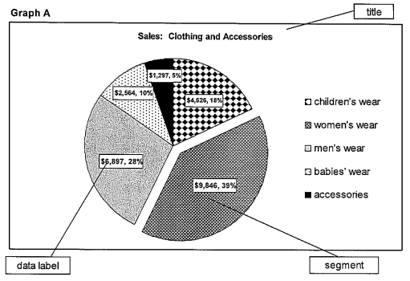
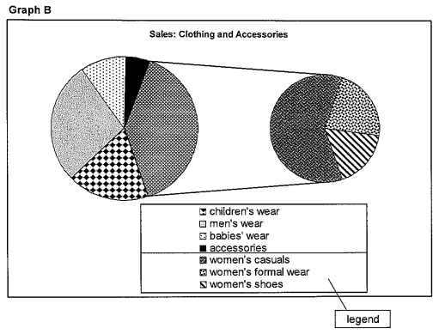

- What is the title of the graphs? ________________________________________________________
- What are the categories displayed on the first graph? ______________________________________
________________________________________________________________________________________________________________________________________________________________________________________________________________________________________________________________________________________________________________________________________
- What two pieces of information are contained in the data labels on pie chart A?
- Using your own words, summarize what Graph A displays. Include information about what the whole and segments represent. _______________________________________________________
________________________________________________________________________________________________________________________________________________________________________________________________________________________________________________________________________________________________________________________________________
- What kind of business might create this graph? ___________________________________________
- Graph B gives further information about one segment of Graph A. Look at both graphs A and B to figure out which segment is shown in more detail. ________________________________________
_________________________________________________________________________________ _________________________________________________________________________________

Additional Practice Activities

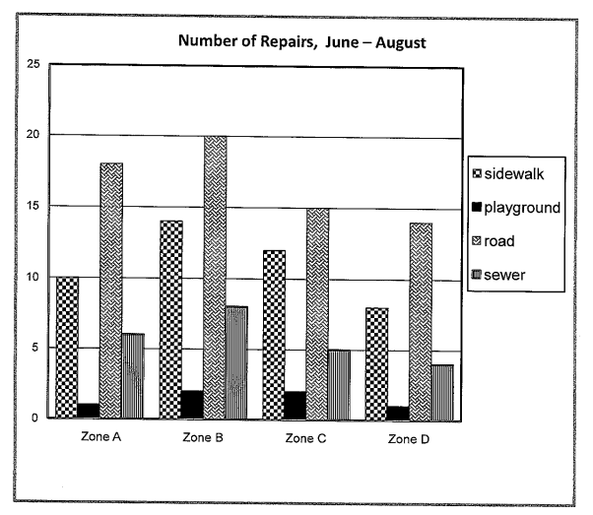
Bar Chart Practice - Graphs can be used to show type and amount of work completed. This graph displays the amount of work that has taken place. Refer to the graph below to answer the questions that follow.
- The graph shows the number of repairs during one part of the year. Which months are included on the graph? ________________________________________________________________________
- How many zones are represented on the graph? _________________________________________
- What are the four types of repairs on the graph? _________________________________________
- What are the four types of repairs displayed on the graph? _________________________________
- How many sidewalk repairs were there in Zone A? ________________________________________
- Which repair is carried out most frequently? _____________________________________________
- Which zone required the most repairs during this time period? ______________________________

Pie Chart Practice - Graphs can be used to summarize survey responses. This graph shows the results of a customer survey question. Refer to the graph below to answer the questions that follow.
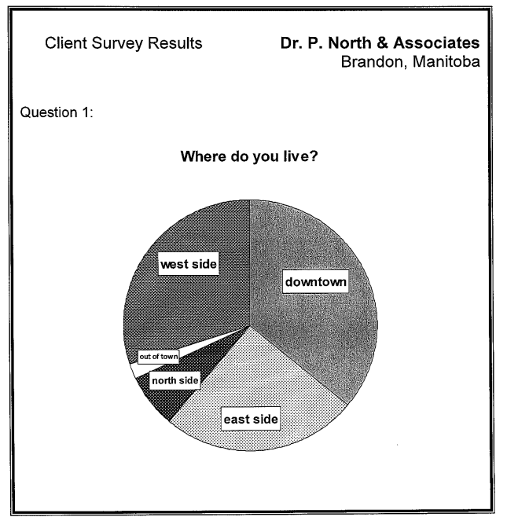

- What is the name of the company? ____________________________________________________
- This graph shows the results of a customer survey question. What is the survey question? ________
__________________________________________________________________________________
- Where do the fewest clients live? ______________________________________________________
- One thousand clients were surveyed. Approximately how many said they were from east of the city?
__________________________________________________________________________________
- This doctor’s office is located downtown. There are plans to open a new location. Use the survey data to decide where the new office should be located. ____________________________________

Summary

- Lists are the “building blocks” of documents
- Used to organize information to make it easier for users to understand, identify and analyze.
- We looked at 3 different types of lists: simple, combined and intersecting.
- Graphs are a way of summarizing numerical data and displaying information quickly.
- We looked at 2 different types of charts: bar charts and pie charts
- Some strategies for reading charts include examining:
  - Title
  - Labels
  - Legends

  - Chart parts (axes, segments, etc.)

Next Class

- Entry forms
- Mimetic Documents (drawings, blueprints, schematics, diagrams)
- Document reading skills

Practice Activities Answers:

Bar Chart Practice

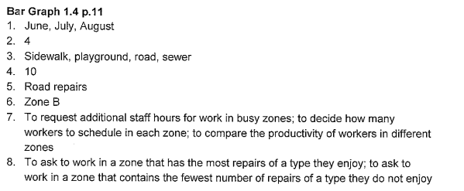

Pie Chart Practice

