*



ESSENTIAL SKILLS TRAINING PROGRAM – DOCUMENT USE

SESSION 3
PARTICIPANT GUIDE

Workplace Education Manitoba would like to express appreciation to the following for supporting the development of this Continuous Learning Skills curriculum:
Employment and Social Development Canada (ERSDC) and
Manitoba Education and Training.
This project was jointly funded through Human Resources Skills Development Canada and Entrepreneurship Training and Trade.
For more information, visit www.wem.mb.ca or contact info@wem.mb.ca

INTRODUCTION TO ESSENTIAL SKILLS: what are Essential Skills?

The nine Essential Skills – What are they?

- Reading – understanding materials written in sentences or paragraphs
- Document Use – using and understanding checklists, symbols, labels and other similar materials
- Numeracy – using and understanding numbers
- Writing – writing txt or typing on a computer
- Oral Communication – using speech to share thoughts or information
- Working with Others – interacting with others to complete tasks
- Thinking – reviewing information to make decisions
There are 6 categories of thinking skills including:
- Problem Solving
- Decision Making
- Job Task Planning and Organizing
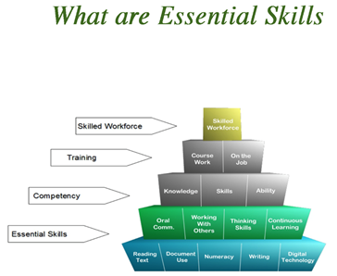
- Significant Use of Memory
- Finding Information

- Computer Use – using computers and other technical tools
- Continuous Learning – participating in an ongoing process of gaining skills and knowledge.

TRAINING OBJECTIVES

How I will use these skills:

- Contribute to classroom discussions by sharing, posing questions and providing responses
- Read and follow instructions to complete tasks
- Work with others to share knowledge
- Develop document use proficiency by watching, applying knowledge and practicing
- Identify opportunities to apply skills gained when back in the workplace

DOCUMENT USE WORKSHOP LEARNING OUTCOMES

Learners will be able to complete the following upon completion of the training:

- Demonstrate understanding of Document Use as an essential skill and how it applies in the workplace.
- Navigate the document process in a step-by-step manner.
- Recognize the importance of accurately entering and locating information in a variety of document templates such as forms, tables, lists and schedules.
- Identify various symbols, signs and legend markers.
- Recognize the importance of following instructions and reporting details in an objective fact-based manner

INTRODUCTION TO SESSION 3

In Session 2 we gained familiarity with using lists and examined different types of lists including simple lists, combined lists (tables) and intersecting lists. Lists are a building block of documents. They are a basic and universal way of organizing information that makes it easier to understand, identify and analyze.

We also examined a variety of charts and graphs which present information, sometimes very detailed information in the form of a picture. Charts are graphs are an efficient means of presenting complex information. Some common charts include bar charts and pie (or circle) charts.

In Session 3 we move on to working with entry forms. Forms are documents that combine text that you read with spaces where you need to enter information. You may need to fill in one word on a line such as your name, or you may need to write a sentence or two, for example, when describing an incident. Requesting vacation time, filing incident reports, completing daily logs and tracking movement of money are examples of tasks that may require the use of forms.

Read Different Types of Forms

In the workplace, there are times when you are not completing forms but rather, reading and interpreting forms completed by others. An example of a completed form is a driver’s licence. It doesn’t seem like that would be a form but it is! Why? Because it contains different types of data (including a picture, abbreviations, reference numbers, addresses, dates, signatures) and uses just words or phrases, no paragraphs.
Province where licence was obtained
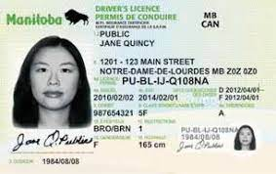
Driver’s height is 165 cm or 165 m. Her eye colour is BRO or brown.
EXP is an abbreviation for expiry date
Photo and signature area

Entry Forms

You use forms when you apply for a credit card or a passport. When you are completing a form, you use items such as checkmarks or Xs and you write or type in information such as dates, signature, quantities, words (your name, for example), short descriptions and short sentences. Forms also often use icons, pictures and abbreviations.

Because forms required that a lot of information be entered in many different ways, it can be easy to miss entering some information. Because the way you enter the information on forms often appears to be “simple” many people tend to speed through completing them. As a result, forms are the workplace documents that are to be completed incorrectly.

Strategies for Completing a Form

- Read the whole form through to understand what it is asking for.
- Be sure you understand what is being requested.
- Give thought to why this data is being collected – how will it be used.
- Take your time completing it
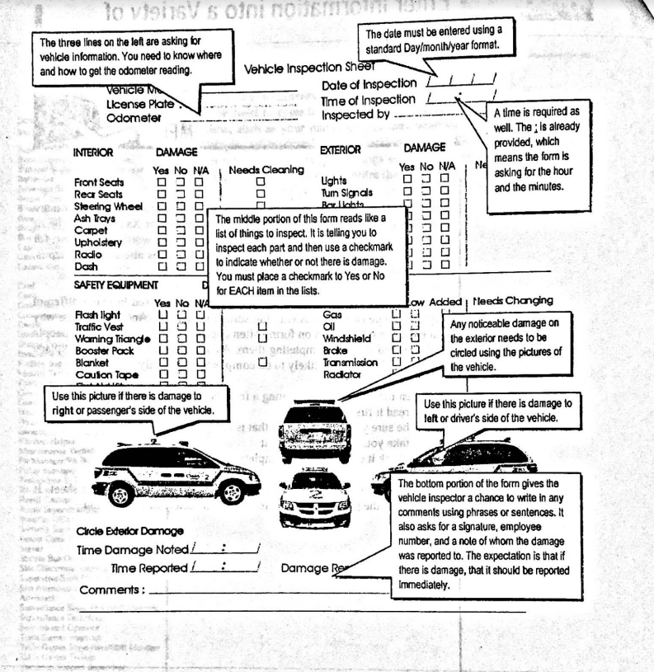
- Check over for completion.
Look at the following form. It is a vehicle-inspection sheet. It requires that the person using this form enter a variety of information.

You use many forms, sheets and logs in your job. While a document might be called a “form”, you may be able to understand the document by breaking it down into its parts – does it have lists, tables, drawings, etc. in the form?

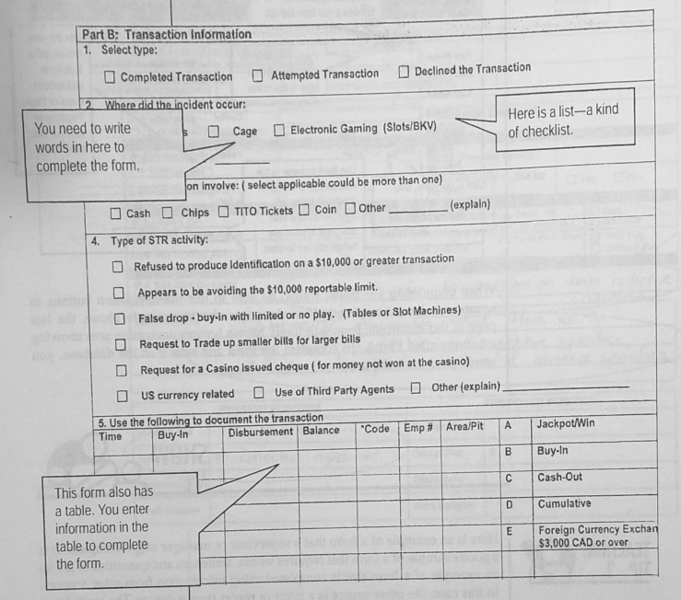

Electronic Forms

Many forms are electronic, accessible and fillable via computer or other electronic device. When completing an electronic form you use letters and numbers, but you also use your mouse to make selections in drop-down boxes or by clicking on radio buttons.
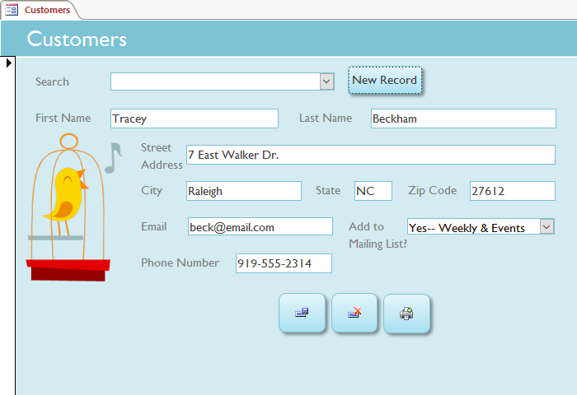
On an electronic form, you are entering data into what seems to be a form, but often it is really a database that you are entering. What you are really doing is entering information into tables that are stored in a database.

A record is a collection of fields (e.g. name, address, date, etc.)

Databases are made up of records.

Data can be “queried” to run reports containing specific data (eg. Run a report to show all of the clients in a certain postal code)
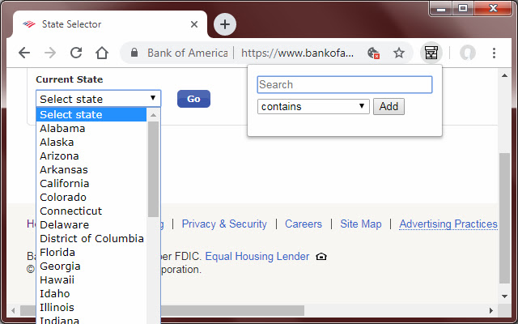

Drop Down Menu

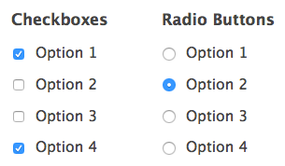
Radio Buttons and Checkboxes

When completing electronic forms, be sure to use the navigation buttons to ensure you have completed all of the pages. These buttons may say “Previous”, “Next” or “Finish”. It is important that you follow the instructions and ensure you click “Finish” or “Save” to actually save the data you entered into the database collecting the data.

Practice!

Now it is your turn. Try these practice activities to see how well you have learned this skill. Look at the form below. It is an example of a form that is completed after a worker sustains an injury at work. Use the form to complete the questions that follows:
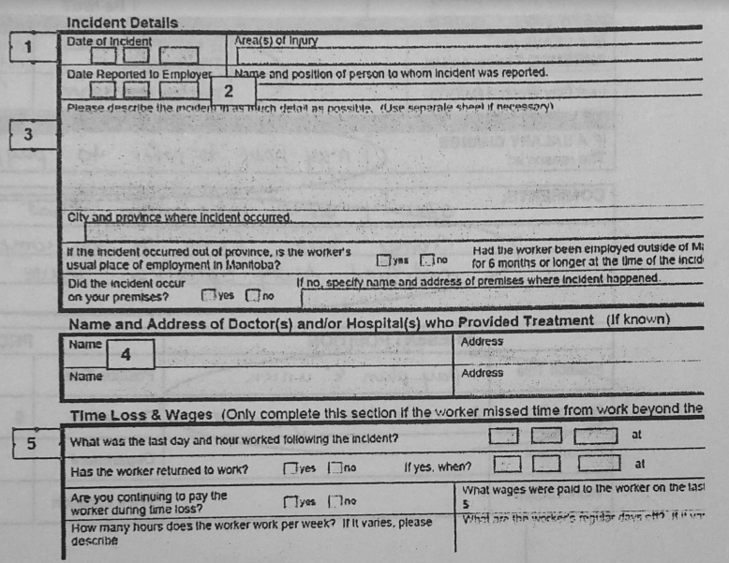

- In area 1 on the form, which of the following information would you enter?
  - Date this form was completed
  - Date the incident was reported to the employer
  - Date the incident occurred

- In area 2 on the form, which of the following information would you enter?
  - The injured employee’s name and position
  - The injured employee’s manager’s name and position
  - The name and position of the person who was reported to after the incident

- In area 3 on the form, which of the following information would you enter?
  - The employee was late for work and rushed too much while doing the cleaning of the light fixtures
  - The employee was using a ladder to dust the light fixtures in the main entrance. The ladder was set up according to correct procedure. The employee was on the third step from the top, dusting a light fixture when a guest accidentally bumped the ladder. The employee fell from the ladder and landed on his wrist. The valet attendant quickly assisted the employee and called for a manager. The employee did not put out a sign warning that a ladder was in use.
  - The employee forgot to put a sign out to say he was going up a ladder, so he fell when a guest bumped the ladder.

- In area 4 on the form, which of the following information would you enter? There is mor than one correct answer. Circle all that apply.
  - The name of the doctor who treated the injured worker.
  - The name of the paramedic who treated the injured worker.
  - The name of the hospital where the worker was taken after the injury.

- In line 5 on the form, which of the following information would you enter?
  - The date and time of the last shift the injured worker was scheduled to work that week.
  - The date and time the accident occurred.
  - The date and time the worker stopped working after the accident occurred.

Imagine if you were a front desk clerk at a hotel and someone was checking in. You might ask for the driver’s licence to verify the person in front of you is the person who made the reservation. You may enter this driver’s licence information into the hotel’s guest database. You would likely be looking for the key information noted on the previous page and transferring this information into your database.

Document Use Practice

Additional Practice Hand-Outs

- Self-Assessment # 2
- Self-Assessment #14

Notes

