Rationale:


Much of the mathematics required in the workplace comes in the form of problems. To simulate, practice, and prepare for these workplace problems- “word problems” are used. Word problems are composed of typical workplace situations (or every day life situations) that require mathematics to solve a problem. Completing word problems simulates workplace problems and prepares workers for the challenges of the work.

The primary skill used in the solving of word problems is to translate the word problem into a mathematical question. With practice you will able to “read” a word problem while seeing a “mathematical” question and solution.

Objective:

The objective of this module is to practice solving word problems, as a way of developing skills to solve workplace problems. To achieve this overall objective, learners will:
- Learn a generic process for solving work problems
- Practice each step of the process
- Apply the process to solve a variety of work problems

Process:

The process for solving word problems consists of seven steps:
- IDENTIFY the specific question embedded within the word problem
- LOCATE the information within problem that will assist in solving the problem
- RECOGNIZE the need for general information (pi= 3.14, A= L x W)
- DETERMINE the mathematical operation(s) required to solve the problem
- COMBINE the relevant information and the required operation(s) into a mathematical statement
- CALCULATE the answering using the mathematical statement
- Decide if the answer is plausible

Each step will be introduced and practiced separately through a series of activities.
After each step has been learned individually, there will be a number of problems that require the application of the process to a variety of word problems.


STEP 1: Identify the question

Instructions
Read each problem and identify the question embedded within the problem by checking the question listed below the problem.

- Apples sell for $1.09 per pound. You plan on buying 2 ½ pounds of apples. How much will this cost?
- What is the cost of a pound of apples?
- How much will 2 ½ pounds of apples cost?
- How much will ½ pound of apples cost?

- You buy items costing $1.99, $4.87, and $8.99. You pay with a $20.00 bill. How much money will you receive in change?
- How much was the sales tax?
- How much money will you get back from your $20.00 bill?
- How much more is the expensive item than the cheapest item?

- How long will it take you to travel 100 kilometers if you are driving at a rate of 60 kilometers per hour?
- How far are you from your destination?
- What time will you arrive?
- What is the amount of time required to travel 100 kilometers at 60 KPH?

- A train leaves Thunder Bay at 9:00 AM traveling at 180 KPH heading to Calgary. A train leaves Winnipeg at 12:00 noon traveling at 90 KPH also heading for Calgary. When will the Thunder Bay train catch up to the train from Winnipeg?
- How much faster is the Thunder Bay train than the Winnipeg train?
- Why is the Winnipeg train going so much slower?
- At what time will the Thunder Bay train pass the Winnipeg train?

- At a garage sale Joe bought a tennis racquet for $5.00. The same racquet at the sporting good store sells for $25.00.
- How much money did Joe save by buying the racquet at the garage sale?
- How much did Joe save by not paying sales tax?
- There is no question stated in this problem

- Mrs. Unka can buy a washing machine for $750.00 if she pays cash. Or she can pay $70.00 a month for 12 months. How much will she save by paying cash?
- The cost of the washer if she pays over 12 months
- The amount of money saved by paying cash
- Can Mrs. Unka afford to buy the new washer
STEP 2: Locate the information
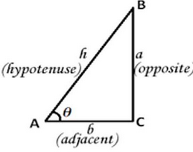

Instructions:
Read each problem and locate the information required to answer the question embedded in the problem. List the specific information in the space provided.

- Apples sell for $1.09 per pound. You plan on buy 2 ½ pounds of apples. How much will this cost?

- Cost of 1 pound- _________________________________

- Amount you plan on buying-________________________

- How long will it take you to travel 100 kilometers if you are driving at a rate of 60 kilometers per hour?

- Distance to travel-_________________________________

- Rate of speed-____________________________________

- Mrs. Unka can buy a washing machine for $750.00 if she pays cash. Or she can pay $70.00 a month for 12 months. How much will she save by paying cash?

- The total cost of buying the washer over the 12 months___________________

- The cost of the washer if she pays cash_________________________________

- Mr. Lee makes $60,000 a year. He spends1/3 of his earnings on his mortgage, $300 dollars a month on food, and he has car payments of $250.00 a month. After paying for these three major expenses how much money does Mr. Lee have for clothing, entertainment, and all his other bills?

- Cost of mortgage in dollars-___________________________________
- Yearly cost for food-_________________________________________
- Amount spent on car payments for the year-_____________________

- How thick would a stack of seven sheets of 3/8 inch plywood be?

- Thickness of one sheet of plywood-_____________________________
- How many sheets in the stack of plywood-_______________________

- Total membership in a union is 5000 people. 88% of the members voted in favour of the collective agreement. How many members voted in favour?

- Total number of members in the union-_________________________
- Percentage that voted in favour-______________________________



STEP 3: Recognize the need for general information

Instructions:

Sometimes word problems assume the person who is solving the problem has a piece or pieces of general information required to solve the problem. For example, if a problem asks you to determine the circumference of a circle an assumption has been made that the solver of the problem knows the formula (C= Pi x Diameter of the circle). Also it is assumed that the solver knows that Pi= 3.1416. Read each problem and recognize what general information is required to solve the problem.

- You buy $43.66 worth of goods. What is the total cost of your purchase including sales tax?

- General information required- _________________________________

- You are carpeting a room for a customer. The dimensions of the room are 8 feet by 9 feet 10 inches. The cost of the carpeting is $8.99 a square foot. How much will the carpet for this room cost?

- General information required- __________________________________

- A hall way measures 12,341 cm. What is the distance in meters?

- General information required- __________________________________

- A farmer delivers 288 eggs to the store. The store sells the eggs for $2.99 a dozen. How many dozen eggs did the store receive?

- General information required- __________________________________

- You are working for a swimming pool installation company. You are assigned the duty of filling a swimming pool with water. The dimensions of the pool are 32 feet long, with a wide of 17 feet, and an average depth of 6 feet. How much water do you need to fill the pool.

- General information required- ___________________________________

- A bar receives a shipment of 40 cases of beer (24 bottles per case). The bar sells the beer for $3.00 a bottle. What is the total revenue derived from the 40 cases of beer.

- General information required-____________________________________



STEP 4: Determine the mathematical operation


Instructions
There are four foundational mathematical operations: adding, subtracting, multiplying, and dividing. One or more these operations will be required to solve a word problem. There are some key words in word problems that can “tip you off” as to what is the appropriate operation to use. While these words are not fool proof as the wording within a problem may alter the meaning of the word, they tend to be quite reliable indicators of what operation to use to solve the problem. Here is a list of key words and the operations they tend to indicate:

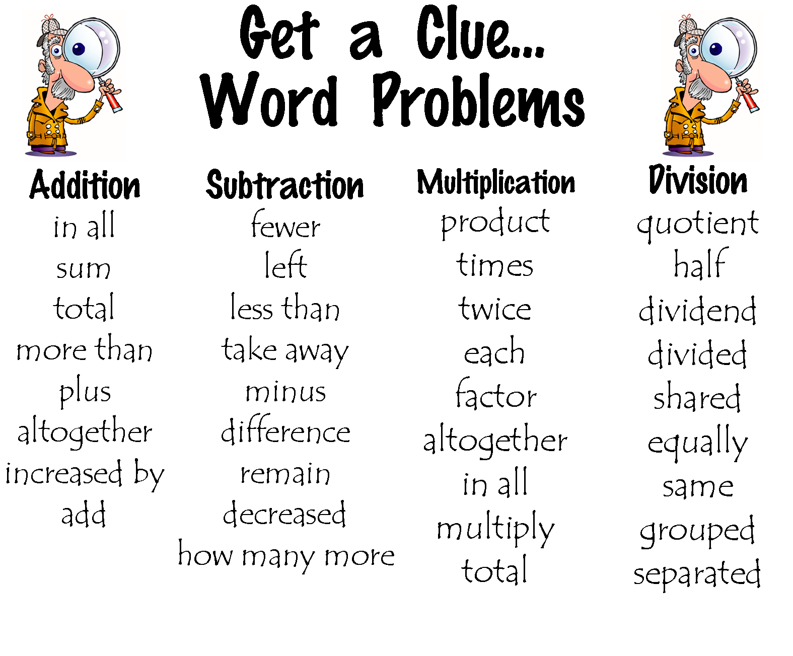

Read each problem and indicate the key word and the operation(s) that should be used to solve the problem.

- Bonnie was paid $10.00 an hour. In her new job she will be paid $12.50 per hour. How much more will she be making per hour?

- Key word- ______________________________
- Operation- _____________________________

- Sixty per cent of the 500 students enrolled in class did not attend the dance. How many members of the class did not attend the dance?

- Key word- _______________________________
- Operation- ______________________________

- Ron worked 9 hours a day for 6 straight days. How many hours did Ron work in total?

- Key word-_______________________________
- Operation-______________________________

- Two pipes are being used to fill a pool. One fills the pool at the rate of five gallons per minute. The other works at the rate of six gallons per minute. How long will the pipes take to fill a 6,000-gallon pool if they are used together?

- Key words- _______________________________
- Operation(s)- _____________________________

- If an average worker gets paid $15.50/hour working construction outside, and works a 10-hour day. How much more does he make than a worker working the same number of hours inside at a rate of $13.75 (assuming there is no overtime for either employee) ?

- Key words- ___________________________
- Operation(s)- _________________________

- Shelly filled the tank on her truck and paid $80.00. Gas was selling for 99.5 cents/ per litre. How many litres of gas did she buy?

- Key words-____________________________
- Operation-_____________________________
STEP 5: Combine the relevant information
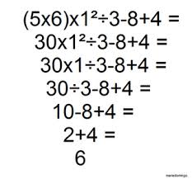
Now that we have determined all the relevant information required to solve the problem and have determined the proper operation(s) to apply, this information needs to be expressed as a mathematical question.

Read each of the following problems to determine the relevant information and the proper operation(s) to create a mathematical question to be solved. Check the mathematical question that best summarizes the word problem.

- A customer pays for items with a $20.00 bill for items costing $4.99, $1.21, and $6.99. Each items is subject to 8% sales tax. How much change will you give the customer?

- $20.00- ($4.99 + $1.21 + $6.99)=
- $20.00 - .8 x ($4.99 + $1.21 + $6.99)=
- $20.00 - .08 x ($4.99 + $1.21 + $6.99)=

- The purchaser for the clothing department of a major retailer can purchase 120 women’s sweaters at a cost of $900. What is the cost per sweater?

- 120 x $900=
- $900/ 120=
- 120/ $900=

- Two pipes are being used to fill a pool. One fills the pool at the rate of five gallons per minute. The other works at the rate of six gallons per minute. How long will the pipes take to fill a 6,000-gallon pool if they are used together?

- 11 x 6,000 gallons=
- 6,000 gallons/ (5 gallons per minute + 6 gallons per minute)=
- 6,000/ (6-5)=

- A housecleaner has run out of window cleaning fluid and wishes to purchase more. At the store, she finds that a 44-ounce bottle of cleaner costs $2.75, while a 55-ounce bottle of a different brand costs $3.70. Which is the better buy?

- $2.75/ 44 ounces= cents per ounce
$3.70/ 55 ounces= cents per ounce
- $3.70 - $2.75=
- ($2.75 + $3.70) / (44 + 55)=

- You are driving a delivery truck and you need to make a trip of 250 kilometres. You fill the tank with 155 litres of gas and your bill comes $225.00. How much did you pay per litre of gas?
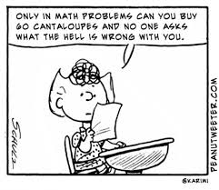
- 250 kilometers/ 155 litres=
- 250 kilometers/ $225.00=
- $255.00/ 155 litres

STEP 6: Calculate the answering
using a mathematical question

Use the steps outlined in this module to solve each of the following word problems. Space is provided for you to outline the mathematical question and to solve the problem.

- The purchaser for the clothing department of a major retailer can purchase 120 women’s sweaters at a cost of $900. What is the cost per sweater?

- A stockperson at a sporting goods store noted the following sales of balls for the month of January in a bar graph:

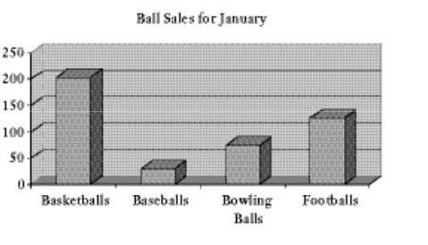
How many more basketballs were sold than footballs in January? What was the total number of balls sold in January
- You purchase $3776 worth of building material. You need to pay PST of 8% and GST of 6%. How much tax do you have to pay? With tax what is the total cost of your bill?

- A lumber supplier makes 16% profit of what is sold. One order was for $2845- how much profit did the supplier make on this order?

- A lot takes up 43,560 square feet. The house and garage take up 6,534 square feet. What percentage of the lot do the house and the garage take up?

- A proportion of 1:3:6 is used to mix cement, sand, and gravel for concrete. How many cubic meters of each should be used to mix 86 cubic meters of concrete?

- The amount of power used in an electrical maintenance shop are as follows:
- April- 41.2 Kilo-watt hours
- May- 59.25 kilowatt hours
- June- 53.63 kilowatt hours
- July- 62.4 kilowatt hours

What is the average monthly power usage? Express the answer to the nearest hundredth.
- An electrician estimates 3 bundles (each bundle is 100 feet) of ½ inch conduit are needed to wire a house. Each bundle costs $62.00 a bundle or $0.62 per foot, the electrician used the following amounts:
- Living room- 42 feet
- Dining room- 38 feet
- Kitchen- 115 feet
- Bedroom A- 24 feet
- Bedroom B- 39 feet
- Bathroom- 12 feet

What was the cost per room? What was the average cost per room? Did the electrician’s estimate cover the cost of the job?

- Five light fixtures for a house cost: Type A- $15.83, Type B- $21.75, Type C- 19.69, Type D- 24.30, and Type E- $9.49. The electrician estimated the cost about $19.00 per fixture. What is the average cost per fixture? How close was the electrician on the estimate?

- A mechanic works on a transmission overhaul. The starting time is 8:00 AM and the finishing time is 3:00 PM, allowing 1 hour for lunch and a rate of pay of $12.85 per hour, how much did the mechanic earn doing this job?

- A piece of 3/8 inch tubing is 20 feet long. One piece of tubing measuring 9 ¾ inches long is cut from the piece. How much of the tubing remains. Express your answer in feet and inches.

- Bob bought a new car. Monday he drove 45 KM. On Tuesday and Wednesday he went 89 and 78 KM. Bob’s 6-passenger car was able to get 100KM/L. How far did Bob travel in his new car?

- Manitoba Moose averaged 6200 fans per home game. If they played 42 home games and 43 road games, how many fans came to MTS Centre to see the Moose.

- Eggs come on flats of 144 eggs per flat. The delivery truck carries 112 flats when it delivers to 12 customers. How many eggs does the truck carry?

- The cook at Pizza Place surveyed his customers regarding the type of pizza crust they prefer. The graph of his findings follows:

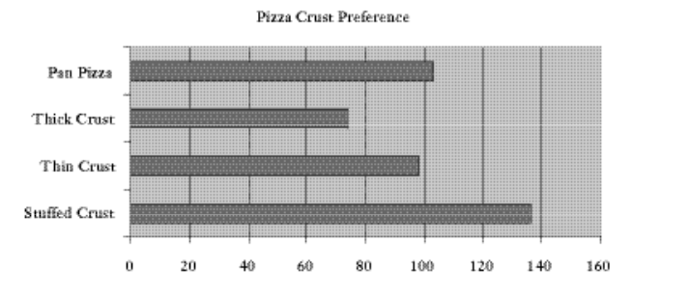
What percentage of customers preferred thick crust pizza? Stuffed crust pizza made up what percentage of the total customer preference?

- Refer to the table out ling the wages of employees at Barb’s Bar B Que:
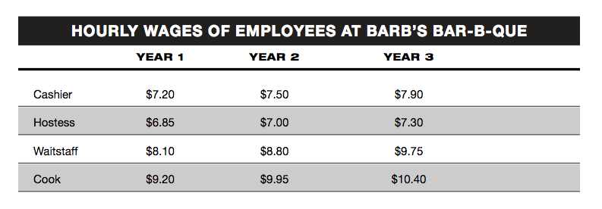

What is the difference in the weekly paycheck of a first-year Cashier and a second-year Hostess, assuming each works a 35-hour week?

- Refer to the following graph to answer the questions listed below. The graph represents sales data for a cell phone distributor for the months since the company was created:

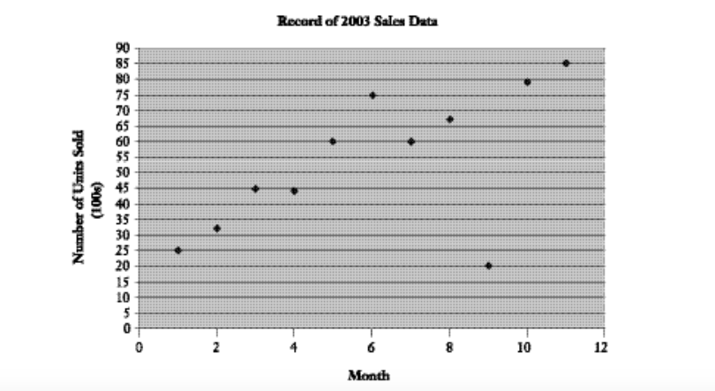

What is greater the increase in sales in months 1 and 2 or the decrease in sales in months 6 and 7? Your boss asks to write a one-sentence summary to describe the sales of cell phones over the past 12 months- what would you write?

- Weight for steel beams, slabs and angle iron are usually calculated in pounds per square foot. Complete the table below:

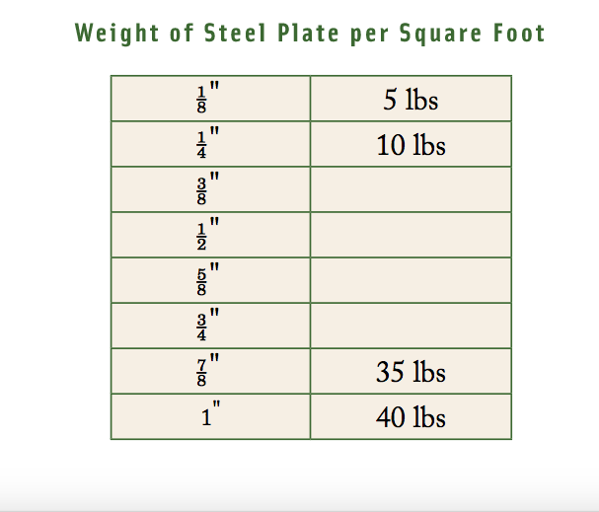

- Using the chart above calculate the weight of a steel plate 3/4" thick with a diameter of 5'.

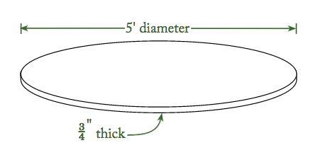

- A carpenter takes one day to complete ½ set of cabinets. What fraction is completed in ¼ of a day?



STEP 7: Decide if the answer plausible

Estimating is important part of mathematics and a very handy tool for everyday life. Get in the habit of estimating amounts of money, lengths of time, distances, and many other physical quantities. One of the best ways to estimate is round the numbers in the question to the nearest practical number. For example $4.89 cents would round up to $5.00. Once you have rounded the numbers do a quick calculation in hour head. Compare your estiamted answer with your calculated answer. If the numbers are reletively close most likeliy your answer is correct. Another way to decide if your answer is plausilbe is to determine if your answer makes sense in the real world. For example if some one pays with a $20.00 bill- most likely they will not get $1000.00 back as change.
Instrutions:
Go back to the 20 word problems you have just completed and estimate your answers and see if your calculated answers are similar to your estimated answers. Then look at each of your answers and ask your self- “Does this answer make sense? Is it logical?”. If the answer to both questions is yes, then there is a good chance your answer is correct.

