Module Name: Problem Solving

Purpose: Much of the mathematics required in the workplace comes in the form of problems. To simulate, practice, and prepare for these workplace problems, “word problems” are used. Word problems are composed of typical workplace situations (or everyday life situations) that require mathematics to solve a problem. Completing word problems simulates workplace problems and prepares workers for the challenges of the work.


Logistics: 19 spots throughout the 12-week program

Facilitator: Member of WEM Facilitation Team

Special Instructions:

The focus should be to teach learners to understand the structure of the problem first, the tendency of good problem solvers, and not to focus on the details of the problem, which is what poor problem solvers do. This helps to prevent the “analysis paralysis” poor problem solvers encounter when becoming overwhelmed with the information in the question. As well, it helps them to make connections to other problems they have experienced previously, which can give them valuable insight into how to (or not to) solve the problem.

Objective:

The objective of this module is to practice solving word problems, as a way of developing skills to solve workplace problems. To achieve this overall objective, learners will:
- Learn a generic process for solving problems
- Practice each step of the process
- Apply the process to solve a variety of work problems

Related Essential Skills: Numeracy, Thinking Skills, Continuous Learning

Transferability to the Workplace:

Workplace examples should be incorporated where possible and appropriate. Learners will be able to use the process to improve their ability to find solutions to problems in the workplace.

Process:

The process for solving word problems consists of four steps:

- Understand the problem
- What is the question asking? Visualize the problem.
- What information is important?

- Devise a plan
- Is this problem like a previously encountered problem? Can I solve it using the same method?
- What strategy could be used to solve it?
- Draw a diagram/Act it out/Make a model
- Look for a pattern
- Construct a table or chart/Create an organized list
- Work backwards
- Logical reasoning/Process of Elimination
- Solve a simpler problem
- Guess and check
- Write an equation
- Is all the information present that is necessary to answer the question? If not, how can I get that information?
- Are the units consistent?

- Carry out the plan
- Use the information in the question to perform the strategy and solve the problem
- Apply the process skills necessary to the selected strategy

- Check your answer
- “Does this answer make sense?”
- “Does it answer the question?”
- Present your answer in an acceptable form (including proper units)

This process gives learners a way to systematically approach word problems. Learners need to be explicitly introduced to each problem-solving strategy to ensure understanding. Once the learners understand the strategies, each step will be introduced and practiced separately through a series of activities.
After each step has been learned individually, there will be several problems that require the application of the process to a variety of word problems.

STEP 1: Identify the question:

- Learners should read the problem carefully as many times as necessary to fully understand what the question is asking
- Learners should ask themselves what the question is asking, and what information in the question is necessary for solving the problem
- A diagram of the problem can help to understand what the question more fully

STEP 2: Devise a plan:

- Learners should try to make predictions or guesses about the problem; this can help them make generalizations which can help solve the problem
  - They should attempt to relate the question to problems they had solved previously, and consider using the same strategies to solve the current problem
- Learners should be discouraged from making wild guesses, but they should be encouraged to take risks
- Learners need to use the information to select an appropriate strategy
  - There is typically more than one strategy that can be used to solve the problem

Problem-Solving Strategies:

There are 8 problem-solving strategies presented here. Learners are encouraged to discuss other methods they may know. Each strategy needs to be explicitly taught to learners prior to its use. It is a good idea to inform learners that, while each of these strategies are distinct from the others, some problems require the learner to use multiple strategies to solve (eg. A geometry or trigonometry problem may require a learner to initially draw a diagram to help understand the question, then write an equation to solve the problem). The 8 distinct problem-solving methods are listed below.

- Draw a Diagram/Act it Out/Make a Model:
- Drawing a picture, playing roles or using manipulatives to act the problem out
- Manipulate your materials to find the solution to the problem
- Different pictures might all lead to the correct solution
- Put the information from the problem into the diagram to see how the information interacts
- Label all steps as you work out the problem

Creating a diagram can help mathematicians to picture the problem and find the solution. To create a diagram, the problem must be read carefully and the information that has been given to them in the question drawn into the diagram. They can then work out the solution from the diagram that has been drawn.

- Guess and Check:
- Think of a reasonable answer that might work, then test that answer
- If incorrect, use your result to change your guess to get closer to the answer
- Write down each guess and result to see patterns, and use that information to revise your guess
- Repeat until you have reached the appropriate answer

The guess and check strategy can be helpful for many types of problems. When students use this strategy, they will make a reasonable guess, based on the information that they have been given and then check to see if their guess is correct. The guesses should get closer and closer to the answer, until the correct answer is found.

- Make a Table, Chart or List
- Decide what information is important to input into the table, list or chart
- List all the possibilities in the table/chart to make sure pieces of the problem don’t get lost
- Organize the information in a logical manner

Using a table is a good way to sort out and organise the information that has been given in the question. The information that has been set out in the table will hopefully lead students to the correct solution.
Making a list is a strategy that will help students sort out the information that has been given in the problem. Once the students can see all the possibilities for the solution, they can then attempt to solve the problem more easily.

- Logical Reasoning/Process of Elimination
- Organize your information
- Examine the relationships and think about your information to form a logical answer
- Generalize each relationship to reach a logical conclusion

This strategy requires students to use the information they have been given in the question to eliminate possible solutions to finally discover the correct solution.

- Find a Pattern
- List the information you know, and identify the information you need to locate
- This strategy can be used in tandem with a table or organized list
- Examine your list to look for a recognizable pattern
- Use the pattern to find the missing information

When students use this strategy, they look for a pattern from the information that has been given. Once the pattern has been identified, the students can predict what will happen next and then continue the pattern to find the correct solution.

- Working Backwards
- Start with the end of a problem and work in a step-by-step toward the beginning to get a solution
- Write down what you don’t know and what you do know
- Write down each step as you get closer to the answer
- The last step will verify that the solution works

Working backwards is an excellent strategy to use when the final outcome of the problem has already been given. Students just need to work out what the events were that occurred previously.

- Solve a Simpler Problem
Sometimes the problem is too difficult to solve in one step. When this happens, the students will be able to make the problem simpler by dividing it into smaller and/or easier steps, such as rewording the problem using smaller numbers. Once the learner understands the process using smaller numbers, the learner repeats the same process, substituting in original numbers in the word problem.

- Write an equation
One of the most advanced strategies in problem-solving, learners use the information in the question to create a number sentence that can be used to solve the problem. Most often this equation will involve the use of a variable that must be solved. Many weaker problem-solvers will not be able to use this strategy initially. It is recommended the instructor repeatedly demonstrate this strategy as an alternative to learners to help learners begin to see how it is formed. “Let statements” are useful in helping the learners keep track of what each variable represents (“Let x be…)” and should be presented as a mandatory part of the use of this strategy.

Additional Instructions:
There are four foundational mathematical operations: adding, subtracting, multiplying, and dividing. One or more these operations will be required to solve a word problem. There are some key words in word problems that can “tip you off” as to what is the appropriate operation to use. While these words are not fool proof as the wording within a problem may alter the meaning of the word, they tend to be quite reliable indicators of what operation to use to solve the problem. Here is a list of key words and the operations they tend to indicate:

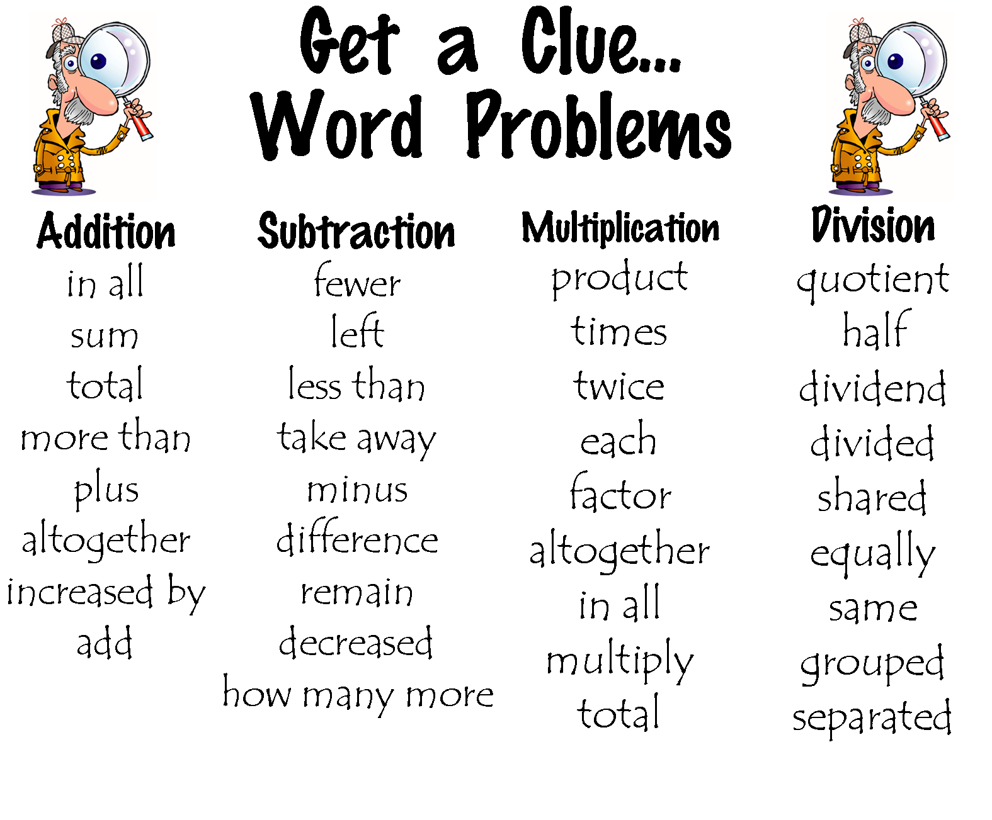

STEP 3: Carry Out the Plan

- Learners should document all their work to help them in explaining their thinking
- They should develop a strategy and use a systematic approach. If learners get stuck in their strategy, they should re-evaluate whether their strategy is appropriate, and if they have all the necessary information required to utilize their strategy
- Learners should be given an opportunity to explain their process and how they arrived at their answer

The following template can be used to help learners to develop their skills and ability to use the problem-solving process.

Note to Instructors about using the template: It is important to have learners state the answer in the form of a sentence so that they can demonstrate an understanding of what the answer really means, including units. When performing problem-solving in the workplace, this is most often the way their answer will need to be communicated. Often learners still developing their skills in mathematical processes will lose sight of the end objective while they are performing their calculations. By making the learner write their answer in sentence form, it ensures the learner keeps their focus on the larger context of their work and demonstrate an understanding of why they are using those processes.

Problem Solving Template

Word Problem:

Question:

Relevant Information Given:

Choose a Strategy (Circle One):
- Draw a diagram/ Act it out
- Make a model
- Look for a pattern
- Construct a table or chart
- Create an organized list
- Work backwards
- Logical reasoning/Process of elimination
- Solve a simpler problem
- Guess and check
- Write an equation

Show your Work:

Conclusion:__________________________________________________________________________________________________
STEP 4: Check your Answer

- Learners should ask themselves whether their answer makes sense
- They should make sure that the answer is expressed in the appropriate units
- Learners should write down all their work in an organized fashion so they can reflect on their practices
- They should be able to explain their processes to someone else
- Learners should ask themselves ‘what if’ questions to create connections to other problems -> this encourages the development of logical thought processes
- Learners should consider if there are other ways to solve the problem, including perhaps simpler processes

Assessment:

- MIA Assessment completed prior to the program
- Completion of activities during the module
- Practice activities within each module/lesson/assessment

References:
Mathematics Problem Solving Strategies
https://garyhall.org.uk/maths-problem-solving-strategies.html
Problem Solving: Draw a Picture: https://www.teachervision.com/mathematics/problem-solving-draw-picture
Problem Solving: Acting it Out or Using Concrete Material: http://www.blake.com.au/v/vspfiles/downloadables/pt3_problemsolving.pdf

