TOOL QUIZ
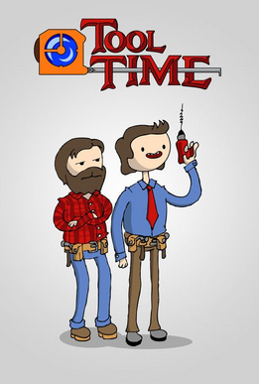
ANSWER SHEET- ANSWER KEY

1 | Pipe wrench | 2 | Portable circular saw
3 | Adjustable wrench | 4 | Allan wrench (key)
5 | Aviation snips | 6 | Ball Pein hammer
7 | Bent nose pliers | 8 | Bolt cutters
9 | Box end wrench | 10 | C Clamp
11 | Combination square | 12 | Combination wrench
13 | Coping saw | 14 | Cordless drill
15 | Cutting torch | 16 | Diagonal cutting pliers
17 | End cutting snips | 18 | Extension socket
19 | Grease gun | 20 | Groove joint pliers
21 | Hack saw | 22 | Lag screw
23 | Level | 24 | Long nose pliers
25 | Machine bolt | 26 | Nail/ claw hammer
27 | Nut driver | 28 | Open-ended wrench
29 | Phillips screw driver | 30 | Pipe wrench
31 | Reversible ratchet | 32 | Slip-joint pliers
33 | Vice-grip pliers | 34 | Mallet
35 | Tape measure | 36 | Slotted screw driver
37 | Side-cutting pliers | 38 | Round head stove bolt
39 | Regular socket | 40 | Portable circular saw

