

ESSENTIAL SKILLS

“Essential Skills provide the foundation for learning all other skills and enable people to evolve with their jobs and adapt to workplace changes.”

WRITING IN THE WORKPLACE
Introduction

© Workplace Education Manitoba, 2022

WRITING IN THE WORKPLACE

INTRODUCTION

Writing is your ability to share information using the written word. Communication through writing has become embedded in the workplace. Even if writing isn’t a core part of your job, you’ll likely use it to communicate with others in the workplace by composing e mails, writing an accident report, requesting information, providing feedback, filling out forms, posting on social media, or requesting time off work. Being able to communicate clearly through writing will help your work go more smoothly, prevent misunderstanding, keeps co-workers informed and ultimately strengthen your work relationships. To achieve these benefits your writing must be appropriate for your purpose, the intendant reader, and the context in which you work.

RATIONALE

Effective writing skills equip you to communicate clearly your thoughts and ideas; preventing misunderstanding by ensuring the reader understands the key points of your message. Effective writing skills reduce the need for time consuming meetings and endless telephone messages. Writing fosters our ability to refine our thinking and to express these thoughts and ideas clearly and concisely.

LEARNING OBJECTIVES

The learning objectives of this module are:
- Understand the basic structure of a sentence
- Apply the standard conventions for grammar and punctuation
- Understand the basic structure of a paragraph
- Organize thoughts and ideas logically to ensure understanding
- Provide appropriate level of detail
- Write a 4-6 sentence paragraph clearly expressing an idea or thought

INSTRUCTIONAL PROCESS

- Explain that writing has become embedded as a workplace skill at all the levels of employment
- Outline the benefits of communicating clearly: prevents misunderstanding, while reducing the need for time consuming meetings
- Explain that effective writing is based upon the structure and clarify of the message
- Outline the structure of a sentence is built upon the use of capital letters and punctuation marks
- Walk learners through the 7 rules for capitalization
- Explain the usage of the 4 most common punctuation in workplace writing
- Learners complete “Structure of Messages Task”, using the answer key to correct their work
- Discuss questions arising from the task
- Define term “clarity of message”; review 6 tips for writing a clear message
- Explain that clarity of a message is built upon knowing what the reader of the message already know and what they need to know
- Provide an example, walking learners through the sample in the “clarity of message tasks”
- Learners complete “Clarity of Messages Task”, using the answer key to correct their work
- Upon completion of tasks, discuss what things are important to include in a message (who, what, when, where, and why that the reader needs to know)

EFFECTIVE WRITING

Effective writing is based upon structure and clarity of the message. In writing, structure is built upon the sentence formation and punctuation, while clarity of message is based upon ability of the writer to focus on only the most relevant pieces of information.

STRUCTURE OF THE MESSAGE

A sentence is composed of two parts:

The subject of a sentence is the person, place, or thing that is performing the action of the sentence.
- And a word that expresses mental (ie: thinking, planning, or observing) or physical action (lifting, moving, or operating) is a verb. The verb tells what the subject of the sentence is doing.

A complete sentence must have both of these parts- subject and verb.

The structure of the sentence is built using capital letters and punctuation. The 7 common rules for capitalizing in the work place:
- Capitalize the first word of a sentence
- Capitalize Names (Bob Smith)
- Capitalize the pronoun “I”
- Capitalize titles (Mr. ,Mrs., Dr.)
- Capitalize Days, Months, and Holidays, But Not Seasons
- Capitalize Brand names (McDonalds)
- Cities, countries, nationalities, languages
Common punctuation marks used in workplace writing are:
- Periods (.)- at the end of a sentence
- Question mark (?)- at the end of a sentence that asks a question
- Comma (,)- used to separate items in a list
- Colon (;)- used before listing items


STRUCTURE OF THE MESSAGE TASKS
INSTRUCTIONS: Re-write the following notes editing the punctuation and capitalization.

NOTES | EDITED NOTES
please excuse my daughter sophie for being absent yesterday she started feeling sick on monday night i stayed home to look after her i gave sophie some tylenol and she felt better

when you go to store on saturday make sure you pick up bananas bread butter milk heinz ketchup and remember nails screws and gorilla glue from the home depot

I think there is something wrong with the off set press when running the press spits out ink and makes strange sounds you need to complete job order #123 by tuesday on the off set

before you start the forklift make a visual check for obstructions fire extinguisher in place and oil level and tires start the engine and check engine oil radiator water levels and fuel supply with the engine running check the electrolyte levels condition of battery terminals lights while sitting on the forklift test the forks report any problems to supervisor

CLARITY OF THE MESSAGE

Effective writer constructs clear, readable, and easily understood sentences by choosing the appropriate words and combining them in to sentences that clearly communicates the writer’s thoughts and ideas.

Some general tips on writing sentences in the workplace:
- Know what you are trying to say and identify words that express your message clearly
- Your first sentence should state the purpose of your message
- Get to the point by knowing what the reader already knows and what the reader needs to know
- Avoid miscommunicating your message by giving too much information or too little information
- Read and re-read your message to ensure the message makes sense
- Edit your message checking for spelling, punctuation, and capitalization

Ultimately, you want your message to be easily understood by being complete and accurate and without unnecessary information.

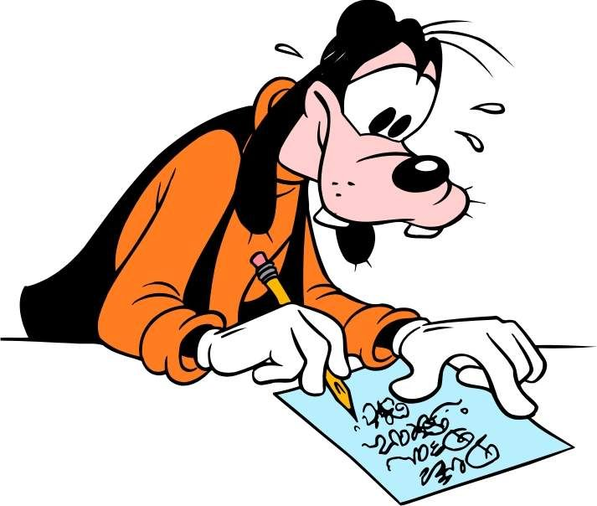

CLARITY OF MESSAGE TASKS

INSTRUCTIONS: Before writing your note, take a moment and identify what the reader already knows and what the reader needs to know about the situation. For each situation below, list 3 pieces of information the reader would already know, and three pieces of information that will help the reader understand your message. An example is done below.

SITUATION | ALREADY KNOWS | NEEDS TO KNOW
- Fork lift in not working well and appears to be leaking some type of fluid | - That you work for the company  - That you are a fork lift operator  - It is the reader’s responsibility to maintain the company’s fork lifts | - The day & date of the note  - The number and make of the fork lift  - Where the fork lift is located  - How the fork lift not working well affects you getting your job done
- All is not going well with work order #1122 and will not be completed on time. The delay is due to the labeller not affixing the ingredients label straight on the product. As of right now you are not sure if the problem is the labels or the glue.
- You are planning to leave work early tomorrow for a doctor’s appointment.
- The regular Monday morning staff meeting will be held Tuesday afternoon due to Monday being a long weekend.

