

DOCUMENT USE

INTRODUCTORY

WORKSHOP
ANSWER KEY

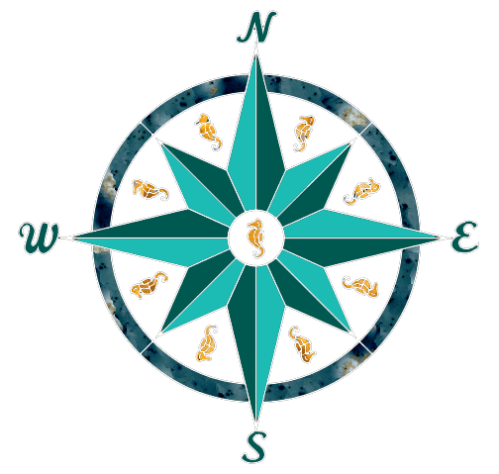

INTRODUCTION TO ESSENTIAL SKILLS

Essential Skills are the abilities that people need to learn, work, and live. They are used in the community and the workplace, in different forms and at different levels of complexity.

Essential Skills are used in different combinations, in different applications, in every occupation. Essential Skills are the foundational abilities that employees use to carry out their work tasks. Essential Skills are the abilities employees use to learn job specific skills to perform tasks in a workplace.
Since 1994 the Federal government has surveyed more than 3000 Canadians in workplaces in all sectors and of all types and sizes of organizations. All were asked what workplace Essential Skills they felt were needed in order for workers to be most effective, efficient and productive.
The results of the survey identified of the following nine workplace Essential Skills:
- Reading
- Document use
- Numeracy
- Writing
- Oral Communication
- Working with Others
- Thinking
- Digital Technology
- Continuous Learning

The focus of this workshop is the Essential Skill of Document Use.

DOCUMENT USE SKILLS

Document Use is the essential skill that relates to the ability to understand documents that combine text with graphs, symbols, numbers, colors and shapes. The Essential Skill of Document Use is the ability to find, understand, or enter information (e.g. text, numbers, or symbols) in various types of documents. Document Use includes the ability to read and understand signs, labels, lists, graphs, charts, forms, and schematics, as well as entering information into specific documents. A workplace example of Document Use is the skill of a bricklayer to interpret blueprints to determine the height, length, and thickness of the wall that is to be built.

Recent studies reveal that up to 95% of the reading performed in the workplace relates to searching information from a wide variety of documents. Studies do not only point to an increase quantity of document usage in the workplace, but also to an increase in the variety and complexity of documents used in the work process. The ability to read and interpret a variety of documents has become a critical feature of modern industrial economies around the world.

The ability to read and interpret documents is described as document navigation. A document could be thought of as a map- a map helps you find a specific location and a document helps you find specific information. Document navigation is a reading strategy composed of 8 steps:

- Skim the document to get a general understanding regarding what the document is about- skimming is a kind of reading where you look for the main idea or purpose of the document. People who design documents use titles, headings, and an overall structure to make it easier for the reader to find the specific piece of information for which they are looking.

- Read the question to understand what information you are required to find- look for the key words in the question

- Re-phrase the question in your own words to ensure you have understood the question

- Highlight on the document the key words in the questions as well as any headings, subheadings, bullet points, keys or legends or symbols (that could help you locate specific pieces of information)

- Scan the document using the key words and headings you highlighted in the previous step- 90% of the time the key words in the question will be the key words in the document

- Based upon the scan, predict where you are most likely to find the answer to the question

- Answer the question with a response that is as specific as the document

- Re-read the question and your answer to ensure your answer fully responded to the question

When you see a document for the first time, you should follow these steps to ensure that you understand the document and that you respond correctly. Once you become comfortable with the document, you will be able to quickly locate specific information by combining or omitting steps.

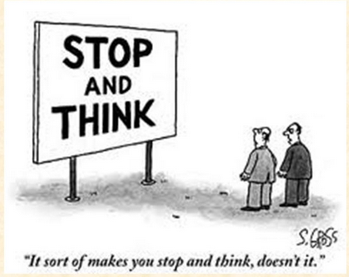
PRACTISING THE 8 STEPS IN NAVIGATING A DOCUMENT:

STEP 1: Skim Document 1

- Complete the statement below:

- The purpose of this document is: The list outlines the average number of hours worked by wage earners paid by the hour.

- Examine sample Document 1. Check off the type of document it is:

- List | - Map
- Graph | - Chart
- Form | - Other

STEP 2: Read the question

- List the key words in the question: Names of provinces and years

STEP 3: Rephrase the question

- In your own words, state what the question is asking: A) How many hourly wage earners in Saskatchewan in 2003? B) What is the change on hourly wage earners in Nova Scotia from 2001 to 2004?

STEP 4: Highlight key words and headings in the document- On document

STEP 5: Scan the document using key words and headings- On document

STEP 6: Predict the location of the information required- On document

- Circle the section on the document where you think the answer will be located

STEP 7: Answer the question

- Write the answer to the question (answer needs to be as specific as it is stated in the document: A) 31.0 hours B) .9 hours

STEP 8: Re- read the question to ensure that your answer fully responds to the question

DOCUMENT 1

Average weekly hours of hourly paid employees
 | 2001 | 2002 | 2003 | 2004 | 2005
Canada | 31.6 | 31.9 | 32.1 | 31.9 | 31.7
Newfoundland and Labrador | 31.1 | 31.3 | 31.5 | 31.0 | 30.5
Prince Edward Island | 30.6 | 30.4 | 30.9 | 31.0 | 29.5
Nova Scotia | 29.8 | 30.0 | 30.7 | 30.7 | 30.4
New Brunswick | 31.8 | 31.9 | 32.3 | 31.9 | 31.6
Quebec | 31.4 | 31.8 | 32.2 | 32.1 | 31.9
Ontario | 32.2 | 32.5 | 32.6 | 32.3 | 31.8
Manitoba | 30.2 | 30.2 | 30.6 | 30.6 | 30.6
Saskatchewan | 30.3 | 30.6 | 31.0 | 30.9 | 30.3
Alberta | 31.8 | 32.1 | 32.4 | 31.9 | 32.4
British Columbia | 31.2 | 31.3 | 31.5 | 31.2 | 31.1
Yukon Territory | 30.9 | 31.5 | 33.1 | 33.2 | 32.8
Northwest Territories | 34.1 | 34.5 | 34.8 | 34.1 | 33.8
Nunavut | 34.3 | 34.2 | 34.7 | 34.2 | 35.2

QUESTIONS:

- What was the average number of hours for hourly paid employees in Saskatchewan in 2003? 31.0
- In Nova Scotia, what was the increase in hours for hourly paid employees from 2001 to 2004? 30.7 – 29.8= 0.9 hours



PRACTISING THE 8 STEPS IN NAVIGATING A DOCUMENT:

STEP 1: Skim Document 2

- Complete the statement below:

- The purpose of this document is: Summarize the unemployment rates for males and females in 6 countries.

- Examine sample Document 1. Check off the type of document it is:

- List | - Map
- Graph | - Chart
- Form | - Other

STEP 2: Read the question

- List the key words in the question: A) Unemployment rate, Canada and Mexico B) Unemployment for women greater than unemployment for men C) Canada’s unemployment rate compared to other countries

STEP 3: Rephrase the question

- In your own words, state what the question is asking: A) Difference in unemployment rates in Canada and Mexico? B) Where is unemployment for women greater than for men? C) How does Canada’s unemployment rate compare to the other countries listed?

STEP 4: Highlight key words and headings in the document- On document

STEP 5: Scan the document using key words and headings- On document

STEP 6: Predict the location of the information required- On document

- Circle the section on the document where you think the answer will be located

STEP 7: Answer the question

- Write the answer to the question (answer needs to be as specific as it is stated in the document: A) On average Canada’s unemployment is nearly 4 times greater than Mexico. B) France C) Canada’s rate for unemployment is greater than every country except France.

- STEP 8: Re- read the question to ensure that your answer fully responds to the question

DOCUMENT 2

AVERAGE UNEMPLOYMENT BY COUNTRY AND GENDER

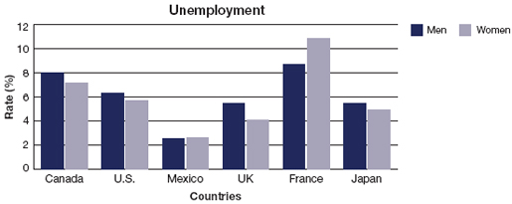

QUESTIONS:

- How does the unemployment rate of Canada compare to Mexico? Canada’s rate is higher
- In what countries is unemployment for women greater than the unemployment for men? France
- How does Canada’s unemployment compare to the other 5 countries? Higher unemployment except for France

PRACTISING THE 8 STEPS IN NAVIGATING A DOCUMENT:

STEP 1: Skim Document 3

- Complete the statement below:

- The purpose of this document is: To provide an accurate account to the purchaser of these goods that were ordered.

- Examine sample Document 1. Check off the type of document it is:

- List | - Map
- Graph | - Chart
- Form | - Other

STEP 2: Read the question

- List the key words in the question: A) total amount of tax to be paid B) Motorola V3 Raxr C) Note in space provided

STEP 3: Rephrase the question

- In your own words, state what the question is asking: A) What is the total amount of tax to be paid? B) What is the cost of 1 Motorola V3 Raxr? C) What do I need to write on the document?

STEP 4: Highlight key words and headings in the document- On document

STEP 5: Scan the document using key words and headings- On document

STEP 6: Predict the location of the information required- On document

- Circle the section on the document where you think the answer will be located

STEP 7: Answer the question

- Write the answer to the question (answer needs to be as specific as it is stated in the document: A) $1204.50 B) $500.00 C) This order will be delivered in 2 weeks.

STEP 8: Re- read the question to ensure that your answer fully responds to the question

DOCUMENT 3

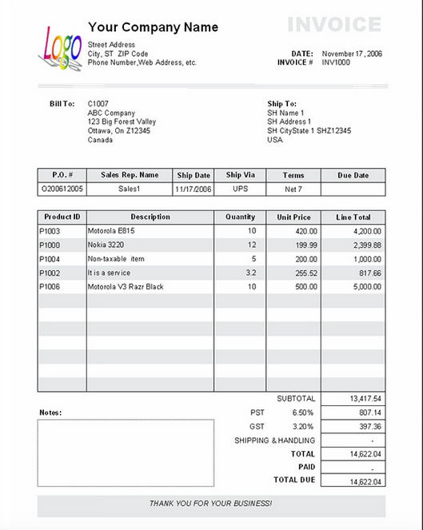
Total amount of tax is
$1204.50. Order will be shipped in 2 weeks.

QUESTIONS

- Write a note on the invoice indicting the total amount of tax being paid.
- What is the cost of 1 Motorola V3 Raxr ? $500.00
- In the space provided, write a brief note explaining that the order will be delivered in 2 weeks.

PRACTISING THE 8 STEPS IN NAVIGATING A DOCUMENT:

STEP 1: Skim Document 4

- Complete the statement below:

- The purpose of this document is: The purpose of this document is to provide the plans for wiring a miniature FM transmitter.

- Examine sample Document 1. Check off the type of document it is:

- List | - Map
- Graph | - Chart
- Form | - Other- schematic

STEP 2: Read the question

- List the key words in the question: A) Name of schematic B) Amount of wire, antennae C) Battery denoted

STEP 3: Rephrase the question

- In your own words, state what the question is asking: A) What is the title of the schematic? B) How much wire should be allowed for the connecting of the antennae? C) What size battery is required to make the transmitter work?

STEP 4: Highlight key words and headings in the document- On document

STEP 5: Scan the document using key words and headings- On document

STEP 6: Predict the location of the information required- On document

- Circle the section on the document where you think the answer will be located

STEP 7: Answer the question

- Write the answer to the question (answer needs to be as specific as it is stated in the document: A) Miniature FM transmitter B) 8-10 feet of wire C) 9 volt

STEP 8: Re- read the question to ensure that your answer fully responds to the question

DOCUMENT 4

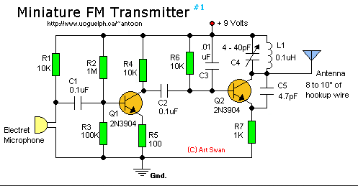

QUESTION

- For what is this schematic? Miniature FM Transmitter
- How much wire should be allowed to hookup the antenna? 8-10 feet
- What size battery is denoted on the schematic? 9 volt battery

PRACTISING THE 8 STEPS IN NAVIGATING A DOCUMENT:

STEP 1: Skim Document 5

- Complete the statement below:

- The purpose of this document is: The purpose of the document is to identify a specific product, the hazards of the product, and first aid and fire fighting measures.

- Examine sample Document 1. Check off the type of document it is:

- List | - Map
- Graph | - Chart
- Form | - Other- Material Safety Data Sheet

STEP 2: Read the question

- List the key words in the question: A) Name of the product B) 4 ways chemical may enter the body C) First Aid Measures

STEP 3: Rephrase the question

- In your own words, state what the question is asking: A) For what product is this MSDS sheet? B) How may this chemical enter your body and cause health problems? C) What should you do in case the chemical has entered someone’s body?

STEP 4: Highlight key words and headings in the document- On document

STEP 5: Scan the document using key words and headings- On document

STEP 6: Predict the location of the information required- On document

- Circle the section on the document where you think the answer will be located

STEP 7: Answer the question

- Write the answer to the question (answer needs to be as specific as it is stated in the document: A) Benefect B) Eye, Skin, Inhale, and Ingest C) flush with water, Wash with soap & water, Move victim to fresh air, Wash out mouth

STEP 8: Re- read the question to ensure that your answer fully responds to the question

DOCUMENT 5

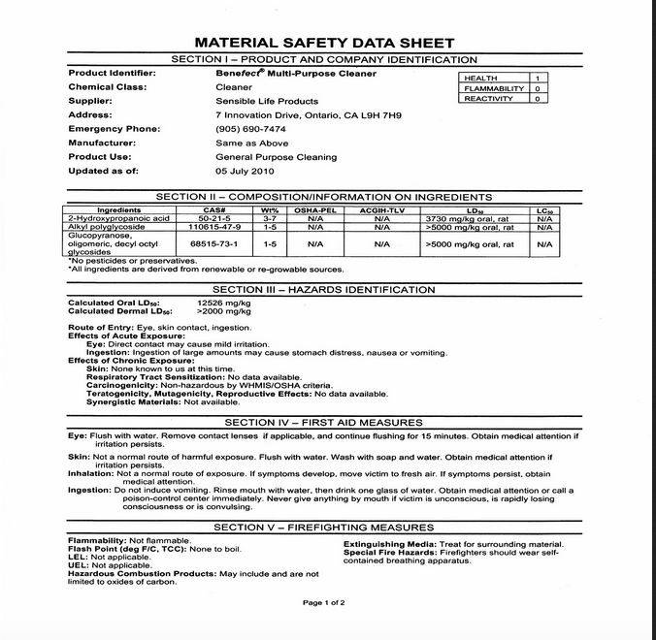

QUESTIONS:

- What is the name of the product? Benefect Multi purpose cleaner
- List the four ways the chemical may enter the body? Eyes, skin, ingestion, & breathing
- List the four first aid measures for this product. Eyes- Flush with water, remove contact lenses, continue flushing; Skin- flush with water, wash with soap & water; Nose- move to fresh air, Moth- do not induce vomiting

PRACTISING THE 8 STEPS IN NAVIGATING A DOCUMENT:

STEP 1: Skim Document 6

- Complete the statement below:

- The purpose of this document is: The purpose of this document is to keep track of what and how much a truck driver did on a specific trip.

- Examine sample Document 1. Check off the type of document it is:

- List | - Map
- Graph | - Chart
- Form | - Other- log book

STEP 2: Read the question

- List the key words in the question: A) Date completed B) 4 types of activities C) Percentage of time spent driving

STEP 3: Rephrase the question

- In your own words, state what the question is asking: A) On what date was this document filled in. B) What are the four activities tracked on this document? C) Of the total trip, what percentage of the time is spent driving?

STEP 4: Highlight key words and headings in the document- On Document

STEP 5: Scan the document using key words and headings- On document

STEP 6: Predict the location of the information required- On document

- Circle the section on the document where you think the answer will be located

STEP 7: Answer the question

- Write the answer to the question (answer needs to be as specific as it is stated in the document: A) January 2, 2008 B) Off duty, Sleeping, Driving, On duty C) 43.75%

STEP 8: Re- read the question to ensure that your answer fully responds to the question

DOCUMENT 6

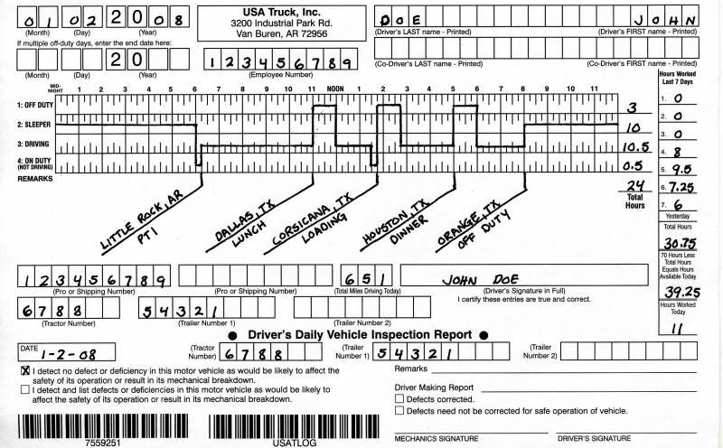

QUESTIONS:

- For what date is the log sheet completed? January 2, 2008
- List the 4 activities recorded on the log sheet. Off duty, Sleeping, Driving, & On duty
- What is the percentage of the total time spent driving? 10 – 11 hours

PRACTISING THE 8 STEPS IN NAVIGATING A DOCUMENT:

STEP 1: Skim Document 7

- Complete the statement below:

- The purpose of this document is: The purpose of this document is to illustrate the relationship between the price of a used car and the age of the car.

- Examine sample Document 1. Check off the type of document it is:

- List | - Map
- Graph | - Chart
- Form | - Other

STEP 2: Read the question

- List the key words in the question: A) Title of the graph B) The price of the car becomes less as the car gets older. C) Price of four-year-old-car

STEP 3: Rephrase the question

- In your own words, state what the question is asking: A) What is the name of this graph? B) Explanation the relationship between price of the car and the age of the car? C) How much would a four-year-old care cost?

STEP 4: Highlight key words and headings in the document- On document

STEP 5: Scan the document using key words and headings- On document

STEP 6: Predict the location of the information required- On document

- Circle the section on the document where you think the answer will be located

STEP 7: Answer the question

- Write the answer to the question (answer needs to be as specific as it is stated in the document: A) Car age/ price B) As the age increase the price of car decreases C) Between $1000 and $2000

STEP 8: Re- read the question to ensure that your answer fully responds to the question

DOCUMENT 7

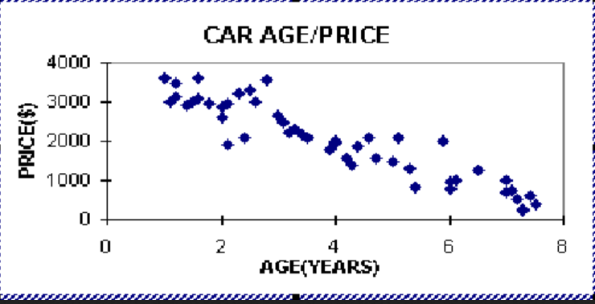

QUESTIONS:

- What is the title of the graph? Car/ Age Price
- Explain the relationship between car age and price. As the car gets older the price gets lower
- Using the graph estimate the price of a four-year-old car. $1800-2000

PRACTISING THE 8 STEPS IN NAVIGATING A DOCUMENT:

STEP 1: Skim Document 8

- Complete the statement below:

- The purpose of this document is: The purpose of the graph is to illustrate students’ preference in tastes of ice ream.

- Examine sample Document 1. Check off the type of document it is:

- List | - Map
- Graph- Circle graph | - Chart
- Form | - Other

STEP 2: Read the question

- List the key words in the question: A) How many students B) 2 favourite flavours C) On document D) How many students?

STEP 3: Rephrase the question

- In your own words, state what the question is asking: A) How many students responded to the survey? B) What are the 2 most popular flavours? C) On document D) How many students preferred vanilla?

STEP 4: Highlight key words and headings in the document- On document

STEP 5: Scan the document using key words and headings- On document

STEP 6: Predict the location of the information required- On document

- Circle the section on the document where you think the answer will be located

STEP 7: Answer the question

- Write the answer to the question (answer needs to be as specific as it is stated in the document: A) 1000 students B) Mint chocolate chip & Vanilla C) Banana and Pecan cluster D) 250 students

STEP 8: Re- read the question to ensure that your answer fully responds to the question

DOCUMENT 8

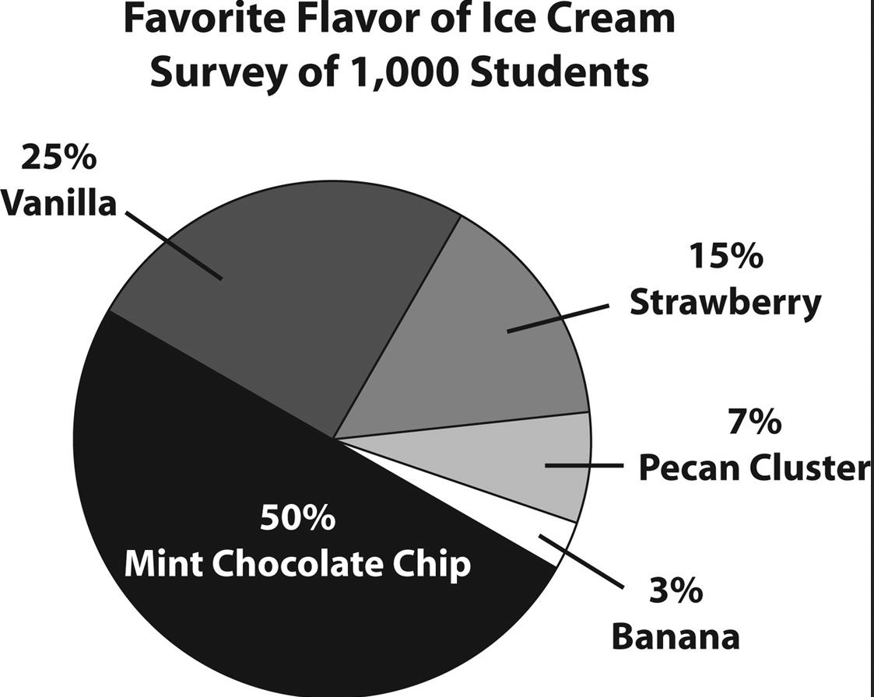

QUESTIONS:

- How many students were surveyed to create this circle graph? 1000 students
- List the 2 most favorite flavours. Mint Chocolate Chip and Vanilla
- On the document highlight the two flavours that equal to 10% of the students surveyed.
- If 25% of the students survey preferred Vanilla- How many students chose vanilla? 250 students chose vanilla

PRACTISING THE 8 STEPS IN NAVIGATING A DOCUMENT:

STEP 1: Skim Document 9

- Complete the statement below:

- The purpose of this document is: The purpose of this document is to illustrate the number of cars rented each day.

- Examine sample Document 1. Check off the type of document it is:

- List | - Map
- Graph- Pictograph | - Chart
- Form | - Other

STEP 2: Read the question

- List the key words in the question: A) Scale B) Rented on Tuesday C) Percentage & Wednesday

STEP 3: Rephrase the question

- In your own words, state what the question is asking: A) Each car represents how many cars? B) How many cars were rented on Tuesday? C) Percentage of the total number of cars rented on Wednesday?

STEP 4: Highlight key words and headings in the document- On document

STEP 5: Scan the document using key words and headings- On document

STEP 6: Predict the location of the information required- On document

- Circle the section on the document where you think the answer will be located

STEP 7: Answer the question

- Write the answer to the question (answer needs to be as specific as it is stated in the document: A) 1 picture equals 5 cars B) 40 cars C) 26%

STEP 8: Re- read the question to ensure that your answer fully responds to the question

DOCUMENT 9

CARS RENTED PER DAY

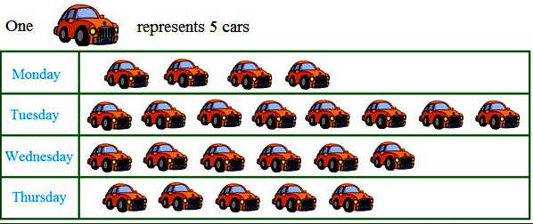

QUESTIONS:

- What is the scale used in this pictograph? 1 picture equals 5 cars
- How many cars were rented on Tuesday? 40 cars
- What percentage of cars was rented on Wednesday? 26%

PRACTISING THE 8 STEPS IN NAVIGATING A DOCUMENT:

STEP 1: Skim Document 10

- Complete the statement below:

- The purpose of this document is: The purpose of this document is to illustrate the steps in the process of making beer.

- Examine sample Document 1. Check off the type of document it is:

- List | - Map
- Graph | - Chart
- Form | - Other- Flow chart

STEP 2: Read the question

- List the key words in the question: A) Highlight process on document B) Louter Tun and Copper Kettle C) 3 options for packaging the beer

STEP 3: Rephrase the question

- In your own words, state what the question is asking: A) Outline the process of making beer B) What is beer called when it passes from the Louter Tun to the Copper Kettle? C) Describe three ways of packaging the beer?

STEP 4: Highlight key words and headings in the document- On document

STEP 5: Scan the document using key words and headings- On document

STEP 6: Predict the location of the information required- On document

- Circle the section on the document where you think the answer will be located

STEP 7: Answer the question

- Write the answer to the question (answer needs to be as specific as it is stated in the document: A) On document B) Sweet wort C) Keg. Bottle, Bulk

STEP 8: Re- read the question to ensure that your answer fully responds to the question.

DOCUMENT 10

PROCESS OF PRODUCING BEER

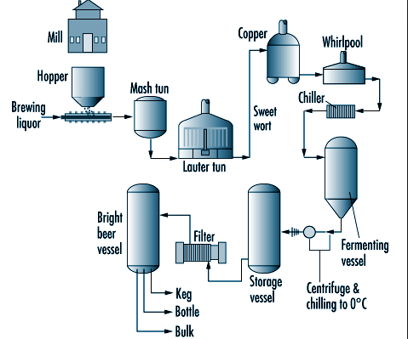

QUESTIONS:

- Using a highlighter, outline the process of producing beer on the document.
- What is the product called when it is moving from the Louter Tun to the Copper Kettle? Sweet Wort
- What are the three options for packaging the beer? Keg, bottle, & bulk

