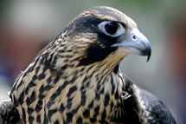
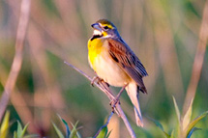
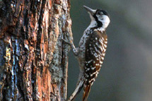
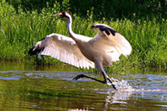
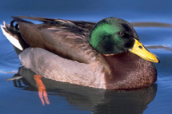
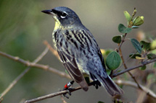
BIRDS
Found across the world, birds range from small and difficult-to-spot songbirds to the majestic bald eagle. Though a few birds are flightless, most fly and have feathers. Typically birds are adapted to have low take-off weights and high power-to-weight-ratios. Many species undertake long migration every year.
BIRDS OF PREY
This fearsome group includes eagles, hawks, falcons, owls and their relatives.
GRASSLAND BIRDS
The prairies and other grasslands of the world provide rich habitat for a wide range of bird species
SONGBIRDS
The term “songbird” refers to a large number of species that are often known for their call rather than their looks.
WOODPECKERS
Planet Earth is home to more than 180 species of woodpecker, each of whom has a unique adaptation to habitat.
WADING BIRDS
Waders and shorebirds feed in the rich shallow waters of shores and coastlines.
WATERFOWL
Humans have long depended upon waterfowl for food and for feathers. This group includes geese, swans and ducks.

1. Align Left
When a bullfrog is stretched to its full length, it may measure up to 36 inches, making it the largest frog in North America. Native to the eastern and central United States, it has been introduced in such far flung places as Jamaica, Thailand and France. Bullfrogs are aquatic frogs, but they spend much time on land and can often be spotted at the water’s edge.
2. Align Right
When a bullfrog is stretched to its full length, it may measure up to 36 inches, making it the largest frog in North America. Native to the eastern and central United States, it has been introduced in such far flung places as Jamaica, Thailand and France. Bullfrogs are aquatic frogs, but they spend much time on land and can often be spotted at the water’s edge.
3. Align Center
When a bullfrog is stretched to its full length, it may measure up to 36 inches, making it the largest frog in North America. Native to the eastern and central United States, it has been introduced in such far flung places as Jamaica, Thailand and France. Bullfrogs are aquatic frogs, but they spend much time on land and can often be spotted at the water’s edge.
4. Align Justify
When a bullfrog is stretched to its full length, it may measure up to 36 inches, making it the largest frog in North America. Native to the eastern and central United States, it has been introduced in such far flung places as Jamaica, Thailand and France. Bullfrogs are aquatic frogs, but they spend much time on land and can often be spotted at the water’s edge.
The Bull Frog
When a bullfrog is stretched to its full length, it may measure up to 36 inches, making it the largest frog in North America. Native to the eastern and central United States, it has been introduced in such far flung places as Jamaica, Thailand and France. Bullfrogs are aquatic frogs, but they spend much time on land and can often be spotted at the water’s edge.

