11 Pictures + Text Wrapping
Introduction
Adding pictures to your document can be a great way to illustrate important information or add decorative accents to existing text.
Used in moderation, pictures can improve the overall appearance
of your document.


Play the video by clicking the link below:
Pictures + Text Wrapping
Exercise 11
Using the sample as a guide, follow the directions below to complete the exercise.
- Open the Corn on the Cob.jpg file
- Save the file in you Pictures Folder:
File >Save As > Pictures
- Name your file by typing in the File Name box:
Word 11 Picture Folder Corn on the Cob
- Repeat with the other 2 pictures (inserting the name of picture where appropriate).
- Open Word 11 Template PICTURES + TEXT WRAPPING
- Save the file in your Documents Folder:
File > Save As > Documents
- Name your file by typing in the File Name box:
Word 11 YourFirstNameLastInitial PICTURES + TEXT WRAPPING
Save as type: Word Document
Click Save
Scroll down to Page 2
- Click the Cloud and Sun graphic. Move your mouse to the edge of the box that
surrounds the graphic.
- When you see the cross/arrows symbol which is the Move tool, click, hold and drag the graphic to move it beside the paragraph Memorial Day Barbecue.
Insert a picture from your computer:
- Place the cursor before the First paragraph Join us Saturday, April 7...
- On the Insert Tab, click the Pictures Icon.
- You will now go to the folder where the pictures are filed:
click Word 11 Picture Folder Pool.
click the Pool image and click Insert.
When you insert an image into your document, it will stay selected.
You will see a frame with little boxes around it. To select and de-select images, hover your mouse over the image and click.
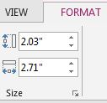
- With the pool image selected, re-size it by typing 2.03 in the height sizing box located in the Picture Tools Format Tab. Press Enter.
Note: Another way to re-size an image is to click and hold a corner handle on the border of an image. Drag your mouse diagonally toward the center of the image to make smaller or drag diagonally outward to make the image bigger
- With the photo selected, left click the Layout Options icon to the right of the photo. The Layout Options button gives you quick access to change how your image interacts with the rest of your document.
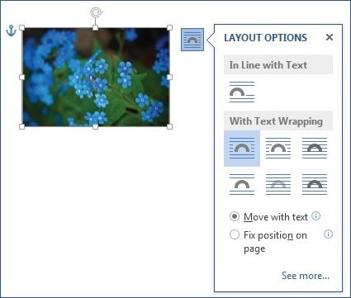
- Read the various layout options below to become familiar with them:
Inline - you image will not move. It acts like a big oversized text character. To move it, you have to cut it and paste it somewhere else in the document.
The image will stay relative to the text – in other words, move up and down on the page along with the text
where it is anchored.
The image will stay relative to the page – in other words, it will stay on a certain spot on the page
it’s anchored to, like the
in the top right corner.
Floating Images
allow for various text wrapping styles to control the way an image interacts with the text in your document.
}
- Under With Text Wrapping, hover your mouse to preview the layout options.
Left click Square to allow the text to run around the photo
- Click Fix Position on Page. This allows the image to stay in a certain spot on the page. Click the X to close the pop out window.
- Adjust the position of the photo to match the sample: Move your mouse to the edge of the box that surrounds the image.
Note: Dragging a center side handle will stretch or squish an image. Images of people + logos should never be distorted.
When you see the cross/arrows symbol, click, hold and drag the image to move it.
Insert another picture from your computer:
- Place the cursor at the end of the Barbecue paragraph.
- On the Insert Tab, click the Pictures Icon.
On the top of the pop out window you will see the path of the folder
you are in. You will most likely be in the last folder you opened, the
Word 11 Picture folder.
- Click the image Corn on the Cob and click Insert.
Only If you did not automatically go to the Word 11 Picture Folder and inserted your Corn on the Cob picture, you will have to click through the path to get to the picture folder:
click Word 11 Picture Folder.
click the image Corn on the Cob and click Insert.
- Click the Layout Options icon next to the photo.
- Under With Text Wrapping, left click Square to allow the text to run around the photo. Click Fix Position on Page. This allows the image to stay in a certain spot on the page. Click the X to close the pop out window.
- Move the photo down to the bottom of the page and to the left to match
the position shown in the sample.
- Pull the middle handle on the right side of the photo until it stretches to
the right edge of the page.
This is a good example of a photo that can be stretched (distorted) without looking weird.

Scroll to Page 1
Insert another picture from your computer:
- Place the cursor before the first Paragraph “Residents are raving...”
On the Insert Tab, click the Pictures Icon.
- Again, on the top of the pop out window you will see the path of the folder you are in. You will most likely be in the last folder you opened, the Word 11 Picture folder.
- Click the image Keyboard and click Insert.
Only If you did not automatically go to the Word 11 Picture Folder and inserted your Keyboard picture, you will have to click through the path to get to the picture folder:
click Word 11 Picture Folder Keyboard.
click the image Keyboard and click Insert.
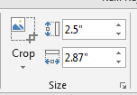
- Type 2.5 in the height sizing box located in the Picture Tools Format Tab.
Press Enter.
- With the photo selected, left click the Layout Options symbol to the right of the graphic.
- Under With Text Wrapping, left click Tight to allow the text to run tightly around the graphic. Click Fix Position on Page. This allows the image to stay in the spot where you place it on the page, not to move with the text.
- Click the X to close the pop out window.
- Move the image to the right side of the paragraph as shown on the sample.
- Save your assignment and email it to your instructor.

