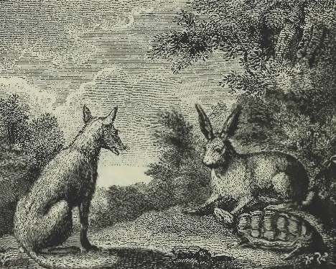
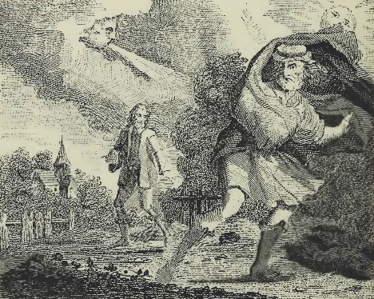
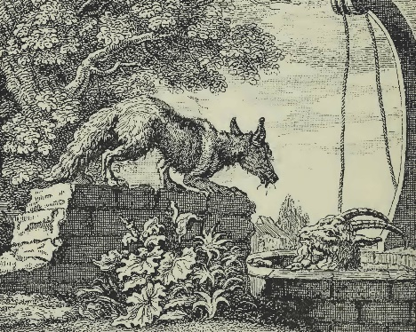
Aesop's Fables
Word Exercise 21 – Sample

The Fox, the Goat
and the Well
Look before you leap
A fox fell into a well and was stuck there. A passing goat saw the fox asked if the water tasted good. "It's the best water you'll ever taste," said the fox, at which the goat promptly jumped into the well to drink. On realising he was stuck too, the goat agreed that the fox could climb up and over him out of the well and then help the goat out. The fox duly climbed up and over the goat to his freedom but left the goat stranded.
The North Wind
and the Sun
Persuasion is better than force
The north wind and the sun argued which was the stronger. On seeing a traveller they agreed a suitable test would be to strip him of his cloak. First the wind blew with all his might, but the more he blew, the more than man wrapped the cloak tightly around himself. When the sun's turn came, he gently beamed at the man, who loosened the cloak. The sun shone brighter still, and the man threw off his cloak.
The Hare and
the Tortoise
Slow and steady wins the race
A hare derided a tortoise for being so slow, and the tortoise challenged the hare to a race, to which the amused hare agreed. After the race started the hare soon found himself far ahead, and so decided to rest, but fell fast asleep. When he awoke he dashed to the finish but found that the plodding tortoise had comfortably beaten him to it.

